

a Fitchsolutions company

Q3 2025

[www.fitchsolutions.com/bmi](https://www.fitchsolutions.com/bmi)

Argentina

Oil & Gas Report

Includes 10-year forecasts to 2034



**Argentina Oil & Gas Report | Q3 2025**

a Fitchsolutions company

**Contents**

**Key View 5**

**SWOT 7**

Oil & Gas SWOT 7

**Industry Forecast 8**

Upstream Exploration 8

Upstream Projects 12

Upstream Oil Production 14

Upstream Gas Production 20

Refining 26

Refined Fuels Consumption 29

Gas Consumption 33

Oil Trade 37

Gas Trade 41

**Industry Risk/Reward Index 45**

Latin America Upstream Oil & Gas Risk/Reward Index 45

Latin America Downstream Oil & Gas Risk/Reward Index 53

Argentina Upstream Oil & Gas Risk/Reward Index 60

Argentina Downstream Oil & Gas Risk/Reward Index 62

**Market Overview 64**

Oil & Gas Market Overview 64

Oil & Gas Infrastructure 69

**Competitive Landscape 75**

**Company Profile 77**

YPF 77

Chevron Argentina 79

ExxonMobil 81

**Regional Overview 83**

Latin America Oil & Gas Regional Overview 83

**Oil & Gas Glossary 91**

**Oil & Gas Methodology 92**

This commentary is published by BMI – A Fitch Solutions Company, and is not a comment on Fitch Ratings' Credit Ratings. Any comments or data included in the report are solely derived from BMI and independent

sources. Fitch Ratings analysts do not share data or information with BMI.

**fitchsolutions.com/bmi** 3

**Argentina Oil & Gas Report | Q3 2025**

a Fitchsolutions company

© 2025 Fitch Solutions Group Limited. All rights reserved.

All information, analysis, forecasts and data provided by Fitch Solutions Group Limited are for the exclusive use of subscribing persons or organisations (including those using the service on a trial basis). All such content is copyrighted in the name of Fitch Solutions Group Limited and as such no part of this content may be reproduced, repackaged, copied or redistributed without the express consent of Fitch Solutions Group Limited.

All content, including forecasts, analysis and opinion, is based on information and sources believed to be accurate and reliable at the time of publishing. Fitch Solutions Group Limited makes no representation or warranty of any kind as to the accuracy or completeness of any information provided, and accepts no liability whatsoever for any loss or damage resulting from opinion, errors, inaccuracies or omissions affecting any part of the content.

This report from BMI – A Fitch Solutions Company is a product of Fitch Solutions Group Limited; UK Company registration number 08789939 ('FSG'). FSG is an affiliate of Fitch Ratings Inc. ('Fitch Ratings'). FSG is solely responsible for the content of this report, without any input from Fitch Ratings.

Copyright © 2025 Fitch Solutions Group Limited.

**Argentina Oil & Gas Report | Q3 2025**

a Fitchsolutions company

Key View

***Key View:*** *Argentina will see strong oil and gas production growth, both in the short-and-long term as midstream infrastructure comes online. The sector is being boosted by recent policy changes and deregulation which are favourable to private investment and favouring upstream investments, with notable efforts being made to develop unconventional resources (notably in the Vaca Muerta). In addition, the completion of critical oil and gas transportation infrastructure is also allowing a significant increase in*

*output, with further gains to come in the coming quarters.*

Headline Forecasts (Argentina 2023-2029)

|  |  |  |  |  |  |  |  |
| --- | --- | --- | --- | --- | --- | --- | --- |
| **Indicator** | **2023** | **2024e** | **2025f** | **2026f** | **2027f** | **2028f** | **2029f** |
| Crude, NGPL & other liquids prod, 000b/d | 806.7 | 879.1 | 986.7 | 1,012.8 | 1,039.7 | 1,058.7 | 1,078.1 |
| Refined products production, 000b/d | 519.0 | 526.8 | 529.4 | 534.7 | 540.1 | 545.5 | 550.9 |
| Refined products consumption & ethanol, 000b/d | 782.7 | 757.8 | 776.7 | 792.0 | 805.3 | 817.0 | 827.2 |
| Dry natural gas production, bcm | 43.7 | 46.0 | 49.5 | 50.9 | 53.7 | 55.4 | 57.3 |
| Dry natural gas consumption, bcm | 46.0 | 46.9 | 48.1 | 49.6 | 50.8 | 52.1 | 53.4 |
| Brent, USD/bbl | 82.18 | 79.86 | 68.00 | 71.00 | 70.00 | 70.00 | 70.00 |

*e/f = BMI estimate/forecast. Source: EIA, national sources, BMI*

**Latest UpdatesAnd Key Forecasts**

• As expected, IOCs are ramping up shale exploration and production as they benefit from increased midstream capacity and

favourable business environment, facilitated by President Javier Milei, who took over office in 2024. Drilling activity has recovered from 2020 lows of rig counts of 22. The rig count was at 49 rigs early 2025 (with one offshore rig, a first since 2016, although this remains significantly below the 2018 average level of 71.

• The new ‘Incentive Regime for Large Investments’ was approved by Congress in 2024, and could increase stability and

attractiveness for long-term large investments in the oil and gas sector. It will offer 30 years of fiscal stability, fiscal, customs and exchange incentives for large investments of over USD200mn in several sectors, of which oil and gas. This could significantly improve the stability and attractiveness of investments in the Argentinian oil and gas sector, and creates significant long-term upside risks to oil and gas production.

• Oil output increased by an impressive 11.0% y-o-y in 2024, to a total of 706,000b/d, the highest level since 2004. This is being led by unconventional oil growth: in 2024, unconventional oil output surpassed conventional oil production for the first time.

• The Oldelval pipeline system (Oleoductos del Valle) has recently been expanded to 225,000b/d and 300,000b/d in 2023, to 377,000b/d end-2024, and total capacity of 540,000b/d in 2025 (the final expansion reportedly came online in April 2025

boosting total capacity to 540,000b/d). The expansion will allow significant increases in deliveries to the export terminal from

2025 to 2027 and is expected to result in substantial increases in oil output in the coming quarters. We forecast another 15.0% y-o-y crude oil and condensates production gain in 2025 thanks the Oldelval pipeline expansion.

• We currently forecast oil output to reach 896,000b/d by 2029, and nearly 1.0mn b/d by 2034, although we note that the

completion of the critical Vaca Muerta South oil pipeline project to a new oil terminal on the coast will be necessary to ensure continued production gains past 2027/2028.

• In November 2024, YPF reported it started developing the second section of the Vaca Muerta South oil pipeline. The pipeline will start exports in 2026/2027 with an initial capacity of 390,000b/d, increasing to 700,000b/d by 2028. In January 2025, YPF also awarded an engineering and management contract related to the development of the Vaca Muerta project, to Técnicas

Reunidas. The USD440mn contract is an engineering, procurement and construction management contract for a hydrocarbon storage and dispatch terminal that will be located in Punta Colorada, on the coast of the province of Río Negro. This will become the main port for exporting crude oil from the new Vaca Muerta South oil pipeline.

**Argentina Oil & Gas Report | Q3 2025**

a Fitchsolutions company

• Thanks to rising unconventional production and oil export infrastructure, Argentina is considerably increasing its net crude oil exports. This will see crude oil net exports rise from 352,000b/d in 2024 to over 600,000b/d by 2034, with rising upside risks to this forecast. The country is a mid-scale importer of refined fuels, which we expect will remain the case given rising demand for fuels and stable refining capacity. Argentina will see slowly rising net fuels import requirements throughout the forecast period.

• The expansion of midstream capacity for natural gas, initially through the Nestor Kirchner pipeline and now with Northern

Pipeline reversal project, is also supportive of out bullish outlook for gas production from the Vaca Muerta over the coming years. We expect output to increase by 7.6% y-o-y in 2025 to 49.5bcm, after an estimated increase of 5.2% y-o-y growth in 2024 to

46.0bcm.

• Producers are also considering new gas export markets such as exporting to Brazil through Bolivia's gas network, in addition to potential LNG exports through new LNG export infrastructure. Our current outlook includes first LNG exports from a floating

terminal in 2027, boosting long-term gas production growth outlook. We are therefore increasingly bullish on long-term gas

production outlook, should the required infrastructure projects materialise, with our forecasts seeing production rise to 67.1bcm by 2034, with risks to the upside.

• We identify upside risks to gas production given Argentina triggered a tender in February 2025 for a USD500mn gas

compression project on the Gasuducto Presidente Nestor Kirchner. This would aim to boost capacity of the Vaca Muerta

debottlenecking gas pipeline, notably to help substitute winter imports of LNG. However, it remains unclear whether this would replace plans for the second phase of the Vaca Muerta pipeline that was initially planned to boost dispatch to the north.

• We expect Argentina to become a net exporter of gas in 2025, as it cuts pipeline imports from Bolivia and LNG imports, while ramping up pipeline exports to Chile. In the long term, we see booming natural gas production to support net export growth, which we forecast will rise to 6.7bcm by 2034. Our current forecast remains conservative given continues infrastructure

constraints and a lack of LNG export terminals.

• We expect the government of Javier Milei to support the expansion of LNG export capabilities and therefore recognise upside

risks to our long-term gas production and net exports forecasts stemming from advancing talks about a large-scale LNG facility. We do not yet incorporate this large-scale terminal, rather we expect small scale terminals to be deployed over the medium term. Notably, in November 2024, YPF partnered with Southern Energy to deploy a 2.45 Mt/year FLNG vessel, the Hilli Episeyo in the Gulf of San Matias, Rio Negro.

**Argentina Oil & Gas Report | Q3 2025**

a Fitchsolutions company

SWOT

Oil & Gas SWOT (Executive Summary)

|  |  |
| --- | --- |
| **Strengths** | **Weaknesses** |
| • The Vaca Muerta shale formation in ArgentinaIs Neuquén Province is home to some of the largest hydrocarbon  resources in the world.  • Large conventional onshore and offshore segments as well.  • Competitive environment has improved in the recent years, with many major IOCs investing in exploring and developing unconventional reserves.  • Improving regulatory environment under president Javier Milei, who supports the expansion of hydrocarbons sector. | • A deficit of domestic oil field services and infrastructure has kept upstream development costs elevated within  unconventional acreage.  • A complete dependence on the spot market for LNG imports exposes YPF and Enarsa to steep price volatility and heavy  competition with other Latin America markets, such as Brazil.  • Insufficient midstream infrastructure hinders the development of Vaca Muerta reserves, although infrastructure works are beginning to bear fruit. |
| **Opportunities** | **Threats** |
| • The resolution of the Repsol-YPF dispute, coupled with an  increasingly investor-friendly regulatory environment, will  further encourage international participation into the sector.  • A growing cadre of international and national oil companies are investing in the Vaca Muerta formation.  • A few companies eyeing offshore acreage off the Buenos Aires province coast.  • Strong unconventional growth pushing the market to  increasingly large net exports of crude. Should also become net gas exporter in 2025. | • Economic weakness could undermine future growth  prospects as the government increases austerity measures, reducing investor confidence.  • Regulatory uncertainty has left many companies waiting on the sidelines.  • Delays to key offtake infrastructure is the main threat to continued unconventional production growth. |

阿根廷内乌肯省的巴卡穆埃尔塔页岩层拥有世界上一些最大的油气资源。

• 同样拥有大型的传统陆上和海上业务板块。

近年来，竞争环境有所改善，许多主要的国际石油公司（IOC）都在投资勘探和开发非常规储量。

• 在哈维尔·米莱总统的支持下，改善监管环境，以促进油气行业的扩张。

国内油田服务和基础设施的不足导致非常规油田区块的上游开发成本居高不下。

• 液化天然气进口完全依赖现货市场，使YPF和Enarsa面临价格剧烈波动以及与巴西等其他拉丁美洲市场的激烈竞争。

• 尽管基础设施工程已初见成效，但中游基础设施的不足仍阻碍着瓦卡穆埃尔塔油田储量的开发。

雷普索尔-YPF（Repsol-YPF）纠纷的解决，加之监管环境日益有利于投资者，将进一步鼓励国际资本进入该行业。

• 越来越多的国际和国内石油公司正在对瓦卡穆埃尔塔（Vaca Muerta）地层进行投资。

• 一些公司正关注布宜诺斯艾利斯省海岸线外的海上油田。

• 强劲的非传统增长推动市场原油净出口量不断增加。到2025年，该市场还应成为天然气净出口国。

经济疲软可能会削弱未来的增长

随着政府加大紧缩措施的力度，投资者信心下降，前景堪忧。

• 监管的不确定性让许多公司持观望态度。

• 关键承购基础设施的延误是持续非常规生产增长的主要威胁。

**Argentina Oil & Gas Report | Q3 2025**

a Fitchsolutions company

Industry Forecast

Upstream Exploration

***Key View:*** *We are increasingly optimistic about Argentina's proven hydrocarbons reserves thanks to positive trends in the upstream market, midstream infrastructure expansions, increased capital expenditures, and strong interest from IOCs. Growth is expected*

*from shale exploration in particular and offshore development. However, long-term forecasts indicate declining reserves as*

*production increases, with potential upside dependent on attracting foreign investment in exploration over the coming years.*

**Latest Updates**

• We have become increasingly bullish in our proven hydrocarbons reserves forecast for Argentina given improving sentiment in the broader upstream market amid the progress in midstream infrastructure expansion, plans for growing capital expenditures and continued interest from the IOCs.

• As expected, IOCs are ramping up shale exploration and production as they benefit from increased midstream capacity and favourable business environment, facilitated by President Javier Milei, who took over office in January 2024.

• Drilling activity has recovered from 2020 lows of rig counts of 22. The rig count was at 49 rigs early 2025 (with one offshore rig, a first since 2016, although this remains significantly below the 2018 average level of 71.

• We maintain the view that YPF will continue raising its capital expenditures over the next years. We see YPF's capex lingering

between USD5-6bn over 2024-2028. Our outlook is in line with the company announcement of keeping the capex between

USD5-6bn over the near term. Media reports indicate that YPF plans to focus exploration efforts on D-129 formation in Golfo San Jorge basin and Santa Cruz province over the near term.

• The Argentine government extended the concession for exploration and development of offshore acreage in the Austral Basin till 2041 for three companies Total Austral, Wintershall Dea Argentina and Pan American Sur. Companies committed to invest the total of USD700mn in the acreage between 2031-2041.

**Structural Trends**

**Foreign Investment Is Improving Following Market Reforms**

Argentina has significant oil and gas reserves - in 2024, we estimate the market holds reserves of 2.4bn bbl of oil and 0.47tcm of gas. The market has a substantial unconventional resource base, with an estimated 22.7tcm of technically recoverable shale gas and 27bn bbl of recoverable shale oil.

Despite strong below ground prospectivity, poor fiscal terms and an uncertain regulatory environment stemmed exploration in

Argentina over the first half of the decade. Momentum built in 2010 and 2011 behind the market's emergent shale sector, but

came off sharply in 2012 after the government's expropriation of YPF from Spanish major Repsol. The resolution of the Repsol-YPF dispute in 2014 removed a major legal barrier to exploration. The deal, which awarded Repsol a USD5bn settlement in bonds, saw the company relinquish its claim to YPF's assets, opening the door to a series of JV agreements between the Argentine NOC and foreign firms.

The settlement followed a number of incremental reforms in 2012 and 2013, improving the market's business environment:

• In November 2012, the government raised the wellhead price of natural gas from USD5.00/mnBTU, to USD7.50/mnBTU.

• In January 2013, they cut export tax on crude, which significantly increased the return on oil sold abroad.

**Argentina Oil & Gas Report | Q3 2025**

a Fitchsolutions company

• In July 2013, presidential degree 929 stipulated that international companies investing at least USD1bn in the Argentine oil and gas sector in the first-five years of a project were allowed to export 20% of their production tax exempt, and could repatriate a portion of the revenue. The threshold investment has now been reduced to USD250mn.

• In July 2013, US supermajor Chevron and YPF signed a USD1.2bnJV agreement, which included the commitment to drill 100 wells in the Vaca Muerta shale formation. This has since been upgraded to a USD1.6bn investment and a commitment to drill

170 wells.

Since then, there has been a slow but steady increase in the number and amounts companies have invested in the market. Other major agreements include ExxonMobil, Shell, TotalEnergies and Petronas. Following the YPF-Repsol settlement in 2015, this trend has accelerated, marking the gradual de-risking of the business environment.

Rig Count Continues To Recover

Argentina - Number Of Active Oil- and Gas-directed Rigs, 2019-2024

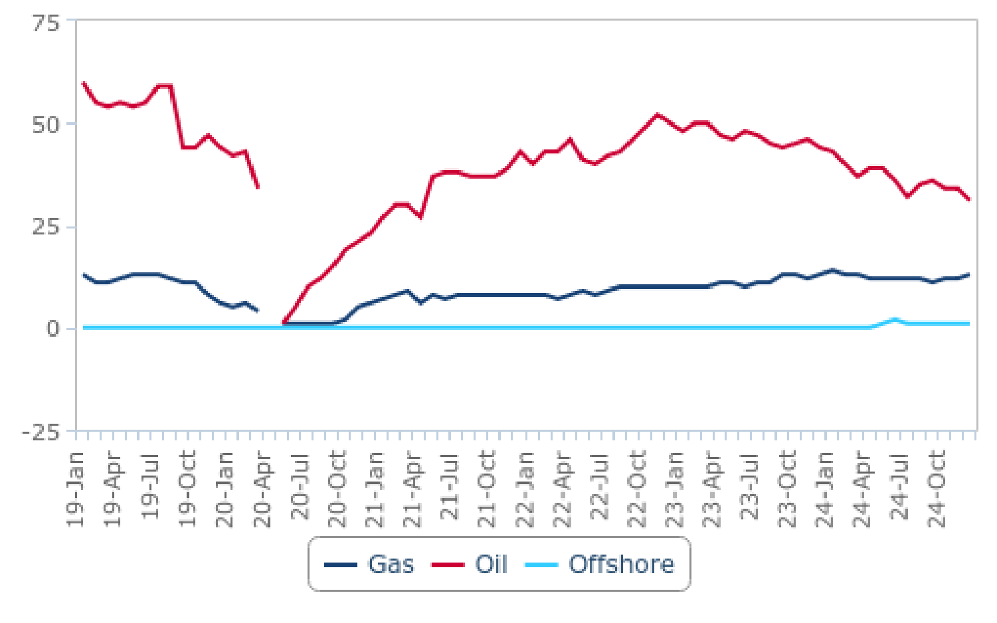

*Source: Baker Hughes, BMI*

Argentine shale, and in particular the Vaca Muerta, is highly prospective but underexplored, and drilling remains high risk and capital intensive. A recession across 2019-2020 and uncertainty of the stance on reforms of former Alberto Fernández's cabinet slowed

down private investments, as did the fall in global demand in the wake of the Covid-19 pandemic. While exploration activity waned, we expect long-term growth due to:

• **Lowering Operating Costs:** The cost to develop wells is falling. According to YPF, drilling and completion of a shale exploration well was around USD29/boe in 2015, and fell to approximately USD11/boe in 2018. Drilling efficiencies will improve via reducing the number of drilling days and increasing laterals from current levels.

• **Growing Prospectivity:** Early exploration in the Vaca Muerta has returned broadly positive drilling results. Testing points to good reservoir quality and a high recovery rate. A string of discoveries should help support the upward trend in investment, as companies weigh continued operational risk against the market's shale potential.

**Argentina Oil & Gas Report | Q3 2025**

a Fitchsolutions company

**YPF, Majors And Smaller Private Companies Focus On Vaca Muerta**

We estimate commercial breakeven costs for the Chevron-YPF joint venture in Loma La Lata Norte and Loma Campana in the Vaca Muerta are below USD40-50/bbl, which is looking less profitable due to the early 2020 fall in global oil prices. Project costs vary

significantly and break-evens for theJV project will fall to the lower end of the spectrum. The project is the most advanced in

Argentina and the companies involved have both substantial experience and strong technical capability. Lower breakevens have been supported by a significant drawdown in drilling costs over the past several years as well as improved well productivity and access to pre-existing infrastructure.

In May 2016, Chevron revealed it was considering a new unconventional development project at its maturing El Trapial concession following promising exploration tests. The company reportedly evaluated the results of four shale wells drilled in the play which

suggested upwards of 1bn bbls of recoverable oil equivalent, the focus of which will be gas condensate. The company hoped to begin the eight-well appraisal project which no later than mid-2017, but delayed the campaign into 2018 after offering USD20mn for the plan in Q417. As of 2020, Chevron reports it is using waterflood operations to offset declining output at El Trapial.

In December 2015, the JV between ExxonMobil and Gas y Petroleo del NeuquenJV was approved by the government of Neuquen to develop shale resources in the Bajo el Choique and La Invernanda blocks. The JV planned to drill over 550 wells with investments

likely to reach upwards of USD10.0bn investment. This strategy follows on from a USD225mn investment through the Exxon

subsidiary XTO Energy which explored for unconventional resources in the blocks and has had strong results thus far with more discoveries likely to follow given the supermajor's more stable financial position. In April 2016, ExxonMobil unveiled its upstream

investment plan for the Vaca Muerta shale play, revealing spending could reach USD10bn over the next several decades as it transfers its US unconventional strategy into the market. We note that in 2020, ExxonMobil excluded its Argentine

upstream projects from its core assets.

We note that some companies focus predominantly on shale oil rather than natural gas. As an example - Vista Oil & Gas intensifies exploration and development of shale oil assets in Vaca Muerta. By the end of 2021, Vista has become the third-largest oil producer in the market. The company has plans to double its production over the next five years.

Breakeven costs for smaller and less-evolved pilot projects will likely be higher, and these types of projects may come under

pressure in a lower price environment. Exploration in the more frontier Noroeste and Chaco Paranaense regions is particularly vulnerable; investment inflows to the more commercially developed regions, such as Neuquén and Golfo San Jorge will remain more robust.

**Brighter Outlook For Offshore Development**

As of now, most offshore development is located offshore the southern-most province of Tierra del Fuego. Offshore prospects are improving in the wake of the market's first offshore licensing round which closed in April 2019. A total of 38 blocks were on offer in the licensing round, the first open bid round for Argentinean offshore acreage in more than 20 years. The blocks are spread along Argentina's coast; in the Malvinas basin, approximately 320km offshore Tierra del Fuego and include MLO-113,

MLO-117 and MLO-118 and further north with CAN100,102,108 and 114 off Mar al Plata in Buenos Aires. Equinor, with partners

(YPF and Shell), conducts seismic studies in CAN100 after receiving approval for an exploration campaign in December 2021. Total Austral pursues its Fenix offshore gas project off Tierra del Fuego. We note that we see some regulatory hurdles for offshore projects in Argentina as federal judge has suspended the exploration campaign in CAN100 in February 200 on the basis of environmental

risks. Although the government plans to appeal the verdict, we indicate on regulatory risks related to offshore projects in Argentina.

**Argentina Oil & Gas Report | Q3 2025**

a Fitchsolutions company

**Risks To Outlook**

The key risks to the Argentine shale sector are political uncertainty, macroeconomic instability and commodity price volatility. Under new president Javier Milei, we estimate the economy contracted by 1.7% in 2024. However, we forecast the market to return to

growth in 2025, with our Country Risk team forecasting real GDP growth of 4.8% in 2025 and 4.4% in 2026.

At the same time, Milei's free-market agenda would likely result in an improved regulatory environment for oil and gas companies. The president has been promoting limited government interference in the market with his free-market agenda that will likely

include efforts to lift capital controls, limit price setting, and remove hydrocarbons export taxes. However, we highlight lingering

regulatory uncertainty on the back of very narrow legislative margins. Hence although we expect a push to market liberalisation in some form form the Milei government, we note that there remains relatively heightened uncertainty over the final shape of the

reforms.

**Argentina Oil & Gas Report | Q3 2025**

a Fitchsolutions company

Upstream Projects

Key Upstream Projects

|  |  |  |  |  |  |  |  |  |
| --- | --- | --- | --- | --- | --- | --- | --- | --- |
| **Name** | **Field Name** | **Companies** | **Completion Date** | **Status**  **Select** | **Est.**  **Peak**  **Oil/**  **Liquids**  **Range (b/d)** | **Est.**  **Peak Gas**  **Output**  **(bcm)** | **Type Of**  **Project** | **On-**  **shore/ Off-**  **shore** |
| Aguada  Federal Block, Neuquen  basin | Aguada Federal Block | GyP Neuquen (50%), Wintershall (50%) | - | Exploration | na | na | Oil & gas | Onshore |
| Bandurria Sur | Bandurria Sur | YPF (40%), Shell  (30%), Equinor (30%) | - | Development | 10,000 | 2.4 | Shale oil  and gas | Onshore |
| Block Bajo el Choique | Block Bajo el Choique | GyP Neuquen (10%), ExxonMobil (90%) | - | Exploration | na | na | Shale oil  and gas | Onshore |
| Block Coiron Amargo,  Neuquen Basin | Block Coiron Amargo | Pluspetrol Chile  (45%), Madalena  Energy (35%), Roch (10%), GyP Neuquen  (10%) | - | Exploration | na | na | Oil & gas | Onshore |
| Block Cuenca Marina  Austral-1 (CMA) | Vega Pleyade | Total (37.5%), Pan American Energy (25%), Wintershall (37.5%) | 2016 | Development | 70,000 | na | Gas &  condensate | Offshore |
| Block Cuenca Marina  Austral-1 (CMA) | Carina, Aries | Total (37.5%),  Wintershall (37.5%), Pan American Energy (25%) | 2005 | Production | na | 3.2 | Gas &  condensate | Offshore |
| Block La  Invernada | Block La Invernada | GyP Neuquen (10%), ExxonMobil (90%) | - | Exploration | na | na | Shale oil  and gas | Onshore |
| Block Perales- Las Meseta | Block Perales-Las Meseta | YPF (100%) | - | Discovery | na | na | Oil & gas | Onshore |
| Cerro Dragon | Cerro Dragon | Pan American Energy (100%) | 1958 | Production | 106,800 | 3.6 | Oil, gas and  condensate | Onshore |
| Chihuido de la Sierra Negra (ChSN),  Neuquen Basin | Chihuido de la Sierra Negra (ChSN) | YPF (100%) | 1979 | Production | 28,000 | na | Oil | Onshore |
| La Amarga Chica,  Neuquen basin | LaAmarga Chica | GyP Neuquen (10%), CompaniasAsociadas Petroleras (20%), YPF (70%) | - | Exploration | na | na | Oil & gas | Onshore |
| La Ribera  Prospect | La Ribera Prospect | YPF (100%) | - | Discovery | na | na | Gas | Onshore |
| Loma  Campana, | Loma Campana | Chevron (50%), YPF (50%) | - | Production | 50,000 | 1.2 | Oil & gas | Onshore |

**Argentina Oil & Gas Report | Q3 2025**

a Fitchsolutions company

|  |  |  |  |  |  |  |  |  |
| --- | --- | --- | --- | --- | --- | --- | --- | --- |
| **Name** | **Field Name** | **Companies** | **Completion Date** | **Status**  **Select** | **Est.**  **Peak**  **Oil/**  **Liquids**  **Range (b/d)** | **Est.**  **Peak Gas**  **Output**  **(bcm)** | **Type Of**  **Project** | **On-**  **shore/ Off-**  **shore** |
| Neuquen basin |  |  |  |  |  |  |  |  |
| Loma la Lata, Neuquen  basin | Loma la Lata | YPF (50%), Chevron (50%) | - | Production | na | 18.8 | Gas | Onshore |
| Morena Sur,  Austral basin | Morena Sur | Compania General de Combustibles (100%) | - | Discovery | na | na | Gas | Onshore |
| Paso de las Bardas Norte Block | Paso de las Bardas Norte Block | YPF (100%) | - | Discovery | na | na | Tight gas | Onshore |
| Puesto  Guardian  Concession, Noroeste  Basin | Puesto Guardian,  Canada Grande, Dos Puntitas, Pozo  Escondido, Pozo  Escondido Este | President Energy (100%) | - | Production | 98,781 | na | Oil | Onshore |

*na = not available. Source: BMI Upstream Oil & Gas Projects Database*

**Argentina Oil & Gas Report | Q3 2025**

a Fitchsolutions company

Upstream Oil Production

***Key View:*** *Argentina’s oil production sector is increasingly dynamic, with both conventional and unconventional production. Oil production (crude oil and condensates) saw an impressive 11.0%y-o-ygrowth in 2024, and we forecast another 15.0%y-o-y*

*production gain in 2025 thanks the Oldelval pipeline expansion. The sector is being boosted by recent policy changes and*

*deregulation which are favourable to private investment and favouring upstream investments, with notable efforts being made to develop unconventional resources (notably in the Vaca Muerta).*

核心观点：阿根廷石油生产行业活力日益提升，常规与非常规生产均有涉及。2024 年，石油产量（原油与凝析油）同比大幅增长 11.0%；得益于奥尔德瓦尔（Oldelval）输油管道的扩建，我们预测 2025 年产量将再同比增长 15.0%。近期的政策调整与放松管制为该行业提供了助力，这些举措有利于私人投资，尤其支持上游投资，同时阿根廷还在大力推进非常规资源开发（重点是瓦卡穆尔塔页岩区）。

**Latest Updates**

• Oil output increased by an impressive 11.0% y-o-y in 2024, to a total of 706,000b/d, the highest level since 2004. This is being led by unconventional oil growth: in 2024, unconventional oil output surpassed conventional oil production, with government data indicating unconventional output averaged 392,000b/d, compared to conventional production of 314,000b/d.

• The Oldelval pipeline system (Oleoductos del Valle) has recently been expanded to 225,000b/d and 300,000b/d in 2023, to

377,000b/d end-2024, and total capacity of 540,000b/d in 2025 (the final expansion reportedly came online in April 2025

boosting total capacity to 540,000b/d). This pipeline connects Vaca Muerta with the Port of Rosales terminal in Bahia Blanca in the Buenos Aires province. The expansion will allow significant increases in deliveries to the export terminal from 2025 to 2027 and is expected to result in substantial increases in oil output in the coming quarters.

• We forecast another impressive 15.0% y-o-y growth in crude oil and condensates output in 2025, thanks notably to the

completed expansion of the Oldelval pipeline. We have recently increased our production forecasts for the 2025-2027 period, and note that the sector is increasingly on track to meet its ambitious 1.0mn b/d oil production target by 2030. However, we remain on the conservative side however, assuming some delays in the completion of midstream projects, which will postpone the ramp-up of production, and notably on the Vaca Muerta South oil pipeline. We forecast oil output of 914,000b/d in 2030.

• ln November 2024 YPF reported it started developing the second section of the Vaca Muerta South oil pipeline, a 440km link

between Allen and Punta Colorada in Rio Negro province in Argentina. The pipeline will start exports in 2026/2027 with an initial capacity of 390,000b/d, increasing to 700,000b/d by 2028.

• ln January 2025, VMOS SA, a company owned by YPF, awarded an engineering and management contract related to the

development of the Vaca Muerta project, to Técnicas Reunidas. The USD440mn contract is an EPCm (engineering, procurement and construction management) contract for a hydrocarbon storage and dispatch terminal that will be located in Punta Colorada, on the coast of the province of Río Negro. YPF plans for the entire development of the Vaca Muerta project and its infrastructure to begin commercial operation in July 2027. This includes the construction of the 437km crude oil export pipeline, the loading and unloading terminal, and a tank and storage yard.

• We also highlight risk to our forecast stemming from heightened regulatory uncertainty. We maintain our view that Javier MileiIs free-market agenda is broadly supportive of the oil and gas sector and is expected to foster long-term hydrocarbons production growth. The new Qlncentive Regime for Large lnvestments, (RlGl) could increase stability and attractiveness for long-term large investments in the oil and gas sector. lt will offer 30 years of fiscal stability, fiscal, customs and exchange incentives for large

investments of over USD200mn in several sectors, of which oil and gas. This could significantly improve the stability and

attractiveness of investments in the Argentinian oil and gas sector, and creates significant long-term upside risks to oil and gas production.

最新动态

2024 年，阿根廷石油日产量同比大幅增长 11.0%，达到 70.6 万桶，创下 2004 年以来的最高水平。这一增长主要由非常规石油推动：2024 年，非常规石油日产量超过常规石油，官方数据显示，非常规石油日均产量为 39.2 万桶，而常规石油日均产量为 31.4 万桶。

奥尔德瓦尔输油管道系统（Oleoductos del Valle）近期持续扩建：2023 年运力为 22.5 万 - 30 万桶 / 日，2024 年底提升至 37.7 万桶 / 日，2025 年总运力将达 54 万桶 / 日（据悉最终扩建工程于 2025 年 4 月投产，使总运力提升至 54 万桶 / 日）。该管道连接瓦卡穆尔塔页岩区与布宜诺斯艾利斯省巴伊亚布兰卡市的罗萨莱斯港码头，2025-2027 年期间，扩建后的管道将大幅增加向出口码头的运输量，预计未来几个季度石油产量将显著提升。

得益于奥尔德瓦尔输油管道扩建工程的完工，我们预测 2025 年阿根廷原油与凝析油产量将再同比大幅增长 15.0%。我们近期上调了 2025-2027 年的产量预测，同时注意到该行业正逐步朝着 2030 年实现 100 万桶 / 日的宏伟石油产量目标迈进。不过，我们仍持保守态度，因为中游项目（尤其是瓦卡穆尔塔南部输油管道）的完工可能出现延迟，这将推迟产量提升进程。我们预测 2030 年阿根廷石油日产量将为 91.4 万桶。

2024 年 11 月，阿根廷国家石油公司（YPF）宣布启动瓦卡穆尔塔南部输油管道第二段的建设。该管道长 440 公里，连接阿根廷内格罗河省的艾伦市与蓬塔科罗拉多市，将于 2026-2027 年开始用于出口，初始运力为 39 万桶 / 日，2028 年将提升至 70 万桶 / 日。

2025 年 1 月，阿根廷国家石油公司（YPF）旗下的 VMOS 公司，将瓦卡穆尔塔项目的一项工程管理合同授予泰尼卡斯・雷乌尼达斯公司（Técnicas Reunidas）。这份合同金额为 4.4 亿美元，属于 EPCm（设计、采购、施工管理）合同，涉及在内格罗河省沿海城市蓬塔科罗拉多建设一座油气储输终端。阿根廷国家石油公司计划让瓦卡穆尔塔项目及其相关基础设施于 2027 年 7 月全面投入商业运营，其中包括 437 公里长的原油出口管道、装卸码头以及储油区的建设。

我们还需强调，监管不确定性加剧给我们的预测带来了风险。不过我们仍认为，哈维尔・米莱（Javier Milei）的自由市场议程总体上对油气行业有利，有望推动油气产量长期增长。新出台的《大型投资激励制度》（RIGI）或将提升行业稳定性，增强对油气行业长期大型投资的吸引力。该制度将为多个行业（包括油气行业）中 2 亿美元以上的大型投资提供 30 年的财政稳定性，以及财政、海关和外汇方面的激励。这一举措可能显著提升阿根廷油气行业投资的稳定性与吸引力，为油气产量带来显著的长期增长空间。

**Structural Trends**

Argentina,s oil production sector is increasingly dynamic, with both conventional and unconventional production. The sector is

being boosted by recent policy changes and deregulation by the Javier Milei government, which are favourable to private

investment and favouring upstream investments, with notable efforts being made to develop unconventional resources (notably in the Vaca Muerta). ln addition, the completion of critical oil transportation infrastructure is also allowing a significant increase in

**Argentina Oil & Gas Report | Q3 2025**

a Fitchsolutions company

output, with further gains to come in the coming quarters. Unconventional oil production has overtaken conventional output in

terms of total output in 2024, and we expect this trend to continue over the coming years, as conventional output matures and

unconventionals soar thanks to new oil transport infrastructure. Our forecasts currently remain on the conservative side however, assuming some delays in the completion of midstream projects, which will postpone the ramp-up of production, and notably on the Vaca Muerta South oil pipeline. However, we have recently increased our production forecasts for the 2025-2027 period, and note that the sector is increasingly on track to meet its ambitious 1.0mn b/d oil production target by 2030.

**Producing Basins**

The conventional oil sector is primarily composed of mature basins such as the San Jorge Gulf Basin, historically the dominant oil-

producing region before unconventional shale oil production began. Notable fields include the key Cerro Dragon field in Santa Cruz, operated by Pan American Energy, the Cuyana Basin in the Mendoza region, and fields in the Neuquen Basin, which feature a mix of conventional and unconventional fields. In addition to the Cerro Dragon field, key conventional oil fields include the El Tordillo field, operated by YPF, and the Canadon Seco field, operated by Tecpetrol. However, most of these fields are mature with declining

production rates and increasingly rely on enhanced oil recovery techniques (EOR) to mitigate production declines. Initial data

provided by the government show that conventional oil production in Argentina declined in 2024 compared to 2023, indicating that current EOR efforts are insufficient to reverse production declines. We expect this trend to continue over the coming quarters, as investor funds are increasingly directed towards boosting output at unconventional assets rather than conventional fields.

The unconventional oil segment is largely responsible for recent oil production gains in Argentina and is expected to drive

production growth in the coming years. It mainly consists of fields located in the Vaca Muerta Formation, one of the world’s largest shale plays, with an estimated 16bn bbl of technically recoverable shale oil, along with significant tight and shale gas reserves.

Situated in west-central Argentina in the Neuquen Basin, the Vaca Muerta spans four provinces: Neuquen, Mendoza, Rio Negro, and La Pampa.

Key blocks for unconventional oil output include:

• Loma Campana, operated by YPF in partnership with Chevron, which is the first large-scale Vaca Muerta development.

• Bandurria Sur, operated by YPF with partners Shell and Equinor (though Equinor is exiting as of 2025).

• La Amarga Chica, operated by YPF with partner Vista Energy (Petronas sold its share in the block to Vista Energy in 2025).

• Bajada del Palo Oeste, operated by Vista Energy.

• Aguada Pichana Este/Oeste, operated by TotalEnergies with partners YPF, Wintershall, and PAA (although this block primarily produces gas and condensates).

We forecast unconventional oil output to continue increasing and lead overall oil production growth in Argentina. The main

impediment to quicker sector development remains pipeline infrastructure bottlenecks that hinder exports. Delays in infrastructure projects pose the largest risk to production growth, as midstream investment must develop at sufficient speed to support

unconventional oil production growth. However, this is being addressed with key expansions and project materialising (see further below) and allowing significant production gains int he past months.

Other key risks include economic volatility and currency controls, though these have eased as of 2025. President Javier Milei

removed most currency controls in April 2025, and the IMF disbursed the first installment of Argentina’s new USD20 billion bailout. However, most capital controls on companies remain in place, and while foreign companies will be able to repatriate profits from 2025 onward, this will not apply to earnings from previous years.

We do note however that the recently approved RIGI is a positive for the industry, and should increase stability and attractiveness for long-term large investments in the oil and gas sector. It will offer 30 years of fiscal stability, fiscal, customs and exchange incentives for large investments of over USD200mn in several sectors, of which oil and gas. This could significantly improve the stability and

attractiveness of investments in the Argentinian oil and gas sector, and creates significant long-term upside risks to oil and gas

**Argentina Oil & Gas Report | Q3 2025**

a Fitchsolutions company

production.

Strong Shale Output Growth Overtaking Conventional Production In 2024

Argentina - Oil Production By Type Of Reserve (2018-2024)

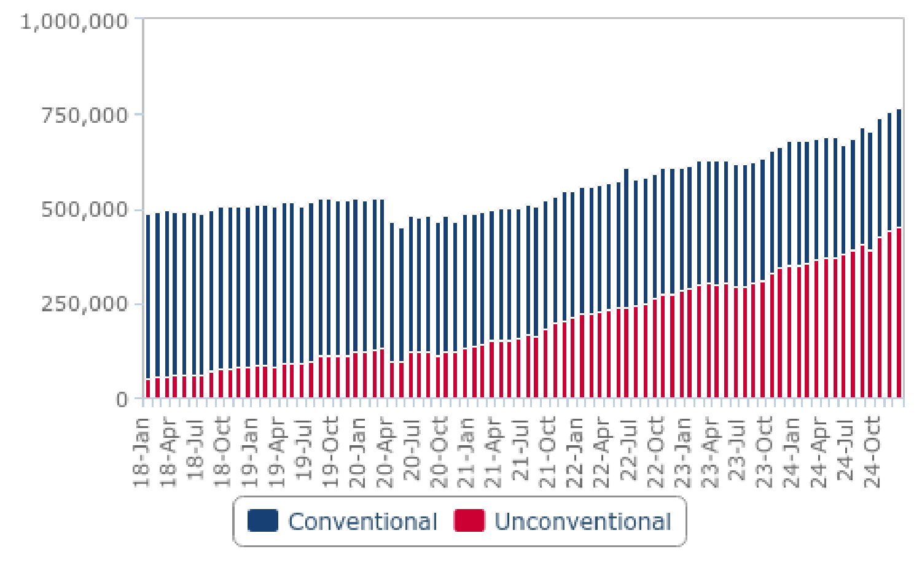

*Source: Datos Energia, BMI*

**Returning To A Strong Upward Trend, Shale Output Takes Centre Stage**

Argentina's crude oil production has returned to growth in recent years, driven by a combination of sector-based reforms aimed at creating a more conducive investment environment for foreign oil companies, increasing oil transport infrastructure, as well as

broader macroeconomic factors such as higher oil prices and improved global demand. Crude oil and condensates production began to grow again in 2020/2021, reaching levels of 706,000b/d in 2024, up from a low of 480,000b/d in 2020. These levels represent the highest oil production since 2004.

The strong return to growth in crude oil and condensates production has been notably led by shale and tight oil developments.

State-led YPF, the largest hydrocarbons producer in the market, is prioritising oil assets over natural gas assets in the prolific Vaca

Muerta in the near term, as the more extensive and expanding oil midstream transport infrastructure supports robust output

growth. Notably, unconventional output is being pushed by production at the Loma Campana, which is being developed as a joint project between the state-owned YPF and Chevron. YPF is also partnered with Shell and Equinor to develop the Bandurria del Sur field, and with Vista Energy (Vista Energy acquired the 50% stake previously held by Petronas in April 2025) to develop the La

Amarga Chica field. Smaller players have also been actively boosting production since 2023, although YPF remains the key driver of oil production growth. In 2024, YPF was responsible for 49% of total oil output in Argentina, followed by Pan American Energy with 15%, Vista Energy Argentina at 9%, Pluspetrol with 5%, and Shell Argentina at 4%, with the remainder of output produced by over 50 companies producing smaller amounts of oil.

In 2024, unconventional oil output surpassed conventional oil production, with government data indicating unconventional output averaged 392,000b/d, compared to conventional production of 314,000b/d. In 2023, production was still dominated by

conventional output averaging 324,000 b/d, while unconventional production was at 311,000b/d. As of early 2025 data,

unconventional oil production represented close to 60% of total crude and condensates output, up from levels of only 4% in 2015. Meanwhile, conventional oil output continues to decline given maturing asset base and underinvestment as key upstream

producers raise spending allocation on their unconventional oil asset.

**Argentina Oil & Gas Report | Q3 2025**

a Fitchsolutions company

**Infrastructure Coming Together and Key for Future Oil Growth**

Recent quarters have seen significant improvements in oil transport infrastructure, which is contributing to the strong increase in oil production over 2023 and 2024. These developments will also enable further production gains in the coming years.

Notably:

• **Trasandino Pipeline:** In 2023, the Trasandino oil pipeline was reopened after years of closure. This pipeline connects Neuquen with Chile and has a capacity to export 110,000b/d, facilitating oil exports to Chile.

• **Vaca Muerta North Pipeline:** In October 2024, the construction of the USD250mn Vaca Muerta North pipeline was completed, with a capacity of 160,000b/d, thereby increasing the export utilisation rates ofthe Trasandino pipeline.

• **Oldelval Pipeline:** The Oldelval pipeline system (Oleoductos del Valle) has recently been expanded to 225,000b/d and

300,000b/d in 2023, to 377,000b/d end-2024, and total capacity of 540,000b/d in 2025 (the final expansion reportedly came

online in April 2025 boosting total capacity to 540,000b/d). This pipeline connects Vaca Muerta with the Port of Rosales terminal in Bahia Blanca in the Buenos Aires province. The expansion will allow significant increases in deliveries to the export terminal

from 2025 to 2027 and is expected to result in substantial increases in oil output in the coming quarters.

• **Vaca Muerta South Pipeline:** A USD2.5bn project connecting Vaca Muerta to a new oil export terminal in the Gulf of San

Matias in the Rio Negro Province, reportedly planned for construction (the Punta Colorada Terminal), is expected to have a

capacity of about 550,000b/d by 2028. This project should contribute to the country’s long-term plans to boost oil output to over 1.0mn b/d by 2030, given that the the Oldelval pipeline capacity (even after expansion) will likely be close to saturated by

2027 or 2028 at current production growth rates.

• **Two YPF Oil Pipelines:** These two existing pipelines are owned by YPF and supply oil to refineries. One YPF pipeline runs from Puerto Rosales to the La Plata refinery near Buenos Aires, and another from Puerto Hernandez near Vaca Muerta North to the Lujan de Cuyo refinery in the Mendoza region.

**Bullish Outlook Going Forward**

Our medium-term outlook to 2029 is bullish, with our forecasts indicating an average y-o-y growth in oil output of about 5.0% y-o-y over the 2025-2029 period, boosting oil production from 706,000b/d in 2024 to a forecasted 896,000b/d in 2029. This is an

increase this quarter on our previous forecasts on the back of successful oil pipeline transport infrastructure growth. The output

growth will be driven by shale oil projects, which will benefit from further infrastructure expansions. Our forecast anticipates

additional expansion of the midstream infrastructure from Vaca Muerta, as already announced by the Oldelval consortium and YPF.

We recognise that our forecasts remain on the conservative side, notably when compared to official production targets by YPF of output of over 1.0mn b/d by 2030. While there is clear upside risks to our current medium-term production outlook to 2029, much of this upside risk is dependent on progress being made on midstream projects allowing the transportation of new production

volumes, in addition to spending commitments from larger producers actually materialising. Our current forecasts assume some delays in the completion of midstream projects, which will postpone the ramp-up of production.

Notably, the outlook past 2028/2029 is dependent on the completion of the Vaca Muerta Sur pipeline and the Punta Colorada oil terminal, given the existing oil pipeline infrastructure system (including the 2025 expansion of the Odelval pipeline system) will be near to saturated by that time.

**Argentina Oil & Gas Report | Q3 2025**

a Fitchsolutions company

Growing Upside Risks To Oil Production Forecast

Argentina - Oil Production Forecast (2023-2034)

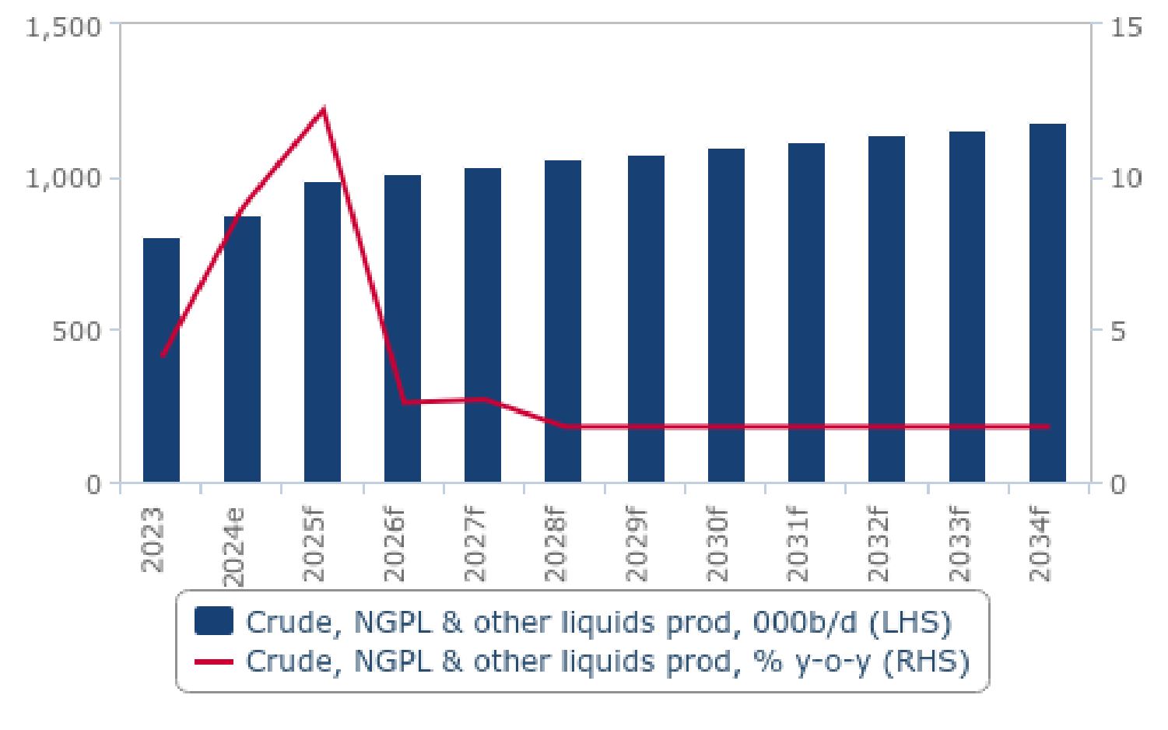

*e/f = BMI estimate/forecast. Source: EIA, national sources, BMI*

The long-term resilience of Argentina's shale activity is due to several factors:

**1. The Immaturity And High Prospectivity Of The Acreage**

Neuquén's Vaca Muerta shale formation is an emerging shale play housing a vast resource base. Drilling results have been broadly positive and exploration is increasingly concentrating in the discovered sweet spots. These areas have higher productivity and are less vulnerable to a lower oil price environment.

**2. The Strength Of The Competitive Landscape**

Unlike the US, Argentina's shale exploration is heavily dominated by a few major companies, most notably Chevron and YPF.

ExxonMobil and Shell are expanding their presence. Larger integrated companies have less exposure to falling revenues, stronger cash flows, are typically less levered and have higher capex budgets. These companies have the capacity to ringfence the most

prospective, strategic investments, including Argentina's shale, and cutback expenditure on more peripheral, less prospective parts of their portfolios.

**3. Improving Fiscal And Regulatory Environment**

Over past years, the government, at both the federal and provincial level, has enacted reforms to improve both fiscal and licensing terms and support the development of the nascent shale sector. Several major concessions have been made, streamlining

permitting processes and reducing the tax burden on unconventionals. Though these efforts have taken a hit in the wake of

an economic downturn, we believe the government remains largely supportive of upstream development. The Peronist

government with the Minister of Economy Sergio Massa, did not manage to lift some of the largest constraints put on upstream producers, including the capital controls and central oil price, set at USD56/bbl, much below the global oil price benchmark of USD80-90/bbl in 2023.

We expect the regulatory environment to improve under new president Javier Milei. He has been promoting limited government interference in the market with his free-market agenda that will likely include efforts to lift capital controls, limit price setting, and

**Argentina Oil & Gas Report | Q3 2025**

a Fitchsolutions company

remove hydrocarbons export taxes. He declared plans to attract foreign capital to the prolific Vaca Muerta and floated the idea of privatising the state-led YPF. He has been vocal in his support for the expansion of Argentina’s LNG export capabilities, which would likely see him promoting a favorable LNG regulatory framework. That said, we expect the implementation timeframe of these

reforms to be rather slow. The degree to which Milei would be able to implement the most aggressive policy items depends on Congress's support. We note broad support for the oil and gas industry across the political scene in Argentina.

Going in this direction, the new RIGI was approved by Congress in 2024, and could increase stability and attractiveness for long- term large investments in the oil and gas sector. It will offer 30 years of fiscal stability, fiscal, customs and exchange incentives for large investments of over USD200mn in several sectors, of which oil and gas. This could significantly improve the stability and

attractiveness of investments in the Argentinian oil and gas sector, and creates significant long-term upside risks to oil and gas production.

Oil Production (Argentina 2023-2028)

|  |  |  |  |  |  |  |
| --- | --- | --- | --- | --- | --- | --- |
| **Indicator** | **2023** | **2024e** | **2025f** | **2026f** | **2027f** | **2028f** |
| Crude, NGPL & other liquids prod, 000b/d | 806.7 | 879.1 | 986.7 | 1,012.8 | 1,039.7 | 1,058.7 |
| Crude, NGPL & other liquids prod, % y-o-y | 4.1 | 9.0 | 12.2 | 2.6 | 2.7 | 1.8 |

*e/f = BMI estimate/forecast. Source: EIA, national sources, BMI*

Oil Production (Argentina 2029-2034)

|  |  |  |  |  |  |  |
| --- | --- | --- | --- | --- | --- | --- |
| **Indicator** | **2029f** | **2030f** | **2031f** | **2032f** | **2033f** | **2034f** |
| Crude, NGPL & other liquids prod, 000b/d | 1,078.1 | 1,097.8 | 1,117.9 | 1,138.4 | 1,159.3 | 1,180.6 |
| Crude, NGPL & other liquids prod, % y-o-y | 1.8 | 1.8 | 1.8 | 1.8 | 1.8 | 1.8 |

*f = BMI forecast. Source: EIA, national sources, BMI*

**Argentina Oil & Gas Report | Q3 2025**

a Fitchsolutions company

Upstream Gas Production

***Key View:*** *The expansion of midstream capacity for natural gas, initially through the Nestor Kirchner pipeline and now with*

*Northern Pipeline reversal project, supports our bullish outlook for gas production from the Vaca Muerta over the coming years. We expect output to increase by 7.6%y-o-yin 2025 to 49.5bcm, after an estimated increase of5.2%y-o-ygrowth in 2024 to 46.0bcm. Producers are also considering new gas export markets such as exporting to Brazil through Bolivia's gas network, in addition to*

*potential LNG exports through new LNG export infrastructure. Our current outlook includes first LNG exports from a floating*

*terminal in 2027, boosting long-term gas production growth outlook. We are therefore increasingly bullish on long-term gas*

*production outlook, should the required infrastructure projects materialise, with our forecasts seeing production rise to 67.1bcm by 2034, with risks to the upside.*

**Latest Updates**

• We hold our forecast of accelerating natural gas production growth in Argentina in 2025. We expect output to increase by 7.6% y-o-y in 2025 to 49.5bcm, after an estimated increase of 5.2% y-o-y growth in 2024 to 46.0bcm. Our bullish forecast is supported by the increased demand from Argentine northern provinces amid the completion of the Northern Pipeline Reversal project in 2025, coupled with new production coming from the offshore Fenix project and continued growth in unconventional gas

production.

• We note an increasingly bullish sentiment among shale gas producers in Argentina who have delivered a robust estimated

monthly average unconventional gas output growth of 13.6% y-o-y in 2024 (based on provisional data) relative to the same

period of 2023, indicating a strong production growth year and a bright outlook for unconventional gas production in 2025 and 2026.

• In November 2024, the Argentine government inaugurated the Tío Pujio-La Carlota Federal Integration Pipeline, which links the Central and Northern Pipeline, and constitutes a key part of the broader Northern Pipeline Reversal Project. The Northern

Pipeline Reversal project notably allows Argentina to end natural gas imports from Bolivia in its norther provinces, to be replaced by domestically produced gas.

• The Fénix project, located offshore Tierra del Fuego and operated by Total Austral, commenced operations in September 2024, supporting our bullish 2025 gas production forecast. This project is composed of three horizontal wells, with the production

capacity of 10 m3/d of natural gas (70,000boe/d) and relatively low carbon footprint with emissions of 9kg CO2e/boe.

• However, we no longer expect the Néstor Kirchner Stage 2 project to come online over the near term given limited support from the government. The project was a key factor for medium-term upside risk to our forecast. The expansion project is not a priority for the government of Javier Milei, who is vocal about the need for private financing of the project. Given the heightened

uncertainty amid economic and political turmoil in 2024, we see limited risk of companies committing private capital to the pipeline project in the short-term.

• However, we still identify upside risks given Argentina triggered a tender in February 2025 for a USD500mn gas compression

project on the Gasuducto Presidente Nestor Kirchner. This would aim to boost capacity of the Vaca Muerta debottlenecking gas pipeline, notably to help substitute winter imports of LNG. it would involve four new compression plants along the Tratayen-

Salliquelo stretch. However, it remains unclear whether this would replace plans for the second phase of the Vaca Muerta pipeline that was initially planned to boost dispatch to the north.

• We also highlight upside risk to our long-term production forecast stemming from a possible construction of a large scale LNG

export facility. Representatives of Malaysian Petronas and state-led YPF signed an initial land lease with a part of Bahia Blanca

where companies plan to invest in an LNG export facility with a planned initial capacity of 5mtpa, which would then be raised to 25mtpa. Should we see this project materialising during our production forecast, we could see an uptick in production to provide enough feedstock for the facility.

**Argentina Oil & Gas Report | Q3 2025**

a Fitchsolutions company

**Structural Trends**

The natural gas market in Argentina remains fragmented, with largest producer - YPF - delivering little over one fourth of total output in 2024. New players have emerged over the last quarters with Chevron, Shell and Mexico-based Vista Oil & Gas starting production in Vaca Muerta. We maintain a rather bullish outlook for Argentina's natural gas production. However, we highlight mounting challenges to the needed midstream infrastructure expansion which, if delayed, could weaken the momentum.

The unconventional output has seen robust growth over the last years, supported by the expansion of exit infrastructure in Vaca

Muerta and subsidy programs which stabilised natural gas prices for sellers under Gas.Ar scheme. We expect the shale production to remain the key driver behind natural gas production growth in Argentina over the next decade. We also hold an optimistic outlook for Argentina's offshore, with the recently started Fenix upstream project set to raise conventional offshore output over the medium term. Depending on the success of Vaca Muerta's development, the market will not only reverse its decline in production but also

move to a net exporter status over the next decade. Looking to the long term, we believe Argentina's vast reserves could act as a critical game changer, altering its role in the region and beyond.

Unconventional Output Outstrips Conventional Production

Argentina - Natural Gas Production Per Type, bcm (2018-2024)

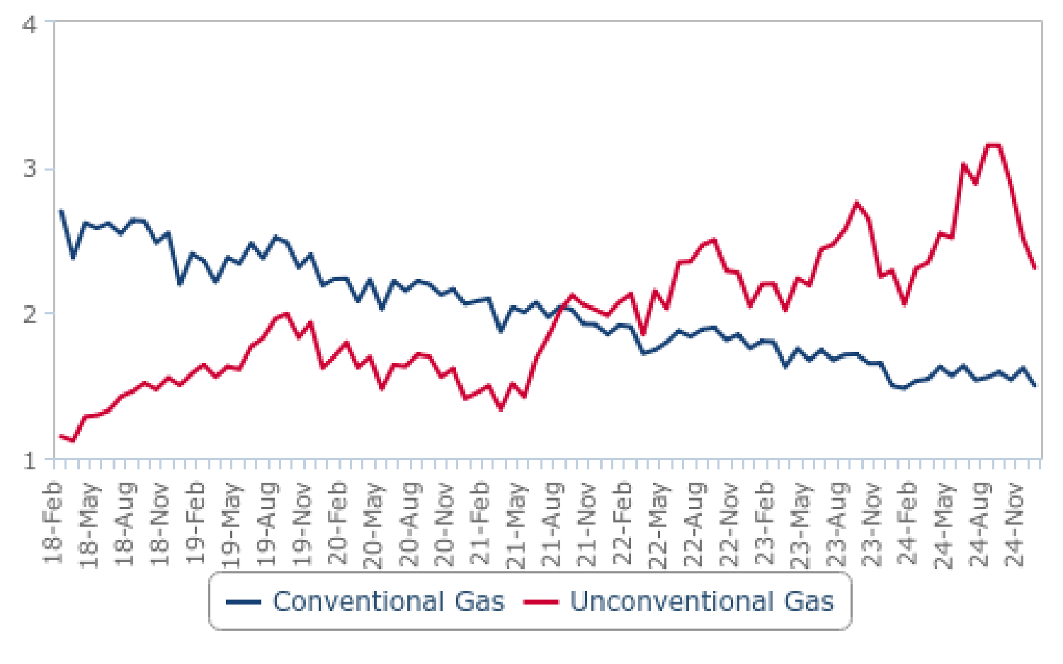

*Source: Secretaria de Energia, BMI*

**Bullish Short-Term Gas Production Growth Outlook**

We hold our forecast of accelerating natural gas production growth in Argentina in 2025. We expect output to increase by 7.6% y-o- y in 2025 to 49.5bcm, after an estimated increase of 5.2% y-o-y growth in 2024 to 46.0bcm. Our bullish forecast is supported by the increased demand from Argentine northern provinces amid the completion of the Northern Pipeline Reversal project in 2025,

coupled with new production coming from the offshore Fenix project and continued growth in unconventional gas production.

One of the key growth drivers is the commencement of production at the Fénix offshore project developed by TotalEnergies,

located in the CMA-1 concession in the offshore Tierra del Fuego region. The operator announced the start-up of the project in

September 2024 and from preliminary governmental data it appears that the project added approximately 0.1bcm per month to

the Carina-Fénix-Orion-Orion Norte-Orion Oeste field in October and November 2024, raising aggregate field output from 0.3bcm to 0.4bcm. According to TotalEnergies updates, the Fénix field is estimated to contribute up to 10mcm/d, approximately 0.3bcm per

**Argentina Oil & Gas Report | Q3 2025**

a Fitchsolutions company

month at its peak. The broader field has already solidified its position among the largest gas producing fields in Argentina, alongside shale gas projects in Aguada Pichana Este Vaca Muerta and Fortin de Piedra. We expect a further ramp up of production from the

Fenix project in 2025 and 2026, supporting our bullish gas output forecast.

On top of that, YPF continues to invest in gas midstream projects which will further support the NOC's strategy to raise

unconventional natural gas output. YPF remains the largest gas producer in Argentina and its capex is expected to linger at USD5.5-5.7bn between 2024-2026, substantially above historical average levels of USD3.6bn for 2016-2023. We have also highlighted improving sentiment towards unconventional gas projects among majors active in Argentina. In terms of 2024

production, initial data suggests a strong gas production growth rate of 5.2% y-o-y growth in 2024 to 46.0bcm, with notably a 13.6% y-o-y increase in production of unconventional output.

Argentina is also seeing continued momentum in midstream infrastructure projects, which is crucial for the expansion of the

domestic natural gas market. We note that the expansion of midstream capacity for natural gas, initially through the Nestor Kirchner pipeline and now with the Northern Pipeline reversal, supports increasingly bullish sentiment among gas producers in Vaca Muerta.

In 2023, Argentina's government inaugurated the long-awaited Néstor Kirchner Gas Pipeline, connecting gas-rich Neuquén with

Buenos Aires Province. Crucially, the completion of the Northern Reversal project, slated for 2025, will allow for the transportation of domestic gas to Argentina's northern provinces, replacing legacy Bolivia's imports. In November 2024, the Argentine government inaugurated the Tío Pujio-La Carlota Federal Integration Pipeline, which links the Central and Northern Pipeline, and constitutes a

key part of the broader Northern Pipeline Reversal Project. This development will allow Argentina to supply domestically-sourced natural gas to its northern-most provinces, replacing imported gas from Bolivia. According to media reports, the final step in the project is the completion of automation of four existing compressor stations, with llikely start-up in H2 2025. In the first phase, the project will allow the transport of 5mcm/d to seven provinces, with a possibility to increase the capacity to 9mcm/d. We also note the possibility of this project supporting future exports to Bolivia or Brazil, raising upside risks for our long-term net gas export

forecast.

**Argentina Oil & Gas Report | Q3 2025**

a Fitchsolutions company

Momentum In Natural Gas Infrastructure In Argentina

Argentina - Key Midstream Gas Infrastructure Projects

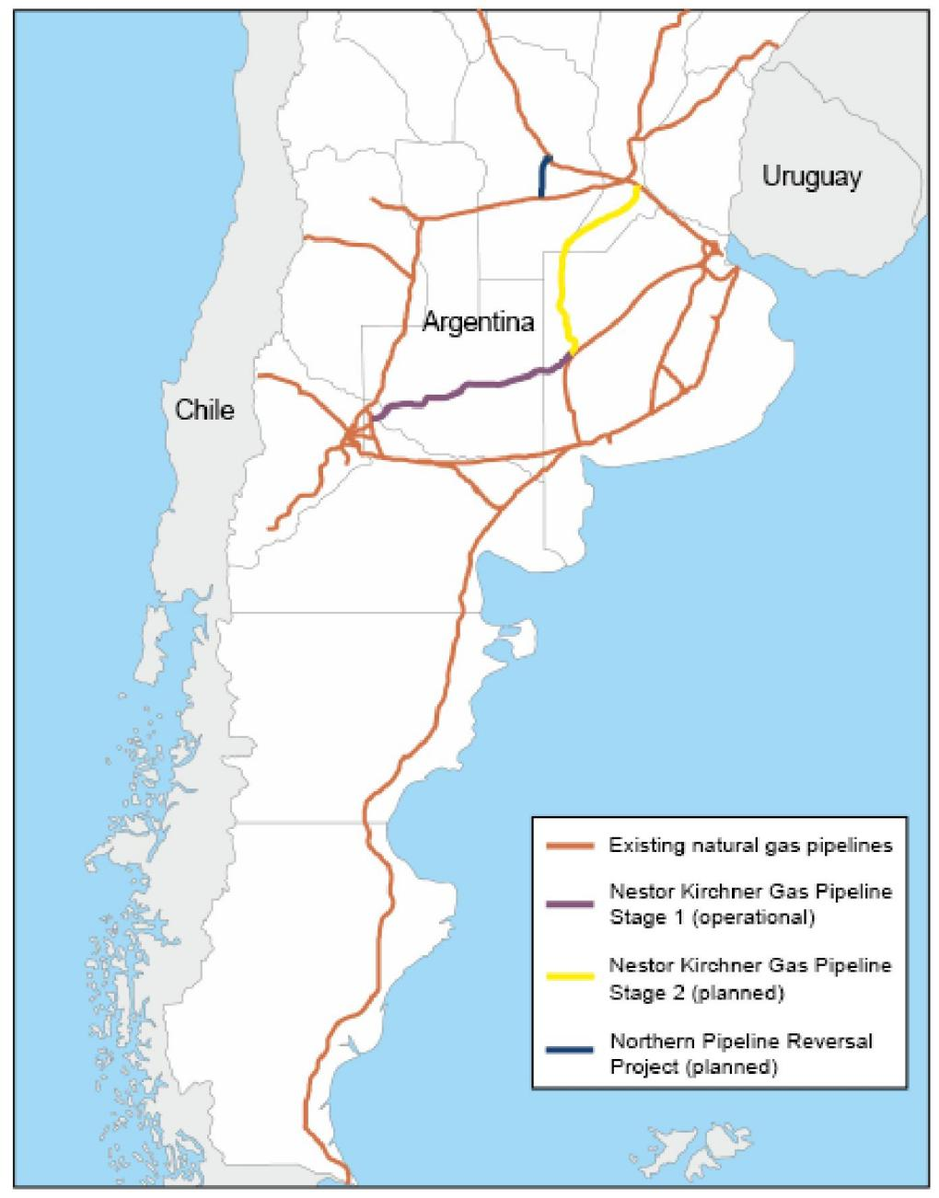

*Source: Secretaria de Energia, BMI*

**Upside Risks To Our Long-Term Forecasts**

We remain bullish on Argentina's long-term gas production outlook, with our forecasts indicating annual average growth of 3.9% y- o-y to 2034, with gas output rising from 49.5bcm in 2025 to some 67.1bcm by 2034. This growth outlook is led by our expectation of continued production gains in the unconventional gas segment, in addition to some developments in the offshore sector, both led by strong domestic demand for gas and opportunities for gas exports.

We maintain that our current outlook for gas production remains conservative. We notably recognize upside risks to our long-term gas production and net exports forecasts stemming from advancing talks about a large-scale LNG facility. In our current forecast, we have only incorporated small-scale LNG export facilities. One project, led by Pan American Energy, in cooperation with YPF and

Pampa Energy among others, is set to commence operations in 2027/2028 adding approximately 4.1bcm of export capacity,

however we do not expect it to use its full capacity immediately after commencing operations. Another small-scale project is

considered by Tecpetrol, however there have been limited updates on this one. We note that both projects are in the pre-FID stage which raises some downside risks to our long-term LNG export forecast.

**Argentina Oil & Gas Report | Q3 2025**

a Fitchsolutions company

At the same time, we highlight upside risks to our long-term outlook for Argentina’s gas production and net exports. Media reports indicated some progress in talks about a large-scale LNG export facility between YPF and Shell, after the Malaysian state-led

Petronas decided to step away from this initiative. Argentina’s NOC and Shell will now collaborate to push the project to the front- end engineering design stage. In the initial phase, this project would allow the export of up to 10bcm of LNG, which constitutes

material upside risk to our long-term LNG net export and gas production forecast for Argentina, should it be completed within the next decade.

We note that the supportive stance towards the oil and gas industry expressed by the current government of Javier Milei in

Argentina limits downside risks to the forecasts, however, we recognise some risks stemming from the lower oil price environment expected for the next years which could weaken the upstream and midstream investor sentiment globally.

Gas Production Growth Hinges On Infrastructure Progress

Argentina - Gas Production Forecast (2023-2034)

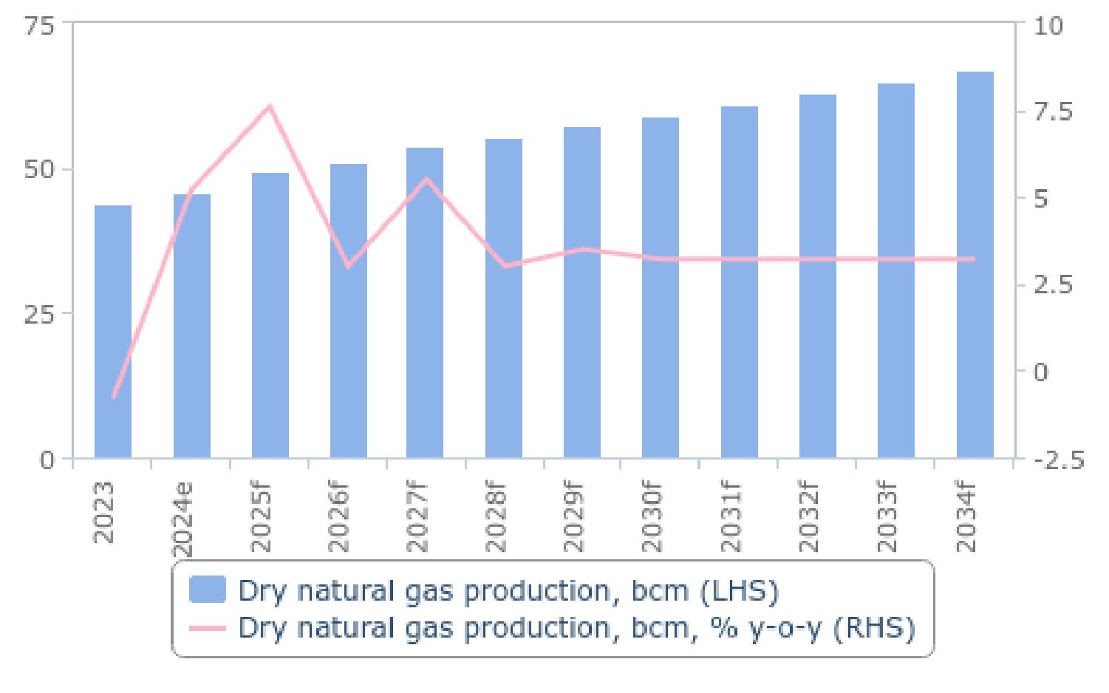

*e/f = BMI estimate/forecast. Source: EIA, BMI*

**Risks To Outlook**

The key risks to Argentina's shale sector are political uncertainty, macroeconomic instability and commodity price volatility. We note lingering above ground risks which could weaken investor sentiment. As expected, IOCs are ramping up shale production as they

benefit from increased midstream capacity and favourable business environment, facilitated by President Javier Milei, who took over office in January 2024. However, we note that some above ground challenges continue to weaken the sentiment and could

adversely impact future oil and gas upstream investment.

Although we remain bullish in our outlook on oil and gas sector investment in Argentina, we note that above-ground risks continue to hinder investment. For example, media reports indicated that Petronas raised some doubts about its investment in the largest

scale LNG export terminal in Argentina, a project planned initially in cooperation with state-led YPF. The decision has not been

approved yet, and the company is yet to decide about FLNG design funding. We note however lingering risks to the hydrocarbons investments and infrastructure projects.

**Argentina Oil & Gas Report | Q3 2025**

a Fitchsolutions company

Gas Production (Argentina 2023-2028)

|  |  |  |  |  |  |  |
| --- | --- | --- | --- | --- | --- | --- |
| **Indicator** | **2023** | **2024e** | **2025f** | **2026f** | **2027f** | **2028f** |
| Dry natural gas production, bcm | 43.7 | 46.0 | 49.5 | 50.9 | 53.7 | 55.4 |
| Dry natural gas production, bcm, % y-o-y | -0.8 | 5.2 | 7.6 | 3.0 | 5.5 | 3.0 |
| Dry natural gas production, % of domestic consumption | 94.9 | 97.9 | 102.8 | 102.8 | 105.8 | 106.3 |
| *e/f = BMI estimate/forecast. Source: EIA, national sources, BMI*  Gas Production (Argentina 2029-2034) | | | | | | |
| **Indicator** | **2029f** | **2030f** | **2031f** | **2032f** | **2033f** | **2034f** |
| Dry natural gas production, bcm | 57.3 | 59.1 | 61.0 | 63.0 | 65.0 | 67.1 |
| Dry natural gas production, bcm, % y-o-y | 3.5 | 3.2 | 3.2 | 3.2 | 3.2 | 3.2 |
| Dry natural gas production, % of domestic consumption | 107.3 | 108.1 | 108.8 | 109.5 | 110.3 | 111.0 |

*f = BMI forecast. Source: EIA, national sources, BMI*

**Argentina Oil & Gas Report | Q3 2025**

a Fitchsolutions company

Refining

***Key View:*** *We anticipate a further rise in Argentina's fuel production in 2025, projecting ay-o-y growth of0.5%. The government's fuel price liberalisation initiatives under Javier Milei, combined with a recovering economy in 2025 and 2026, will create a favorable environment for refiners and see enhanced fuel output. Additional domestic output of light crudes thanks to higher production at shale plays in the Vaca Muerta, in addition to easier access to the crude thanks to expanding oil infrastructure, should also see*

*refinery runs remains elevated.*

**Latest Updates**

• We maintain another increase in Argentina's fuel production in 2025, forecasting 0.5% y-o-y growth. We highlight an improving environment for refiners in Argentina with fuel prices liberalisation efforts pursued by the government of Javier Milei. A recovering economic backdrop could also result in higher fuels demand, and production over 2025 and 2026 than currently forecasted.

• YPF pursues a modernisation program at Lujan de Cuyo refinery, focused on expanding facility's capabilities to produce low-

sulphur fuel. A hydrogen gas production plant and a diesel hydro-treatment unit are also being built. The USD600mn investment is expected to be operational by end of 2025.

**Structural Trends**

Argentina has an estimated refining capacity of 580,000b/d, the largest of which is YPF's 180,000b/d La Plata refinery. YPF operates approximately 60% of the market's crude processing. Utilisation rates at the YPF-operated refineries - La Plata, Lujan de Cuyo and

Plaza Huincul - tend to be higher than for facilities operated by private companies.

After a substantial drop in fuels production in 2020 due to the lockdowns and its impact on fuels demand over the year, domestic fuel production has seen a strong recovery over 2021-2023 amid elevated global fuel prices with widened margins. The broad

market deregulation push, offered by the government of Javier Milei will improve operating environment for refiners through for

example liberalising fuel prices, and constitutes an upside risk to our refining output forecast. We currently estimate Argentina saw a further boost in fuels production of 1.5% y-o-y in 2024, with output rising to 523,000b/d in 2024, based on preliminary Energy

Ministry data.

Refinery complexity varies significantly. YPF's Lujan de Cuyo and La Plata facilities, and Campana and Bahia Blanca plants are relatively complex, with coking, catalytic cracking and hydrotreating capacity to process the heavier and sourer grade oils. The remaining refineries comprise more basic crude distillation units.

**Argentina Oil & Gas Report | Q3 2025**

a Fitchsolutions company

Argentina Unlikely To Expand Refining Capacity

Argentina - Refining Capacity Forecast (2023-2034)

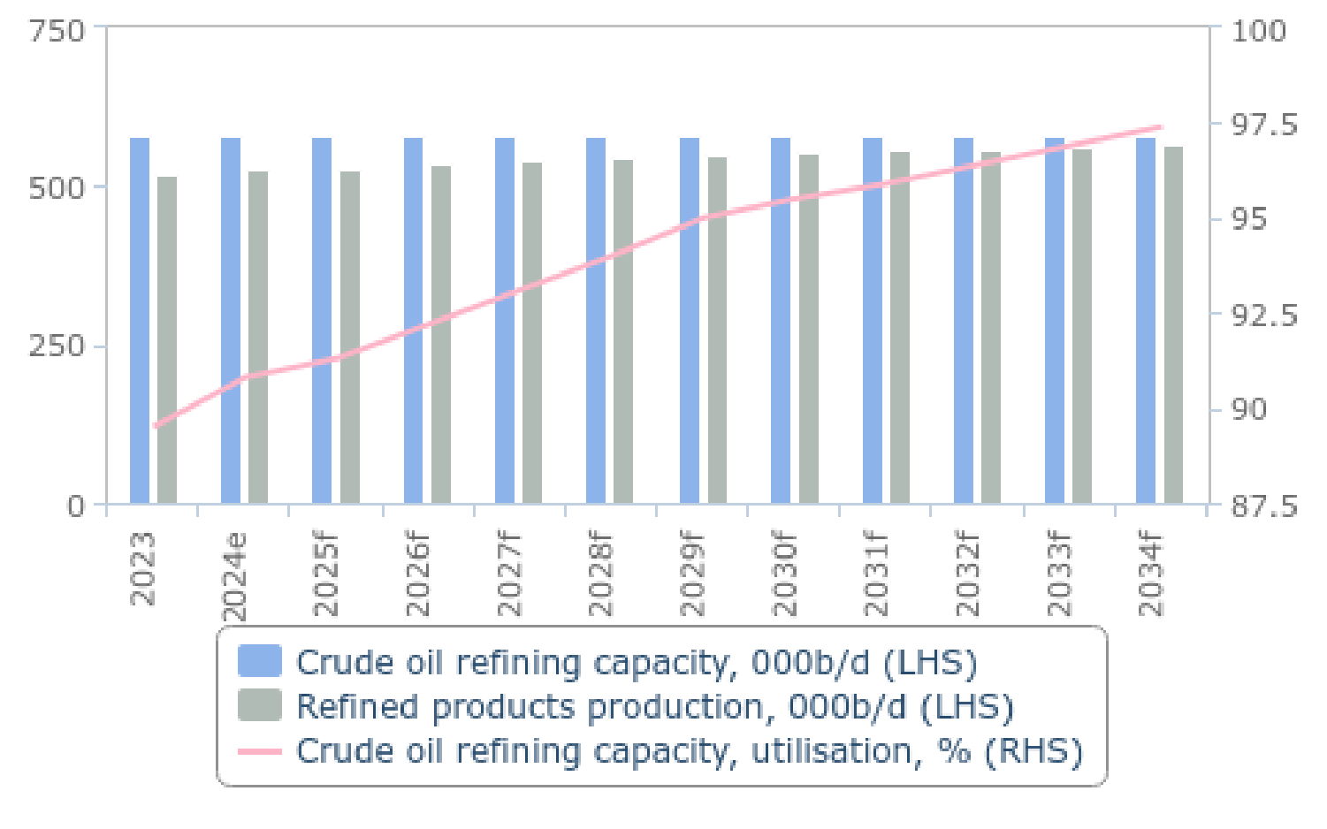

*e/f = BMI estimate/forecast. Source: Minem, BMI*

The expansion and modernisation of the Campana refinery put the sector in a better position. This project increased throughput at the refinery's crude, catalytic cracking, and diesel hydrotreating units as well as improve the quality of the fuel produced. The

expansion cost USD1.5bn, boosting capacity by an estimated 20,000b/d.

Ongoing works at refinery are notably being led by YPF, which is progressing its modernization program to produce low-sulphur

fields at the Lujan de Cuyo refinery in the Mendoza region. Increased deliveries of light crude oil to the refienery from rising

production at the Neuquen basin following the expansion of the Puesto Hernandez-Lujan de Cuyo and Vaca Muerta Norte pipelines are prompting the site's proposed capacity expansion. Notably, modernisation will reduce sulphur content in diesel fuels, in line with Argentina's fuels specifications. A hydrogen gas production plant and a diesel hydro-treatment unit are also being built. The

USD600mn investment is expected to be operational by end of 2025.

Refining Capacity And Refined Products Production (Argentina 2023-2028)

|  |  |  |  |  |  |  |
| --- | --- | --- | --- | --- | --- | --- |
| **Indicator** | **2023** | **2024e** | **2025f** | **2026f** | **2027f** | **2028f** |
| Crude oil refining capacity, 000b/d | 580.0 | 580.0 | 580.0 | 580.0 | 580.0 | 580.0 |
| Crude oil refining capacity, % y-o-y | 0.0 | 0.0 | 0.0 | 0.0 | 0.0 | 0.0 |
| Crude oil refining capacity, utilisation, % | 89.5 | 90.8 | 91.3 | 92.2 | 93.1 | 94.0 |
| Refined products production, 000b/d | 519.0 | 526.8 | 529.4 | 534.7 | 540.1 | 545.5 |
| Refined products production, % y-o-y | 6.1 | 1.5 | 0.5 | 1.0 | 1.0 | 1.0 |
| Refined products production & ethanol, 000b/d | 578.6 | 587.0 | 590.2 | 596.1 | 602.1 | 608.2 |
| Refined products production & ethanol, % y-o-y | 5.9 | 1.4 | 0.6 | 1.0 | 1.0 | 1.0 |

*e/f = BMI estimate/forecast. Source: Minem, BMI*

**Argentina Oil & Gas Report | Q3 2025**

a Fitchsolutions company

Refining Capacity And Refined Products Production (Argentina 2029-2034)

|  |  |  |  |  |  |  |
| --- | --- | --- | --- | --- | --- | --- |
| **Indicator** | **2029f** | **2030f** | **2031f** | **2032f** | **2033f** | **2034f** |
| Crude oil refining capacity, 000b/d | 580.0 | 580.0 | 580.0 | 580.0 | 580.0 | 580.0 |
| Crude oil refining capacity, % y-o-y | 0.0 | 0.0 | 0.0 | 0.0 | 0.0 | 0.0 |
| Crude oil refining capacity, utilisation, % | 95.0 | 95.5 | 95.9 | 96.4 | 96.9 | 97.4 |
| Refined products production, 000b/d | 550.9 | 553.7 | 556.4 | 559.2 | 562.0 | 564.8 |
| Refined products production, % y-o-y | 1.0 | 0.5 | 0.5 | 0.5 | 0.5 | 0.5 |
| Refined products production & ethanol, 000b/d | 614.3 | 617.7 | 621.1 | 624.6 | 628.1 | 631.6 |
| Refined products production & ethanol, % y-o-y | 1.0 | 0.6 | 0.6 | 0.6 | 0.6 | 0.6 |

*f = BMI forecast. Source: Minem, BMI*

**Argentina Oil & Gas Report | Q3 2025**

a Fitchsolutions company

Refined Fuels Consumption

***Key View:*** *The beginning of an economic recovery, a rising vehicle fleet and lower oil prices over 2025 and 2026 will see refined*

*fuels consumption return to an uptrend after several years of contraction. We have also recently revised our long-term forecasts for fuels demand growth, as we expect a positive long-term economic impact from the Milei government's recent economic measures. Our Autos team's increasingly bullish long-term vehicle sales forecasts are also supportive of long-term fuels demand growth. We forecast fuels demand to increase by ay-o-y average of0.1% to 2034.*

**Latest Updates**

• We expect Argentina's economy to commence recovery in 2025, with forecasted real GDP growth rate of 4.8% y-o-y, after an estimated contraction of 1.7% in 2024. We expect this will translate into an improved outlook for refined fuels consumption in Argentina over 2025: we forecast total fuels consumption to expand by 2.5% y-o-y in 2025, after an estimated contraction in demand of 3.4% in 2024.

• An improving trend in fuel demand in Argentina will also be supported by our price forecasts for crude oil and global fuel price benchmarks. We currently expect Brent prices to decline to an average of USD68.0/bbl in 2025, from USD79.9/bbl in 2024, which will support demand.

• Our fuel demand forecast is also underpinned by vehicle sales forecast provided by our Autos team. We expect vehicle sales in Argentina to rebound strongly in 2025 (+16.9% y-o-y), driven by a more favourable economic environment, including a rebound in economic activity, lower inflation, and the continuance of higher credit availability with more favourable car loan terms.

• In May 2025, YPF has implemented another nationwide 4% reduction in gasoline and diesel prices due to lower crude oil prices, and after another similar cut implemented in October 2024. YPF’s move was followed by other fuel distributors, namely Shell,

Axion and Puma Energy. The decision was supported by a decline in global oil prices and fuel price benchmarks. This will be supportive of fuels demand growth in 2025.

• We have recently revised our long-term fuel demand forecast to reflect an increasingly bullish outlook on vehicle sales in

Argentina, and a rising vehicle fleet. We expect the new economic measures should bolster vehicle demand once the market's economy subsequently recovers. Our Autos team forecasted y-o-y average growth in the vehicle fleet of 1.2% y-o-y over the

2025-2034 forecast period, which will support refined fuels consumption growth. We forecast fuels demand to increase by a y-o- y average of 1.2% to 2034. Growth will slow however over the latter years of the forecast period, when stronger penetration of

electric vehicles and increasing fuel efficiency will weaken growth.

**Structural Trends**

**Consumption Tied To Economic Trends**

Refined fuels consumption has been on a downwards trend in recent years, reflecting Argentina's wider economic struggles. The market has been mired in a recession coupled with high rates of inflation which has put a cap on private consumption growth and in turn limited refined fuels consumption growth, despite government restrictions on fuel price increases.

Since 2016, fuel demand has declined from over 760,000b/d to 680,000 in 2019. The Covid-19 pandemic brought a severe

contraction on the fuel market in Argentina with total demand declining by 34% to shy of 450,000b/d. Subsequently Argentina saw a robust growth in fuel demand reaching an average of 675,000b/d in 2021. Over 2022-2023, total fuel consumption grew to an

average of 707,000b/d in 2023 as Argentina struggled with inflations.

**Argentina Oil & Gas Report | Q3 2025**

a Fitchsolutions company

Return To Growth In 2025, Boosting Demand

Argentina - Real GDP Growth Forecast, % (2022-2028)

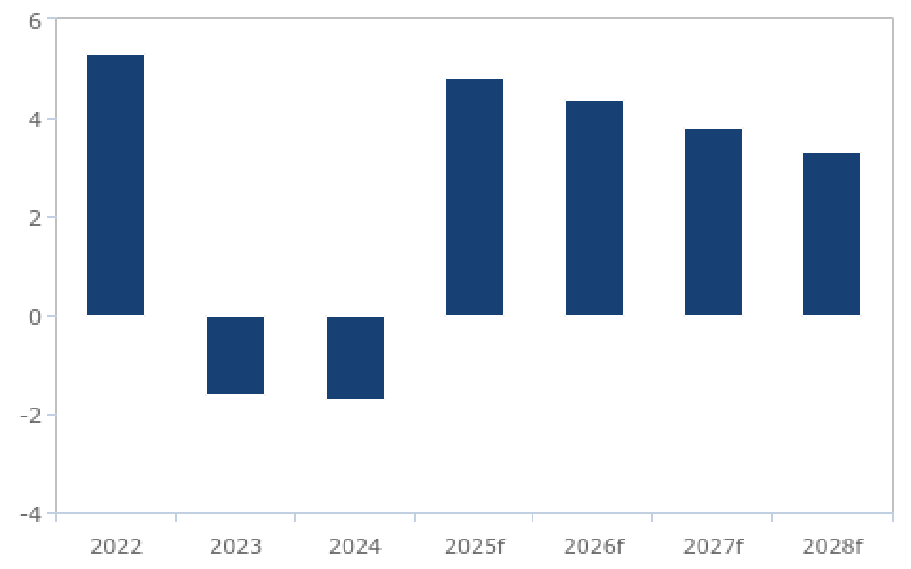

*f = BMI forecast. Source: INDEC*

Argentina has faced accelerating inflation over the last years. Elevated inflation remained a core structural weakness of Argentina's economy in 2024. However we note improving outlook on consumer price inflation rate averaging 28.0% y-o-y in 2025, down from its levels of 117.8% in 2024 and 211.4% in 2023, as governmental policies targeting hyperinflation work.

Inflation Finally Returns To Downtrend

Argentina - Consumer price inflation, % y-o-y (2016-2034)

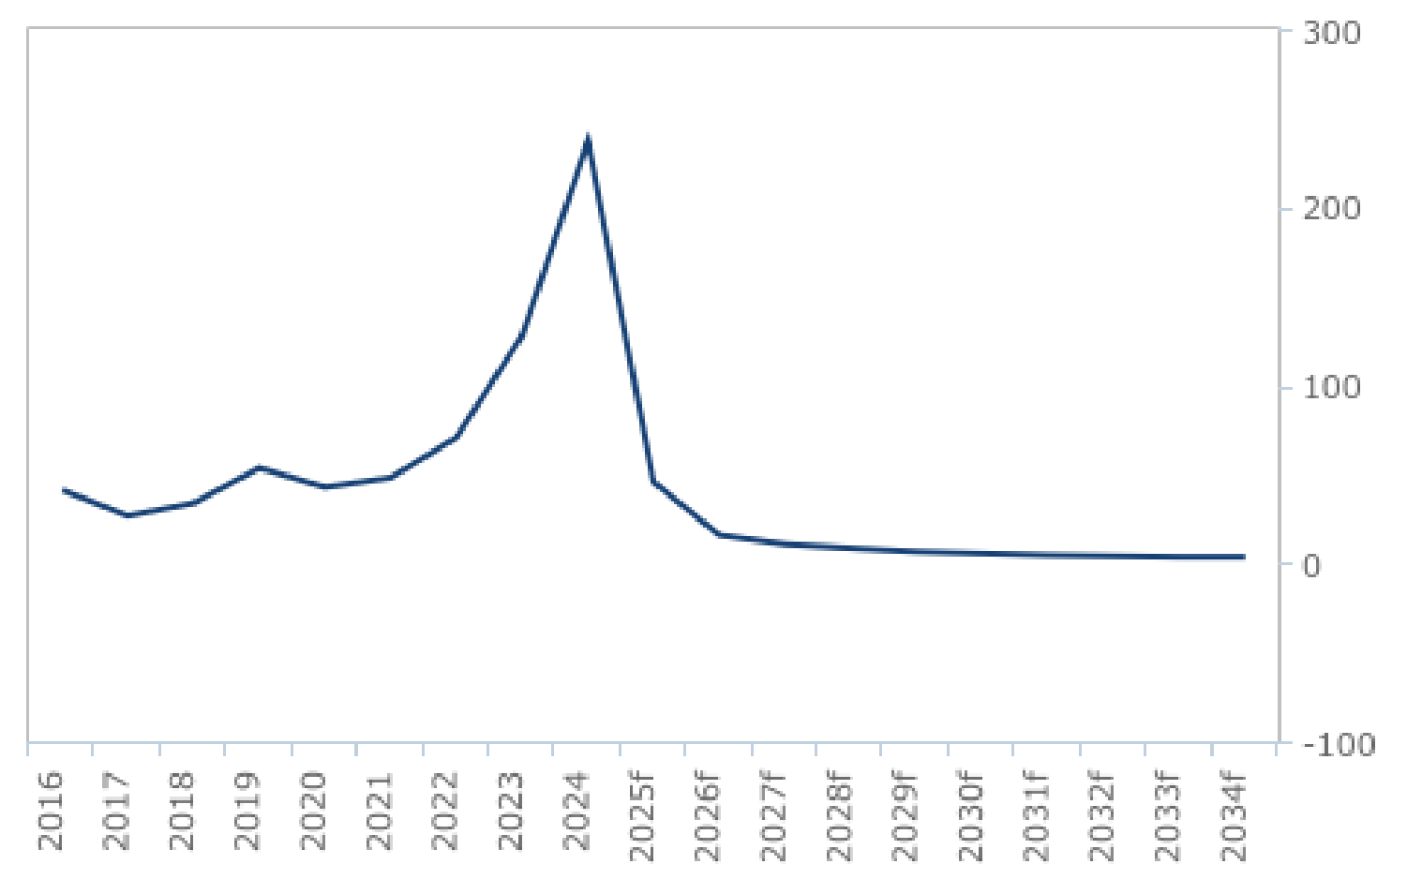

*f = BMI forecast. Source: IDNEC, BMI*

**Argentina Oil & Gas Report | Q3 2025**

a Fitchsolutions company

We forecast that inflation will continue to ease through end-2025, as President Javier Milei and his government implement an

economic stablisation plan that targets money supply growth in order to clamp down on inflation and related currency pressures.

Milei has made clamping down on rampant price growth his number one priority. While the government emphasised that the new phase of the monetary framework – dubbed ‘Stage II’ – will prioritise reducing drivers of the monetary base, the first eight months of Milei’s tenure have already demonstrated some progress. Most notably, the government established a strong ‘fiscal anchor’, which has now accumulated a sizable fiscal surplus (ARS5.9trn) in the first seven months of his government. This has not only removed a sizable amount of currency from the economy, but has also eliminated the need to monetise the deficit which was a prime driver of money supply growth.

We expect Argentina's economy to commence recovery in 2025, with forecasted real GDP growth rate of 4.8% y-o-y, after an estimated contraction of 1.7% in 2024. We expect this will translate into an improved outlook for refined fuels consumption in Argentina over 2025: we forecast total fuels consumption to expand by 2.5% y-o-y in 2025, after an estimated contraction in demand of 3.4% in 2024.

Demand Recovery Supported By Improving Economic Growth

Argentina - Refined Products Production & Consumption Forecast (2023-2034)

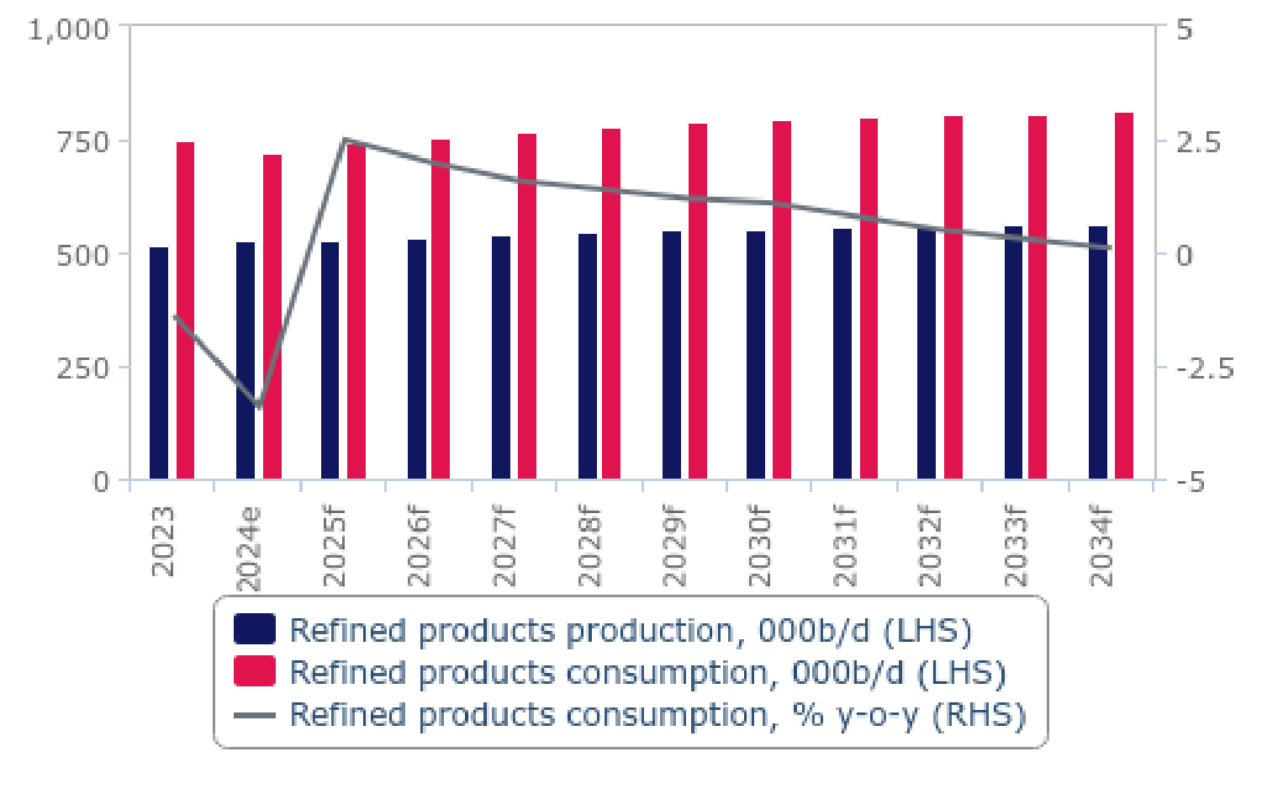

*e/f = BMI estimate/forecast. Source: Minem, BMI*

The anticipated growth in demand for fuels over the medium-to-long term will be driven by the demand from the agribusiness

sector and expanding transportation sector, expected to be bolstered by economic measures introduced by president Javier Milei's economic measures. Notably, our fuel demand forecast is also underpinned by vehicle sales forecast provided by our Autos team. We expect vehicle sales in Argentina to rebound strongly in 2025 (+16.9% y-o-y), driven by a more favourable economic

environment, including a rebound in economic activity, lower inflation, and the continuance of higher credit availability with more favourable car loan terms.

An improving trend in fuel demand in Argentina will also be supported by our price forecasts for crude oil and global fuel price

benchmarks. We currently expect Brent prices to decline to an average of USD68.0/bbl in 2025, from USD79.9/bbl in 2024, which will support demand.

Our Autos team has become increasingly bullish in long-term vehicle sales forecast. We stress that the new economic measures, as

**Argentina Oil & Gas Report | Q3 2025**

a Fitchsolutions company

part of the new administration’s broader plan to tackle Argentina’s recurrent fiscal deficit, should bolster vehicle demand once the market's economy subsequently recovers. Our Autos team forecasted y-o-y average growth in the vehicle fleet of 1.2% y-o-y over the 2025-2034 forecast period, which will support refined fuels consumption growth. We forecast fuels demand to increase by a y- o-y average of 1.2% to 2034. Growth will slow however over the latter years of the forecast period, when stronger penetration of

electric vehicles and increasing fuel efficiency will weaken growth. Risks to our forecast are heavily weighed to the upside, as Argentina's autos market is operating significantly below its 2010-2017 ‘pre-crisis’ period and there is a growing need from households and businesses to renew vehicle fleets.

Refined Products Consumption (Argentina 2023-2028)

|  |  |  |  |  |  |  |
| --- | --- | --- | --- | --- | --- | --- |
| **Indicator** | **2023** | **2024e** | **2025f** | **2026f** | **2027f** | **2028f** |
| Refined products consumption, 000b/d | 748.8 | 723.4 | 741.5 | 756.3 | 768.8 | 779.5 |
| Refined products consumption, % y-o-y | -1.4 | -3.4 | 2.5 | 2.0 | 1.6 | 1.4 |
| *e/f = BMI estimate/forecast. Source: EIA, BMI*  Refined Products Consumption (Argentina 2029-2034) | | | | | | |
| **Indicator** | **2029f** | **2030f** | **2031f** | **2032f** | **2033f** | **2034f** |
| Refined products consumption, 000b/d | 788.9 | 797.6 | 804.0 | 808.0 | 810.4 | 811.2 |
| Refined products consumption, % y-o-y | 1.2 | 1.1 | 0.8 | 0.5 | 0.3 | 0.1 |

*f = BMI forecast. Source: EIA, BMI*

**Argentina Oil & Gas Report | Q3 2025**

a Fitchsolutions company

Gas Consumption

***Key View:*** *Economic recovery will support a 2.5%y-o-y growth in gas demand in 2025 and 3.0% in 2026. Over the long term,*

*continued economic recovery, alongside rising gas power capacity and generation should ensure an average annual gas demand growth rate of2.6% to 2034, boosting gas consumption to 60.4bcm by 2034. Notably, an economic recovery seeing real GDP*

*growth average 3.3%y-o-ygrowth over 2025-2034 boosting the demand from gas-heavy industries like petrochemicals should drive up gas demand in Argentina over the entire forecast period.*

**Latest Updates**

• We forecast a continuation of gas demand growth in 2025, with our current forecasts for 2025 indicating a 2.5% y-o-y rise to

48.1bcm. This will notably be pulled up by our expectation for a return to economic growth, which should stimulate gas demand growth from the power sector and the industrial sectors in particular. Our Country Risk team forecasts real GDP growth of 4.8% in 2025 and 4.4% in 2026, after another contraction of 1.7% in 2024.

• Our Power & Renewables team forecast gas power generation to rise by a yearly average of 2.5% over the 2025-2034 forecast period, with gas power representing about 47-48% of total power output throughout the forecast period. In addition to

continued use in the industrial and residential segments, with an economic recovery seeing real GDP growth average 3.3% y-o-y growth over 2025-2034, this should drive up gas demand in Argentina over the entire forecast period.

**Structural Trends**

One of the longest lockdowns imposed by the federal government in Argentina has weighed on industrial and power sector

demand for natural gas over 2020. After a steep recession in 2019, the combination of the Covid-19 pandemic and lingering

economic challenges led to a 7.0% decline in gas demand over 2020, followed by another three years of contraction, by 1.4% y-o-y in 2021, a stagnation in 2022, and another 2.0% contraction in 2023, in the context of the difficult macroeconomic context in

Argentina. In 2024, we estimate gas demand made a partial recovery of 2.0% y-o-y, notably on the back of stronger winter demand for gas from the residential sector, amid extreme cold weather.

**Argentina Oil & Gas Report | Q3 2025**

a Fitchsolutions company

Improving Economic Environment In 2025 To Support Gas Demand Growth

Argentina - Natural Gas Production & Consumption Forecast (2023-2034)

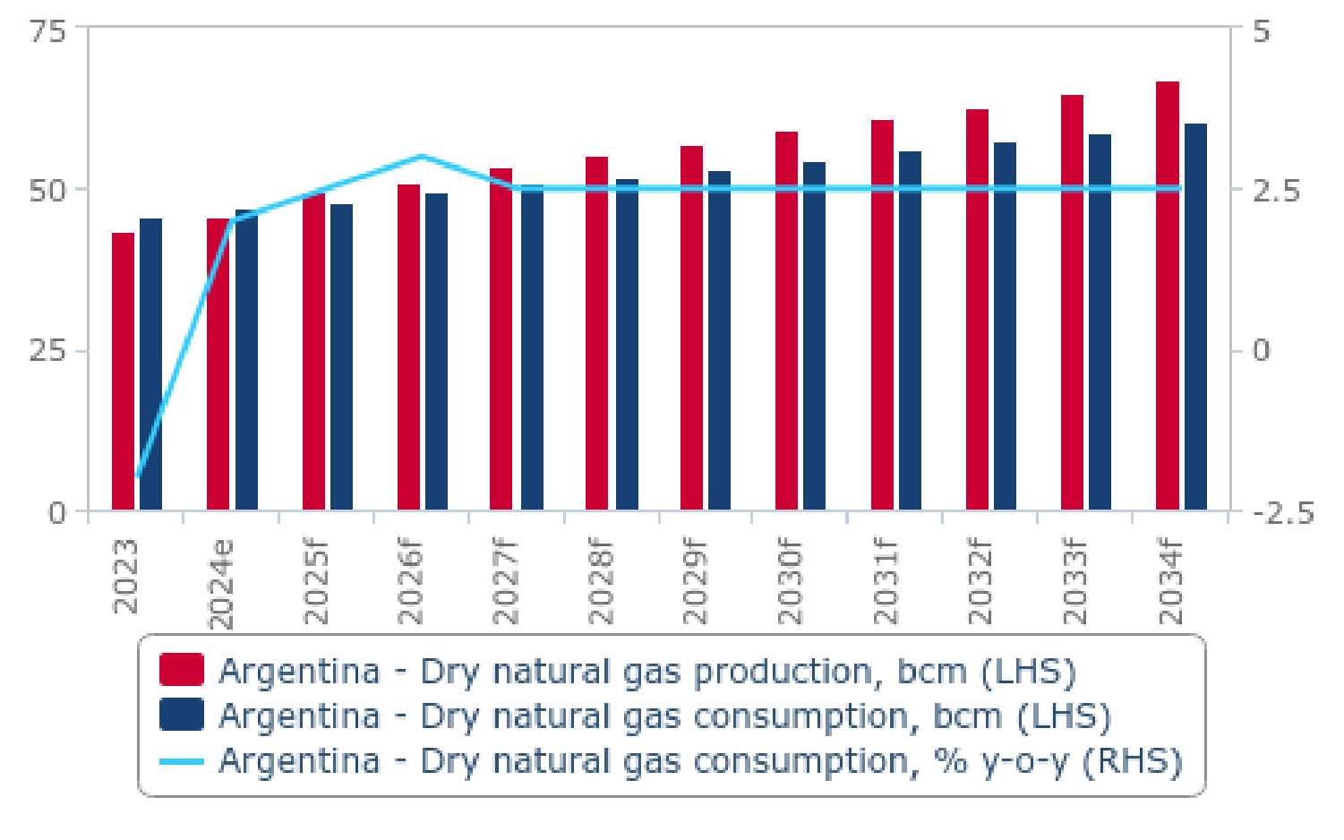

*e/f = BMI estimate/forecast. Source: EIA, Enargas, BMI*

Heading into 2025, we forecast a continuation of demand growth, with our current forecasts for 2025 indicating a 2.5% y-o-y rise to 48.1bcm. This will notably be pulled up by our expectation for a return to economic growth, which should stimulate gas demand

growth from the power sector and the industrial sectors in particular. Our Country Risk team forecasts real GDP growth of 4.8% in

2025 and 4.4% in 2026, after another contraction of 1.7% in 2024. They highlight that broader macroeconomic stability, particularly currency and price stability, will support the recovery in 2025 and 2026.

Strong Demand From Power And Residential Segment Outbalanced Declines In Industrial Demand

Argentina - Natural Gas Consumption Per Recipient Type, bcm (2020-2024)

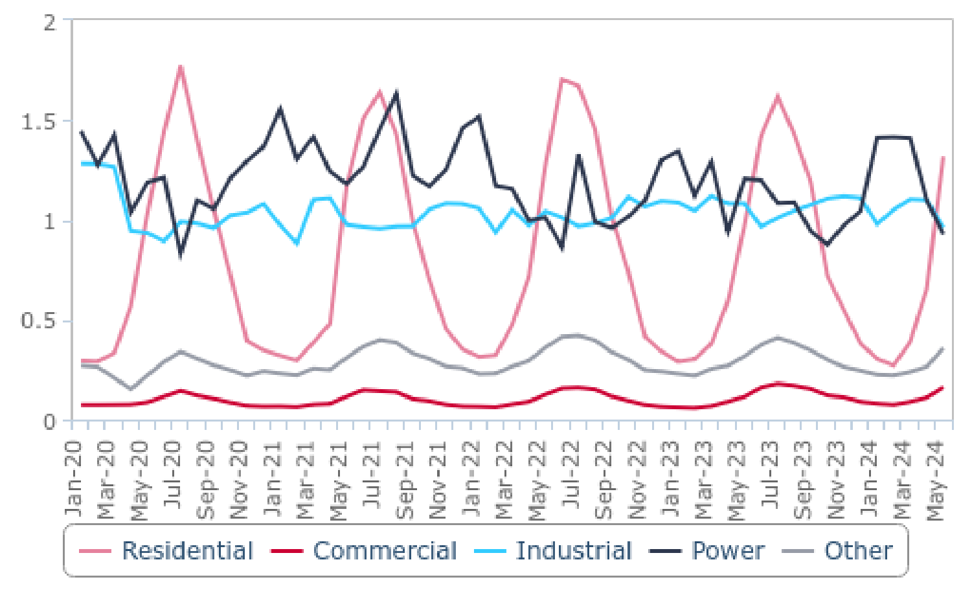

*Source: Enargas, BMI*

**Argentina Oil & Gas Report | Q3 2025**

a Fitchsolutions company

Natural gas consumption is expected to continue to grow over the long-term horizon on the back of the expansion of natural gas fired power generation capacity and strong demand from the residential sector. The abundance of the domestic resource would

stimulate the growth in demand, however, the northern parts of the country, where the majority of the demand is concentrated,

would likely turn to occasional LNG imports given the limited midstream capacity connecting the gas-rich Vaca Muerta and Buenos Aires metropolitan area.

Gas demand will be led by rising demand from the power sector. Our Power & Renewables team forecast gas power generation to rise by a yearly average of 2.5% over the 2025-2034 forecast period, with gas power representing about 47-48% of total power

output throughout the forecast period. In addition to continued use in the industrial and residential segments, this should drive up gas demand in Argentina over the entire forecast period. We do highlight some downside risks to gas demand from the power

sector, due to growing competition from non-hydropower renewables. Our Power & Renewables team expects the market to focus on the development of non-hydro renewables capacity in the long term. We caution that the investments in other renewable power plants require a flexible back-up system to deal with the inherent intermittency issues.

We also expect that the domestic production of natural gas will support higher consumption should the midstream system be

expanded to serve the most demand-intense regions of the country. The recent cancellation of the large pipeline project, which was expected to connect Vaca Muerta with demand intensive Buenos Aires region weighs on the expansion of both growth and the

demand for natural gas in Argentina. However, the expansion of gas infrastructure with the Néstor Kirchner gas pipeline underpins our more bullish forecast for the medium term as we expect the abundance of domestically produce gas will lower its cost on the domestic market, boosting the demand from gas-heavy industries like petrochemicals.

Plan To Boost Renewable But Natural Gas Remains Key

Argentina - Power Generation Forecast (2021-2034)

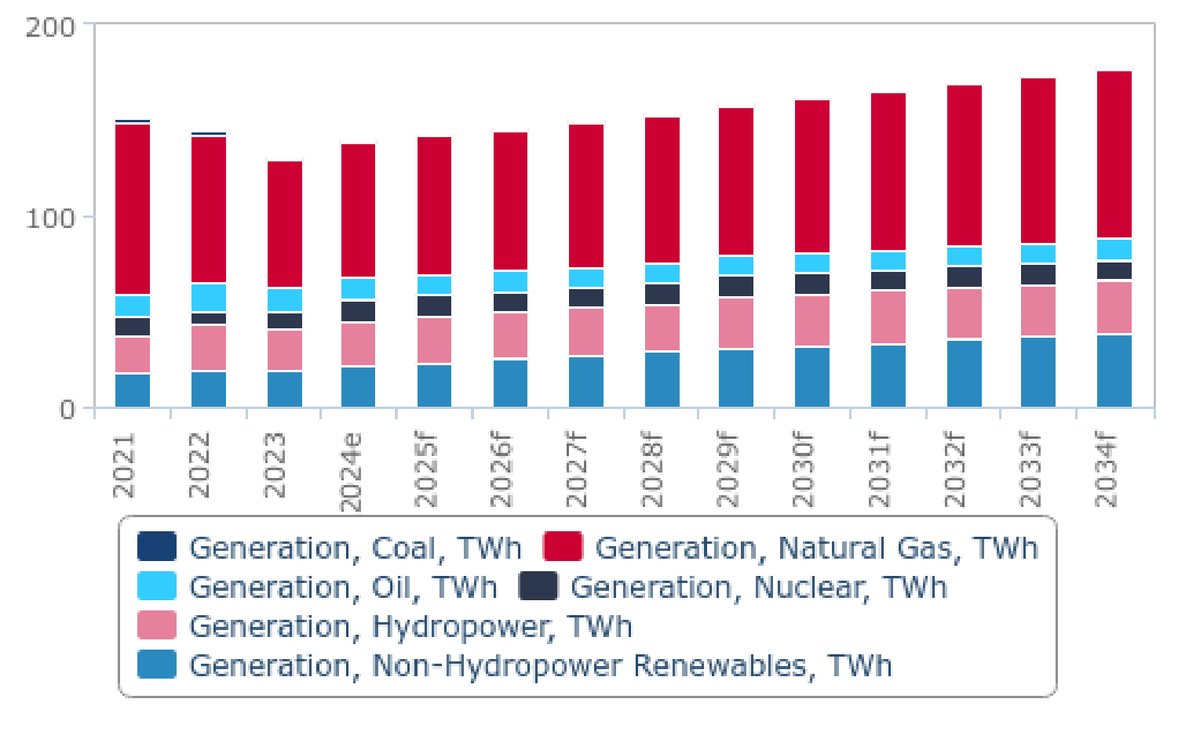

*e/f = BMI estimate/forecast. Source: National sources, BMI*

**Argentina Oil & Gas Report | Q3 2025**

a Fitchsolutions company

Gas Consumption (Argentina 2023-2028)

|  |  |  |  |  |  |  |
| --- | --- | --- | --- | --- | --- | --- |
| **Indicator** | **2023** | **2024e** | **2025f** | **2026f** | **2027f** | **2028f** |
| Dry natural gas consumption, bcm | 46.0 | 46.9 | 48.1 | 49.6 | 50.8 | 52.1 |
| Dry natural gas consumption, % y-o-y | -2.0 | 2.0 | 2.5 | 3.0 | 2.5 | 2.5 |
| *e/f = BMI estimate/forecast. Source: Minem, BMI*  Gas Consumption (Argentina 2029-2034) | | | | | | |
| **Indicator** | **2029f** | **2030f** | **2031f** | **2032f** | **2033f** | **2034f** |
| Dry natural gas consumption, bcm | 53.4 | 54.7 | 56.1 | 57.5 | 58.9 | 60.4 |
| Dry natural gas consumption, % y-o-y | 2.5 | 2.5 | 2.5 | 2.5 | 2.5 | 2.5 |

*f = BMI forecast. Source: EIA, Minem, BMI*

**Argentina Oil & Gas Report | Q3 2025**

a Fitchsolutions company

Oil Trade

***Key View:*** *Argentina is increasing its net crude oil exports thanks to rising unconventional production and oil export infrastructure. This will see crude oil net exports rise from 352,000b/d in 2024 to over 600,000b/d by 2034, with rising upside risks to this forecast. The country is a mid-scale importer of refined fuels, which we expect will remain the case given rising demand for fuels and stable refining capacity. Argentina will see slowly rising net fuels import requirements throughout the forecast period, from 197,000b/d in 2024 to 246,000b/d by 2034.*

**Crude Oil Trade Forecast**

**Latest Updates**

• We expect Argentina to see a robust increase in net crude oil exports of 29.8% y-o-y in 2025, following an already strong 22.4% y-o-y increase in 2024. This is thanks to our forecasted strong increase in unconventional oil output expected in 2025. This will boost crude oil net exports to 457,000b/d in 2025, compared to 352,000b/d in 2024 and 288,000b/d in 2023. This is another increase this quarter on our forecasts, on the back of stronger than expected crude and condensates production growth in

2024, in addition to an upward revision in our crude production forecasts over 2025.

• Over the long term, Argentina is expected to export over 600,000b/d by the end of our forecast period in 2034, on the back of strong upstream performance and rather limited refining utilisation growth.

• Our long-term outlook is supported by the expansion of oil midstream infrastructure connecting Vaca Muerta and export

facilities. The expansion projects announced by Oldelval and plans for the Vaca Muerta South oil pipeline project, will allow for the export growth.

**Structural Trends**

Argentina's upstream producers have seen a robust growth in crude oil exports on the back of growing shale production over

2020-2024. Net crude oil exports grew from below 40,000b/d in 2018 to estimated 352,000b/d in 2024. We expect Argentina to

see robust growth in net crude oil exports, on the back of surging domestic shale production coupled with limited growth in

domestic refining capacity. By 2034, Argentina's net crude oil exports are set to surge beyond 600,000b/d, supported by expanding midstream oil infrastructure and export terminal capacity. This is another increase this quarter on our previous long-term forecasts, on the back of an upward revision to our long-term oil production forecasts.

**Argentina Oil & Gas Report | Q3 2025**

a Fitchsolutions company

Robust Upstream Performance Supports Growth In Oil Exports

Argentina - Crude Oil Net Exports Forecast (2023-2034)

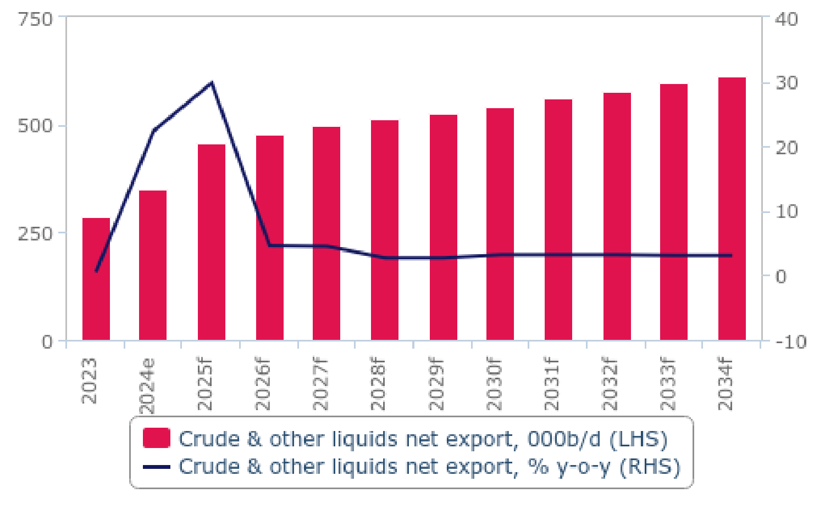

*e/f = BMI estimate/forecast. Source: EIA, national sources, BMI*

Currently, Argentina primarily exports its shale crude with total exports being dominated by Medanito crude produced in Neuquen, Rio Negro and La Pampa basins. Medanito crude currently makes up about 70% of total crude oil exported. We expect the bulk of new midstream infrastructure to be concentrated in Neuquen, and we therefore expect the Medanito grade to continue to

dominate exports over the next decade. Medanito crude is a light sweet grade with API grade of 0.4 and 0.15% sulphur content.

Argentina is continuing to diversify its oil trade partners. In 2024, crude oil exports bound to Chile made up 41.2% of Argentina's total crude oil net exports, followed by the US (40.3%), Brazil (9.3%) and Uruguay (3.9%).

Crude Oil Net Exports (Argentina 2023-2028)

|  |  |  |  |  |  |  |
| --- | --- | --- | --- | --- | --- | --- |
| **Indicator** | **2023** | **2024e** | **2025f** | **2026f** | **2027f** | **2028f** |
| Crude & other liquids net export, 000b/d | 287.7 | 352.3 | 457.3 | 478.1 | 499.6 | 513.2 |
| Crude & other liquids net export, % y-o-y | 0.5 | 22.4 | 29.8 | 4.6 | 4.5 | 2.7 |
| *e/f = BMI estimate/forecast. Source: EIA, national sources, BMI*  Crude Oil Net Exports (Argentina 2029-2034) | | | | | | |
| **Indicator** | **2029f** | **2030f** | **2031f** | **2032f** | **2033f** | **2034f** |
| Crude & other liquids net export, 000b/d | 527.2 | 544.1 | 561.5 | 579.2 | 597.3 | 615.8 |
| Crude & other liquids net export, % y-o-y | 2.7 | 3.2 | 3.2 | 3.2 | 3.1 | 3.1 |

*f = BMI forecast. Source: EIA, national sources, BMI*

**Argentina Oil & Gas Report | Q3 2025**

a Fitchsolutions company

**Refined Fuels Trade Forecast**

**Latest Updates**

• In 2025, Argentina will see net fuel import requirements increase to 212,000b/d compared to levels of 197,000b/d in 2024, as domestic demand picks up and refining output increases only marginally.

• Given our forecasts for a progressive strengthening of fuels demand from 2025 onwards as the economy recovers and as the

vehicle fleet return tor growth, we believe Argentina will see rising net fuels import requirements throughout the forecast period, set to reach levels of 246,000b/d by 2034.

**Structural Trends**

Argentina is a mid-scale net fuels importer, as domestic fuels production in insufficient to meet domestic demand, and this despite the decrease in fuels demand in recent years linked to weak economic activity. In 2024, fuels oil exports bound to Paraguay made up 41.7% of Argentina's fuels exports, followed by the United States (34.2%), Uruguay (8.6%), Chile (2.6%) and Brazil (3.0%), amongst other smaller export destinations. Net fuels imports into Argentina mostly came from the United States (30.5%), the UAE (18.2%),

Belgium (7.7%), India (6.4%) and Brazil (5.4%).

Demand Recovery Translates to Higher Fuel Imports

Argentina - Refined Products Net Exports Forecast (2023-2034)

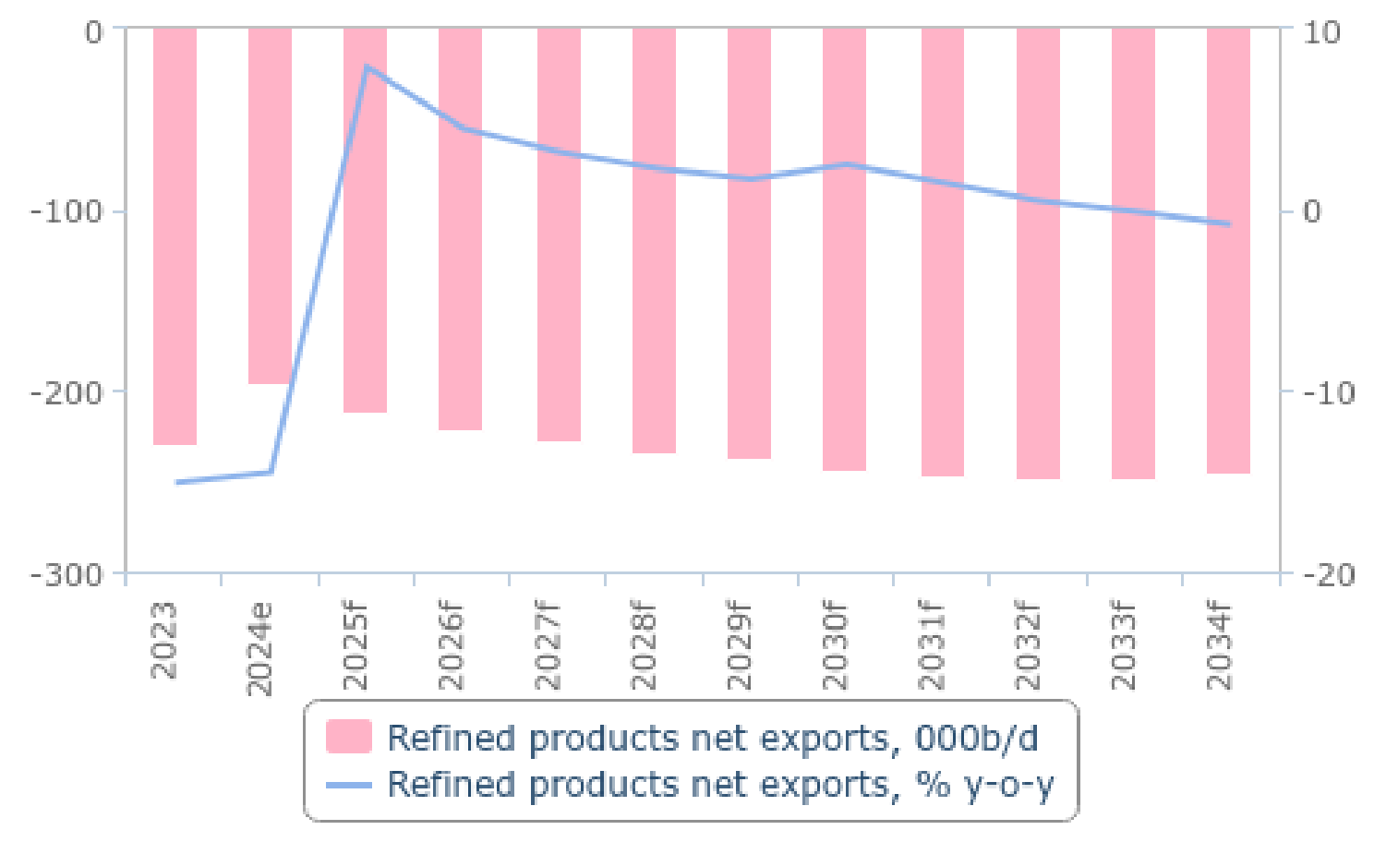

*e/f = BMI estimate/forecast. Source: EIA, national sources, BMI*

Given our forecasts for a progressive strengthening of fuels demand from 2025 onwards as the economy recovers and as the

vehicle fleet return tor growth, we believe Argentina will see rising net fuels import requirements throughout the forecast period, set to reach levels of 246,000b/d by 2034.

**Argentina Oil & Gas Report | Q3 2025**

a Fitchsolutions company

Refined Fuels Net Exports (Argentina 2023-2028)

|  |  |  |  |  |  |  |
| --- | --- | --- | --- | --- | --- | --- |
| **Indicator** | **2023** | **2024e** | **2025f** | **2026f** | **2027f** | **2028f** |
| Refined products net exports, 000b/d | -229.8 | -196.6 | -212.0 | -221.6 | -228.7 | -234.1 |
| Refined products net exports, % y-o-y | -15.1 | -14.5 | 7.9 | 4.5 | 3.2 | 2.3 |
| Refined products net exports, USDbn | -8.1 | -6.3 | -6.3 | -6.5 | -6.4 | -6.7 |
| *e/f = BMI estimate/forecast. Source: EIA, national sources, BMI*  Refined Fuels Net Exports (Argentina 2029-2034) | | | | | | |
| **Indicator** | **2029f** | **2030f** | **2031f** | **2032f** | **2033f** | **2034f** |
| Refined products net exports, 000b/d | -238.0 | -243.9 | -247.5 | -248.8 | -248.4 | -246.4 |
| Refined products net exports, % y-o-y | 1.7 | 2.5 | 1.5 | 0.5 | -0.1 | -0.8 |
| Refined products net exports, USDbn | -6.8 | -7.0 | -7.1 | -7.2 | -7.1 | -7.1 |

*f = BMI estimate/forecast. Source: EIA, national sources, BMI*

**Argentina Oil & Gas Report | Q3 2025**

a Fitchsolutions company

Gas Trade

***Key View:*** *We expect Argentina to become a net exporter of gas in 2025, as it cuts pipeline imports from Bolivia and LNG imports, while ramping up pipeline exports to Chile. Our bullish outlook for net gas exports hinges on certain midstream infrastructure*

*projects. In the long-term, we see booming natural gas production to support net export growth, which we forecast will rise to 6.7bcm by 2034. Our current fofecass remains conservative given continues infrastructure constraints and a lack of LNG export terminals. However, we expect the government ofJavier Milei to support the expansion of LNG export capabilities and therefore recognise upside risks to our long-term gas production and net exports forecasts stemming from advancing talks about a large- scale LNG facility.*

**Latest Updates**

• We expect Argentina to become a net exporter of gas in 2025, as it cuts pipeline imports from Bolivia and LNG imports, while

ramping up pipeline exports to Chile. We note that the completion of the Northern Pipeline Reversal project in October 2024 was a major milestone to raise gas self-sufficiency, by supplying seven northern-most provinces by domestically produced gas as

opposed imported Bolivian gas. Argentina terminated gas imports from Bolivia over Q3 2024, while ramping up gas exports to Chile. The prospect of exporting gas through the Bolivian gas grid to Brazil further supports our bullish view.

• We currently see net gas exports reaching 1.3bcm in 2025 and 1.4bcm in 2026. We note however existing risk of severe weather which would limit volumes available for exports. At the same time, we highlight existing cross-border midstream infrastructure

which adds upside risks to our exports forecast.

• In November 2024, Brazil and Argentina signed an MoU to facilitate gas exports from the Vaca Muerta shale formation. The two governments estimate gas exports to start at about 2mn cm per day in 2025 (0.7bcm in 2025), to rise to 10mncm per day

(3.6bcm per year) in the next three years, reaching 30mncm per day in 2030 (11bcm per year).

• On the LNG front, the passage ofthe Milei’s Law of Bases in late June 2024, which included the large-scale investment framework (RIGI) marks a broad improvement of the regulatory framework for the future large-scale LNG (and other) investments in the

country. In August 2024, YPF and Petronas, which are planning a USD50bn export terminal in Argentina, announced Rio Negro as a location for their flagship project. The companies target an FID in H2 2025. In December 2024 however, it is reported that

Petronas is exiting the project, but that it will be replaced by Shell. Shell and YPF signed an agreement to develop the initial phase ofthe LNG terminal. The terminal aims to produce some 10mtpa of LNG.

• In our forecast, we do not yet incorporate this large-scale terminal, rather we expect small scale terminals to be deployed over the medium term. Most probably, Pan American Energy is expected to commence LNG exports in 2027, reaching annual export volumes of 2.6bcm. This view is reaffirmed by the company’s agreement with Golar LNG in July 2024, to deploy a floating LNG vessel off the Argentine coast.

• In November 2024, YPF partnered with Southern Energy to deploy a 2.45mt/year FLNG vessel, the Hilli Episeyo in the Gulf of San Matias, Rio Negro. The project aims to boost production from Vaca Muerta shale gas field. Southern Energy, aJV between Pan

American Energy (PAE) and Golar LNG will oversee LNG operations, with Golar holding a 10% stake. Exports are expected to start by 2027.

**Structural Trends**

Historically, Argentina was a net importer of natural gas. The market briefly returned to net exporter status in 2016 on the back of growing natural gas production. In 2018, Argentina's economic growth slowed due to a severe contraction in agricultural

production and the feed-through of financial market volatility. The Covid-19 pandemic has exacerbated the situation in Argentina, leading to a weakened growth. In our view, Argentina will continue to rely on seasonal gas imports. The transportation bottlenecks between gas-rich Vaca Muerta and demand-heavy region of Buenos Aires will lead to continued LNG imports to Escobar Terminal serving the most demand-intensive region of Buenos Aires and Rosario and pipeline imports from Bolivia to the remote northern

**Argentina Oil & Gas Report | Q3 2025**

a Fitchsolutions company

part of the market.

Argentina currently has one LNG receiving terminal as a contract for the Bahia Blanca floating storage and regasification unit (FSRU), which had a baseload throughput capacity of 14mcm/d (500mn cf/d) remains inactive. The active terminal - Escobar FSRU supplies the region of Buenos Aires and Rosario as it is located on Parana River 40km west from Buenos Aires. Transportation bottlenecks

between Vaca Muerta and Buenos Aires support the spot imports via Escobar FSRU to meet higher demand.

The ongoing midstream infrastructure expansion is set to position Argentina as a rising natural gas exporter in Latin America from 2025 onwards. Our bullish outlook for net gas exports hinges on certain midstream infrastructure projects. The Northern Pipeline Reversal project, which will be completed in a timely manner to allow domestic supplies to reach norther provinces, is historically reliant on Bolivia's gas. In the long-term, we see booming natural gas production to support net export growth. For now, exports continue to be constrained by insufficient capacity, in particular non-existent LNG export terminal, limiting expansion to pipeline exports and trade partners demand. We expect the government of Javier Milei to support the expansion of LNG export capabilities; however, we note that all projects remain in pre-FID stage.

The completion of the Northern Reversal project, slated for H225, will limit imports and support our net exports forecast. In

November 2024, the Argentine government inaugurated the Tío Pujio-La Carlota Federal Integration Pipeline, which links the

Central and Northern Pipeline, and constitutes a key part of the broader Northern Pipeline Reversal Project. This development will allow Argentina to supply domestically-sourced natural gas to its northern-most provinces, replacing imported gas from Bolivia.

According to media reports, the final step in the project is the completion of automation of four existing compressor stations. In the first phase, the project will allow the transport of 5mcm/d to seven provinces, with a possibility to increase the capacity to 9mcm/d. We also note the possibility of this project supporting future exports to Bolivia or Brazil, raising upside risks for our long-term net gas export forecast. In our current forecast, we see Argentina becoming a net exporter of natural gas in 2025, reaching 1.3bcm in net gas exports, with long term net exports rising to 6.7bcm by 2034. For context, Argentina is already exporting natural gas to Chile.

Argentina To Become A Net Gas Exporter In 2025

Argentina - Gas Net Exports Forecast (2023-2034)

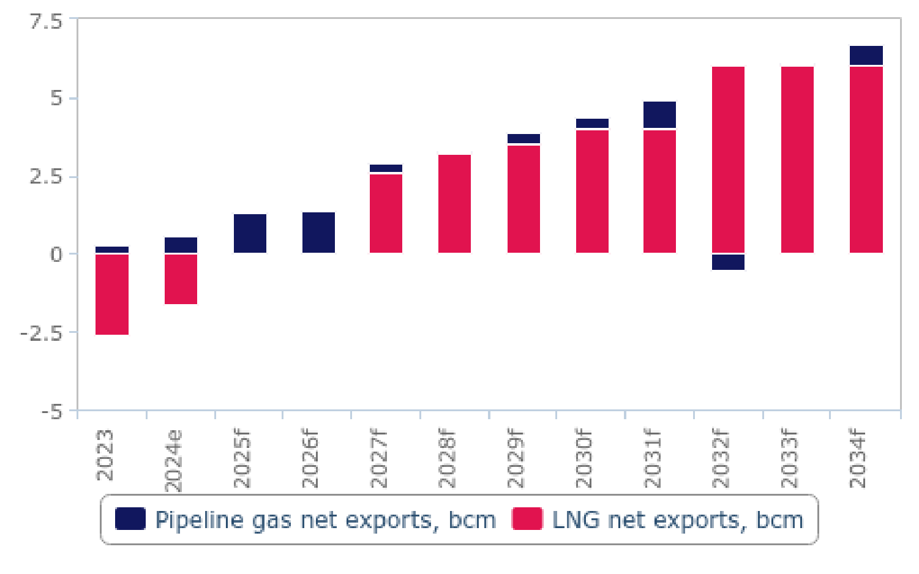

*e/f = BMI estimate/forecast. Source: EIA, national sources, BMI*

**Argentina Oil & Gas Report | Q3 2025**

a Fitchsolutions company

We also recognise upside risks to our long-term gas production and net exports forecasts stemming from advancing talks about a large-scale LNG facility. In our current forecast, we have only incorporated small-scale LNG export facilities. One project, led by Pan American Energy, in cooperation with YPF and Pampa Energy among others, is set to commence operations in 2027 adding

approximately 4.1bcm of export capacity, however we do not expect it to use its full capacity immediately after commencing

operations. Another small-scale project is considered by Tecpetrol, however there have been limited updates on this one. We note that both projects are in the pre-FID stage which raises some downside risks to our long-term LNG export forecast.

At the same time, we highlight upside risks to our long-term outlook for Argentina’s gas production and net exports. Media reports indicated some progress in talks about a large-scale LNG export facility between YPF and Shell, after the Malaysian state-led

Petronas decided to step away from this initiative. Argentina’s NOC and Shell will now collaborate to push the project to the front- end engineering design stage. In the initial phase, this project would allow the export of up to 10bcm of LNG, which constitutes

material upside risk to our long-term LNG net export and gas production forecast for Argentina, should it be completed within the next decade.

We note that the supportive stance towards the oil and gas industry expressed by the current government of Javier Milei in

Argentina limits downside risks to the forecasts, however, we recognise some risks stemming from the lower oil price environment expected for the next years which could weaken the upstream and midstream investor sentiment globally.

Gas Net Exports (Argentina 2023-2028)

|  |  |  |  |  |  |  |
| --- | --- | --- | --- | --- | --- | --- |
| **Indicator** | **2023** | **2024e** | **2025f** | **2026f** | **2027f** | **2028f** |
| Dry natural gas net exports, bcm | -2.3 | -1.0 | 1.3 | 1.4 | 2.9 | 3.3 |
| Dry natural gas net exports, % y-o-y | -20.7 | -57.8 | -235.1 | 3.0 | 113.8 | 11.7 |
| Dry natural gas net exports, USDbn | -1.0 | -0.4 | 0.4 | 0.5 | 1.0 | 1.1 |
| Pipeline gas net exports, bcm | 0.3 | 0.6 | 1.3 | 1.4 | 0.3 | 0.1 |
| Pipeline gas net exports, % y-o-y | -205.4 | 134.0 | 117.3 | 3.0 | -75.6 | -76.9 |
| Pipeline gas net exports, % of total | -11.2 | -62.2 | 100.0 | 100.0 | 11.4 | 2.4 |
| LNG net exports, bcm | -2.6 | -1.6 | 0.0 | 0.0 | 2.6 | 3.2 |
| LNG net exports, % y-o-y | -3.7 | -38.5 | -100.0 |  |  | 23.1 |
| LNG net exports, % of total gas exports | 111.2 | 162.2 | 0.0 | 0.0 | 88.6 | 97.6 |

*e/f = BMI estimate/forecast. Source: EIA, national sources, BMI*

**Argentina Oil & Gas Report | Q3 2025**

a Fitchsolutions company

Gas Net Exports (Argentina 2029-2034)

|  |  |  |  |  |  |  |
| --- | --- | --- | --- | --- | --- | --- |
| **Indicator** | **2029f** | **2030f** | **2031f** | **2032f** | **2033f** | **2034f** |
| Dry natural gas net exports, bcm | 3.9 | 4.4 | 4.9 | 5.5 | 6.1 | 6.7 |
| Dry natural gas net exports, % y-o-y | 19.4 | 12.7 | 11.9 | 11.2 | 10.5 | 10.0 |
| Dry natural gas net exports, USDbn | 1.3 | 1.5 | 1.7 | 1.9 | 2.1 | 2.3 |
| Pipeline gas net exports, bcm | 0.4 | 0.4 | 0.9 | -0.5 | 0.1 | 0.7 |
| Pipeline gas net exports, % y-o-y | 433.1 | -0.3 | 127.3 | -154.9 | -112.5 | 942.7 |
| Pipeline gas net exports, % of total | 10.6 | 9.3 | 19.0 | -9.4 | 1.1 | 10.1 |
| LNG net exports, bcm | 3.5 | 4.0 | 4.0 | 6.0 | 6.0 | 6.0 |
| LNG net exports, % y-o-y | 9.4 | 14.3 | 0.0 | 50.0 | 0.0 | 0.0 |
| LNG net exports, % of total gas exports | 89.4 | 90.7 | 81.0 | 109.4 | 98.9 | 89.9 |

*f = BMI forecast. Source: EIA, national sources, BMI*

**Argentina Oil & Gas Report | Q3 2025**

a Fitchsolutions company

Industry Risk/Reward Index

LatinAmerica Upstream Oil & Gas Risk/Reward Index

***Key View*:** *Latin America is home to some of the top-performing markets in our Upstream Oil & Gas Risk/Reward Index due to the region's substantial untapped reserves, particularly offshore. The region's score exceeds global average in Industry Rewards;*

*however, it underperforms in all other index components.*

Brazil Ranks Highest In The Region

Latin America - Upstream Risk/Reward Index Heat Map

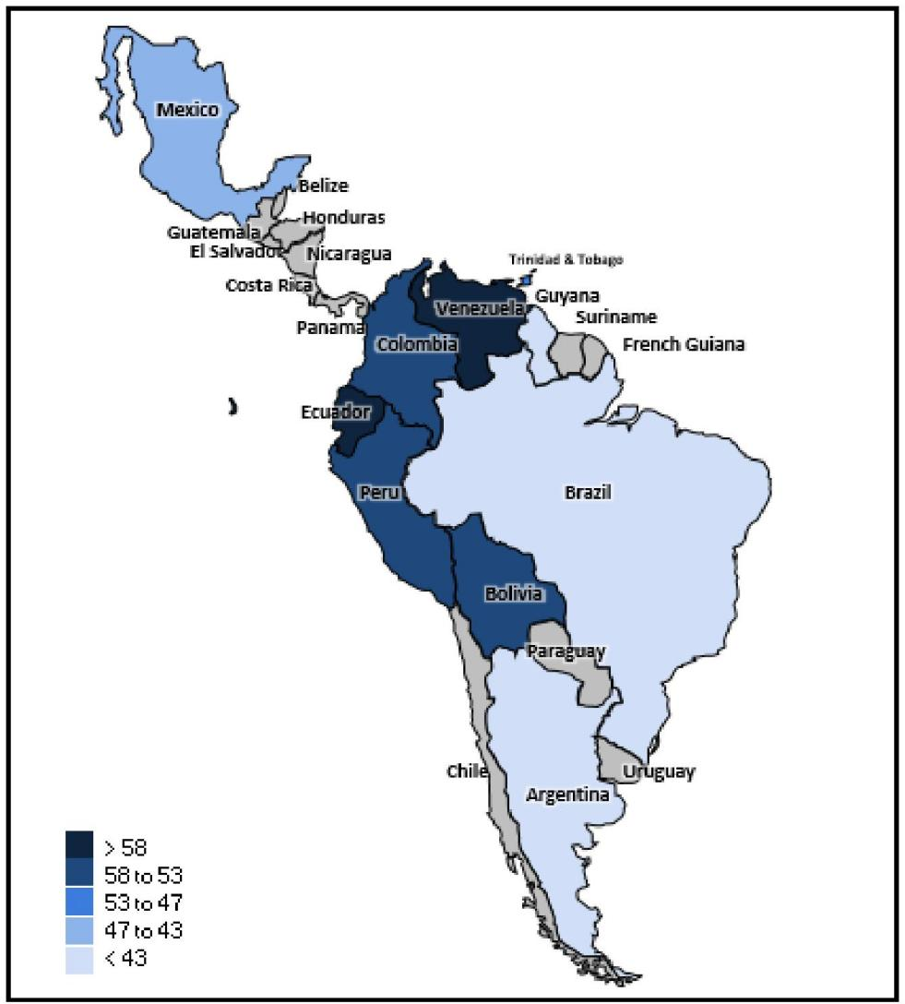

*Note: Scores out of 100; lower score = more attractive market. Source: BMI Upstream Oil & Gas Risk/Reward Index*

**Main Regional Features And Latest Updates**

• Latin America achieves a score of 49.3 out of 100 in our Upstream Oil & Gas Risk/Reward Index (RRI), slightly below the global average of 50. The region's performance is bolstered by high Industry Rewards, scoring 44.1. Latin America excels in

Hydrocarbon Production Growth, with notable scores for Guyana, Brazil, and Argentina, and surpasses the global average in Hydrocarbon Production and Oil Reserves, with scores of 40.1 and 39.2 respectively.

• The second highest category for the region is Country Rewards, scoring 54.4. However, the region encounters below-average risk in Infrastructure Integrity (46.1), but faces challenges due to relatively poor performance in the State Asset Ownership

category (56.1) and Competitive Landscape (61.1), attributed to the dominance of national oil companies.

**Argentina Oil & Gas Report | Q3 2025**

a Fitchsolutions company

• In the Risks categories, Latin America scores poorly, with Industry Risks at 60.1, weakened by high Legal Environment Risk (67.0), and risks related to Licence Type (58.9) and Bureaucratic Environment (58.0). The region also experiences elevated Country

Risks, with a score of 55.3, above the global average. The weakest component in this category is the Political Risk Index, scoring 58.7, with Venezuela and Bolivia showing poor performance in the Governance subcomponent. Despite these challenges, Latin America closely matches the global average in Long-Term Economic Risk (50.9), the best-performing category of the Country Risk Index.

Guyana Rises Due To Bullish Oil Production Growth Outlook

Latin America - Upstream Risk/Reward Snapshot

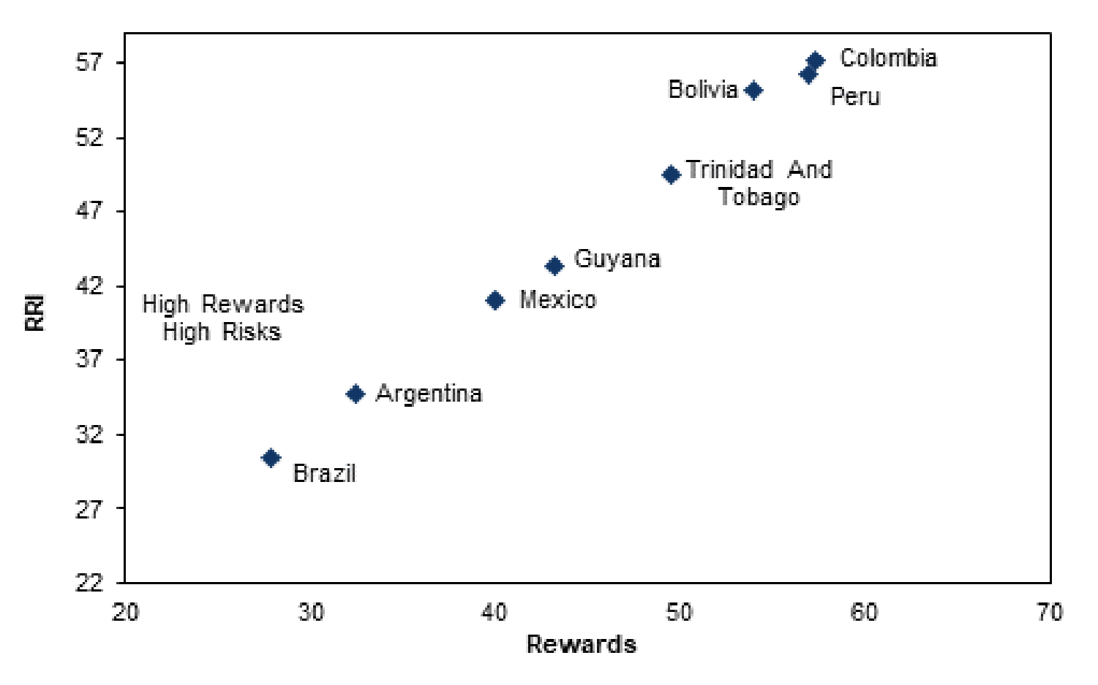

*Note: Scores out of 100; lower score = more attractive market. Source: BMI Upstream Oil & Gas Risk/Reward Index*

**Top Ranks Supported By Below-Ground Rewards**

Latin America has prolific resource basins, with Venezuela's onshore fields and Brazil's deepwater reserves leading. Guyana has boosted regional output since 2019. Argentina and Mexico have significant untapped reserves but face regulatory uncertainties affecting investor sentiment.

Brazil ranks highest due to a bullish outlook for crude oil production, driven by projects from Petrobras and IOCs. Oil production is expected to grow 3.7% annually from 2024 to 2033, reaching 4.9mn b/d by 2030. Brazil plans to increase crude oil production by 5.0% y-o-y in 2025, with an average growth rate of 4.3% from 2026 to 2029. Petrobras will launch three new FPSOs in 2025: Buzios

7, Buzios 6, and Mero 4. Equinor's Bacalhau project will deliver first oil, boosting output. Despite weak 2024 performance, Brazil's oil production will rebound in 2025. The Atapu field project supports growth with a capacity of 225,000b/d. Brazil's entry into OPEC+ poses risks, but it remains excluded from production cuts as of early 2025.

Argentina holds the second position in the Upstream RRI ranking, with a bullish outlook for production driven by shale oil and natural gas. Sector liberalization under President Milei offers long-term upside, but economic uncertainties pose challenges.

Argentina's oil production will increase 5.0% y-o-y in 2025 to 741,000b/d, following 11.0% growth in 2024. Between 2025 and

2029, growth will average 4.3% annually, supported by shale projects and infrastructure expansions. The Oldelval consortium and YPF plan to expand midstream capacity, crucial for Vaca Muerta's exit capacity. Infrastructure projects like Vaca Muerta South oil pipeline and Oldelval's Duplicar project will boost midstream capacity. Despite regulatory uncertainties, President Milei's agenda is expected to foster long-term growth.

**Argentina Oil & Gas Report | Q3 2025**

a Fitchsolutions company

Mexico ranks third, facing challenges with Pemex and limited private market share. The outlook is bearish, with a 2.0% production

decline in 2025, following a 5.0% decline in 2024. Claudia Sheinbaum's presidency is expected to maintain a similar industry stance, integrating more renewables while keeping crude oil output stable. Restrictive policies limit private participation, constraining

growth. Pemex dominates with over 93% market share. Efforts to prioritise fields like Bakte and modernize Bacab have seen weaker performance. The medium-term forecast relies on projects like Zama, expected to deliver first oil in 2025, and Trion, slated for first oil in 2028. However, regulatory hurdles and focus on shallow water/onshore fields pose challenges to growth.

Ecuador Supersedes Venezuela In Our RRI

Brazil & Ecuador Vs Latam Average - RRI Index, By Component

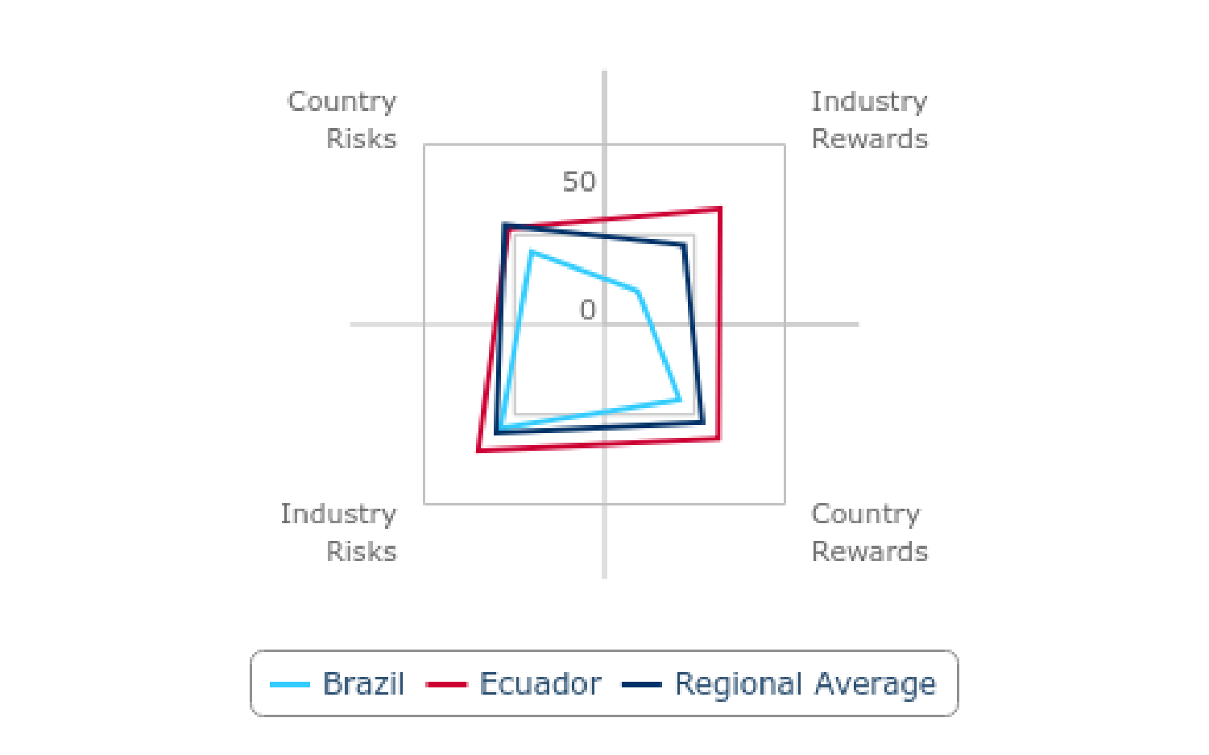

*Note: Scores out of 100; lower score = more attractive market. Source: BMI*

Guyana has risen high in Industry Rewards, driven by robust growth in crude oil production and some natural gas output over the next decade. ExxonMobil is currently producing from three projects, with two more awaiting final investment decisions:

Hammerhead in 2025 and Longtail in 2027. In April 2024, the Whiptail project was sanctioned, set to begin production in 2027. H2 2024 data prompted a revision of crude oil production estimates to 607,500 b/d, with a 23% growth anticipated by 2025. Major

developments like Yellowtail, Uaru, and Whiptail are expected to significantly boost production, reaching 895,200b/d by 2026 and 1.40mn b/d by 2032.

However, inflationary pressures pose risks to project timelines, as seen with Uaru's cost rise from USD10.0bn to USD12.7bn.

Guyana's strategic initiatives, including potential adjustments to bidding rounds and local content laws, and geopolitical tensions with Venezuela, could influence future production dynamics. Despite challenges, the country remains a hotspot for upstream oil exploration, with attractive project economics like Liza 1 drawing international interest.

Trinidad & Tobago scores in the middle of the rankings, with some medium-term production growth but limited long-term

investment. Oil production is set to decline over the next decade due to mature fields and insufficient exploration investment,

averaging 68,050b/d in 2024 and expected to fall below 57,215b/d. Recent developments, such as new PSCs with EOG Resources and a deepwater bidding round, aim to attract investment. However, the joint gas fields with Venezuela face geopolitical challenges despite their potential to address gas shortages. BP's asset sale to Perenco reflects ongoing shifts in the sector.

While projects like BHP Ruby and enhanced oil recovery offer some upside, the outlook is constrained by a lack of major new projects and deferred drilling activities. The sector remains heavily focused on gas exploration, with fiscal regime revisions and

**Argentina Oil & Gas Report | Q3 2025**

a Fitchsolutions company

onshore, offshore, and deepwater exploration offering potential for future discoveries. However, the absence of significant new initiatives weighs on the long-term outlook.

The Latin America region presents a complex landscape of opportunities and challenges in the oil and gas sector. Brazil leads with strong growth potential, Argentina shows promise with its shale revolution, and Mexico faces hurdles in sustaining production amid policy constraints.

**Weak Bureaucratic And Legal Environment And NOCs' Dominance Weigh On Scores**

Key producers in Latin America face challenges due to weak bureaucratic and legal frameworks. The unfavorable tax climate

discourages international oil companies (IOCs), allowing national oil companies (NOCs) to dominate the market. In Mexico, market liberalisation has stalled, with Pemex maintaining its stronghold. Argentina has seen efforts to create a more competitive market, with several IOCs gaining exploration and production rights, but regulatory uncertainty and economic instability may impede this progress. Smaller markets like Colombia and Ecuador have difficulty attracting new entrants, leaving the development of upstream projects largely to state-owned enterprises.

**Elevated Economic And Operational Risks Weighs On Scores**

Latin America faces heightened short-term economic and operational risks, with weak real GDP growth anticipated across the

region, except for Guyana, which benefits from new oil projects. Guyana's economic prospects remain strong, with real GDP

expected to increase by approximately 13% from USD25.6bn in 2024 to USD29.0bn in 2025, driven by significant investments in its expanding oil sector. We project a regional economic slowdown in 2025, with GDP growth decreasing from 2.4% in 2024 to 2.0% in 2025. This slowdown is expected to affect 12 of the 17 Latin American markets, with significant slowdowns in Brazil (from 3.4% to 2.0%) and Mexico (from 1.5% to 0.2%), which together make up about 60% of the regional GDP. Their economic performance

heavily influences Latin America's overall growth. Additionally, persistent security issues continue to increase operational risks in the region.

**Argentina Oil & Gas Report | Q3 2025**

a Fitchsolutions company

Rewards Outweigh Risks In The Region

Selected Latin America Markets - Upstream Risk/Reward Score

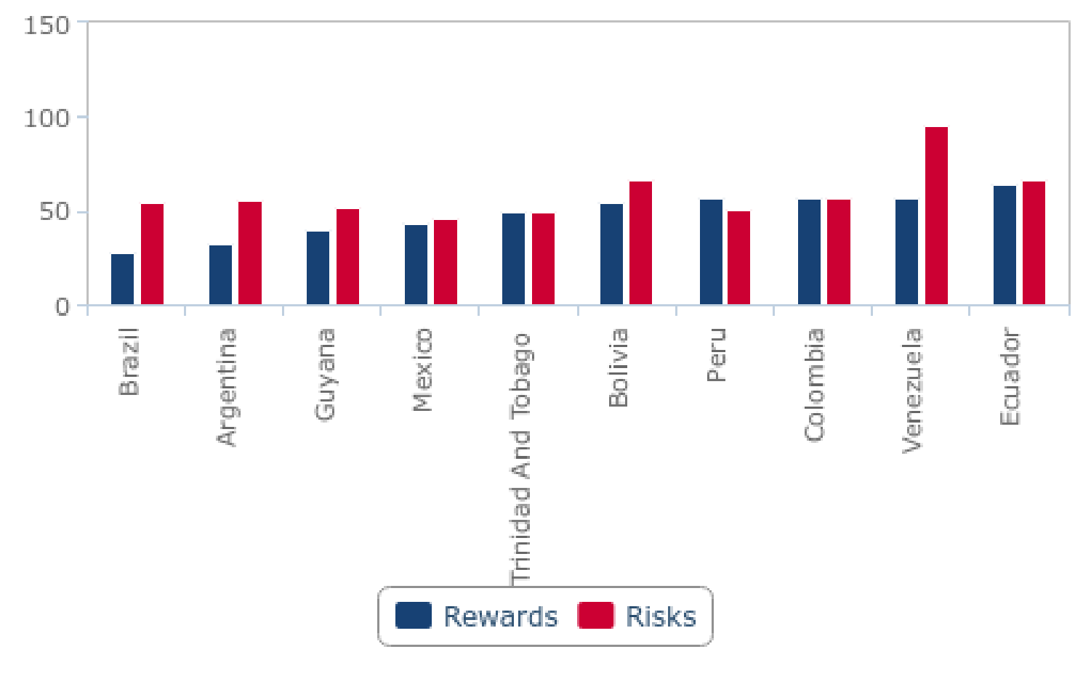

*Note: Scores out of 100; lower score = more attractive market. Source: BMI*

**Political Risk Elevated In Many Countries**

Ecuador has now dropped below Venezuela in regional standings, ranking 62nd globally out of 72 countries, while Venezuela holds the 57th position. Venezuela continues to face significant challenges due to high political risk and governance issues, exacerbated by the re-imposition of U.S. sanctions in April 2024. The uncertainty surrounding Venezuela's presidential elections and sector-

specific challenges make it a high-risk investment destination according to our rankings. Similarly, political instability in Bolivia and

Ecuador adversely affects investor confidence. In the updated regional rankings, Ecuador's standing reflects its ongoing struggles, as it now ranks 10th regionally and 62nd globally, impacted by factors such as bureaucratic inefficiencies and legal risks. Meanwhile,

Venezuela's high political risk and operational challenges place it 9th regionally and 57th globally, highlighting its precarious position in attracting foreign investment.

**Argentina Oil & Gas Report | Q3 2025**

a Fitchsolutions company

Guyana Outperforms In Industry Rewards

Guyana, Colombia & Ecuador Vs Latin America Average - RRI Score, By Component

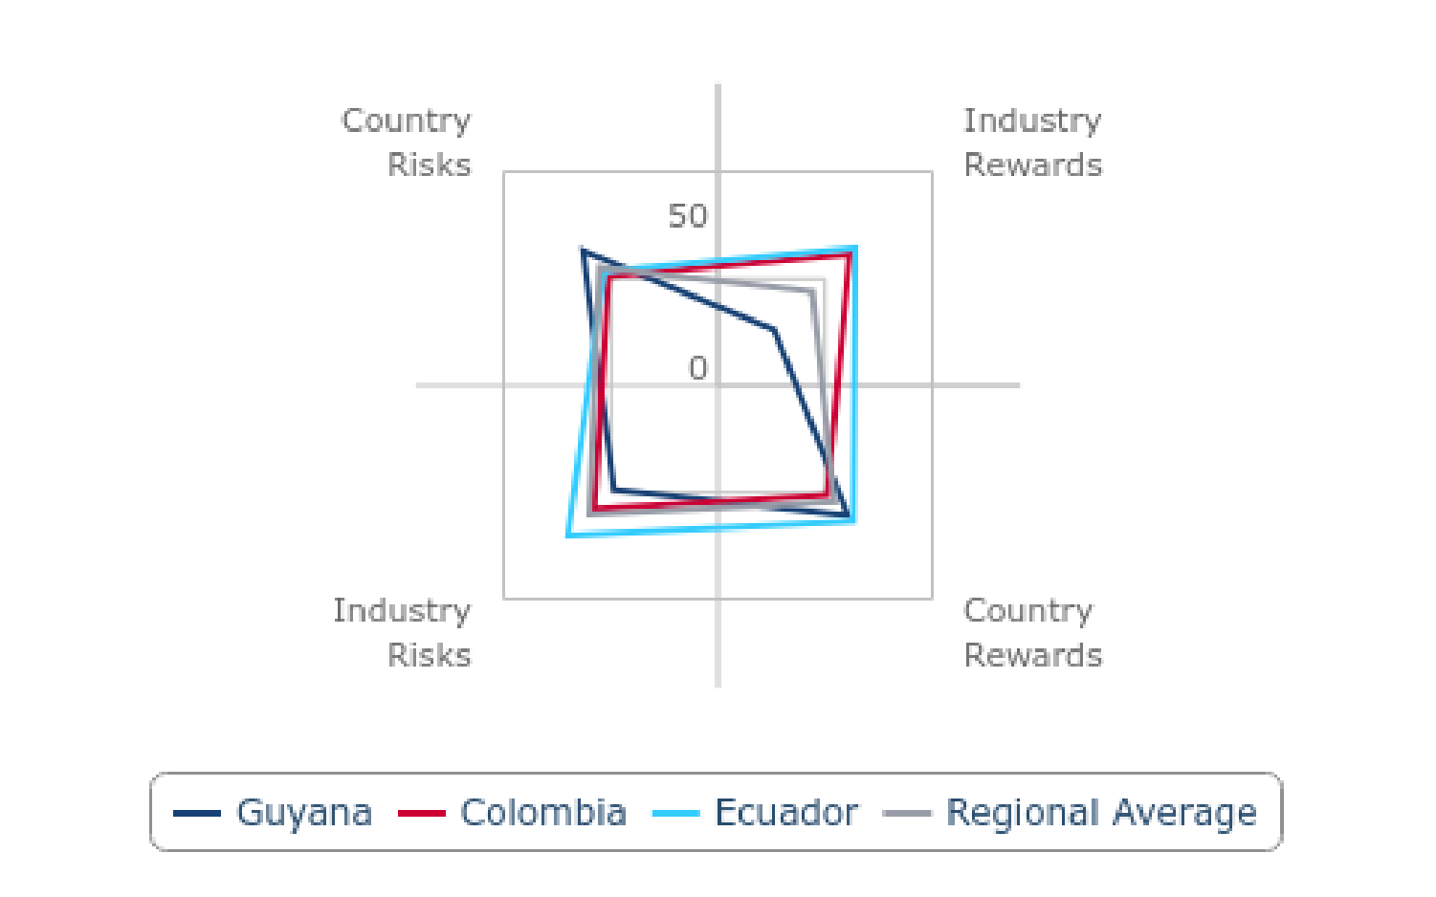

*Note: Scores out of 100; lower score = more attractive market. Source: BMI*

Latin America Upstream Risk/Reward Index

|  |  |  |  |  |  |  |  |  |  |
| --- | --- | --- | --- | --- | --- | --- | --- | --- | --- |
|  | **Industry**  **Rewards** | **Country**  **Rewards** | **Rewards** | **Industry**  **Risks** | **Country**  **Risks** | **Risks** | **RRI** | **Regional**  **Rank** | **Global**  **Rank** |
| Brazil | 18.6 | 41.8 | 27.9 | 57.6 | 40.6 | 54.2 | 30.5 | 1 | 5 |
| Argentina | 31.0 | 34.7 | 32.5 | 56.5 | 49.3 | 55.0 | 34.7 | 2 | 9 |
| Guyana | 26.2 | 60.6 | 39.9 | 48.6 | 63.1 | 51.5 | 41.1 | 3 | 19 |
| Mexico | 34.4 | 56.3 | 43.2 | 45.9 | 44.8 | 45.7 | 43.4 | 4 | 59.9 |
| Trinidad And Tobago | 52.3 | 45.3 | 49.5 | 54.2 | 33.3 | 50.0 | 49.5 | 5 | 33 |
| Bolivia | 59.6 | 45.5 | 54.0 | 62.7 | 79.8 | 66.1 | 55.2 | 6 | 45 |
| Peru | 60.7 | 51.2 | 56.9 | 52.0 | 43.2 | 50.2 | 56.2 | 7 | 47 |
| Colombia | 61.4 | 51.2 | 57.3 | 57.7 | 51.2 | 56.4 | 57.2 | 8 | 51 |
| Venezuela | 32.5 | 94.1 | 57.2 | 95.8 | 94.6 | 95.5 | 61.0 | 9 | 57 |
| Ecuador | 64.4 | 63.4 | 64.0 | 70.0 | 53.4 | 66.7 | 64.2 | 10 | 62 |
|  |  |  |  |  |  |  |  |  |  |
| Global  Average | 50.0 | 50.0 | 50.0 | 50.0 | 50.0 | 50.0 | 50.0 | ~ | ~ |
| Regional  Average | 44.1 | 54.4 | 48.2 | 60.1 | 55.3 | 59.1 | 49.3 | ~ | ~ |

*Note: Scores out of 100; lower score = more attractive market. Source: BMI Upstream Oil & Gas Risk/Reward Index*

**Argentina Oil & Gas Report | Q3 2025**

a Fitchsolutions company

Latin America Upstream Industry Rewards

|  |  |  |  |  |  |  |
| --- | --- | --- | --- | --- | --- | --- |
|  | **Oil Reserves** | **Gas Reserves** | **Discoveries**  **Rate** | **Hydrocarbon**  **Production** | **Hydrocarbon**  **Production**  **Growth** | **Industry**  **Rewards** |
| Brazil | 19.7 | 42.3 | 2.8 | 12.7 | 15.5 | 18.6 |
| Argentina | 46.5 | 45.1 | 15.5 | 29.6 | 18.3 | 31.0 |
| Guyana | 22.5 | 59.2 | 2.8 | 43.7 | 2.8 | 26.2 |
| Mexico | 28.2 | 52.1 | 8.5 | 21.1 | 62.0 | 34.4 |
| Trinidad And Tobago | 70.4 | 53.5 | 51.4 | 49.3 | 36.6 | 52.3 |
| Bolivia | 71.8 | 47.9 | 38.7 | 62.0 | 77.5 | 59.6 |
| Peru | 57.7 | 57.7 | 85.2 | 52.1 | 50.7 | 60.7 |
| Colombia | 50.7 | 73.2 | 57.7 | 40.8 | 84.5 | 61.4 |
| Venezuela | 0.0 | 11.3 | 85.2 | 39.4 | 26.8 | 32.5 |
| Ecuador | 23.9 | 90.1 | 85.2 | 50.7 | 71.8 | 64.4 |
|  |  |  |  |  |  |  |
| Global Average | 50.0 | 50.0 | 50.0 | 50.0 | 50.0 | 50.0 |
| Regional Average | 39.2 | 53.2 | 43.3 | 40.1 | 44.6 | 44.1 |

*Note: Scores out of 100; lower score = more attractive market. Source: BMI Upstream Oil & Gas Risk/Reward Index*

Latin America Upstream Country Rewards

|  |  |  |  |  |  |
| --- | --- | --- | --- | --- | --- |
|  | **State Asset**  **Ownership** | **Competitive**  **Landscape** | **Infrastructure**  **Integrity** | **Country Rewards** | **Rewards** |
| Brazil | 40.8 | 73.2 | 11.3 | 41.8 | 27.9 |
| Argentina | 35.9 | 47.9 | 20.4 | 34.7 | 32.5 |
| Mexico | 4.9 | 84.5 | 92.3 | 60.6 | 39.9 |
| Guyana | 83.8 | 64.8 | 20.4 | 56.3 | 43.2 |
| Trinidad And Tobago | 52.8 | 36.6 | 46.5 | 45.3 | 49.5 |
| Bolivia | 73.9 | 28.2 | 34.5 | 45.5 | 54.0 |
| Peru | 21.8 | 50.7 | 81.0 | 51.2 | 56.9 |
| Colombia | 73.9 | 52.1 | 27.5 | 51.2 | 57.3 |
| Venezuela | 93.0 | 97.2 | 92.3 | 94.1 | 57.2 |
| Ecuador | 79.6 | 76.1 | 34.5 | 63.4 | 64.0 |
|  |  |  |  |  |  |
| Global average | 50.0 | 50.0 | 50.0 | 50.0 | 50.0 |
| Regional average | 56.1 | 61.1 | 46.1 | 54.4 | 48.2 |

*Note: Scores out of 100; lower score = more attractive market. Source: BMI Upstream Oil & Gas Risk/Reward Index*

**Argentina Oil & Gas Report | Q3 2025**

a Fitchsolutions company

Latin America Upstream Industry Risks

|  |  |  |  |  |  |  |
| --- | --- | --- | --- | --- | --- | --- |
|  | **Royalties** | **Income**  **Tax** | **Licence Type** | **Bureaucratic**  **Environment** | **Legal Environment Risk** | **Industry Risks** |
| Brazil | 55.6 | 84.5 | 60.6 | 29.6 | 57.7 | 57.6 |
| Argentina | 66.9 | 69.0 | 39.4 | 50.7 | 56.3 | 56.5 |
| Mexico | 36.6 | 44.4 | 50.7 | 63.4 | 47.9 | 48.6 |
| Guyana | 55.6 | 53.5 | 28.9 | 31.0 | 60.6 | 45.9 |
| Trinidad And Tobago | 28.9 | 90.1 | 50.7 | 60.6 | 40.8 | 54.2 |
| Bolivia | 9.2 | 32.4 | 87.3 | 90.1 | 94.4 | 62.7 |
| Peru | 39.4 | 47.2 | 50.7 | 45.1 | 77.5 | 52.0 |
| Colombia | 92.3 | 69.0 | 28.9 | 39.4 | 59.2 | 57.7 |
| Venezuela | 100.0 | 90.1 | 95.8 | 93.0 | 100.0 | 95.8 |
| Ecuador | 79.6 | 21.1 | 95.8 | 77.5 | 76.1 | 70.0 |
|  |  |  |  |  |  |  |
| Global average | 50.0 | 50.0 | 50.0 | 50.0 | 50.0 | 50.0 |
| Regional average | 56.4 | 60.1 | 58.9 | 58.0 | 67.0 | 60.1 |

*Note: Scores out of 100; lower score = more attractive market. Source: BMI Upstream Oil & Gas Risk/Reward Index*

Latin America Upstream Country Risks

|  |  |  |  |  |  |  |
| --- | --- | --- | --- | --- | --- | --- |
|  | **Long-Term Economic Risk**  **Index** | **Short-Term Economic Risk**  **Index** | **Political Risk**  **Index** | **Operational**  **Risk Index** | **Country**  **Risks** | **Risks** |
| Brazil | 22.5 | 43.7 | 46.5 | 42.3 | 40.6 | 54.2 |
| Argentina | 67.6 | 74.6 | 27.5 | 49.3 | 49.3 | 55.0 |
| Mexico | 56.3 | 52.1 | 59.2 | 76.1 | 63.1 | 51.5 |
| Guyana | 31.0 | 35.2 | 60.6 | 40.8 | 44.8 | 45.7 |
| Trinidad And Tobago | 35.2 | 8.5 | 27.5 | 50.7 | 33.3 | 50.0 |
| Bolivia | 74.6 | 94.4 | 91.5 | 63.4 | 79.8 | 66.1 |
| Peru | 36.6 | 26.8 | 50.0 | 47.9 | 43.2 | 50.2 |
| Colombia | 47.9 | 53.5 | 57.7 | 45.1 | 51.2 | 56.4 |
| Venezuela | 94.4 | 93.0 | 100.0 | 90.1 | 94.6 | 95.5 |
| Ecuador | 43.0 | 40.8 | 66.2 | 52.1 | 53.4 | 66.7 |
|  |  |  |  |  |  |  |
| Global average | 50.0 | 50.0 | 50.0 | 50.0 | 50.0 | 50.0 |
| Regional average | 50.9 | 52.3 | 58.7 | 55.8 | 55.3 | 59.1 |

*Note: Scores out of 100; lower score = more attractive market. Source: BMI Upstream Oil & Gas Risk/Reward Index*

***Please Note:*** *Our Risk/Reward Indices are updated frequently; as a result, scores in this section may not match scores in the rest of the report.*

**Argentina Oil & Gas Report | Q3 2025**

a Fitchsolutions company

LatinAmerica Downstream Oil & Gas Risk/Reward Index

***Key View:*** *Latin America continues to underperform in our Downstream Oil & Gas Risk/Reward Index as a result of common state intervention, low utilisation rates and relatively weak fuel demand growth. The liberalisation of the downstream sector is slow and faces many challenges across the region.*

Brazil And Mexico Dominate

LatinAmerica - Downstream LatinAmerica Heat Map

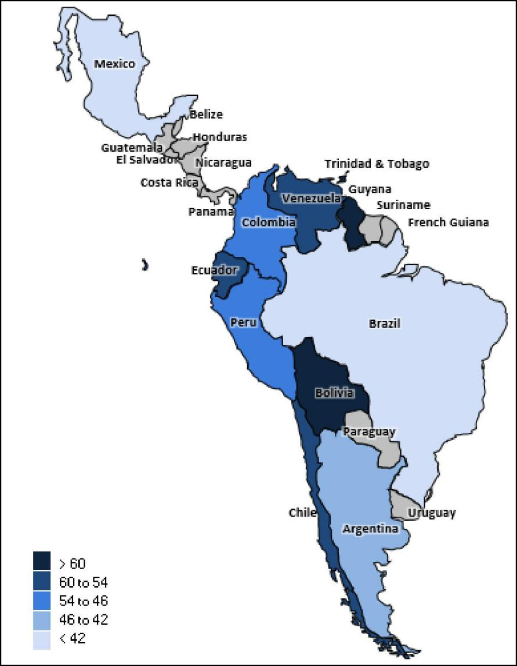

*Note: Scores out of 100; lower score = more attractive market. Source: BMI Downstream Oil & Gas Risk/Reward Index*

**Argentina Oil & Gas Report | Q3 2025**

a Fitchsolutions company

**Main Regional Features & Latest Updates**

• Latin America's downstream sector continues to be an underperformer in our global Downstream Risk/Reward Index (RRI). The regional score is now 53.6, slightly above the global average of 50.0.

• Latin America continues to underperform in various categories. The regional average for Industry Rewards is 52.4, which remains the best performance across all categories. The relatively high level of theoretical net crude oil exports, significant refining

capacity base, and relatively bullish outlook on domestic fuel demand support the performance of the Industry Rewards.

• The region scores 53.7 in Country Rewards, where State Asset Ownership continues to impact attractiveness negatively. Reliance on fuel subsidies, coupled with heightened logistical risk, affects the Industry Risk score, which is now 60.9, marking the region as relatively unattractive for downstream producers. Latin America scores highest in Industry Risks.

• The region also underperforms in terms of Country Risk scores. Despite modest performance in long- and short-term economic outlooks, elevated political and operational risks weigh on the score in this category. Relatively attractive markets like Brazil

(regional rank 1, global rank 7) and Mexico (regional rank 2, global rank 23) help balance out smaller, less attractive markets like Guyana (regional rank 11, global rank 91) and Trinidad and Tobago (regional rank 10, global rank 89), which are at the bottom of the list for this category.

**Investments In Brazil And Mexico Add To Rewards, Other Markets Fall Behind**

Brazil and Mexico remain the largest and most attractive downstream markets in the region, according to our Downstream Risk/ Reward Index. Brazil's efforts to revitalise its downstream sector have been gradually yielding results, with refined production

reaching 2.16mn b/d in 2024—a 22% increase from 2018-2019 levels. Brazil is expected to sustain growth in fuel output over the medium term, with strategic investments from Petrobras and smaller investors, supported by a 91% utilisation rate forecast for

2025. Petrobras's refining capacity expansion plans, including the RNEST expansion, aim to increase capacity to 2.1mn b/d by 2029, despite reduced capital expenditure allocations in the latest strategic update.

Brazil benefits from running larger and complex plants, competing in domestic markets while enjoying access to crude supplies.

Despite a shift in strategy under Lula's administration away from market liberalisation, Petrobras continues to drive downstream investments, including potential repurchases of previously sold assets like the Mataripe refinery, posing upside risks to capacity growth.

In Mexico, refined products production is poised for growth, driven by the ramp-up of operations at the Olmeca refinery and

investments in existing facilities. The country's refined products production is expected to grow strongly, with a forecasted 4.0% y-o- y increase in 2025. The Olmeca refinery's gradual capacity ramp-up and upgrades to older facilities are projected to raise the

utilisation rate to 54% in 2025. However, Pemex faces challenges with ageing infrastructure and low utilisation rates, impacting

overall production. Despite these challenges, Mexico remains committed to increasing the share of higher-quality fuels in its output, supported by refinery upgrades and new capacity additions.

Argentina, Colombia, and Peru occupy a central position on the list due to their well-established downstream markets, despite the absence of new planned investments. Argentina benefits from high utilization rates and relatively modern infrastructure, whereas Peru stands out for its appealing fuel demand growth. However, all Latin American countries lag in the Regional Fuel Demand

category.

**Argentina Oil & Gas Report | Q3 2025**

a Fitchsolutions company

Brazil And Mexico Most Attractive

Brazil And Mexico - Scores For Industry Rewards Subcomponents

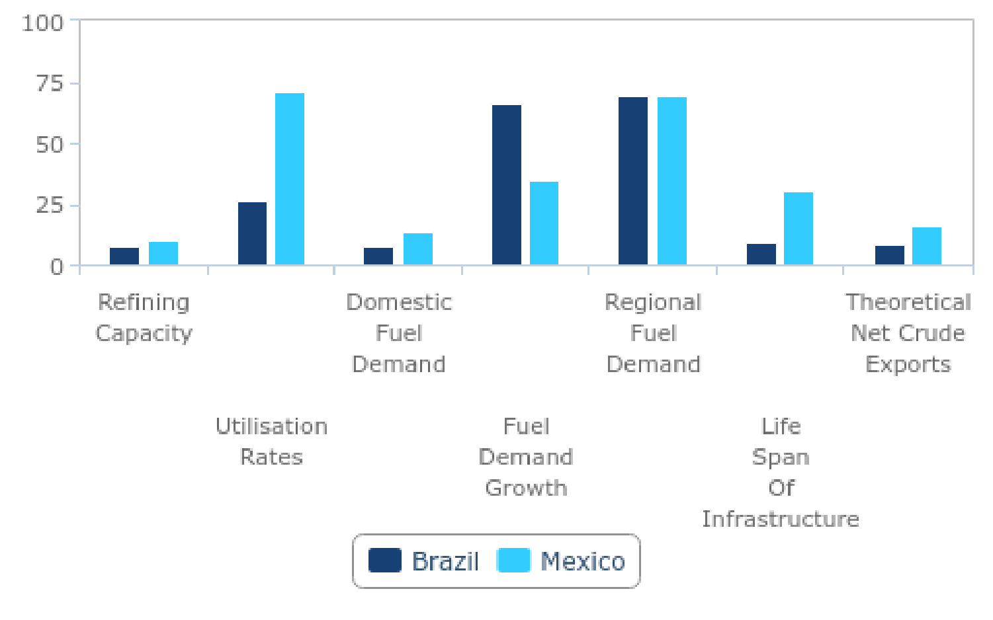

*Note: Scores out of 100; lower score = more attractive market. Source: BMI*

**Large Population Base Enhances Appeal, but State Dominance Hampers Performance**

Latin America, notably Brazil, Mexico, Colombia, Argentina, and Peru, enjoys the advantage of a significant population base, though population growth in the region is anticipated to be modest. Additionally, the region shows relatively poor performance in the

Country Rewards category, largely due to the prevalence of state-owned assets. With liberalisation efforts in Brazil potentially stalling or reversing, the medium-term outlook remains unfavorable, as private downstream producers are likely to face ongoing limitations in the largest markets.

Large population And Demand Growth Support BrazilIs High Rank

Latin America - Downstream Country & Industry Risks/Rewards

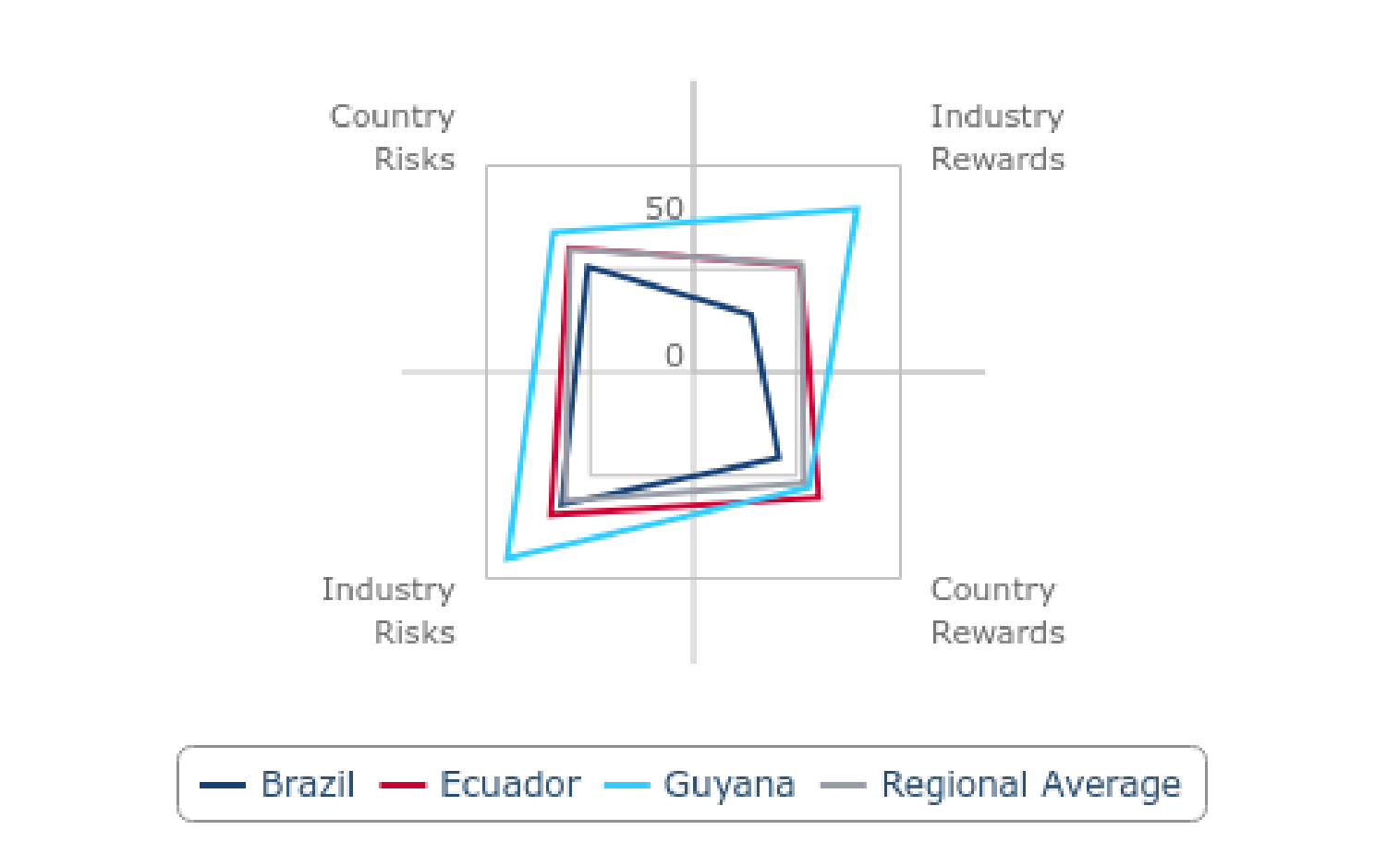

*Note: Scores out of 100; lowest score = more attractive market. Source: BMI*

**Argentina Oil & Gas Report | Q3 2025**

a Fitchsolutions company

**Downstream Liberalization Processes To See Continued Constraints**

We maintain a cautious outlook for the liberalization of downstream markets in the region's largest fuel consumers. In Brazil, while the previous administration under former president Jair Bolsonaro advanced the liberalisation of the downstream sector through Petrobras' refinery divestment plan, progress has largely stalled under President Luiz Inácio Lula da Silva. Since early 2023, the

Petrobras divestment program has effectively been frozen, with Lula's administration revising the strategy to ensure Petrobras retains ownership of most downstream assets.

Petrobras has introduced a new strategic plan for 2024–2030 focused on financial strengthening, increased productivity, and

sustainability, including the merger of subsidiaries to achieve efficiency gains. The plan aims to boost gasoline, diesel, and jet fuel production by 343,000 barrels per day and increase natural gas output. Despite these ambitions, we remain cautious due to

Petrobras' historically weak track record in executing large downstream projects, which have been marked by delays and cost overruns. Furthermore, a decree issued in August 2024 granting ANP powers to limit gas reinjection rates is likely to lead to increased government intervention across the energy sector, elevating regulatory risks.

In Mexico, President Andrés Manuel López Obrador's interventionist policies in the fuel distribution market remain significant. His 2021 regulatory overhaul, aimed at curbing private participation by tightening permit rules and storage obligations, has enabled state-owned Pemex to regain market share. Under the incoming administration of Claudia Sheinbaum, who won the June 2024 presidential elections, major policy shifts are not anticipated. Early indications suggest Sheinbaum intends to continue López

Obrador's nationalist energy agenda, emphasizing Pemex's central role.

Pemex's latest strategy for 2024–2030 outlines a further push toward fuel self-sufficiency, supported by the operational ramp-up of the Dos Bocas refinery and the integration of the Deer Park refinery in Texas. Plans to expand refinery capacity, install new coking

plants, and enhance fuel output underline the government's intent to reduce dependency on imports. Nonetheless, private sector involvement in Mexico's downstream segment will remain heavily constrained, and broader liberalisation prospects are unlikely to improve over the forecast period.

LatinAmerica Underperfoms In Both RisksAnd Rewards

Selected Latin America Markets - Downstream Risks/Rewards Scores

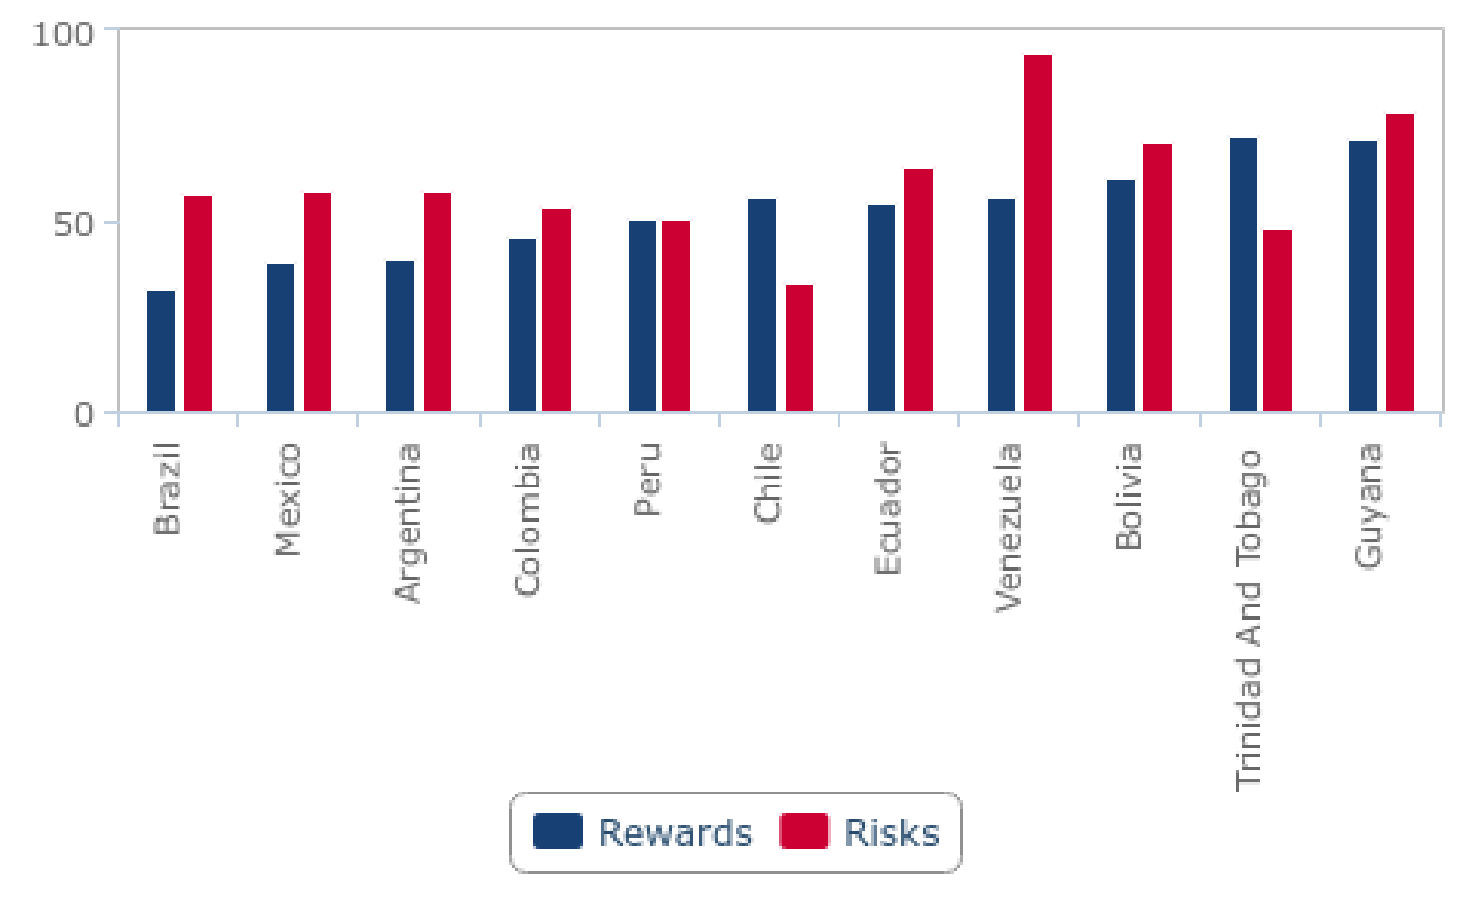

*Note: Scores out of 100; lowest score = more attractive market. Source: BMI*

**Argentina Oil & Gas Report | Q3 2025**

a Fitchsolutions company

**Logistics Risk And Fuel Subsidies Weigh On Sentiment**

Latin America faces significant logistics challenges, with frequent attacks on oil and gas midstream infrastructure and widespread oil siphoning. Media reports indicate a substantial increase in attacks on pipeline infrastructure in countries such as Colombia and Peru. In Venezuela, fuel distribution heavily depends on illegal transactions. These issues negatively impact investor sentiment and

increase the risks associated with operating in the downstream sector. Furthermore, Latin American countries continue to offer fuel subsidies, with the financial burden likely falling on producers.

Latin America Downstream Risk/Reward Index

|  |  |  |  |  |  |  |  |  |  |
| --- | --- | --- | --- | --- | --- | --- | --- | --- | --- |
|  | **Industry**  **Rewards** | **Country**  **Rewards** | **Rewards** | **Industry**  **Risks** | **Country**  **Risks** | **Risks** | **RRI** | **Regional**  **Rank** | **Global**  **Rank** |
| Brazil | 27.9 | 41.4 | 32.0 | 64.0 | 51.3 | 57.6 | 34.5 | 1 | 7 |
| Mexico | 35.1 | 50.7 | 39.8 | 64.6 | 52.3 | 58.4 | 41.6 | 2 | 23 |
| Argentina | 37.4 | 46.7 | 40.2 | 59.9 | 55.9 | 57.9 | 41.9 | 3 | 25 |
| Colombia | 41.0 | 56.6 | 45.7 | 49.7 | 58.2 | 53.9 | 46.5 | 4 | 38 |
| Peru | 54.9 | 40.3 | 50.5 | 51.4 | 50.4 | 50.9 | 50.5 | 5 | 48 |
| Chile | 60.3 | 46.9 | 56.3 | 34.3 | 32.8 | 33.6 | 54.0 | 6 | 52 |
| Ecuador | 51.9 | 60.6 | 54.5 | 69.0 | 60.3 | 64.6 | 55.5 | 7 | 61 |
| Venezuela | 56.0 | 56.8 | 56.2 | 92.9 | 96.5 | 94.7 | 60.1 | 8 | 73 |
| Bolivia | 63.3 | 57.0 | 61.4 | 56.9 | 85.0 | 70.9 | 62.3 | 9 | 82 |
| Trinidad And Tobago | 69.9 | 77.8 | 72.3 | 50.3 | 46.2 | 48.2 | 69.9 | 10 | 89 |
| Guyana | 79.1 | 55.7 | 72.1 | 90.1 | 67.8 | 78.9 | 72.8 | 11 | 91 |
|  |  |  |  |  |  |  |  |  |  |
| Global average | 50.0 | 50.0 | 50.0 | 50.0 | 50.0 | 50.0 | 50.0 | ~ | ~ |
| Regional  average | 52.4 | 53.7 | 52.8 | 62.1 | 59.7 | 60.9 | 53.6 | ~ | ~ |

*Note: Scores out of 100; lower score = more attractive market. Source: BMI Downstream Oil & Gas Risk/Reward Index*

**Argentina Oil & Gas Report | Q3 2025**

a Fitchsolutions company

Latin America Downstream Industry Rewards Index

|  |  |  |  |  |  |  |  |  |
| --- | --- | --- | --- | --- | --- | --- | --- | --- |
|  | **Refining**  **Capacity** | **Utilisation**  **Rates** | **Domestic**  **Fuel**  **Demand** | **Fuel**  **Demand**  **Growth** | **Regional**  **Fuel**  **Demand** | **Life Span Of**  **Infrastructure** | **Theoretical**  **Net Crude**  **Exports** | **Industry**  **Rewards** |
| Brazil | 7.7 | 26.4 | 7.7 | 66.5 | 69.2 | 9.3 | 8.8 | 27.9 |
| Mexico | 9.9 | 71.4 | 13.2 | 35.2 | 69.2 | 30.2 | 16.5 | 35.1 |
| Argentina | 35.2 | 3.3 | 31.9 | 58.2 | 69.2 | 38.5 | 25.3 | 37.4 |
| Colombia | 41.8 | 22.0 | 41.8 | 38.5 | 69.2 | 49.5 | 24.2 | 41.0 |
| Peru | 50.5 | 49.5 | 45.1 | 26.9 | 69.2 | 79.1 | 63.7 | 54.9 |
| Chile | 57.1 | 61.5 | 40.7 | 82.4 | 69.2 | 38.5 | 72.5 | 60.3 |
| Ecuador | 62.6 | 56.0 | 47.3 | 31.9 | 69.2 | 73.1 | 23.1 | 51.9 |
| Venezuela | 20.9 | 82.4 | 49.5 | 51.6 | 69.2 | 98.4 | 19.8 | 56.0 |
| Bolivia | 73.6 | 69.2 | 76.9 | 62.6 | 69.2 | 49.5 | 41.8 | 63.3 |
| Trinidad And Tobago | 94.5 | 92.9 | 91.2 | 56.0 | 69.2 | 49.5 | 36.3 | 69.9 |
| Guyana | 94.5 | 92.9 | 95.6 | 100.0 | 69.2 | 86.3 | 15.4 | 79.1 |
|  |  |  |  |  |  |  |  |  |
| Global average | 50.0 | 50.0 | 50.0 | 50.0 | 50.0 | 50.0 | 50.0 | 50.0 |
| Regional  average | 49.9 | 57.0 | 49.2 | 55.4 | 69.2 | 54.7 | 31.6 | 52.4 |

*Note: Scores out of 100; lower score = more attractive market. Source: BMI Downstream Oil & Gas Risk/Reward Index*

Latin America Downstream Country Rewards Index

|  |  |  |  |  |  |
| --- | --- | --- | --- | --- | --- |
|  | **State Asset**  **Ownership** | **Population** | **Population**  **Growth** | **Country**  **Rewards** | **Rewards** |
| Brazil | 49.5 | 6.6 | 68.1 | 41.4 | 32.0 |
| Mexico | 86.3 | 9.9 | 56.0 | 50.7 | 39.8 |
| Argentina | 43.4 | 35.2 | 61.5 | 46.7 | 40.2 |
| Colombia | 78.6 | 28.6 | 62.6 | 56.6 | 45.7 |
| Peru | 30.8 | 47.3 | 42.9 | 40.3 | 50.5 |
| Chile | 8.8 | 56.0 | 75.8 | 46.9 | 56.3 |
| Ecuador | 83.0 | 59.3 | 39.6 | 60.6 | 54.5 |
| Venezuela | 93.4 | 50.5 | 26.4 | 56.8 | 56.2 |
| Bolivia | 78.6 | 62.6 | 29.7 | 57.0 | 61.4 |
| Trinidad And Tobago | 59.9 | 95.6 | 78.0 | 77.8 | 72.3 |
| Guyana | 8.8 | 98.9 | 59.3 | 55.7 | 72.1 |
|  |  |  |  |  |  |
| Global Average | 50.0 | 50.0 | 50.0 | 50.0 | 50.0 |
| Regional Average | 56.4 | 50.0 | 54.5 | 53.7 | 52.8 |

*Note: Scores out of 100; lower score = more attractive market. Source: BMI Downstream Oil & Gas Risk/Reward Index*

**Argentina Oil & Gas Report | Q3 2025**

a Fitchsolutions company

Latin America Downstream Industry Risks Index

|  |  |  |  |
| --- | --- | --- | --- |
|  | **Logistics Risk** | **Fuel Subsidies** | **Industry Risks** |
| Brazil | 50.5 | 77.5 | 64.0 |
| Mexico | 42.9 | 86.3 | 64.6 |
| Argentina | 58.2 | 61.5 | 59.9 |
| Colombia | 48.4 | 51.1 | 49.7 |
| Peru | 64.8 | 37.9 | 51.4 |
| Chile | 30.8 | 37.9 | 34.3 |
| Ecuador | 51.6 | 86.3 | 69.0 |
| Venezuela | 86.8 | 98.9 | 92.9 |
| Bolivia | 75.8 | 37.9 | 56.9 |
| Trinidad And Tobago | 62.6 | 37.9 | 50.3 |
| Guyana | 87.9 | 92.3 | 90.1 |
|  |  |  |  |
| Global average | 50.0 | 50.0 | 50.0 |
| Regional average | 60.0 | 64.1 | 62.1 |

*Note: Scores out of 100; lower score = more attractive market. Source: BMI Downstream Oil & Gas Risk/Reward Index*

Latin America Downstream Industry Risks Index

|  |  |  |  |  |  |  |
| --- | --- | --- | --- | --- | --- | --- |
|  | **Long-Term Economic Risk Index** | **Short-Term Economic Risk Index** | **Political Risk**  **Index** | **Operational Risk Index** | **Country**  **Risks** | **Risks** |
| Brazil | 37.4 | 54.9 | 56.0 | 51.6 | 51.3 | 57.6 |
| Mexico | 38.5 | 35.7 | 67.0 | 52.7 | 52.3 | 58.4 |
| Argentina | 73.6 | 76.9 | 37.4 | 54.9 | 55.9 | 57.9 |
| Colombia | 53.3 | 58.2 | 64.8 | 53.8 | 58.2 | 53.9 |
| Peru | 42.9 | 24.2 | 60.4 | 57.1 | 50.4 | 50.9 |
| Chile | 44.0 | 45.1 | 23.1 | 30.8 | 32.8 | 33.6 |
| Ecuador | 50.5 | 47.3 | 70.3 | 61.5 | 60.3 | 64.6 |
| Venezuela | 96.7 | 95.6 | 100.0 | 93.4 | 96.5 | 94.7 |
| Bolivia | 81.3 | 96.7 | 90.1 | 75.8 | 85.0 | 70.9 |
| Trinidad And Tobago | 49.5 | 42.9 | 36.3 | 56.0 | 46.2 | 48.2 |
| Guyana | 62.6 | 56.0 | 63.7 | 80.2 | 67.8 | 78.9 |
|  |  |  |  |  |  |  |
| Global average | 50.0 | 50.0 | 50.0 | 50.0 | 50.0 | 50.0 |
| Regional average | 57.3 | 57.6 | 60.8 | 60.7 | 59.7 | 60.9 |

*Note: Scores out of 100; lower score = more attractive market. Source: BMI Downstream Oil & Gas Risk/Reward Index*

***Please Note:*** *Our Risk/Reward Indices are updated frequently; as a result, scores in this section may not match scores in the rest of the report.*

**Argentina Oil & Gas Report | Q3 2025**

a Fitchsolutions company

Argentina Upstream Oil & Gas Risk/Reward Index

***Key View:*** *Argentina is a strong performer in our Upstream Risk/Reward Index, ranking second regionally in the Latin America*

*region, and ninth globally. Its scores are notably boosted by strong Rewards scores, with a large hydrocarbon supply base,*

*particularly in terms of unconventional resources and a favourable production outlook over the medium term. Risks scores are*

*weaker than Rewards, but remain stronger than the regional averages. A history of state intervention, elevated regulatory*

*uncertainty and a struggling national economy continue to dampen its Risks scores, but the situation is beginning to improve, given an expected return to economic growth, and the generally favourable policies being putin place for the Oil & Gas sector by new*

*President Javier Milei.*

Argentina Outperforms On Most Indicators

Argentina & LatAm - Upstream Risk/Reward Index By Component

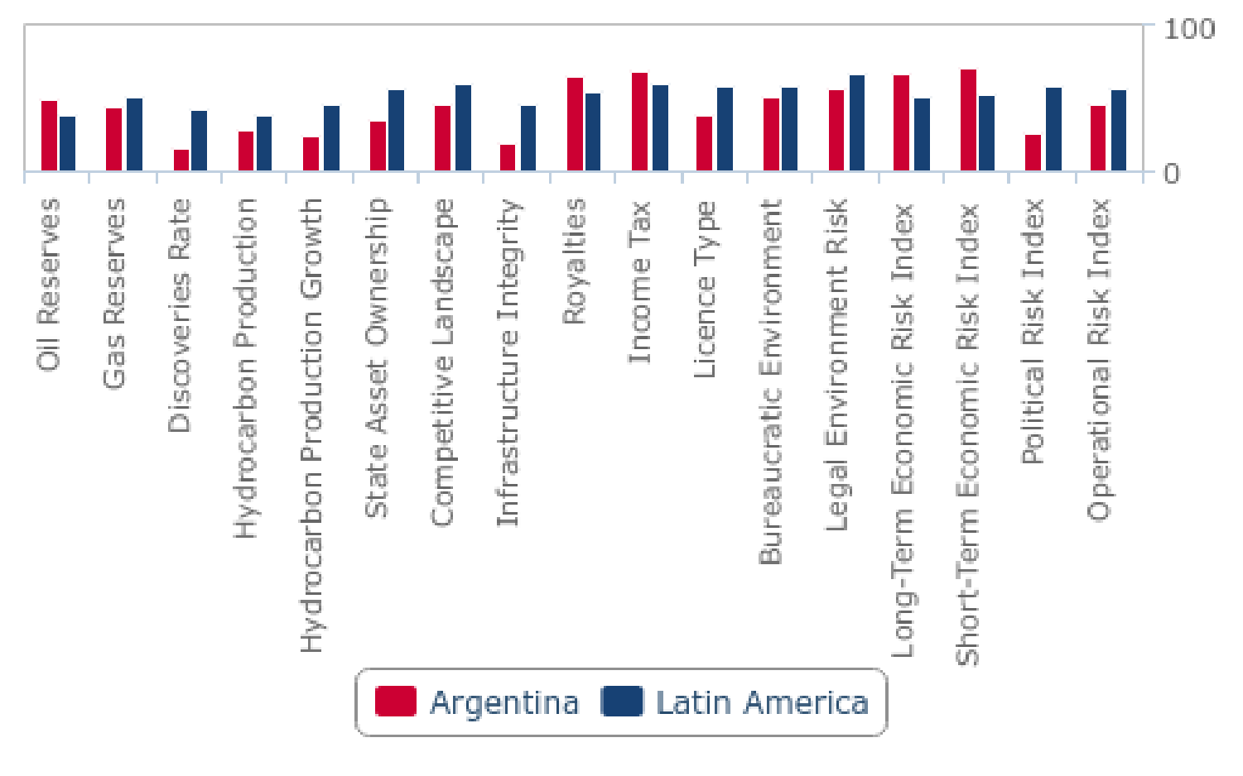

*Note: Scores out of 100, lower score = more attractive market. Source: BMI Oil & Gas Upstream Risk/Rewards Index*

**Global And Regional Rankings**

• Regional rank (out of 10): 2nd

• Global rank (out of 72): 9th

**Key Features And Latest Updates**

• Argentina has maintained its performance in our Upstream Risk/Reward Index this quarter. In the region, Argentina remains in second position, following Brazil. Argentina's current score lingers at 35.4, which compares favorably to the regional average of 49.3. This indicates a favourable rewards and risk balance for oil and gas investments in Argentina.

• Argentina's upstream strength is derived from its larger domestic supply base having risen to the largest producer of natural gas in the region from 2016. Its favourable production outlook is driven by unconventional reserves, a high discovery rate and the production growth outlook of hydrocarbons, notably from unconventional production growth.

• The country performs well across the Country Rewards components of our upstream index, thanks to the rising influence of private IOCs. This metric has improved substantially over the last several quarters as private investment rises and critical

infrastructure projects are sanctioned.

**Argentina Oil & Gas Report | Q3 2025**

a Fitchsolutions company

• Argentina's score and rank on the risks side have also risen in recent years following a series of reforms directed toward the

sector. However, elevated royalties and taxes continue to weigh on development prospects and Industry Risks score. In addition, we note that continued elevated Short-Term and Long-Term Economic Risks and Political Risks. The start of an improving

economic outlook from 2025/2026 onwards could however begin to improve its score in the coming quarters.

• We expect Argentina to remain at the top of our regional and global rankings as private investment inflows grow. However, growing short-term economic risks could threaten its standing over the next several quarters.

Argentina Strongest On Industry Rewards

Argentina & LatAm - Upstream Country & Industry Risk/Reward Index

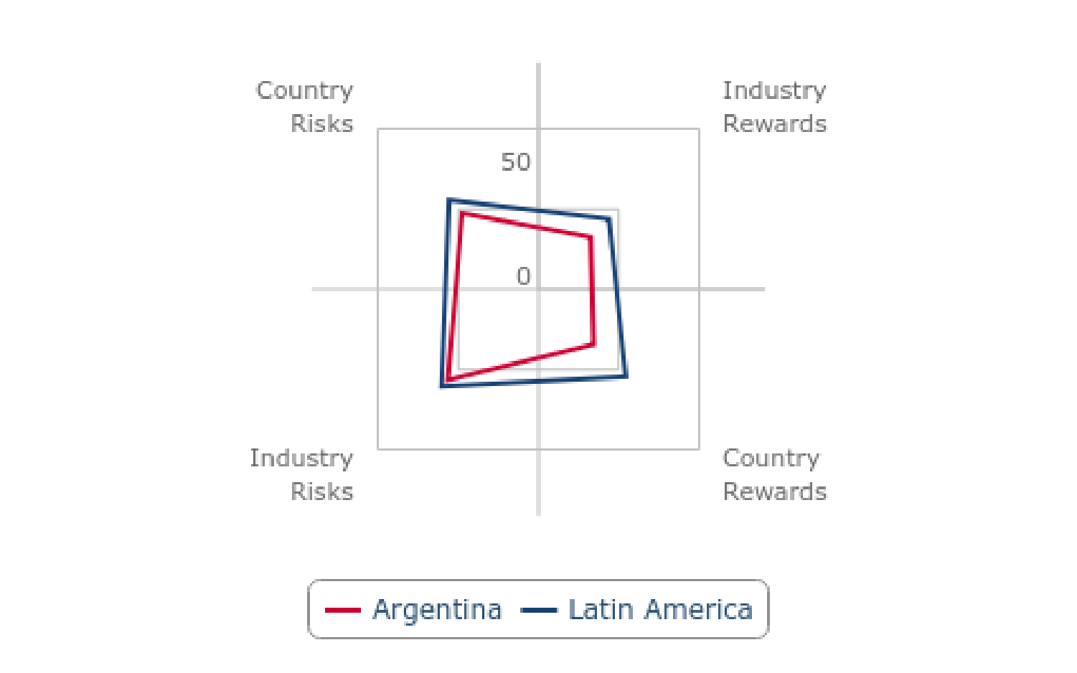

*Note: Scores out of 100, lower score = more attractive market. Source: BMI Oil & Gas Upstream Risk/Rewards Index*

**Argentina Oil & Gas Report | Q3 2025**

a Fitchsolutions company

Argentina Downstream Oil & Gas Risk/Reward Index

***Key View:*** *Argentina continues to be a leading market in our Downstream Risk/Reward Index, maintaining a high position in the regional rankings this quarter, in third position. On the Rewards side, Argentina benefits from a large domestic market, well-*

*developed refining capacity, and strong utilisation rates. However, its scores remain affected by a weak economic outlook that impacts fuel demand and growth, though improvements are expected in 2025 and 2026. On the Risks side, Argentina's profile is weaker due to significant short-term economic and political risks that could affect consumption.*

Strong Downstream Infrastructure Network

Argentina & LatAm - Downstream Risk/Reward Index By Component

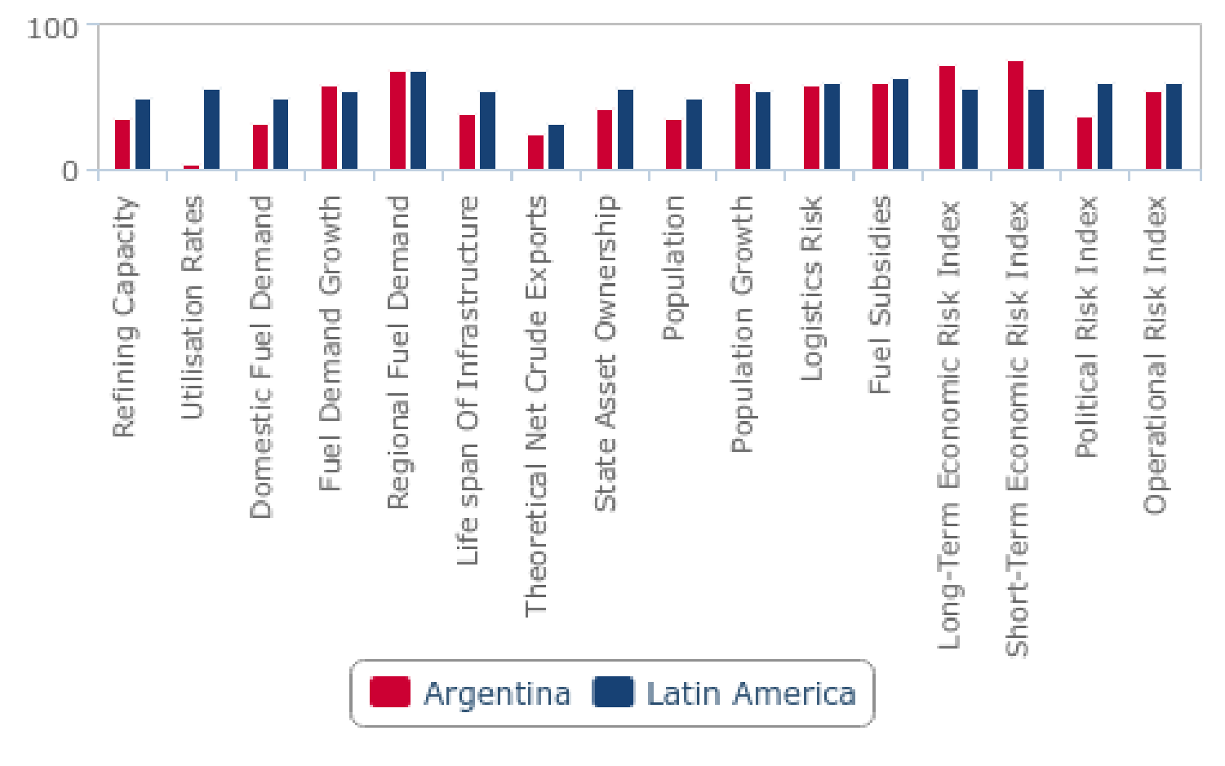

*Note: Scores out of 100, lower score = more attractive market. Source: BMI Downstream Risk/Reward Index*

**Global And Regional Rankings**

• Regional rank (out of 10): 3rd

• Global rank (out of 92): 25th

**Latest UpdatesAnd Key Features**

• Argentina maintains a positive overall performance in our global Downstream Risk/Reward Index (RRI). Scores are strongest on the Rewards side ofthe RRI, with Risks scores close to regional averages. This quarter, Argentina ranks third in the regional RRI, stable from last quarter.

• Argentina's Industry Rewards score notably keeps the country ahead of the regional average. This score is supported with healthy domestic refining capacity and a high utilisation rate, which helps to offset poor fuels demand and demand growth. Argentina scores 37.4, significantly stronger than the regional average of 52.4 in the Industry Rewards category.

• A Country Rewards score keeps Argentina among the top performers in the region for this indicator, supported by a diversified competitive landscape and a large domestic market. Weaker long-term demographics slightly weaken the country's score for this indicator however. Argentina scores 46.7, stronger than regional average of 53.7 in the Country Rewards category.

• Industry Risks are mediocre as the country has a history of interventionism with fuel subsidies. Though not as significant as

several of its regional peers, there are also logistical risks which hinder the development of the market. Argentina scores 59.9 in

**Argentina Oil & Gas Report | Q3 2025**

a Fitchsolutions company

this category, close to the regional average of 62.1.

• Argentina's Country Risks scores are slightly stronger than the regional average, which is an improvement this quarter on

previous quarters. This has and will continue to improve thanks to the arrival of new President Javier Millei, but we caution that a failure to enact reforms could threaten Argentina's ranking within the region. Argentina scores 55.9 in this category (stronger than the regional average of 59.7), but still hampered by its still mediocre short-term and long-term economic risks indices.

Country Risks Remain The Weak Link

Argentina & LatAm - Downstream Country & Industry Risk/Reward Index

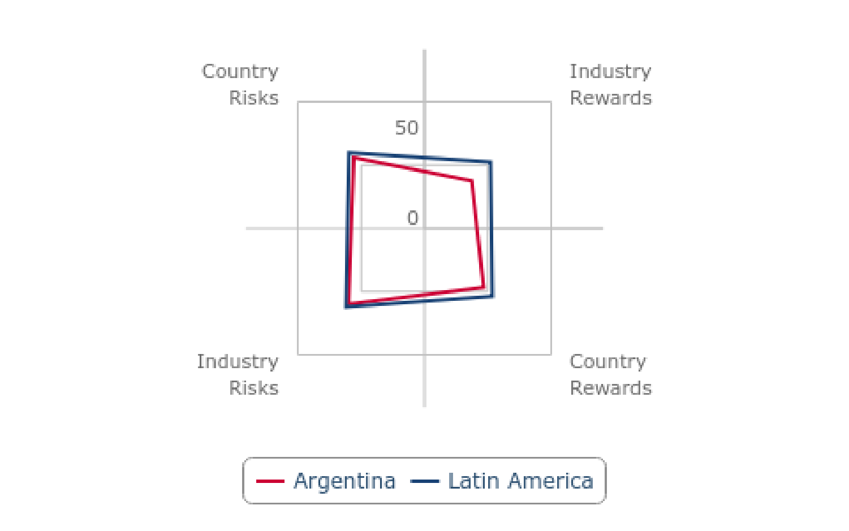

*Note: Scores out of 100, lower score = more attractive market. Source: BMI Downstream Risk/Reward Index*

**Argentina Oil & Gas Report | Q3 2025**

a Fitchsolutions company

Market Overview

Oil & Gas Market Overview

After a challenging period following high levels of state intervention and a wide economic downturn which eroded foreign

investment in Argentina, the oil and gas sector saw an uptick in foreign direct investment in 2018, including a small but growing cadre of international and NOCs seeking to gain early-mover advantage to tap potentially game-changing shale resources in the Vaca Muerta formation. The market experienced some investment over 2019-2024, although lingering macroeconomic risks

weighted on the sentiment. The election of Javier Milei in late 2023 boosts upside risks for upstream market due to his market liberalisation stance; however, we highlight lingering regulatory risks.

**Overview/State Role**

Argentina's oil sector had been completely privatised until the October 2004 with the creation of new state entity, Enersa. The largest upstream and downstream operator is YPF, which was re-nationalised from Repsol in 2012. Five companies, namely YPF, PAE, Chevron, Pluspetrol and Sinopec account for nearly three quarters ofthe market's oil production. The market's gas sector is slightly more diverse, with YPF, PAE and TotalEnergies accounting for approximately two thirds of output.

Since 2012, Chevron, ExxonMobil, Shell, Total and Petrobras have been active in the Vaca Muerta play. Chevron is now the fourth- largest producer of oil in the market, with concessions in the Neuquén Basin. ExxonMobil holds interests in approximately 900,000 net acres in the same basin. Furthermore, YPF signed a series of memorandums with major international and regional oil

companies, including Sinopec, Pemex and Petrobras.

Transportadora de Gas del Sur is the market's largest pipeline company, delivering two thirds of total gas consumption, and is largely owned by Pampa Energia. Transportadora de Gas del Norte, operating in the north and centre of the market, is the other key gas

supplier. Its shareholders include Techint, Compania General de Combustibles (CGC), TotalEnergies and Petronas of Malaysia.

**Government Policy**

Oil & gas licencing works on a concessionaire regime as royalty and tax. Depending on the location of the license area, resource are owned by the province or the federal government, with the federal government holding jurisdiction over offshore areas greater than 12 miles but within territorial waters. Rights to exploration and production are granted by the applicable province or federal

government through a bidding process as well as any enforcement by the governing authority.

The federal regulatory authority for oil and gas sector is Secretariat de Hidrocarburos. There are various laws regulating the oil and gas sector with the laws governing the oil and gas exploration and production as follows:

• **1967:** Law 17,319 creates the legal framework for the oil & gas industry

• **2007:** Law 26,197 transfers H/C ownership to provinces for onshore & offshore (12miles)

• **2014:** Law 27,007 establishes frame work mainly for Unconventionals

In October 2014, Argentina's government passed a bill amending the market's hydrocarbons law. The amendments hoped to

improve fiscal and regulatory stability and increase investment inflows into Argentina's emergent shale sector. The key changes are described here.

**Argentina Oil & Gas Report | Q3 2025**

a Fitchsolutions company

**Licencing Terms**

The federal and provincial states grant exploration permits and production concessions. The exploration permits are usually granted to a company that offers the most amount of investment in the area through a public tender (a bidding round).

Legal Framework for Exploration Permits and Exploitation Concessions for Federal Licensing:

The terms of the exploration permits will be set in each tender, according to the time limits regulated by the hydrocarbons law.

**Exploration Permits**

• Conventional exploration – two three-year periods with an extension up to five years (3+3+5)

• Unconventional and offshore exploration – two four-year periods, with an extension up to five years (4+4+5). Except for shallow waters (Austral Basin) where 4+3+4.

**Production Concession (extensions apply)**

• 25 years for conventional concession,

• 35 years for non-conventional concession,

• 30 years for offshore concession.

Fiscal regime consists of federal and provincial taxes. Selected rates:

**Royalty Regime:** 5-12%

**Corporate Income Tax:** 25-30%

Environmental regulations set by Federal Government and specific legislation set by provinces.

There are specific regulations, encouraging investments in the non-conventional reservoirs in the Neuquén basin or offshore (Resolution No. 46-E/2017 and Resolution No. 65/2018).

On a fundamental basis, we see the risks in Argentina as very different to risks in highly frontier markets with harsh operating

environments. While frontier markets face significant challenges with respect to security and a lack of infrastructure, the relationship that foreign players often have with the governments in these markets has been qualitatively different to the relationship in

Argentina. In highly frontier and risky markets, foreign companies can have significant leverage over the government and are, broadly speaking, able to negotiate from a stronger position.

In Argentina, this relationship has traditionally been inverted, with the foreign companies invited to the negotiating table attending with a significant disadvantage and government policies largely designed to favour local players over foreign ones. Those specific policies had included limits on profit repatriation and strict local content requirements.

In October 2014, Argentina's government passed a bill amending the market's hydrocarbons law. The amendments hoped to improve fiscal and regulatory stability and increase investment inflows into Argentina's emergent shale sector.

**Argentina Oil & Gas Report | Q3 2025**

a Fitchsolutions company

2014Amended Hydrocarbons Law

|  |  |
| --- | --- |
| **Key Terms** | **Content** |
| Extended production licences | Unconventional and offshore production licences will be extended by 10 years, to 35 years and 30 years respectively. Companies can also apply for 10-year extensions, if they meet their investment  commitments. Royalty rates will increase by 3.0% with every extension, to a maximum of 18%. |
| Amended exploration licences | Exploration licences will be standardised, across all provinces. Work commitments and terms for licence renewal will also be tailored to reflect the type of exploration (conventional, unconventional or offshore). |
| Fiscal uniformity | Royalty rates will be capped at a fixed level, across all provinces. Industry taxation will also be unified. |
| Federal licencing | Licences will be awarded via a competitive bidding process, at the federal and not provincial level. |
| Tax incentives | Companies will be allowed to export up to 20% of oil to international markets duty free; they will also be  allowed to hold a part of the export revenue outside Argentina. Restrictions on the import of capital goods for use in exploration and production will be eased. The minimum investment requirement to qualify for these benefits will also be reduced from USD1bn to USD250mn, over a five-year period. |

*Source: Bloomberg, Reuters, BMI*

With the market having endured a tenuous macroeconomic position, further efforts to lure investment back into the country have been led by economic reforms pushed through by former President Mauricio Macri. These include the removal of capital

controls, as well as a USD5bn settlement with Repsol agreed upon in 2015.

Macri also reached a deal with the market's labour unions, chipping away at a long-held source of concern within the industry.

Argentina has some of the highest labour costs and strongest unions within Latin America, stymieing efforts to reduce upstream

costs. In January 2017, the administration reached an agreement with workers in the Vaca Muerta to reduce their benefits and allow for more flexible contracts. The province of Neuquén, where the Vaca Muerta is located, also agreed not to raise taxes and to build additional transport infrastructure, improving the attractiveness for participating IOCs.

In light of plummeting energy prices in 2022, former President Alberto Fernández outlined Plan Gas 4 (also called The Plan for the Promotion of Argentine Gas Production 2020-2023) during his visit to one of Argentina's largest shale fields, Loma Campana. The

key objective of the plan is to spur investment and boost the production of natural gas in order to satisfy domestic demand and

substitute imports with indigenous production, boost employment, and foster development in producing regions. Under the Plan

Gas 4 framework, natural gas producers will have the option to offer their output to the market under a tender scheme at a

guaranteed price up to USD3.70/mnBtu, substantially above the current estimated prices to producers, which averaged at

USD2.50/mnBtu in August 2020, after reaching a nadir of USD1.96/mnBtu in April 2020. The subsidy to producers, covered by the government, is expected to stimulate investment in the upstream natural gas market reaching USD5bn. The tender scheme is

expected to encompass 70mcm/d (approx. 2.17bcm/month), which equals over 55% of total natural gas production in Argentina as of August 2020. The fiscal cost for the government is estimated at USD5.1bn, with the fiscal saving estimated at USD2.6bn over

2021-2024. The producers who participate in the tender will be expected to maintain or increase production from the May-June

2020 baseline. In September 2022, the government released an extension of this incentives program - Plan Gas 5, which would last until 2028.

**Argentina Oil & Gas Report | Q3 2025**

a Fitchsolutions company

**Licencing Rounds**

In 2007, the third licensing round launched by Rio Negro province attracted bids from eight companies seeking to explore in the

Neuquén basin. Offers for the Angostura block came in from US unit Apache Energía Argentina, regional players CGC, Usinas y

Terminales Eléctricas, and Estrella Servicios Petroleros and Petrolifera Petroleum. The Tres Nidos Sur block attracted bids from Roch and Antrim Energy. Geodyne Energy, another Canadian independent, submitted bids for the Blanco de los Olivos and Catriel Viejo Sur blocks. Petrolifera Petroleum also made an offer for the Puesto Guevara block. The round followed the signing of E&P contracts for four blocks in Neuquén Basin offered as part of Rio Negro's second licensing round. According to the province's Deputy

Governor, Mario De Rege, the first two rounds should result in investment of up to USD200mn.

G&P conducted its first two bidding rounds in 2009, awarding 18 exploration licences for low-, medium- and high-risk blocks. The blocks were awarded to TotalEnergues, YPF and Petrobras and Argentina-based firms Energy Operations, Raiser and Rovella

Carranza. G&P'S CEO Ruben Etcheverry said that he expects the companies to invest about USD60.9mn over four years and drill 13 wells at the blocks. G&P will take a 15% stake in each of the blocks.

Argentina delayed the launch of a licensing round in 2011 that would have put 32 offshore blocks up for grabs in the wake of the US debt rating downgrade, a source at Enarsa told Reuters on August 8 2011. A new international bidding round in the Neuquén province was due to occur in March 2014. The round was rescheduled for Q4 2018. In May 2018, the government called on

IOCs to submit proposals for 38 offshore exploration areas. Oil companies, including Shell and Equinor, said they were mulling

bidding in auctions which were tendered in October 2018. In April 2019, these companies, along with ExxonMobil, Total and Qatar Petroleum, were awarded offshore exploration blocks in the Malvinas basin, approximately 320km offshore Tierra del Fuego.

**Changes Under Milei Government**

Initial proposals from the government of Javier Milei, who took over office in late 2023 for the oil and gas sector point to broad

market deregulation, aligning with our expectations. Javier Milei has commenced his presidential tenure with sweeping reform bills, whose key objective is to deregulate the Argentine economy—a central notion Milei promoted during his campaign. His two key

policy proposals—the Decree of Urgency and Necessity (DNU), announced on December 20 2023, and the 'Law of Bases and

Starting Points for the Freedom of the Argentines' bill, also known as the 'omnibus' bill —include a number of articles that liberalise Argentina's oil and gas sector. Although we believe that the DNU and the 'omnibus' law will be partially enacted, it remains uncertain how exactly the regulatory environment will change in every aspect just yet.

We highlight some of the proposed measures that, in our view, will have the most impact on the hydrocarbons market. Under the new regulatory framework, the government:

• liberalises fuel prices. The government will not have the right to fix fuel prices at any stage of production, which effectively means coupling domestic crude oil and fuel prices with import/export parity, while deregulating exporting oil and refined products. This proposal is favoured by producers and aligns with Milei's stance favouring market-based pricing.

• outlines a plan to set up a greenhouse gas emissions trading scheme.

• provides a list of companies set for privatisation, including Argentina's largest oil and gas producer, YPF. Given the growing opposition to privatising the company in Congress, we do not expect this to occur in the near term.

• creates an incentive regime for large-scale investment, including oil and gas projects.

• announces changes to industry governance bodies, including a potential merger of gas and electricity regulators and a concentration of more powers in the executive branch.

**Argentina Oil & Gas Report | Q3 2025**

a Fitchsolutions company

Despite sweeping changes for the oil and gas industry included in the two proposed bills, we note elevated uncertainty over the final shape of the laws governing the industry.

**Argentina Oil & Gas Report | Q3 2025**

a Fitchsolutions company

Oil & Gas Infrastructure

**Oil Refineries**

Argentina has 10 refineries, giving the market a total capacity of about 657,000b/d. Aside from importing diesel, which the market does not have sufficient capacity to refine, government intervention in the market has led Argentina to import significant gasoline quantities as well. Capacity has remained relatively stable in the market since 1971 and despite proposals, we do not currently

expect any significant additions in the near future.

Refineries In Argentina

|  |  |  |  |  |
| --- | --- | --- | --- | --- |
| **Refinery** | **Capacity (b/d)** | **Owner** | **Completed** | **Details** |
| La Plata | 189,000 | YPF | 1925 | Upgrading underway |
| Doc Sud/Buenos Aires | 100,000 | Shell | na | na |
| Lujan de Cuyo | 105,000 | YPF | na | Upgrade started in 2009 |
| Campana | 87,000 | Axion Energy/CNOOC | na | Upgrading underway |
| San Lorenzo | 50,000 | Oil Combustibles | 1938 | na |
| Ricardo Elicabe | 30,000 | Petróleo Brasileiro | na | na |
| Plaza Huincul | 25,000 | YPF | na | na |
| Campo Duran | 32,000 | Refinor SA | 1992 | na |
| Others | 15,000 | DAPSA, Refineria de Neuquen | na | na |
| **Total Capacity** | **643,000** |  |  |  |
|  |  |  |  |  |
| **Planned Additional Capacity** |  |  |  |  |
| General Mosconi II | 150,000 | 30-company consortium | na | Proposed USD2.3bn diesel refinery |
| Lujan de Cuyo | na | YPF | 2012 | Secondary processing |
| Campana | 42,000 | Axion Energy | 2016, 2020 |  |
| La Plata | 11,000 | YPF | 2018 |  |

*na = not available. Source: YPF, BMI*

YPF is the major player in Argentina's refining, with more than 60% of total capacity. Buenos Aires is home to about 68% of

Argentina's refining capacity, and the broader Buenos Aires Province contains six of the market's 10 plants with a combined capacity of 430,000b/d.

**La Plata:** YPF's 189,000b/d La Plata refinery in Buenos Aires is the largest in Argentina, accounting for around 30% of the market's capacity. It produces fuel oil, diesel oil and gasoline, as well as lubricants, asphalt and paraffin. More than one third of the market's consumed fuel is produced at La Plata.

In April 2013, the La Plata refinery was taken offline for repairs as a result of a fire. While the refinery has come back online, it did not return to full capacity until H2 2015. We note that the refinery's outage increased the market's refined products import burden at a time when consumption continued to grow.

**Argentina Oil & Gas Report | Q3 2025**

a Fitchsolutions company

**Buenos Aires:** Shell's Buenos Aires refinery is located in the Doc Sud area of the city, giving it access to crude feedstock and

product transport routes via the local port. The refinery is almost exclusively a processor of Argentina's crudes, including those from Tierra del Fuego. Crude is stored at a dedicated 4.8mn bbl tank farm on site.

**Lujan de Cuyo:** Located in Mendoza Province in the foothills of the Andes, YPF's Lujan de Cuyo receives crude from local fields and from the east coast port of Bahia Blanca by pipeline. In October 2009, YPF announced that it would invest USD396mn over three

years to upgrade the refinery, with much of the investment to be directed towards raising the quality of the gasoline and diesel produced and improving energy use.

**General Mosconi II (Proposed):** In December 2006, the government announced that it had reached agreement with several

IOCs to build a new 150,000b/d refinery. According to press reports in January 2006, the government held talks with a number of

IOCs over construction of the USD2.3bn diesel fuel refinery. The project, provisionally called General Mosconi II (the first plant with such a name, Petroquimca General Mosconi set up in 1970, is a petrochemicals plant), would produce refined products for both the domestic and international market. There is, however, no indication at this point that the project will ever go ahead.

**Service Stations**

Four major players, led by YPF along with Axion, Shell and Trafigura, control the majority of the fuels distribution network, with a combined market share of over 67% and more than 3,000 retail stations. YPF operates over one third of the market.

**Oil Terminals/Ports**

Argentina has 15 oil terminals, around half of which are clustered around Buenos Aires and its riverine hinterland.

**Oil Pipelines**

Argentina has three main oil pipelines (Nueba I, Nueba II and San Martin), which together indirectly link the oil export terminal at La Plata on the east coast with the San Vincente oil terminal on Chile's west coast. Two of the pipelines are domestic and link the

market's major Neuquén Basin oil producing region with the refineries at Plaza Huincul and Lujan de Cuyo. To the east, both pipelines connect to the oil terminal and refinery at Bahía Blanca.

A single pipeline runs north from the terminal to the La Plata oil terminal near Buenos Aires, before doubling back to the Lomas de Zamora mini-refinery. The market's one international link is the 431km Transandino oil pipeline. The pipeline, which can transport 115,000b/d, links the Neuquén Basin with San Vincente.

Contrary to the natural gas market, where growth is somehow hindered by the lack of midstream infrastructure, the market's crude transportation network has recently been expanded, increasing the transportation capacity from Neuquén Basin. In May, a new

88km long oil pipeline started operation, connecting major fields in Añelo region to the existing oil transportation system operated by Oldelval. With this infrastructure addition, producers in Neuquén are able to transport oil to the exporting terminal in Puerto

Rosales, and three refineries in Luján de Cujo, La Plata and Plaza Huincul. The NOC intends to continue the expansion of the

midstream infrastructure by reverting some of the existing pipelines, increasing Oldelval pumping capacity and reactivating the

export route to the Pacific Ocean. If realised, these initiatives will further boost production, providing shale producers with additional room to grow.

**Argentina Oil & Gas Report | Q3 2025**

a Fitchsolutions company

Private producers have stepped into the midstream game with a consortium of Riverstone, Southern Cross and Vista Oil and Gas

establishing Aleph Midstream, a company which is dedicated to expanding the midstream infrastructure in Vaca Muerta. In

November, the government granted Vista a 35-year concession to transport crude between Neuquén and Rio Negro provinces. The company plans to build a 49km long pipeline with the capacity of 5,00cm/d, which can potentially further alleviate bottlenecks,

enabling the company to transport their production from Bajada de Palo Este and Oeste, Charco del Palenque and Entre Lomas.

We highlight other key oil pipeline projects that would raise exit capacity form Vaca Muerta by 500,000b/d until 2029:

• The Oldelval projects, which are set to increase capacity from 300,000b/d in Q1 2024 to 540,000b/d in 2029.

• Vaca Muerta South, developed by YPF, adding 360,000b/d.

**LNG Terminals**

Argentina currently has two floating liquified natural gas (FLNG) import terminals with a combined capacity of 8.2bcm. The first

terminal, the Bahia Blanca GasPort, is a floating regasification vessel, moored at the port of Bahía Blanca. In September 2010,

Excelerate Energy announced that YPF and Enersa had commissioned it to build a 5.2bcm floating regasification plant 48km north of Buenos Aires. The terminal, dubbed Escobar LNG, came on stream in May 2011.

Although Argentina's liquified natural gas (LNG) import capacity is limited, both Chile and Uruguay have put forward proposals to

supply Argentina with externally re-gasified LNG, which is then imported via pipeline. In February 2016, the energy ministers of Chile and Argentina announced that bilateral trade of natural gas would reverse through underutilised midstream infrastructure.

Declining long-term demand resulted in the vacillation of Argentina from the Uruguay's import terminal.

**Bahía Blanca GasPort**

The Bahía Blanca GasPort has a maximum capacity of around 3bcm. The facility comprises a floating regasification vessel known as the Energy Bridge Re-gasification Vessel, moored alongside a dedicated jetty, from which it feeds gas into the national gas

distribution system. The project was developed by Excelerate Energy and YPF.

Argentina currently has one LNG receiving terminal after a contract for the Bahia Blanca FSRU, which had a baseload throughput capacity of 14mn cu m/d (500mn cu f/d), was not renewed.

**Escobar LNG**

Escobar LNG is a floating regasification plant, situated some 48km north of Buenos Aires. The project was launched in September 2010 by US-based Excelerate Energy, YPF and Argentina-based Enersa and received its first cargo in June 2011. The facility has a regasification capacity of 5.2bcm per year. Deliveries to Escobar are generally more expensive because of logistical challenges

associated with its location on a narrow Parana River channel that is only suitable for small or partial cargoes. Beyond logistical difficulties, the LNG activities in Escobar have long faced opposition from local residents, encouraging the development of an additional facility in the Dock Sud area.

**Argentina Oil & Gas Report | Q3 2025**

a Fitchsolutions company

**Tango LNG Export Terminal**

In June 2019, YPF shipped the first cargo its first LNG exporting vessel - Tango LNG. This floating LNG vessel has a production

capacity of 500,000mt and is expected to produce eight export cargos per year. Bahia Blanca is connected with Vaca Muerta via Neuba I gas pipeline.

**Southern Cone LNG (Planned)**

Southern Cone LNG, the market's third FLNG terminal (to be operated by state-owned Enarsa) was expected to come on stream in 2014 with volumes sourced from Qatar under a 20-year purchase agreement. However, the purchase agreement and project

stalled when the government nationalised YPF, according to reports by the LNG Journal in November 2013. At time of writing (August 2024), there has not been an update to the project.

**La Plata LNG (Proposed)**

In October 2016, YPF launched negotiations with Corporacion America to build a third LNG receiving terminal south of Buenos

Aires. The negotiations centre around building regasification facilities on the La Plata River, close to existing port infrastructure in the Dock Sud district of Buenos Aires. Dock Sud is an industrial hub that encompasses an oil refinery and petrochemical activities.

**YPF-Petronas LNG Terminal**

On September 1 2022, representatives of YPF and Petronas signed a memorandum of understanding under which the two

companies agreed to pursue collaboration in an integrated LNG project and other areas including upstream oil, petrochemicals or clean energy. In August 2024, YPF and Petronas, which are planning an export terminal in Argentina, announced Rio Negro as a

location for their flagship project. The companies target an FID in H2 2025. In December 2024 however, it is reported that Petronas is exiting the project, but that it will be replaced by Shell. Shell and YPF signed an agreement to develop the initial phase ofthe LNG terminal. The terminal aims to produce some 10mtpa of LNG.

There are other projects in early-planning stages. TGS, Pan American Energy and some others plan some small scale LNG export facilities

**Natural Gas PipelinesAnd Storage**

Argentina first started storing gas with the inauguration of the Diadema gas storage pilot project in 2001. Located in the southern province of Chubut, the Diadema facility is part of a depleted gas field. Diadema was joined in 2003 by the Lunlunta Carrizal gas

storage facility, located close to Mendoza city in Mendoza province. The facility, operated by YPF, came on stream as a pilot project, with an injection and withdrawal capacity of 1.0mcm a day.

Former president Mauricio Macri postponed the tender for new gas pipeline from September 12 to November 12. The proposed pipeline would connect Neuquen and Salliqueló in Buenos Aires region (referred to as the Neuquen-Salliquelo Pipeline and as the Central Gas Pipeline). In July 2020, the project was cancelled. Infrastructure bottlenecks in Vaca Muerta remain one of the main

downside risk factor for natural gas production growth over the long term.

**Argentina Oil & Gas Report | Q3 2025**

a Fitchsolutions company

**Gas Pipelines**

**Néstor Kirchner pipeline (first phase online mid-2023)**

Néstor Kirchner pipeline project is divided into two phases, with a total budget estimated at USD3.5bn according to media reports. According to government plans, the first phase became operational in mid-2023 and cost USD1.6bn.

The first phase connects Tratayén with Salliqueló in the western part of Buenos Aires province. The pipeline has added 24mcm/d of gas exit capacity from the Neuquén Basin, increasing the overall transport capacity from the basin by approx. 30%. There are three key pipelines that transport natural gas from the basin in operations currently: TGN Centro Oeaste (34mcm/d), Neuba I (15mcm/d), and Neuba II (32mcm/d). We have highlighted that limited midstream capacity has been one of the key hurdles for upstream

companies in Argentina to raise production. With that, we expect that additional exit capacity will lead to increase in production. In September 2022, the tender for engineering for the phase two project was launched. Given limited details on the project's phase two, we have not yet incorporated it into our forecast. Our Infrastructure team points at the possibility that phase two of Néstor

Kirchner Pipeline could use Mainland China's financing.

**Gasoducto del Pacífico**

The Gasoducto del Pacífico (also known as TransGas), links southern Chile's city of Concepción with Argentina's Neuquén Basin.

With Chile's first LNG import terminal on stream there is the possibility of Chile eventually exporting gas to Argentina through the

existing pipeline infrastructure, reversing the long-standing energy relationship between the Andean neighbours. Argentina's

energy supplies to Chile have been falling progressively over the current decade on the back of lower output and growing domestic demand. The decline in the gas trade accelerated sharply after 2004, following the imposition of gas restrictions by Argentina's

government.

Chile's Empresa Nacional del Petróleo announced on June 18 2009 that it had increased its stake in the operating entity Gasoducto del Pacífico from 18.2% to 22.8% at a cost of USD6.88mn, while Gasco raised its stake from 20% to 30% for USD9.97mn. A 15%

stake in the pipeline was acquired by Argentina's Trigas, a subsidiary of Yaconi-Santa Cruz. According to energy news provider Platts, the stakes were acquired from YPF and US independent El Paso, which have exited the consortium. Another 30% of Gasoducto del Pacífico remains in the hands of North America's pipeline company TransCanada.

The Pacífico pipeline began operating in 1999 but in recent years has been running at a fraction of its 3.1bcm capacity because of the imposition of restrictions on gas exports by Argentina's government, which has struggled to boost production to meet growing domestic demand. As well as receiving imports via Pacífico, Chile imports Argentina's gas through the GasAndes pipeline, with the trunkline running from the city of La Mora to Chile's capital Santiago. In 2008, the year Argentina became a net gas importer, total volumes of gas received by Chile from its eastern neighbour stood at merely 0.69bcm, down from 4.07bcm in 2000, according to Cedigaz data.

**Gasoducto del Noreste**

Construction of Enarsa's Gasoducto del Noreste (GNEA) gas pipeline across north-eastern Argentina began in 2011, with

completion anticipated in 2019. The project was originally due online in 2011, but no engineering contracts have been signed yet. The governor of the participating Misiones Province, Maurice Closs, signed project plans for GNEA with the governors ofthe four remaining participating provinces - Chaco, Corrientes, Formosa and Salta - and Argentina's minister of planning, Julio De Vido, in

2011.

Although the project has been delayed, there are some signs of progress after President Christina Fernandez de Kirchner opened a

**Argentina Oil & Gas Report | Q3 2025**

a Fitchsolutions company

tender for construction contracts in February 2014 for the first three phases which have a combined cost of USD490mn. The Salta stretch was awarded to Vertua, the Formosa tranche was awarded to Techint-Panedile, and the Santa-Fe section was contracted to Helport-CPC-Rovella Carranza and Contreras Hermanos in August 2014. The 1,460km GNEA pipeline will have an initial capacity of 7.3bcm per annum. It is designed to be expanded to 11bcm per annum by the end of the decade. GNEA will connect to YPBF's

Juana Azurdy pipeline in Bolivia and will supply gas to approximately 380,000 users in northern and central Argentina.

**Tierra del Fuego Link**

Argentina constructed a new 38km subsea gas pipeline in 2010 to double the supply capacity from the southernmost island of Tierra del Fuego to the mainland. The pipeline, which links up with the national trunkline system, will help to connect gas fields offshore Tierra del Fuego to large domestic markets further north, stimulating E&P in the southernmost province.

The pipeline runs parallel to an existing 30-year-old subsea link, connecting Cape Espíritu Santo in Argentina's section of Tierra del Fuego to Cape Vírgenes in Santa Cruz Province. The pipeline adds 6.2bcm of carrying capacity, doubling Tierra del Fuego's

maximum send-out volumes. The project was carried out on behalf of the government by aJV between Netherlands-based firm Royal Boskalis Westminster and Switzerland-based Allseas Group at a cost of USD265mn.

**Bolivia-Argentina Interconnector**

In March 2010, Bolivia signed a long-awaited gas supply deal with Argentina. The deal bound the two sides to gradually raise gas trade volumes from around 1.7bcm to 10.1bcm.

The majority of new gas will come from new phases ofthe Margarita field in the southern Bolivian province of Santa Cruz, which is operated by the Caipipendi consortium led by YPF. Exports did not pick up until May 2011, when a new 50km Gasoducto de

Integración Juana Azurduy interconnector to Argentina came online. Initial annual capacity of 2.8bcm will be gradually boosted to a maximum of 10.1bcm envisaged under the new supply contract.

With growing domestic production, we expect the Northern Pipeline reversal project to allow Argentina to cut gas imports form Bolivia and supply northern-most provinces with domestically produced gas. The Northern Pipeline Reversal project commenced operations on October 6 2024.

**Argentina Oil & Gas Report | Q3 2025**

BM

a F tch ut n C mpany

Competitive Landscape

**Competitive Landscape Summary**

Argentina has a competitive upstream and downstream industry, with extensive international oil company involvement across all sectors, including oil and gas production, oil refining and fuels distribution.

Upstream Oil Market Dominated By YPF

Argentina - Market Share Per Upstream Oil Producer, % (2023)

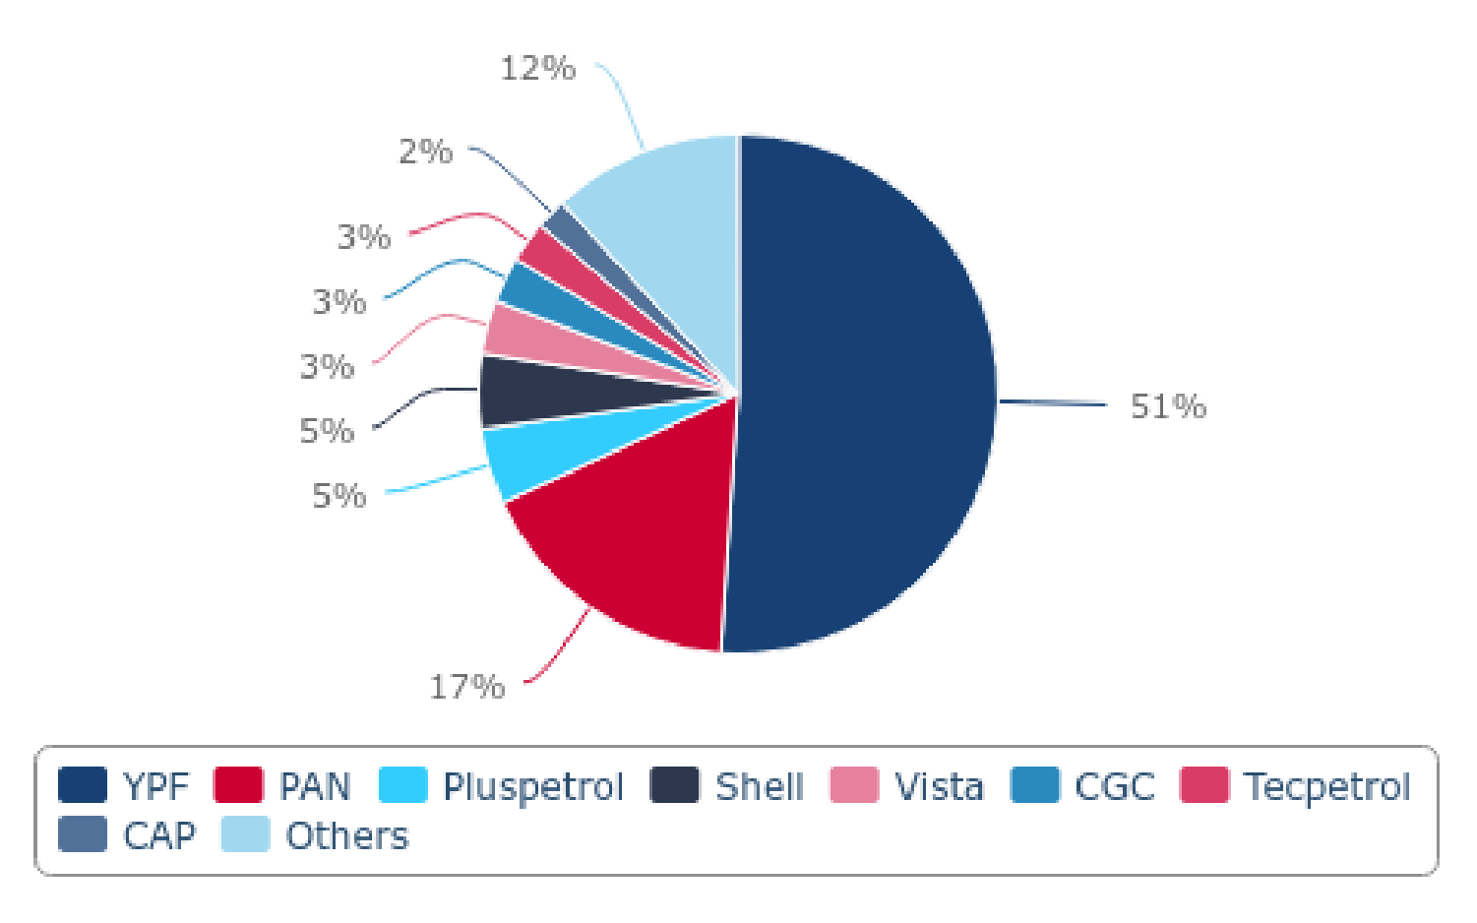

*Note: *Others include 41 producers. Source: Secretaria de Energia, BMI*

**Argentina Oil & Gas Report | Q3 2025**

a Fitchsolutions company

YPF Losing Market Share

Argentina - Natural Gas Output Per Producer (2023)

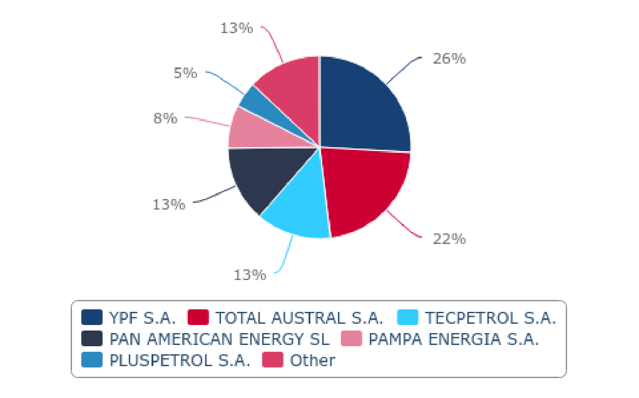

*Source: Secretaria de Energia, BMI*

Key Downstream Players

|  |  |  |  |  |
| --- | --- | --- | --- | --- |
| **Company** | **Refining Capacity ('000b/d)** | **Refining Share (%)** | **Retail Outlets** | **Retail Share (%)** |
| YPF | 320 | 59 | 1,668 | 35 |
| Shell Argentina | 113 | 17 | 1,025 | 14 |
| Axion Energy | 84.5 | 16 | 605 | 12 |
| Pampa Energia | 32.9 | 5 | 285 | 6 |

*Source: Company data as of December 2017, BMI*

**Argentina Oil & Gas Report | Q3 2025**

a Fitchsolutions company

Company Profile

YPF

**Latest Updates**

• In January 2025, VMOS SA, a company owned by YPF, awarded an engineering and management contract related to the

development of the Vaca Muerta project, to Técnicas Reunidas. The USD440mn contract is an EPCm (engineering, procurement and construction management) contract for a hydrocarbon storage and dispatch terminal that will be located in Punta Colorada, on the coast of the province of Río Negro. The terminal will have a storage capacity of 600,000 cubic metres, and a dispatch

capacity of 62,000cubic metres per day through two single-buoys. YPF plans for the entire development of the Vaca Muerta

project and its infrastructure to begin commercial operation in July 2027. This includes the construction of the 437km crude oil export pipeline, the loading and unloading terminal, and a tank and storage yard, which represents a total investment of USD3bn.

• In November 2024 YPF started developing the second section of the Vaca Muerta South oil pipeline, a 440km link between Allen and Punta Colorada in Rio Negro province in Argentina. The pipeline will start exports in 2026 with an initial capacity of

390,000b/d, increasing to 700,000b/d by 2028. The USD2.5bn project is being financed with the help of international investors.

• On October 1, YPF reduced gasoline and diesel prices by respectively 4.0% and 5.0%.

• In August 2024, YPF and Petronas, which are planning a USD50bn LNG export terminal in Argentina, announced Rio Negro as a location for their flagship project. The companies target an FID in H2 2025. In December 2024 however, it is reported that

Petronas is exiting the project, but that it will be replaced by Shell. Shell and YPF signed an agreement to develop the initial phase ofthe LNG terminal. The terminal aims to produce some 10mtpa of LNG.

• As of August 2024, YPF commenced the divestment effort, receiving bids for its business branches in Brazil and Chile. The

company also pursues a sale of 50% stake in the refiner Refinor, which will be most likely followed by a sale of company's share in gas distribution company Metrogas.

• In May 2024, YPF received an environmental approval for its Vaca Muerta Sur oil pipeline which would add exit capacity for crude oil producers in Vaca Muerta. As of August 2024, YPF launched a tender to complete the pipeline and it appears that it would

cooperate with Energy Transfer, a US-based firm to complete this project. The 525km-long pipeline is expected to commence operations by the end of 2026, enabling further unconventional oil production growth past 2026.

• In January 2024, newly-elected President Javier Milei suspended the privatisation of YPF, excluding this provision from the

Omnibus Bill. We have previously highlighted that we do not expect the privatisation to happen over the near term given growing opposition in Congress.

**Argentina Oil & Gas Report | Q3 2025**

a Fitchsolutions company

|  |  |
| --- | --- |
| **Strengths** | **Weaknesses** |
| • Leading domestic oil and gas producer.  • Dominant position in the downstream oil segment.  • Extensive exploration portfolio.  • Involvement in key energy infrastructure. | • Over-dependence on Argentina.  • Mature and competitive industry.  • Vulnerable to state energy policy. |
| **Opportunities** | **Threats** |
| • Steady domestic and regional demand growth  (notwithstanding short-term Covid-19 disruption).  • Scope for productivity gains and cost reductions.  • Can influence government energy policy.  • Shale oil and gas resources from the Vaca Muerta formation. | • State intervention in tariffs and taxation.  • Uncertain political and fiscal outlook.  • Demands of government energy policy. |

**Company Overview**

YPF is the leading producer in Argentina, with assets located in the Neuquén, Gulf of San Jorge, Northeast, Austral and Cuyana

basins. It has interests in 108 oil and gas concessions in Argentina that account for 45% of the market's oil production and 37% of the market's natural gas output. It is Argentina's leading oil refiner, operating three facilities with 319,500b/d of capacity, as well as a half share in the Refinor complex (26,100b/d gross). This provides the group with approximately 59% of Argentina's share of fuels supply, while its service station chain of 1,535 sites accounts for 35% of the retail market.

Key Assets In Argentina

|  |  |  |
| --- | --- | --- |
| **Name** | **Type** | **Capacity ('000boe/d)** |
| Neuquen Province | Upstream | 133.1 |
| Golfo San Jorge Province | Upstream | 44.3 |
| Austral Province | Upstream | 10.5 |
| La Plata Complex | Downstream | 189 |
| Luján de Cuyo Complex | Downstream | 105.5 |

*Source: YPF, BMI*

Key Financial Data, ARSmn

|  |  |  |  |
| --- | --- | --- | --- |
|  | **FY22** | **FY23** | **FY24** |
| Net sales | 3,774,415 | 14,647,287 | 20,523,893 |
| EBITDA | 993,011 | 3,433,579 | 4,950,925 |
| Net Income | 448,334 | -1,110,117 | 2,497,802 |

*Source: YPF, BMI*

**Argentina Oil & Gas Report | Q3 2025**

a Fitchsolutions company

Chevron Argentina

**Latest Updates**

• We note a robust growth in Chevron's oil and gas production in Argentina, primarily unconventional output. Chevron has

observed the most robust increase in shale gas production form all majors, raising output by 723% in August 2024 compared to volumes in August 2023. That said, Chevron remains one of the smallest producers of unconventional gas in Argenina overall.

• Chevron remains a relatively small oil and gas producer in Argentina, focused on unconventional assets. As of 2023, Chevron's market share in oil and gas production lingered at respectively 0.6% and 0.2%. The US major is a member of the Oldelval

consortium, which continues to expand primarily oil midstream infrastructure, which will support production ramp-up.

• In April 2022, Chevron was granted a new concession in the El Trapial Este block in the Vaca Muerta in April 2022. The company committed to investing USD65.7mn on five horizontal wells and USD13mn on infrastructure over the next three years. In June 2023, the US-based company confirmed it will pursue this project allocating USD500mn on it.

|  |  |
| --- | --- |
| **Strengths** | **Weaknesses** |
| • Significant share of domestic oil production.  • Upstream/downstream diversification cushions it from crude price volatility.  • Good spread of exploration interests.  • Share in oil transport infrastructure.  • Strong presence in lubricants sector. | • No refining or fuels marketing presence.  • Limited conventional resource upside potential.  • A high capex and dependence on costly megaprojects  susceptible to delays and cost overruns, with no immediate production ramp-up.  • Large exposure to the US: the companyIs results will remain highly sensitive to developments in the US hydrocarbons industry. |
| **Opportunities** | **Threats** |
| • Steady domestic and regional demand growth.  • Shale drilling venture with YPF. | • State intervention in tariffs and taxation.  • Uncertain political and fiscal outlook.  • Potential for market to slow.  • Costs overruns and lower oil prices reduce margins. |

**Company Overview**

Chevron produces crude oil and natural gas in Argentina through Chevron Argentina, a wholly owned subsidiary. It is the fourth-

largest producer of oil and seventh-largest producer of natural gas in the market, with concessions in the Neuquén Basin. Expanded waterflood operations are sustaining oil output at the El Trapial Field and the company has begun exploring for unconventional oil and gas resources.

Chevron has operated interests ranging from 18.8% to 100% in four concessions in the Neuquén Basin and a 50% non-operated working interest in another concession. In 2015, net daily production averaged 21,000bbl of crude and 1.0mcm of natural gas. The company holds a 14% interest in Oleoductos del Valle, a pipeline system that transports crude oil from the Neuquén Basin in

western Argentina to the Buenos Aires area.

**Argentina Oil & Gas Report | Q3 2025**

a Fitchsolutions company

Key Assets In Argentina

|  |  |  |  |
| --- | --- | --- | --- |
| **Name** | **Type** | **Location** | **Capacity** |
| El Trapial | Concession | Vaca Muerta | Under development |
| Loma Campana | Concession | Vaca Muerta | 50,000boe/d |
| Narambuena Block | Chihuido de la Sierra Negra concession | Vaca Muerta | Exploration |
| Oleoductos del Valle | Pipeline | Neuquén Basin to Buenos Aires | 11.4mcm/d |

*Source: Chevron, BMI*

Key Financial Data, USDmn

|  |  |  |  |
| --- | --- | --- | --- |
|  | **FY22** | **FY23** | **FY24** |
| Net sales | 246,252 | 200,949 | 202,792 |
| EBITDA | 67,483 | 48,293 | 45,382 |
| Net Income | 35,465 | 21,369 | 17,661 |

*Source: Chevron, BMI*

**Argentina Oil & Gas Report | Q3 2025**

a Fitchsolutions company

ExxonMobil

**Latest Updates**

• In November 2024, ExxonMobil has agreed to sell its oil and gas assets in Argentina's Vaca Muerta formation to Pluspetrol. Exxon will sell five blocks in Argentina's western Neuquen province, and its stake in Argentine oil pipeline operator Oleoductos del Valle.

• In August 2024, ExxonMobil unconventional gas production in Argentina increased by 156% compared to August 2023 levels.

• ExxonMobil remains a relatively small oil and gas producer in Argentina, focused on unconventional assets. As of 2023, Chevron's market share in oil and gas production lingered at 1.6% and 0.5% respectively. The US-based major is a member of the Oldelval consortium, which continues to expand primarily oil midstream infrastructure, which will support production ramp-up.

• In March 2024, ExxonMobil returned two exploration blocks in the Malvinas Oeste basin in offshore Argentina.

• In November 2023, ExxonMobil launched a tender to build an oil pipeline in Argentina's Vaca Muerta. The Bajo del Choique

Nordeste Pipeline would move between 8,000-12,000b/d,with a potential to increase capacity to 60,000b/d, and connect Bajo del Choique with La Invernada. The construction is set to begin in Q124 with commencement of operations slated for Q4 2024.

• ExxonMobil, along with Qatar Petroleum, was granted an extension until 2024 for its offshore exploration permits for acreage in the Argentine Sea.

• At the beginning of 2022, ExxonMobil’s net acreage totalled 2.9mn acres, of which 2.6mn net acres were offshore. During the year 2021, a total of 8.1 net development wells were completed.

|  |  |  |  |
| --- | --- | --- | --- |
| **Strengths** | | **Weaknesses** | |
| • | Long history in refining and marketing. | • | Insignificant contribution to group revenues. |
| • | Some gas production upside potential. | • | Weak upstream position. |
| • | Strong global unconventional portfolio. | • | Sunk costs at ongoing projects demand high levels of |
| • | Vertically integrated business model providing flexibility with commodity price volatility. |  | continued capex while oil prices are low. |
|  | **Opportunities** |  | **Threats** |
| • | Steady growth in domestic energy demand. | • | State intervention in tariffs and taxation. |
| • | Modest investment requirement. | • | Uncertain political and fiscal outlook. |
| • | Shale drilling potential. | • | Persistently low oil prices. |
| • | Strong cash position supports opportunities for inorganic expansion. |  |  |

**Company Overview**

ExxonMobil has been investing in Argentina's Vaca Muerta shale play since 2010, holding interests in approximately 900,000 net

acres. The company operates through its subsidiaries, ExxonMobil Exploration Argentina, Mobil Argentina and ExxonMobil Business Support Center Argentina. The company has drilled seven wells with their strategic partners and have recently begun to explore for unconventional resources in the Bajo del Choique and La Invernada blocks, where the company holds 85% interest and Oil and Gas Provincial Company of Neuquén holds the remaining 15%.

**Argentina Oil & Gas Report | Q3 2025**

a Fitchsolutions company

Key Assets In Argentina

|  |  |  |  |  |  |
| --- | --- | --- | --- | --- | --- |
| **Name** | **Stake (%)** | **Type** | **Location** | **Products** |  |
| Sierra Chata | 51 | Onshore field | Neuquén Province | Natural gas, condensates |  |
| Bajo del Choique | 85 | Onshore block | Neuquén Province | In development |  |
| La Invernada | 85 | Onshore block | Neuquén Province | In development |  |
| *Source: ExxonMobil, BMI*  Key Financial Data, USDmn | | | | | |
|  |  | **FY22** | **FY23** |  | **FY24** |
| Net sales |  | 413,680 | 344,582 |  | 349,585 |
| EBITDA |  | 104,451 | 77,183 |  | 73,504 |
| Net Income |  | 55,740 | 36,010 |  | 33,680 |

*Source: ExxonMobil, BMI*

**Argentina Oil & Gas Report | Q3 2025**

a Fitchsolutions company

Regional Overview

Latin America Oil & Gas Regional Overview

***Key View:*** *Latin America's oil production growth is projected to slow to 2.6%y-o-yin 2025, down from 3.3% in 2024, but long-term prospects remain positive with key growth from Brazil and Guyana. Refining capacity is expected to expand, driven by Brazil and*

*Mexico, with significant investments in infrastructure. Natural gas production is set to experience a strong recovery in 2025, led by Argentina and Brazil, with a 4.1% increase, following a decline in 2024. Gas consumption is projected to grow steadily, with Mexico leading the increase due to the expansion of natural gas power generation. Fuel consumption is expected to recover to pre-Covid levels by 2025, driven by economic growth in the region, with increases anticipated in Colombia and Ecuador. Overall, while the*

*region faces challenges, the outlook for oil, gas, and fuel sectors is positive, supported by strategic investments and policy frameworks.*

To highlight the key themes across our Latin America Oil & Gas forecasts, we have assessed markets based on the following indicators:

• Oil production

• Oil consumption

• Refining capacity

• Gas production

• Gas consumption

Our Latin America coverage includes Argentina, Bolivia, Brazil, Chile, Colombia, Ecuador, Guyana, Mexico, Peru, Trinidad & Tobago (T&T) and Venezuela.

**Oil Production: LatinAmerica's Oil Production Growth To Slow In 2025, But Long-Term Prospects Remain Positive**

Latin American oil production has declined from its peak levels in the mid-2010s, mainly due to reduced output in Mexico and

Venezuela. Mexico's challenges include aging oil fields like Cantarell, financial difficulties with PEMEX, and insufficient investment in new projects. Venezuela's production was affected by issues within PDVSA and US sanctions limiting foreign investment. Despite

these challenges, the region experienced a modest recovery in 2021, with a 0.9% y-o-y increase in total oil output. This recovery was driven by rising production in Mexico, Venezuela, and Guyana, which offset declines in Brazil, Colombia, and Ecuador due to project delays. In 2022, high global oil prices led to a 7.0% annual growth in production, continuing with an 8.0% y-o-y increase in 2023. In 2024, total crude oil production in Latin America grew by 3.3% y-o-y. Looking ahead to 2025, the growth rate is projected to slow to 2.6%, before accelerating to 3.7% in 2026 and stabilising at an average growth rate of 2.5% from 2027 to 2034. Overall, oil

production in Latin America is expected to rise from 9.4mn b/d in 2024 to 11.8mn b/d by 2034.

**Argentina Oil & Gas Report | Q3 2025**

a Fitchsolutions company

Growth Among Key Producers To Outbalance Declines Among Smaller Producers

LatAm - Total Oil Production, 000' b/d (2023-2034)

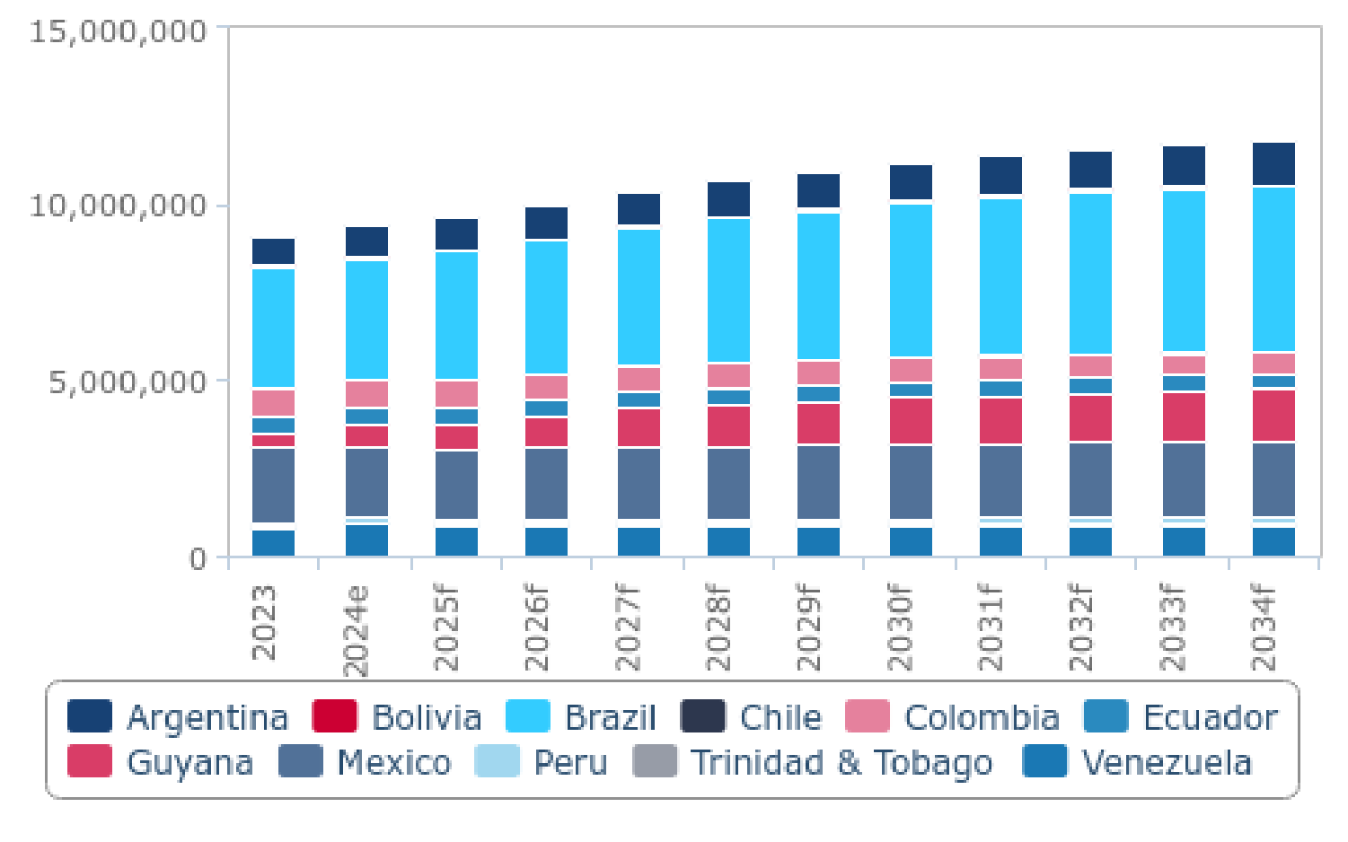

*e/f = estimate/forecast. Source: BMI*

Key growth markets in the region include Brazil, Guyana, and Argentina. Brazil and Guyana are poised to significantly increase their oil production by 2028, with projected increases of 611,000b/d and 805,000b/d respectively, compared to 2023 levels. From 2029 to 2034, Brazil and Guyana are expected to further boost their production by 1.2mn b/d and 1.1mn b/d respectively. Brazil's crude oil production forecast aligns with Petrobras's announcements, projecting a 5.0% y-o-y growth in 2025 and an average annual

increase of 4.3% from 2026 to 2029. Notably, the Mero 3 project has commenced production, significantly enhancing capacity,

while Mero 4 is scheduled to start operations in 2025, adding another 180,000b/d. Equinor's Bacalhau project is anticipated to

deliver first oil in 2025, with a peak production capacity of 220,000b/d. However, limited updates on project progress present risks to the forecast. Despite a strong upstream project pipeline, potential spending adjustments could pose downside risks to Brazil's medium-term crude production outlook, especially given a cautious outlook on crude oil prices in 2025.

**Argentina Oil & Gas Report | Q3 2025**

a Fitchsolutions company

Brazil And Guyana To Represent Key Growth Markets Over Medium Term

Brazil & Guyana- Change In Average Oil Production, 000' b/d (2023-2034)

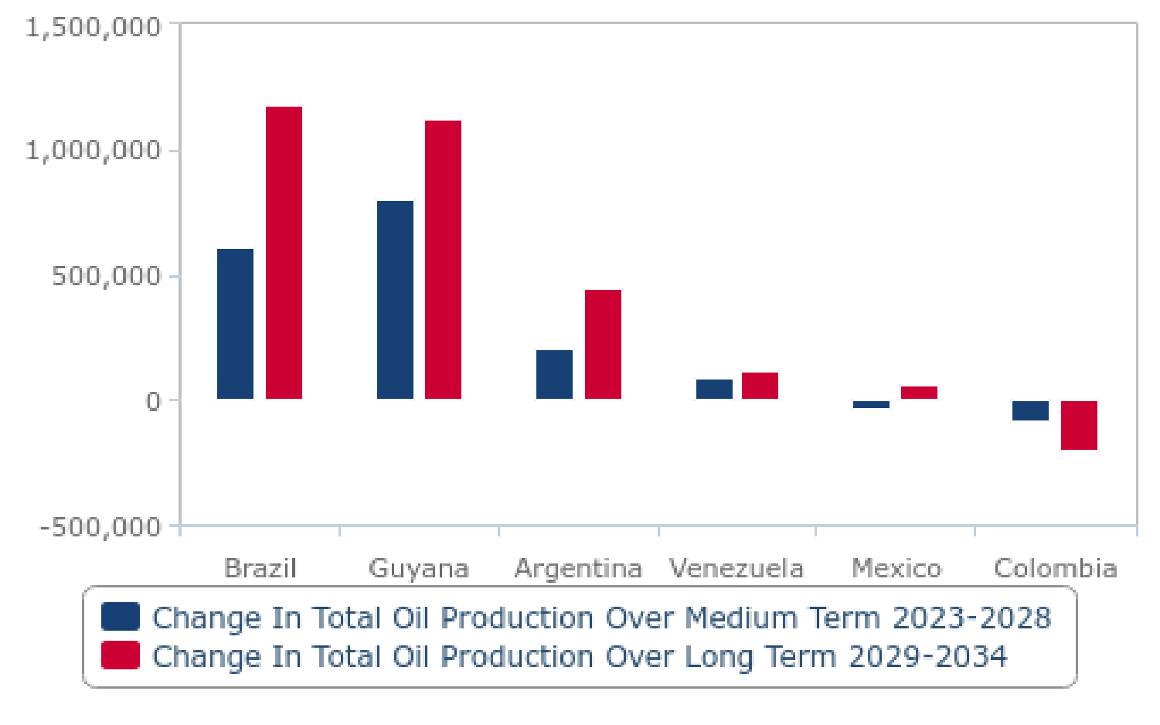

*Source: Local sources, JODI, EIA, BMI*

Guyana's crude oil production forecast has also been revised, with anticipated growth of 23.0% y-o-y in 2025, reaching an average output of 747,500b/d. This revision follows strong performance in the latter half of 2024, leading to an upward estimate of 607,500 b/d for that year's average production. The Yellowtail project is set to become Guyana's largest offshore development, with a

capacity of 250,000b/d, and is expected to commence operations in 2025. Further growth is supported by the upcoming Uaru project in 2026 and Whiptail in 2027. However, inflationary pressures pose risks, as seen with Uaru's cost estimate increase from USD10bn to USD12.7bn. ExxonMobil's planned investment decisions for Hammerhead in 2025 and Longtail in 2027 present

potential upside risks to the long-term forecast. While geopolitical tensions with Venezuela remain a concern, they are unlikely to significantly impact near-term production forecasts. Overall, the outlook for Latin American oil production is positive, with growth expected to continue across the forecast period despite some challenges and risks.

**Refining Capacity: Brazil And Mexico To Drive Latin American Refining Capacity Growth**

The outlook for the Latin American downstream sector over the next decade is characterized by promising growth, primarily driven by strategic developments in Brazil and Mexico. Brazil’s refining capacity is projected to expand from 2.4mn b/d in 2023 to 2.6mn

b/d by 2028. This increase is supported by substantial investments in refining infrastructure, including the expansion of the RNEST refinery and contributions from private sector players like Dax Oil Refino and Noxis Energy. Brazil's fuel production is expected to rise steadily, reaching approximately 2.4mn b/d by 2034, with a focus on higher-value products such as low-sulfur diesel to meet global regulatory standards.

**Argentina Oil & Gas Report | Q3 2025**

a Fitchsolutions company

Mexico & Brazil Account For Bulk Of Refining Capacity In LatAm

LatAm - Refining Capacity & Refined Products Production, 000' b/d (2023-2034)

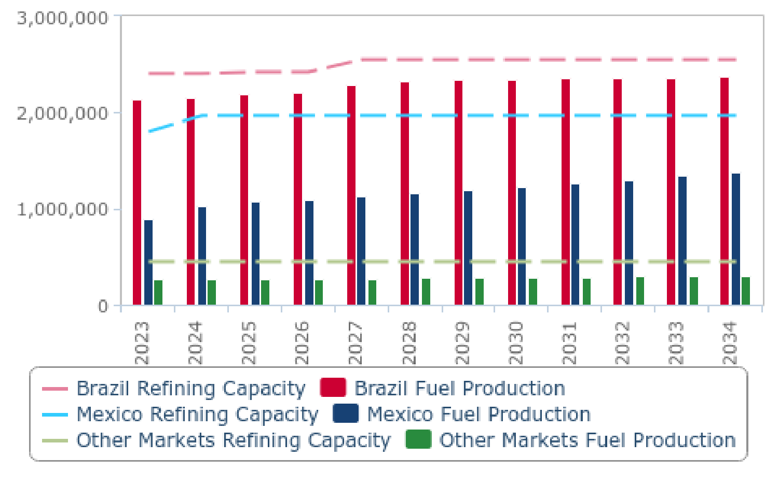

*e/f = estimate/forecast. Source: BMI*

In Mexico, the ramp-up of the Olmeca refinery and ongoing upgrades to existing facilities are set to bolster refining capacity,

maintaining it at 2.0mn b/d from 2024 onwards. Fuel production is anticipated to grow significantly, from 890,300b/d in 2023 to

1.4mn b/d by 2034, driven by investments aimed at increasing the output of higher-quality fuels and reducing reliance on imports. The Olmeca refinery, inaugurated in 2022, is expected to be fully operational by 2025, contributing to the production of high-quality fuels like gasoline and ultra-low-sulfur diesel. However, challenges such as maintenance issues and aging infrastructure pose risks to sustained growth, with Pemex facing particular difficulties in achieving its production targets.

Other markets within Latin America are expected to maintain stable refining capacity at 447,000b/d throughout the forecast period. However, fuel production in these regions is projected to rise gradually from 265,600b/d in 2023 to over 311,100b/d by 2034,

indicating modest growth due to incremental improvements and optimisations in existing refinery operations. Overall, Latin

America's fuel capacity and production landscape are poised for considerable expansion, with Brazil and Mexico leading the charge through strategic investments and operational enhancements. This growth will likely enhance the region's self-sufficiency in fuel

production and support economic development across Latin American markets. The combined efforts of public and private sectors, alongside strategic investments and operational enhancements, underline a positive outlook for the downstream sector in Latin

America, despite challenges in specific areas.

**Gas Production: LatinAmerica's Gas Output Poised For Strong Recovery In 2025 Led By Argentina And Brazil**

Latin America's natural gas production landscape is poised for significant transformation in the coming years, with a marked upturn expected in 2025. After experiencing a decline of 1.3% in 2024, the region's gas production is forecast to rebound with a robust y-o- y growth rate of 4.1% in 2025, increasing total dry natural gas output to 179.9bcm. This resurgence will be largely driven by

Argentina and Brazil, both of which are set to play pivotal roles in bolstering regional gas supplies.

**Argentina Oil & Gas Report | Q3 2025**

a Fitchsolutions company

Argentina Functions As The Largest Gas Production Hub In LatAm

LatAm - Dry Natural Gas Production, bcm (2023-2034)

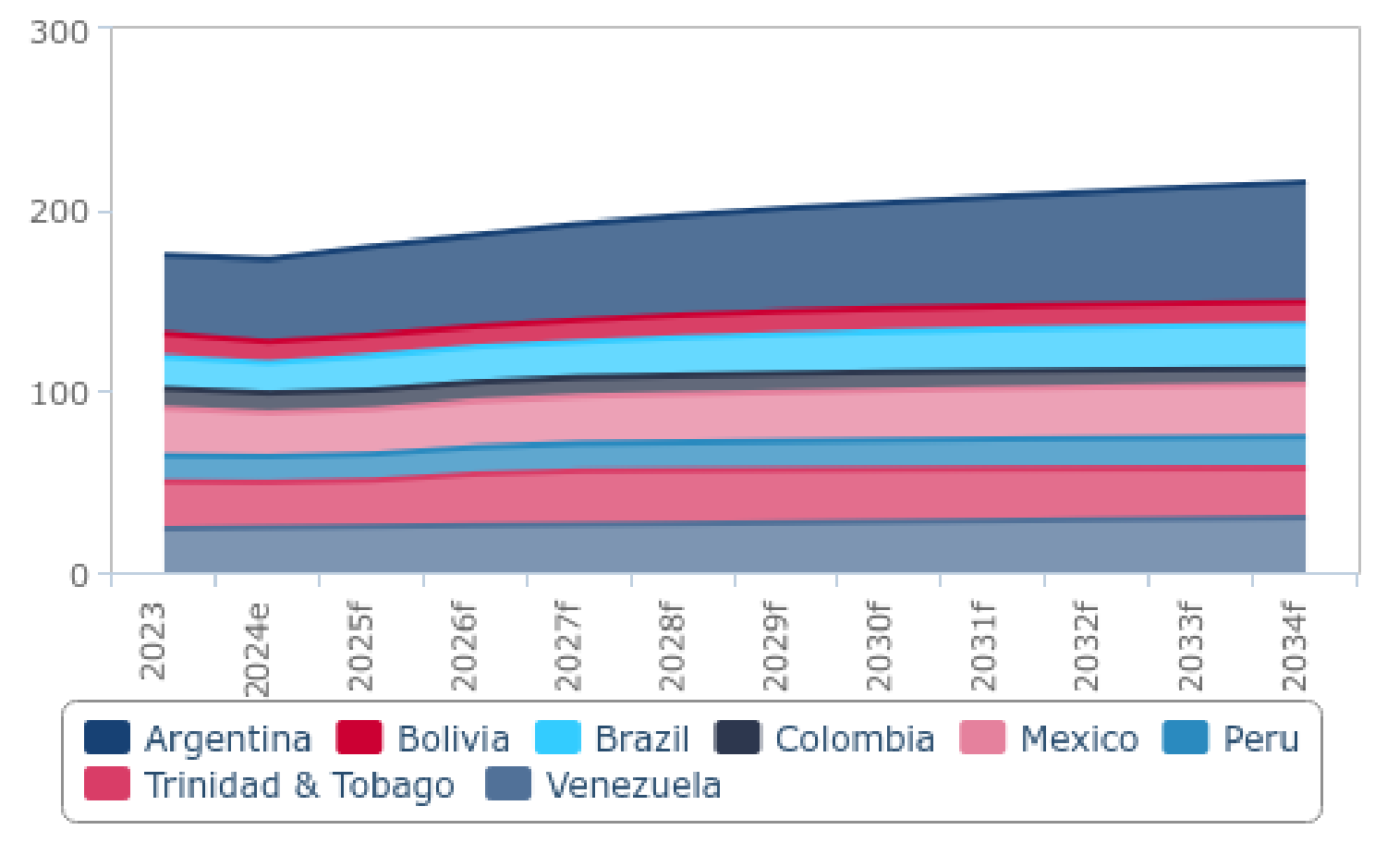

*e/f = estimate/forecast. Source: BMI*

Argentina stands out with its optimistic gas production outlook, fueled by substantial infrastructure advancements and the

expansion of unconventional output. In 2025, the country's gas production is expected to surge by 7.6% y-o-y, reaching 48.9bcm. This growth is supported by key projects like the Northern Pipeline Reversal, which will enable Argentina to reduce reliance on

imports by supplying its northern provinces with domestic gas. The completion of the offshore Fénix project, with its low carbon footprint and significant production capacity, further enhances Argentina's bullish production forecast.

Despite challenges, such as potential delays in the Néstor Kirchner Stage 2 pipeline expansion due to limited government support, Argentina's long-term outlook remains promising. Unconventional gas production, particularly from the Vaca Muerta shale

formation, is expected to drive growth, with forecasts indicating a 3.9% annual average growth rate through 2034. The prospect of large-scale LNG export projects could further solidify Argentina's position as a major gas exporter in the region.

Brazil's natural gas production prospects are equally robust, buoyed by the commencement of the Rota 3 pipeline, which began

operations in late 2024. This development is set to increase marketable gas output by 11.9% y-o-y in 2025, reaching 18.9bcm. The Rota 3 pipeline is pivotal in unlocking new supplies from the Tupi field in the Santos Basin and facilitating the transport of gas from Campos Basin fields.

Despite a temporary production decline in 2024 due to high reinjection rates and disruptions, Brazil's long-term growth projections remain strong. Initiatives such as the BM-C-33 offshore project, expected to add significant capacity by 2028, will support this

trajectory. However, challenges persist, particularly regarding the high CO2 content in gas from pre-salt fields and potential impediments to private sector investment under current government policies.

In Trinidad & Tobago, the outlook for gas production is bullish, with medium-term peaks anticipated in 2026 and 2027. Driven by deepwater block developments by bpTT and Shell, the country's gas output is projected to grow by 2.0% in 2025, reaching

25.5bcm. The Coconut gas project, set to commence in 2027, alongside bpTT's Cypre and Shell's Manatee developments, will

further bolster production. Strategic partnerships and recent asset acquisitions present additional opportunities, with production expected to rise to nearly 32.0bcm by 2026.

Contrasting the positive outlooks elsewhere in the region, Colombia faces a declining natural gas production trajectory due to

depleting reserves and a ban on new oil and gas exploration under President Gustavo Petro's administration. However, Petrobras'

**Argentina Oil & Gas Report | Q3 2025**

a Fitchsolutions company

significant gas discovery at the Sirius-2 well presents a potential upside, with the possibility of achieving self-sufficiency until 2029. Ecopetrol's strategic pivot towards gas-oriented projects offers hope, although structural challenges such as tax reforms and

regulatory risks could dampen investor sentiment and limit sector growth.

**Gas Consumption: Latin American Gas Consumption To Grow Steadily Through 2034, With Mexico Leading The Increase**

Latin America's natural gas demand has experienced notable fluctuations in recent years, marked by a robust recovery in 2021 followed by a subtle decline in 2022 due to improving weather conditions. This trend continued with very limited growth in 2023.

Nonetheless, the forecast for the region remains optimistic, with expectations of positive growth in gas consumption over the next decade. Specifically, Latin American markets are projected to see an increase in natural gas consumption from 223.8bcm in 2024 to 275.2bcm in 2034, representing a 22.9% growth over the forecast period.

A significant portion of this growth is anticipated to emanate from Mexico, which accounted for 43.6% of the region's total gas

consumption as of 2024. Mexico's consumption outlook is on a sustained growth trajectory, largely driven by the expansion of

natural gas power generation. From 2024 to 2028, Mexico's average annual growth in natural gas consumption is projected at 4.3%, though this rate is expected to slow to 1.6% annually between 2029 and 2033. The forecast for 2025 suggests a 2.5% y-o-y

increase, decelerating from an 8.4% growth in 2024 due to weaker economic growth.

Several factors support this outlook in Mexico. The focus on natural gas-fired power generation remains dominant in the country's energy mix, bolstered by government policies and infrastructure investments. The Programa de Desarrollo del Sistema Eléctrico

Nacional (PRODESEN) outlines plans to add 9.7GW of gas-fired combined-cycle plants by 2024. Additionally, a robust pipeline of gas power projects, currently in pre-construction and construction stages, further underscores this growth.

Mexico Is The Largest Gas Consumer In LatAm

LatAm - Dry Natural Gas Consumption, bcm (2023-2034)

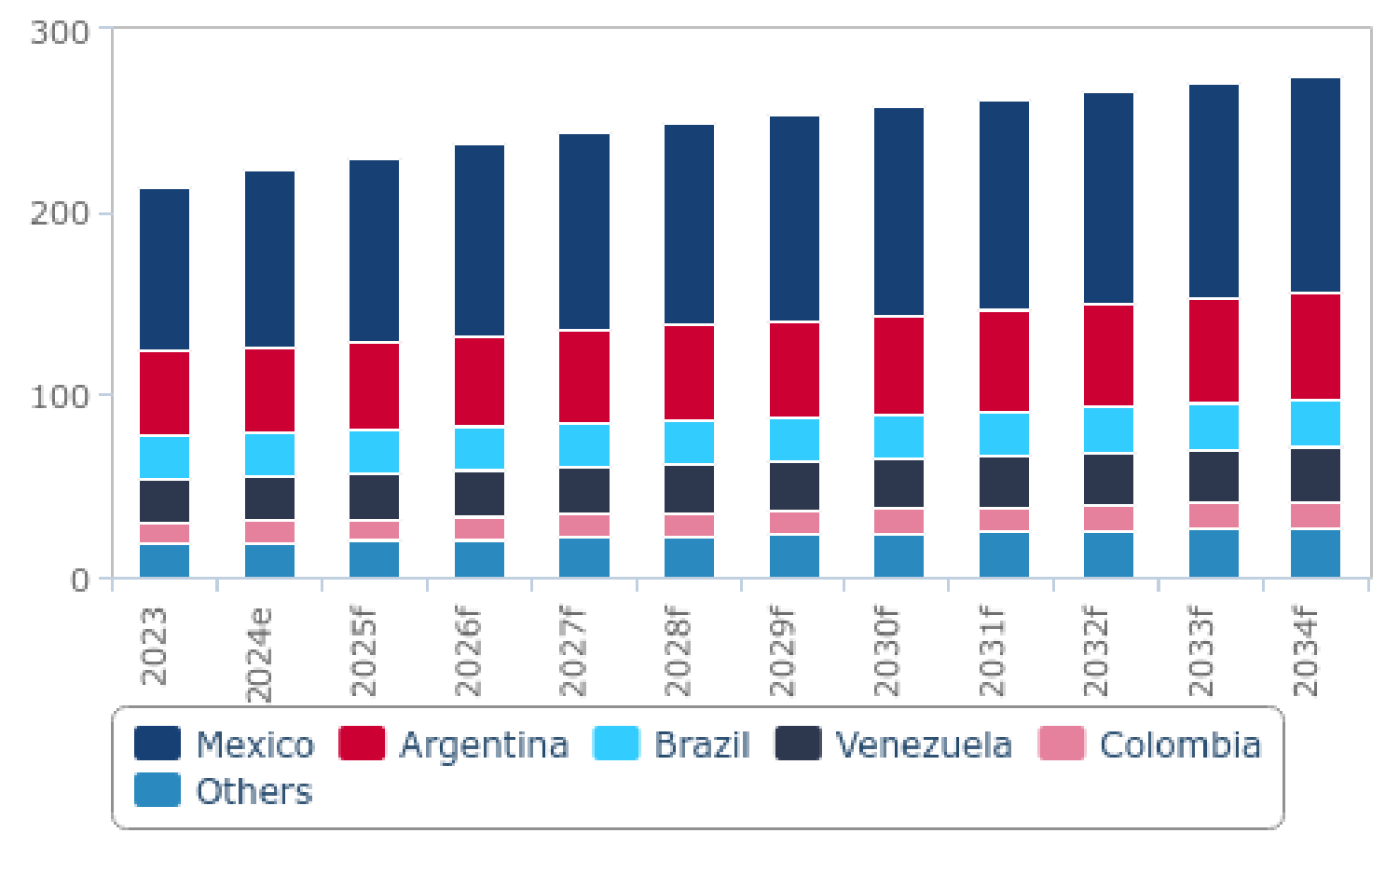

*e/f = estimate/forecast. Source: BMI*

**Argentina Oil & Gas Report | Q3 2025**

a Fitchsolutions company

Mexico's national energy plan, PRODESEN 2021-2035, aligns with these developments, presenting opportunities for additional gas- fired capacity tenders. The government is investing in expanding gas access, including a USD4.5bn project aimed at improving

infrastructure on the Yucatan Peninsula. Moreover, near-shoring investments offer potential for increased natural gas demand, despite recent trends indicating a preference for non-hydropower renewables.

However, challenges persist, such as slower transitions to low-carbon sources and limited private sector participation in renewables under the current administration. Despite these hurdles, Mexico continues to rely heavily on imports of U.S. gas, facilitated by

expanding midstream infrastructure, to meet its growing demand as domestic production lags behind consumption increases.

Across the region, aggregate gas demand growth is expected to decline to 2.5% y-o-y in 2025, down from 4.5% in 2024. This

decline is largely due to the expansion of non-hydropower renewables, particularly in Brazil, which limits gas demand growth from the power sector. However, the La Niña weather phenomenon may bring droughts, leading to reduced hydropower generation and consequently higher utilisation of natural gas power plants.

Overall, while the LatAm region faces challenges, the outlook for natural gas demand remains positive, driven by strategic investments and policy frameworks that support growth, particularly in Mexico.

**Fuel Consumption: LatinAmerica's Fuel Demand To Recover To Pre-Covid Levels By 2025 Amid Economic Growth**

The outlook for fuel consumption in Latin America is shaped by diverse economic, technological, and sectoral factors. By 2025, the region's fuel demand is expected to return to pre-Covid levels, despite ongoing challenges. This recovery is driven by key trends and projections.

Acceleration In Fuel Consumption In 2025

LatAm - Total Fuel Consumption Growth Forecast For Selected Markets, % y-o-y (2023-2034)

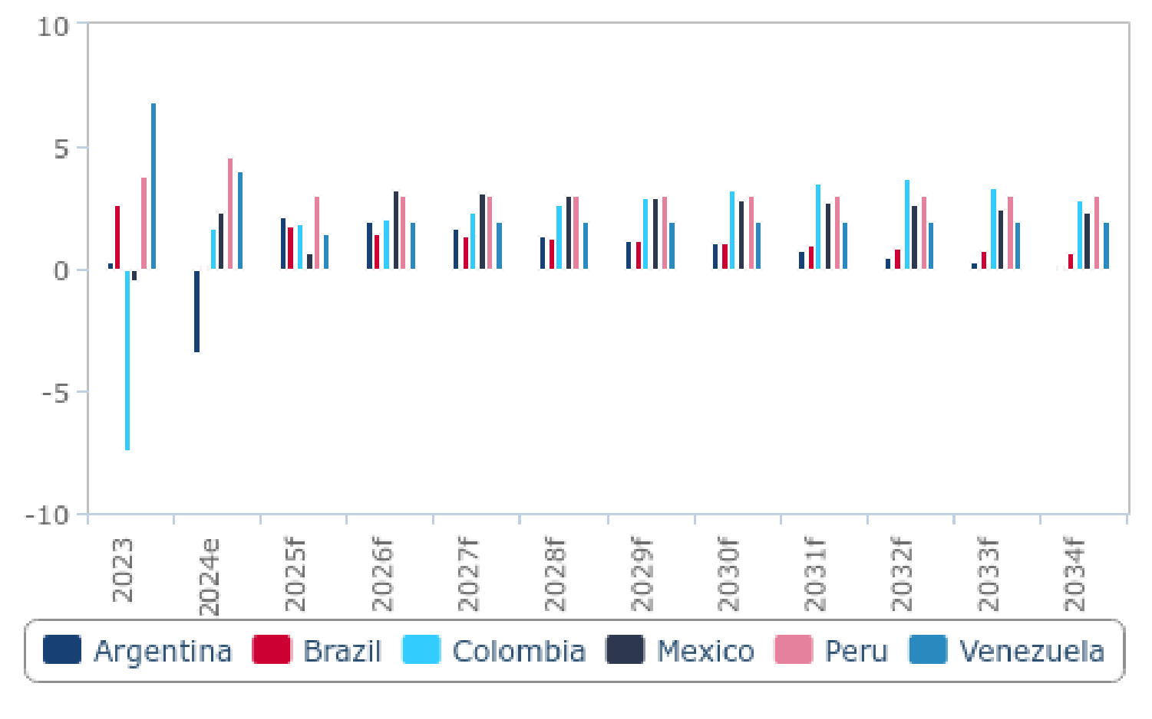

*e/f = estimate/forecast. Source: BMI*

**Argentina Oil & Gas Report | Q3 2025**

a Fitchsolutions company

Brazil, the largest fuel consumer in Latin America, is expected to see demand increase from 2.2mn b/d in 2023 to 2.5mn b/d by

2034. This growth reflects Brazil's economic resilience and the anticipated acceleration of energy transition initiatives under

President Lula. While there is optimism about EV adoption, limited EV infrastructure is likely to hinder widespread adoption, keeping traditional vehicles dominant.

The agricultural sector, which heavily relies on diesel, is poised for growth. This sectoral expansion supports a positive long-term outlook for fuel consumption. As vehicle fleets grow in major economies, diesel consumption is expected to rise alongside

agricultural development.

Overall, fuel consumption in Latin America is projected to reach 7.3mn b/d by 2034, up from 6.0mn b/d in 2023. Colombia and

Ecuador are expected to see significant increases in fuel consumption, with Colombia's demand rising by over 34.0% and Ecuador's by nearly 45.0%. This growth is linked to anticipated positive GDP growth, highlighting the connection between economic

expansion and fuel demand.

Fuel Consumption Largely Expected To Track GDP Growth

LatAm - Select Markets Refined Fuel Consumption & Real GDP, 000' b/d & USD (2025f)

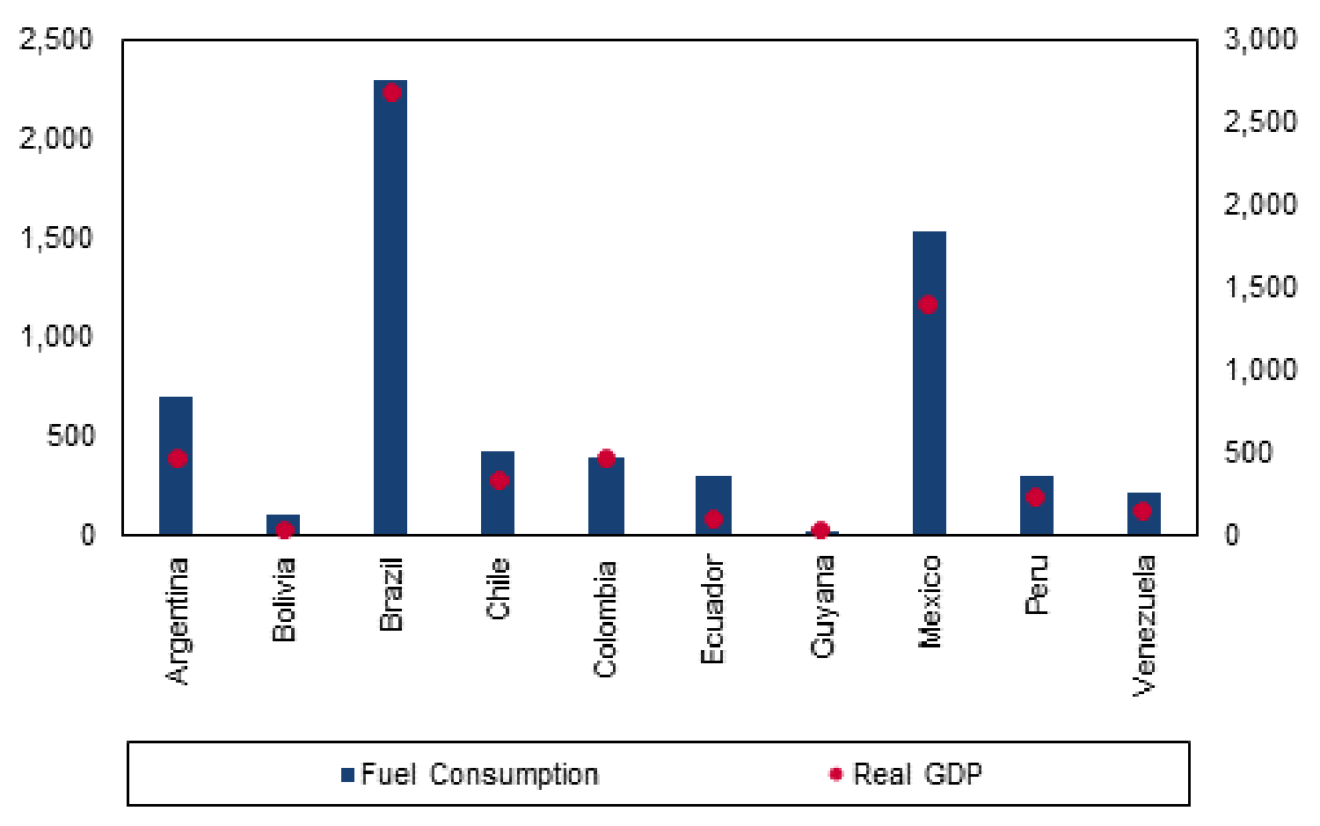

*e/f = estimate/forecast. Source: BMI*

Real GDP growth in the region is projected to slow from 2.1% in 2023 to 1.8% in 2024, before increasing to 2.4% in 2025. Mexico, the second-largest market, will face a slowdown in 2024 due to moderating exports and declining business confidence. However, Chile, Colombia, and Peru are expected to experience growth rebounds.

Fuel consumption growth is expected to track GDP growth. In 2025, Brazil and Mexico, with GDPs of USD2.7bn and USD1.4bn, respectively, are projected to have fuel consumption levels of 2.3mn b/d and 1.5mn b/d. These figures illustrate the strong link between economic growth and fuel demand in these key markets.

**Argentina Oil & Gas Report | Q3 2025**

a Fitchsolutions company

**Oil & Gas Glossary**

|  |  |  |  |
| --- | --- | --- | --- |
| **Term** | **Description** | **Term** | **Description** |
| AOR | additional oil recovery | IOC | international oil company |
| APA | awards for predefined areas | IPO | initial public offering |
| API | American Petroleum Institute | JOC | joint operating company |
| bbl | barrel | JODI | joint organisations data initiative |
| bcm | billion cubic metres | JPDA | joint petroleum development area |
| b/d | barrels per day | LAB | linear alkyl benzene |
| boe | barrels of oil equivalent | LDPE | low density polypropylene |
| BTU | British thermal unit | LNG | liquefied natural gas |
| capex | capital expenditure | LPG | liquefied petroleum gas |
| CBM | coal bed methane | mcm | million cubic metres |
| CEE | Central and Eastern Europe | MENA | Middle East and North Africa |
| CSG | coal seam gas | MoU | memorandum of understanding |
| DoE | US Department of Energy | mt | metric tonne |
| DM | developed markets | mtpa | million tons per annum |
| EBRD | European Bank for Reconstruction & Development | NGL | natural gas liquids |
| EEZ | exclusive economic zone | NGV | natural gas vehicle(s) |
| EIA | US Energy Information Administration | NOC | national oil company |
| EM | emerging markets | opex | operating expenditure |
| EOR | enhanced oil recovery | PE | polyethylene |
| E&P | exploration and production | PP | polypropylene |
| EPSA | exploration and production sharing agreement | PSA | production sharing agreement |
| EV | electric vehicle(s) | PSC | production sharing contract |
| FID | final investment decision | R&D | research and development |
| FDI | foreign direct investment | R/P | reserves/production |
| FEED | front end engineering and design | RPR | reserves to production ratio |
| FLNG | floating liquefied natural gas | SGI | strategic gas initiative |
| FPSO | floating production, storage and offloading | SoI | statement of intent |
| FSRU | floating storage and regasification unit | SPA | sale and purchase agreement |
| FTA | free trade agreement | SPR | strategic petroleum reserve |
| FTZ | free trade zone | SSA | Sub-Saharan Africa |
| GCC | Gulf Cooperation Council | tcm | trillion cubic metres |
| G&G | geological and geophysical | t/d | tonnes per day |
| GS | geological survey | toe | tonnes of oil equivalent |
| GTL | gas to liquids | tpa | tonnes per annum |
| GWh | gigawatt hours | TRIPS | Trade-Related Aspects of Intellectual Property Rights |
| HDPE | high density polyethylene | TWh | terawatt hours |

**Argentina Oil & Gas Report | Q3 2025**

a Fitchsolutions company

|  |  |  |  |
| --- | --- | --- | --- |
| **Term** | **Description** | **Term** | **Description** |
| HoA | heads of agreement | USGS | US Geological Survey |
| IEA | International Energy Agency | WIPO | World Intellectual Property Organization |
| IGCC | integrated gasification combined cycle | WTI | West Texas Intermediate |

**Oil & Gas Methodology**

**Connected Thinking**

BMI employs a unique methodology known as 'Connected Thinking'. This means that our analysis captures the inter-relatedness of the global economy, and takes into account all of the relevant political, macroeconomic, financial market and industry factors that underpin a forecast and view. We then integrate them so as to explain how they interact and affect each other. Our Connected

Thinking approach provides our customers with unique and valuable insight on all relevant macroeconomic, political and industry risk factors that will impact their operations and revenue-generating potential in the industry/industries within which they operate.

We use a transparent forecasting model as a base for our industry forecasts, but rely heavily on our analysts' expert judgement to ensure our forecasts capture all of the insights we derive using our unique Connected Thinking approach. We believe analyst

expertise and judgement are the best ways to provide the most accurate, up-to-date and comprehensive insight to our customers.

**Oil & Gas Methodology**

For the Oil & Gas industry, we have historical data and 10-year forecasts for 45 core industry variables, including oil & gas production, refined fuels production and consumption, refining capacity, refined fuels production, and trade of oil and natural gas. We also have historical data and 10-year forecasts for 36 energy price indicators.

Our forecasts are a combination of analyst expert judgement and a market's own historical time series.

Our Oil & Gas analysts interact with other analytical teams in BMI, including Country Risk, Commodities, Power, Renewables, Autos and Infrastructure. This ensures that they have a comprehensive understanding of external factors that may impact the oil & gas

industry outlook on either a market, regional or global level. In addition, our oil & gas forecasts draw on assessments of political risk, regulatory outlook and outlook for capital expenditure by the industry.

There is a constant rolling cycle of data monitoring, with databases being updated on a quarterly basis. Analysts will use their judgement outside of these cycles to implement forecast changes when necessary.

**Industry-Specific Methodology**

Our approach to forecasting combines both bottom-up and top-down analyses, drawing data from a wide range of corporate,

governmental and multilateral sources. The forecasts also leverage proprietary data and analysis from across our 125 markets and 25 industry verticals.

**Argentina Oil & Gas Report | Q3 2025**

a Fitchsolutions company

**Upstream Production**

Our supply-side forecasts are bottom up, aggregating individual projects (both greenfield and brownfield) up to the market level to derive a total number.

We define oil production as crude oil, NGLs and lease condensates.

We define natural gas as dry natural gas, and exclude NGLs, which is captured under oil production.

The data are mostly sourced from companies active in the market and the relevant regulatory agencies such as the EIA and JODI.

We factor in the production capacity as reported by the given company or agency, but will make informed assumptions as to the project start-up date and commissioning periods.

In general, we include only those projects that are post-FID. However, pre-FID projects that we view to have a high probability of progressing will also be included. The likelihood of a project progressing will be decided on a number offactors, including:

• The economics of a given project

• The prevailing oil or natural gas price

• The political and regulatory environment

• Assumptions as to the capital allocation process of the equity partners

Legacy production (production beginning in any year prior to the forecast period) is forecast out, as per historical trends. However, we make adjustments to the assumed decline rate, based on historical decline rates, forecast investment into enhanced oil recovery or legacy field redevelopment, technological developments and other relevant factors.

Production is expressed in b/d for oil and cubic metres for natural gas.

**Refining Capacity**

Our refining capacity forecasts are bottom up, aggregating individual projects (both greenfield and brownfield) up to the market level and consider nameplate capacity.

The data are mostly sourced from companies active in the market and the relevant regulatory agencies.

We factor in the crude throughput capacity as reported by the given company or agency, but will make informed assumptions as to the project start-up date and commissioning periods. The capacity forecasts cover crude distillation units (otherwise known as

atmospheric distillation units). They do not cover secondary processing capacity.

In general, we include only those projects that are post-FID. However, pre-FID projects that we view to have a high probability of progressing will also be included.

It is expressed in b/d.

**Argentina Oil & Gas Report | Q3 2025**

a Fitchsolutions company

**Refining Capacity Utilisation**

This is a derived indicator. The value is calculated as refined fuels production as a proportion of nameplate refining capacity. Given the lower density of refined fuels, a refinery running at 100% of its nameplate (crude) capacity will operate at above 100%,

according to this indicator. Process optimisation and debottlenecking, which will increase the crude throughput at a given facility but will not be reflected in our headline refining capacity forecast, can also lead to over-utilisation. In general, new and more

complex facilities will run at higher utilisation rates than legacy facilities.

It is expressed in b/d.

**Refined Products Production**

Headline refined fuels production is a function of a market’s refining capacity and its forecast utilisation rates. We further break down production into gas oil/diesel, gasoline, jet fuel, kerosene, fuel oil, LPG and other products. The breakdown of production is modelled on historical trends.

It is expressed in b/d.

**Refined Products And Natural Gas Consumption**

Our refined products as well as natural gas consumption forecasts are top-down and leverage a range of market-level forecasts

from other analytical teams in BMI, in addition to a market's own historical time series. Common drivers of fuels demand include the domestic economic and political environment, demographic trends and developments in energy-intensive sectors ofthe economy, as well as infrastructure build out and availability.

As with refined fuels production, we further break down refined products consumption into gas oil/diesel, gasoline, jet fuel, kerosene, fuel oil, LPG and other products.

It is expressed in b/d for oil and billion cubic metres per year for natural gas.

**Oil Trade**

This is a derived indicator.

We calculate crude and other liquids net exports as crude, NGPL and other liquids production, plus refining capacity gains, less refined products production.

For refined products net exports, the value is calculated as refined products production less refined products consumption. As with our production and consumption forecasts, we further break down trade into gas oil/diesel, gasoline, jet fuel, kerosene, fuel oil, LPG and other products. For total net oil exports (crude, plus, products), the value is calculated as crude, NGPL and other liquids

production, plus refining capacity gains, less refined products consumption.

As derived indicators, our net export forecasts do not take account of annual stock change. This can lead to some small discrepancies between our historical data set and observed trade flows.

**Argentina Oil & Gas Report | Q3 2025**

a Fitchsolutions company

It is expressed in b/d.

**Gas Forecasts**

***Gas Trade***

As derived indicators, our net export forecasts do not take account of annual stock change. This can lead to some small discrepancies between our historical data set and observed trade flows.

***Dry Natural Gas Net Exports***

This is a derived indicator. It is calculated as dry natural gas production less dry natural gas consumption.

*Of which, LNG Net Exports*

LNG net exports are derived based on gross LNG exports, less gross LNG imports.

Gross export and import forecasts are bottom up, aggregating individual liquefaction and regasification projects (both greenfield and brownfield) up to the market level. We rely on our LNG Projects Database, which is a comprehensive catalogue of liquefaction, regasification facilities in each market.

*Of which Pipeline Net Exports*

This is a derived indicator. It is calculated as theoretical natural gas net exports less LNG net exports. Given that stock changes are implicitly captured in the pipeline net export forecast, there may be small discrepancies between our historical data set and

observed trade flows.

**Upstream Oil & Gas Risk/Reward Index**

Our Upstream Oil & Gas Risk/Reward Index (RRI) quantifies and ranks a market's attractiveness within the context of the oil industry, based on the balance between the **risks** and **rewards** of entering and operating in different markets.

We combine industry-specific characteristics with broader economic, political and operational market characteristics. We weight

these inputs in terms of their importance to investor decision-making in a given industry. The result is a nuanced and accurate

reflection of the realities facing investors in terms of the balance between opportunities and risks, and between sector-specific and broader market traits. This enables users of the index to assess a market's attractiveness in a regional and global context.

The index combines our proprietary forecasts and analyst assessment of the regulatory climate. As regulations and forecasts change, so the index scores change, providing a dynamic and forward-looking result.

The Upstream Oil & Gas Risk/Reward Index comprises **72 markets**.

**Benefits Of Using Our Upstream Oil & Gas RRIs**

• **Global Index:** A global table, ranking all the markets in our universe for upstream oil & gas from most attractive (closest to zero) to most risk (closest to 100).

• **Accessibility:** Easily accessible, top-down view of the global, regional or sub-regional risk/reward profiles.

**Argentina Oil & Gas Report | Q3 2025**

a Fitchsolutions company

• **Comparability:** Identical methodology across 72 markets for upstream oil & gas allows users to build lists of markets they wish to compare, beyond the confines of a global or regional grouping.

• **Scoring:** Scores out of 100 with a wide distribution provide nuanced investment comparisons. The higher the score, the less favourable the profile.

• **Quantifiable:** Quantifies the rewards and risks of doing business in the upstream industry in different markets around the world and helps identify flashpoints in the overall business environment.

• **Comprehensive:** Comprehensive set of indicators assessing industry-specific risks and rewards alongside political, economic and operating risks.

• **Entry Point:** A starting point to assess the outlook for the upstream oil & gas industry, from which users can dive into more granular forecasts and analysis to gain a deeper understanding of the market.

• **Balanced:** Multi-indicator structure prevents outliers and extremes from distorting final scores and rankings.

• **Methodology:** It is a combination of proprietary BMI forecasts, analyst insights and globally acceptable benchmark indicators.

Weightings Of Categories And Indicators

Upstream Risk/Reward Index

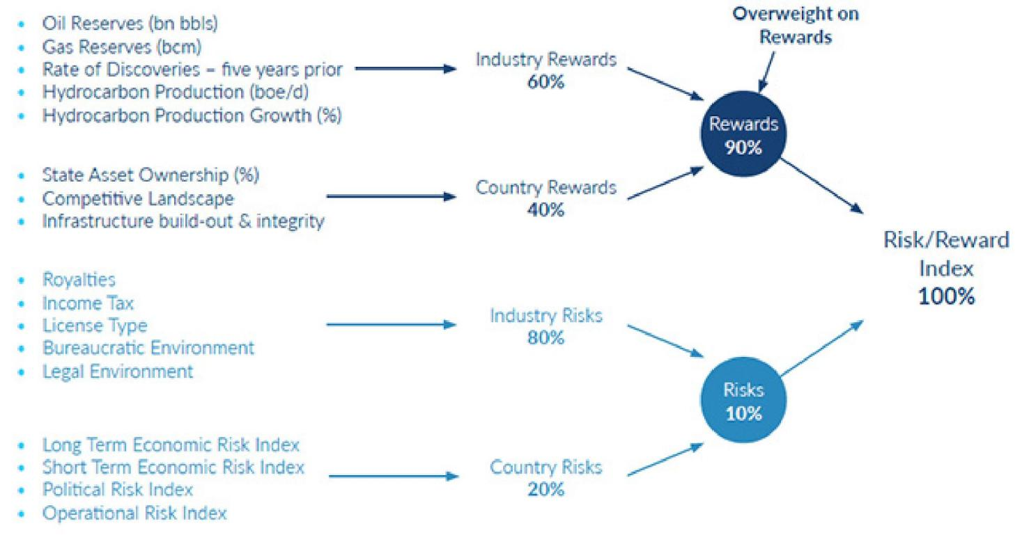

*Source: BMI*

The RRI matrix is divided into two distinct categories:

**Rewards:** Evaluation of an industry's size and growth potential (**Industry Rewards**), and macro industry and/or market characteristics that directly affect the size of business opportunities in a specific industry (**Country Rewards**).

**Risks:** Evaluation of micro, industry-specific characteristics, crucial for an industry to develop to its potential (**Industry Risks**) and a quantifiable assessment of the political, economic and operational profile (**Country Risks**).

**Assessing Our Weightings**

Our matrix is deliberately overweight on **Rewards** (90% of the final RRI score for a market) and within that, the **Industry Rewards** segment (60% of final Rewards score). This is to reflect the fact that when it comes to long-term investment potential, industry size

**Argentina Oil & Gas Report | Q3 2025**

a Fitchsolutions company

and growth potential carry the most weight in indicating opportunities, with other structural factors (demographic, labour statistics and infrastructure quality) weighing in, but to a slightly lesser extent. In addition, our focus and expertise in emerging and frontier markets has dictated this bias towards industry size and growth to ensure we are able to identify opportunities in markets where regulatory frameworks are not as developed and industry sizes not as big as in developed markets, but where we know there is a strong desire to invest.

Upstream RRI Indicators - Explanation And Sources

|  |  |  |
| --- | --- | --- |
|  | **Source Rationale** | |
| **Rewards** |  | |
| *Industry Rewards* | |  |
| **Oil Reserves (bn bbl)** | National sources, BMI  data | Indicates size of the opportunity for oil developments. Data is for the current  year. |
| **Gas Reserves (bcm)** | National sources, BMI  data | Indicates size of the opportunity for gas developments. Data is for the current  year. |
| **Discoveries Rate - last five years** | BMI calculation Outlines the prospectivity and potential of the upstream. | |
| **Hydrocarbon Production (boe)** | BMI forecast Five-year forward looking indication of production volumes. | |
| **Hydrocarbon Production Growth (boe, %)** | BMI forecast Five-year forward looking indication of production growth. | |
| *Country Rewards* | |  |
| **State asset ownership (%)** | BMI calculation Total share NOCs control. Demonstrates the potential access and restrictions  to resources. | |
| **Competitive Landscape** | BMI calculation Divides resource base by the approximate number of companies operating to  indicate the level of competition. | |
| **Infrastructure Integrity** | BMI calculation Calculates the extent and quality of oil and gas infrastructure, indicating ease  of access and level of maintenance investment needed. | |
| **Risks** |  | |
| *Industry Risks* | |  |
| **Licence Type** | BMI calculation Outlines a marketIs score based on whether oil and gas licences are offered as  concessions, production sharing agreements or service contracts. | |
| **Income Tax** | Government sources Outlines the relative tax rate incurred by oil and gas companies. | |
| **Royalties & Special Taxes** | Government sources Indicates further required payments (and supplementary taxes) beyond income tax. | |
| **Bureaucratic Environment** | BMI Operational Risk  score | Outlines the ease of business processes, with a particular emphasis on  mitigating the risk of delay to project timelines. |
| **Legal Environment Risk** | BMI Operational Risk  score | A second ease of business indicator, highlighting potential challenges with the  transparency and effectiveness of rule of law. |
| *Country Risks* | |  |
| **Long-Term Economic Risk Index** | BMI Country Risk Index The Long-Term Economic Risk Index takes into account the structural  characteristics of economic growth, the labour market, price stability,  exchange rate stability and the sustainability of the balance of payments, as well as fiscal and external debt outlooks for the coming decade. | |
| **Short-Term Economic Risk** | BMI Country Risk Index The Short-Term Economic Risk Index seeks to define current vulnerabilities | |
| **Index** | and assess real GDP growth, inflation, unemployment, exchange rate  fluctuation, BOP dynamics, as well as fiscal and external debt credentials over | |

**Argentina Oil & Gas Report | Q3 2025**

a Fitchsolutions company

|  |  |  |
| --- | --- | --- |
|  | **Source** | **Rationale** |
|  |  | the coming two years. |
| **Political Risk Index** | BMI Country Risk Index | The Political Risk Index is a score made up of the mean average across three distinct pillars: Governance Risk, Society Risk and Security Risk. These are  aggregated into an overall assessment of Political Risk. |
| **Operational Risk Index** BMI Operational Risk  Index | | Our Operational Risk Index focuses on existing conditions relating to four main risk areas: Labour Market, Trade & Investment, Logistics, and Crime & Security. |

*Source: BMI*

**Downstream Oil & Gas Risk/Reward Index**

Our Downstream Oil & Gas RRI quantifies and ranks a market's attractiveness within the context of the downstream industry, based on the balance between the **risks** and **rewards** of entering and operating in different markets.

We combine industry-specific characteristics with broader economic, political and operational market characteristics. We weight these inputs in terms of their importance to investor decision-making in a given industry. The result is a nuanced and accurate

reflection of the realities facing investors in terms of the balance between opportunities and risks and between sector-specific and broader market traits. This enables users of the index to assess a market's attractiveness in a regional and global context.

The index combines our proprietary forecasts and analyst assessment of the regulatory regime. As regulations and forecasts change, so the scores change providing a dynamic and forward-looking result.

The Downstream Oil & Gas Risk/Reward Index comprises **92 markets**.

**Benefits Of Using Our Downstream Oil & Gas RRIs**

• **Global Index:** A global table, ranking all the markets in our universe for downstream oil & gas from most attractive (closest to zero) to most risk (closest to 100).

• **Accessibility:** Easily accessible, top-down view of the global, regional or sub-regional risk/reward profiles.

• **Comparability:** Identical methodology across 92 markets for oil & gas allows users to build lists of markets they wish to compare, beyond the confines of a global or regional grouping.

• **Scoring:** Scores out of 100 with a wide distribution provide nuanced investment comparisons. The higher the score, the less favourable the profile.

• **Quantifiable:** Quantifies the rewards and risks of doing business in the downstream industry in different markets around the world and helps identify flashpoints in the overall business environment.

• **Comprehensive:** Comprehensive set of indicators assessing industry-specific risks and rewards alongside political, economic and operating risks.

• **Entry Point:** A starting point to assess the outlook for the downstream oil and gas industry, from which users can dive into more granular forecasts and analysis to gain a deeper understanding of the market.

• **Balanced:** Multi-indicator structure prevents outliers and extremes from distorting final scores and rankings.

• **Methodology:** It is a combination of proprietary BMI forecasts, analyst insights and globally acceptable benchmark indicators.

**Argentina Oil & Gas Report | Q3 2025**

a Fitchsolutions company

Weightings Of Categories And Indicators

Downstream Risk/Reward Index

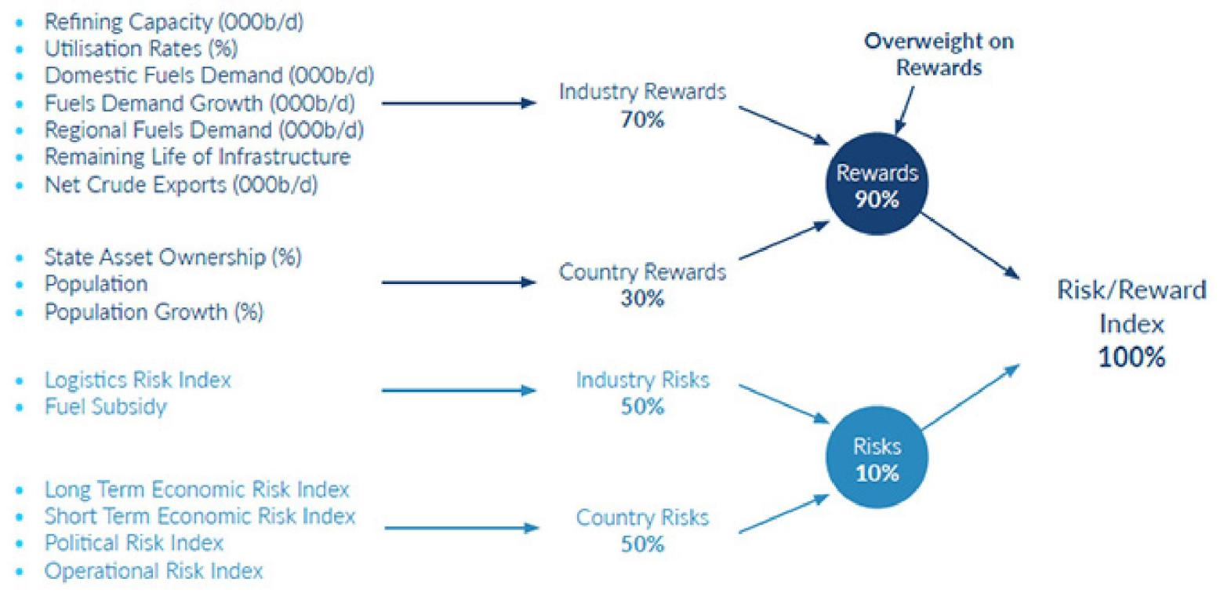

*Source: BMI*

The RRI matrix is divided into two distinct categories:

**Rewards:** Evaluation of an industry's size and growth potential (**Industry Rewards**), and macro industry and/or market characteristics that directly affect the size of business opportunities in a specific industry (**Country Rewards**).

**Risks:** Evaluation of micro, industry-specific characteristics, crucial for an industry to develop to its potential (**Industry Risks**) and a quantifiable assessment of the political, economic and operational profile (**Country Risks**).

**Assessing Our Weightings**

Our matrix is deliberately overweight on **Rewards** (90% of the final RRI score for a market) and within that, the **Industry Rewards** segment (70% of final Rewards score). This is to reflect the fact that when it comes to long-term investment potential, industry size and growth potential carry the most weight in indicating opportunities, with other structural factors (demographic, labour statistics and infrastructure quality) weighing in, but to a slightly lesser extent. In addition, our focus and expertise in emerging and frontier markets has dictated this bias towards industry size and growth to ensure we are able to identify opportunities in markets where regulatory frameworks are not as developed and industry sizes not as big as in developed markets, but where we know there is a strong desire to invest.

**Argentina Oil & Gas Report | Q3 2025**

a Fitchsolutions company

Downstream RRI Indicators - Explanation And Sources

|  |  |  |
| --- | --- | --- |
|  | **Source Rationale** | |
| **Rewards** |  | |
| *Industry Rewards* | |  |
| **Refining Capacity ('000b/d) - 5-year ave** | BMI forecast Quantifies the current size of the refining sector as a comparison to peer  markets. | |
| **Utilisation Rates (%) - 5-year ave** | BMI calculation Outlines the efficiency of the existing facilities, identifying over or under  capacity. | |
| **Domestic Fuels Demand ('000b/d) - 5-year ave** | BMI forecast Shows the size of the domestic market demand as a comparison to peer  markets. | |
| **Fuel Demand (% growth) - 5-year ave** | BMI forecast Identifies the domestic demand opportunity and trend in consumption  patterns. | |
| **Regional Fuel Demand - 5-year ave** | BMI forecast Shows the regional export market size to represent the opportunity for  exports. | |
| **Life Span Of Infrastructure** | BMI calculation Approximate calculation of the life span of infrastructure to identify the  remaining operating life. | |
| **Theoretical Net Crude**  **Exports ('000b/d) - 5-year ave** | BMI calculation Identifies spare capacity of domestic oil supply as a potential feedstock. | |
| *Country Rewards* | |  |
| **State asset ownership (%)** | BMI calculation Indicates how much of the given market is open for private investment. | |
| **Population** | BMI calculation Assesses market size based on total population size. | |
| **Population Growth (%)** | BMI calculation Assesses potential market size based on the population growth rate over five  years. | |
| **Risks** |  | |
| *Industry Risks* | |  |
| **Logistics Risk** | BMI Operational Risk  Index | Offers a comparative indicator on ease of transport for feedstock supply, fuels  distribution and import/export flexibility. |
| **Fuel Subsidies** | BMI calculation Penalises a markets’ score if fuels prices are sold at below market costs. | |
| *Country Risks* | |  |
| **Long-Term Economic Risk Index** | BMI Country Risk Index The Long-Term Economic Risk Index takes into account the structural  characteristics of economic growth, the labour market, price stability,  exchange rate stability and the sustainability of the balance of payments, as well as fiscal and external debt outlooks for the coming decade. | |
| **Short-Term Economic Risk Index** | BMI Country Risk Index The Short-Term Economic Risk Index seeks to define current vulnerabilities  and assess real GDP growth, inflation, unemployment, exchange rate  fluctuation, balance of payments dynamics, as well as fiscal and external debt credentials over the coming two years. | |
| **Political Risk Index** | BMI Country Risk Index The Political Risk Index is a score made up of the mean average across three  distinct pillars: Governance Risk, Society Risk and Security Risk. These are aggregated into an overall assessment of Political Risk. | |
| **Operational Risk Index** BMI Operational Risk  Index | | Our Operational Risk Index focuses on existing conditions relating to four main  risk areas: Labour Market, Trade & Investment, Logistics, and Crime & Security. |

*Source: BMI*



a Fitchsolutions company

30 North Colonnade, Canary Wharf, London, E14 5GN, UK

Tel: +44 (0)20 7248 0468

Fax: +44 (0)20 7248 0467

Web: [www.fitchsolutions.com/bmi](https://www.fitchsolutions.com/bmiIISSSSNN::1748-3808)

[IISSSSNN:: 1748-3808](https://www.fitchsolutions.com/bmiIISSSSNN::1748-3808)

Copy Deadline: April 2025

© 2025 Fitch Solutions Group Limited. All rights reserved.

All information, analysis, forecasts and data provided by Fitch Solutions Group Limited are for the exclusive use of subscribing persons or organisations (including those using the service on a trial basis). All such content is copyrighted in the name of Fitch Solutions Group Limited and as such no part of this content may be reproduced, repackaged, copied or redistributed without the express consent of Fitch Solutions Group Limited.

All content, including forecasts, analysis and opinion, is based on information and sources believed to be accurate and reliable at the time of publishing. Fitch Solutions Group Limited makes no representation or warranty of any kind as to the accuracy or completeness of any information provided, and accepts no liability whatsoever for any loss or damage resulting from opinion, errors, inaccuracies or omissions affecting any part of the content.

This report from BMI – A Fitch Solutions Company is a product of Fitch Solutions Group Limited; UK Company registration number 08789939 ('FSG'). FSG is an affiliate of Fitch Ratings Inc. ('Fitch Ratings'). FSG is solely responsible for the content of this report, without any input from Fitch Ratings.

Copyright © 2025 Fitch Solutions Group Limited.

Reproduced with permission of copyright owner. Further reproduction

prohibited without permission.