

**College of Engineering**

## CS 1337/1337L Introduction to Object-Oriented Programming

## Dr. Fatemeh (Azi) Tabei

## Fall 2021

**Lab: 10/26/2021**

**Due:10/26/2021**

Create a class named Person, with firstname and lastname properties, and a printname method:

class Person:

def __init__(self, fname, lname):

self.firstname = fname

self.lastname = lname

def printname(self):

print(self.firstname, self.lastname)

**You can try**

x = Person("John", "Doe")  
x.printname()

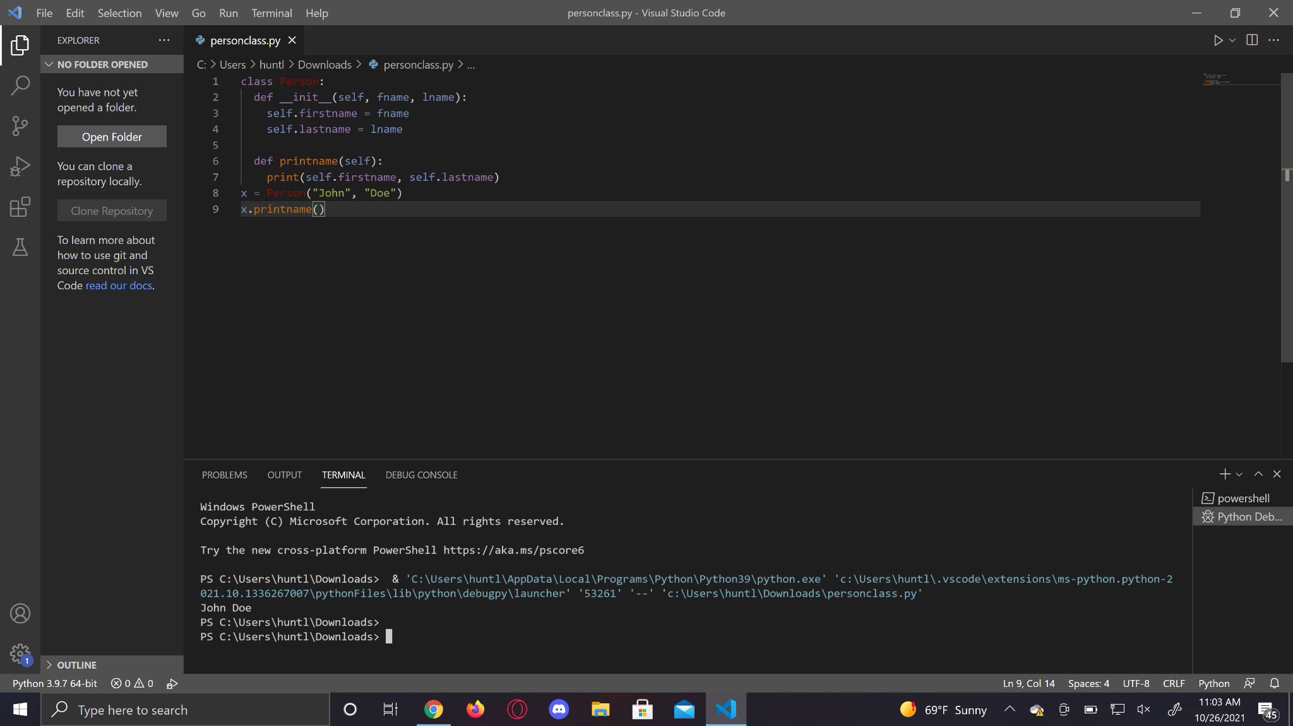

**Create a Child Class**

To create a class that inherits the functionality from another class, send the parent class as a parameter when creating the child class:

class Person:

def __init__(self, fname, lname):

self.firstname = fname

self.lastname = lname

def printname(self):

print(self.firstname, self.lastname)

class Student(Person):

pass

**Note**: Use the **pass** keyword when you do not want to add any other properties or methods to the class.

**You can try**

x = Student("Mike", "Olsen")

x.printname()

**Add the __init__() Function**

class Student(Person):  
  def __init__(self, fname, lname):  
 self.firstname = fname

self.lastname = lname

def printname(self):

print(self.firstname, self.lastname)

**Note**: The child's __init__() function overrides the inheritance of the parent's __init__() function.

**Example**

class Person:

def __init__(self, fname, lname):

self.firstname = fname

self.lastname = lname

def printname(self):

print(self.firstname, self.lastname)

class Student(Person):

def __init__(self, fname, lname):

Person.__init__(self, fname, lname)

**You can try**

x = Student("Mike", "Olsen")

x.printname()

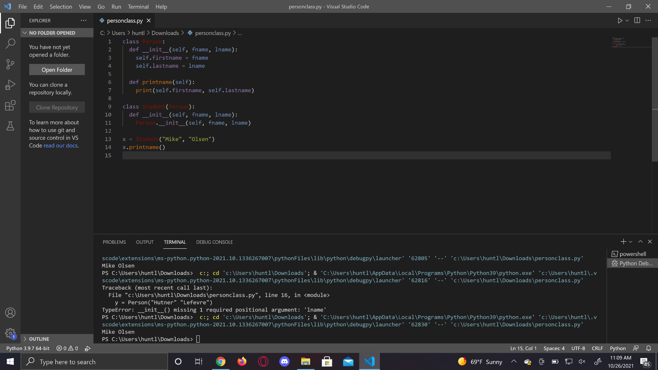

**Use the super() Function**

Python also has a super() function that will make the child class inherit all the methods and properties from its parent:

**Example**

class Person:

def __init__(self, fname, lname):

self.firstname = fname

self.lastname = lname

def printname(self):

print(self.firstname, self.lastname)

class Student(Person):

def __init__(self, fname, lname):

super().__init__(fname, lname)

**You can try**

x = Student("Mike", "Olsen")

x.printname()

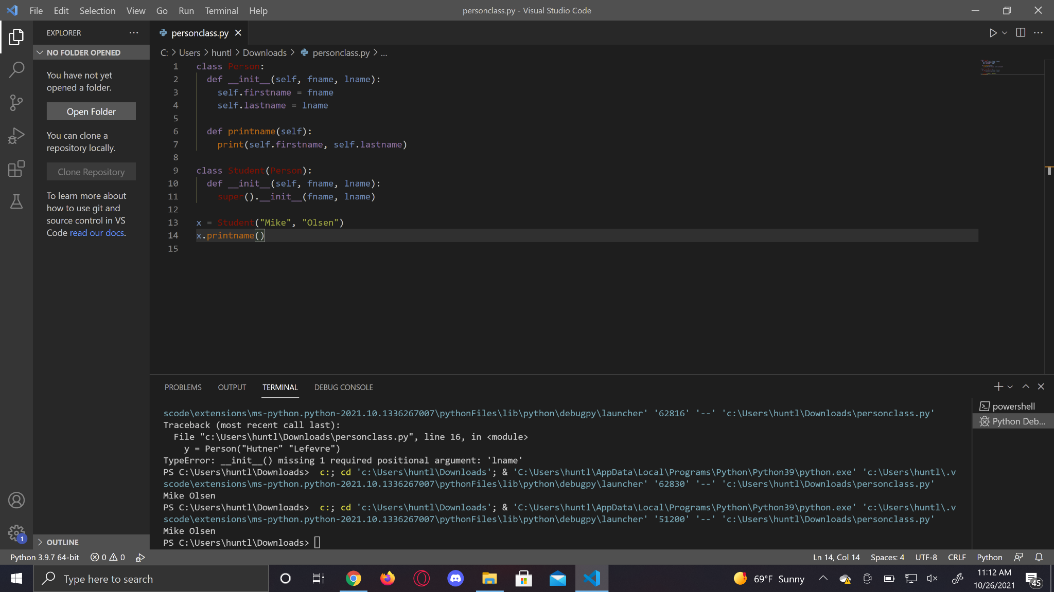

By using the super() function, you do not have to use the name of the parent element, it will automatically inherit the methods and properties from its parent.

Add Properties

**Example**

Add a property called graduationyear to the Student class:

class Student(Person):

def __init__(self, fname, lname):

super().__init__(fname, lname)

self.graduationyear = 2019

**You can try**

x = Student("Mike", "Olsen")

print(x.graduationyear)

