

**College of Engineering**

## CS 1337/1337L Introduction to Object-Oriented Programming

## Dr. Fatemeh (Azi) Tabei

## Fall 2021

**Lab (Chapter 18, Building a GUI program** **): 11/04/2021**

**Due:11/04/2021**

In this lab, you just review the lecture by implementing the provided code on your computer. You only need to provide a screenshot of your work and understand what exactly you are implementing in each step.

* **TkInter First Program**

Let’s see a very basic program.

**from** tkinter **import** **\*** *### (1)*

root **=** Tk() *### (2)*

root**.**mainloop() *### (3)*

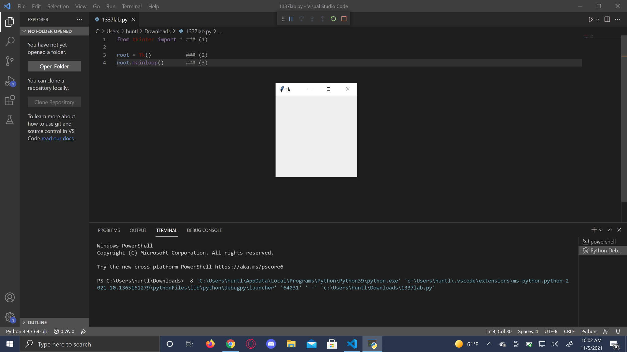

* **Widgets and Containers**

**from** tkinter **import** **\***

root **=** Tk()

main_frame **=** Frame(root)

main_frame**.**pack()

top_frame **=** Frame(main_frame)

top_frame**.**pack(side**=**TOP)

bottom_frame **=** Frame(main_frame)

bottom_frame**.**pack(side**=**BOTTOM)

button1 **=** Button(top_frame, text**=**"Top 1")

button1**.**pack(side**=**LEFT)

button2 **=** Button(top_frame, text**=**"Top 2")

button2**.**pack(side**=**RIGHT)

button3 **=** Button(bottom_frame, text**=**"Bottom 1")

button3**.**pack(side**=**LEFT)

button4 **=** Button(bottom_frame, text**=**"Bottom 2")

button4**.**pack(side**=**RIGHT)

root**.**mainloop()

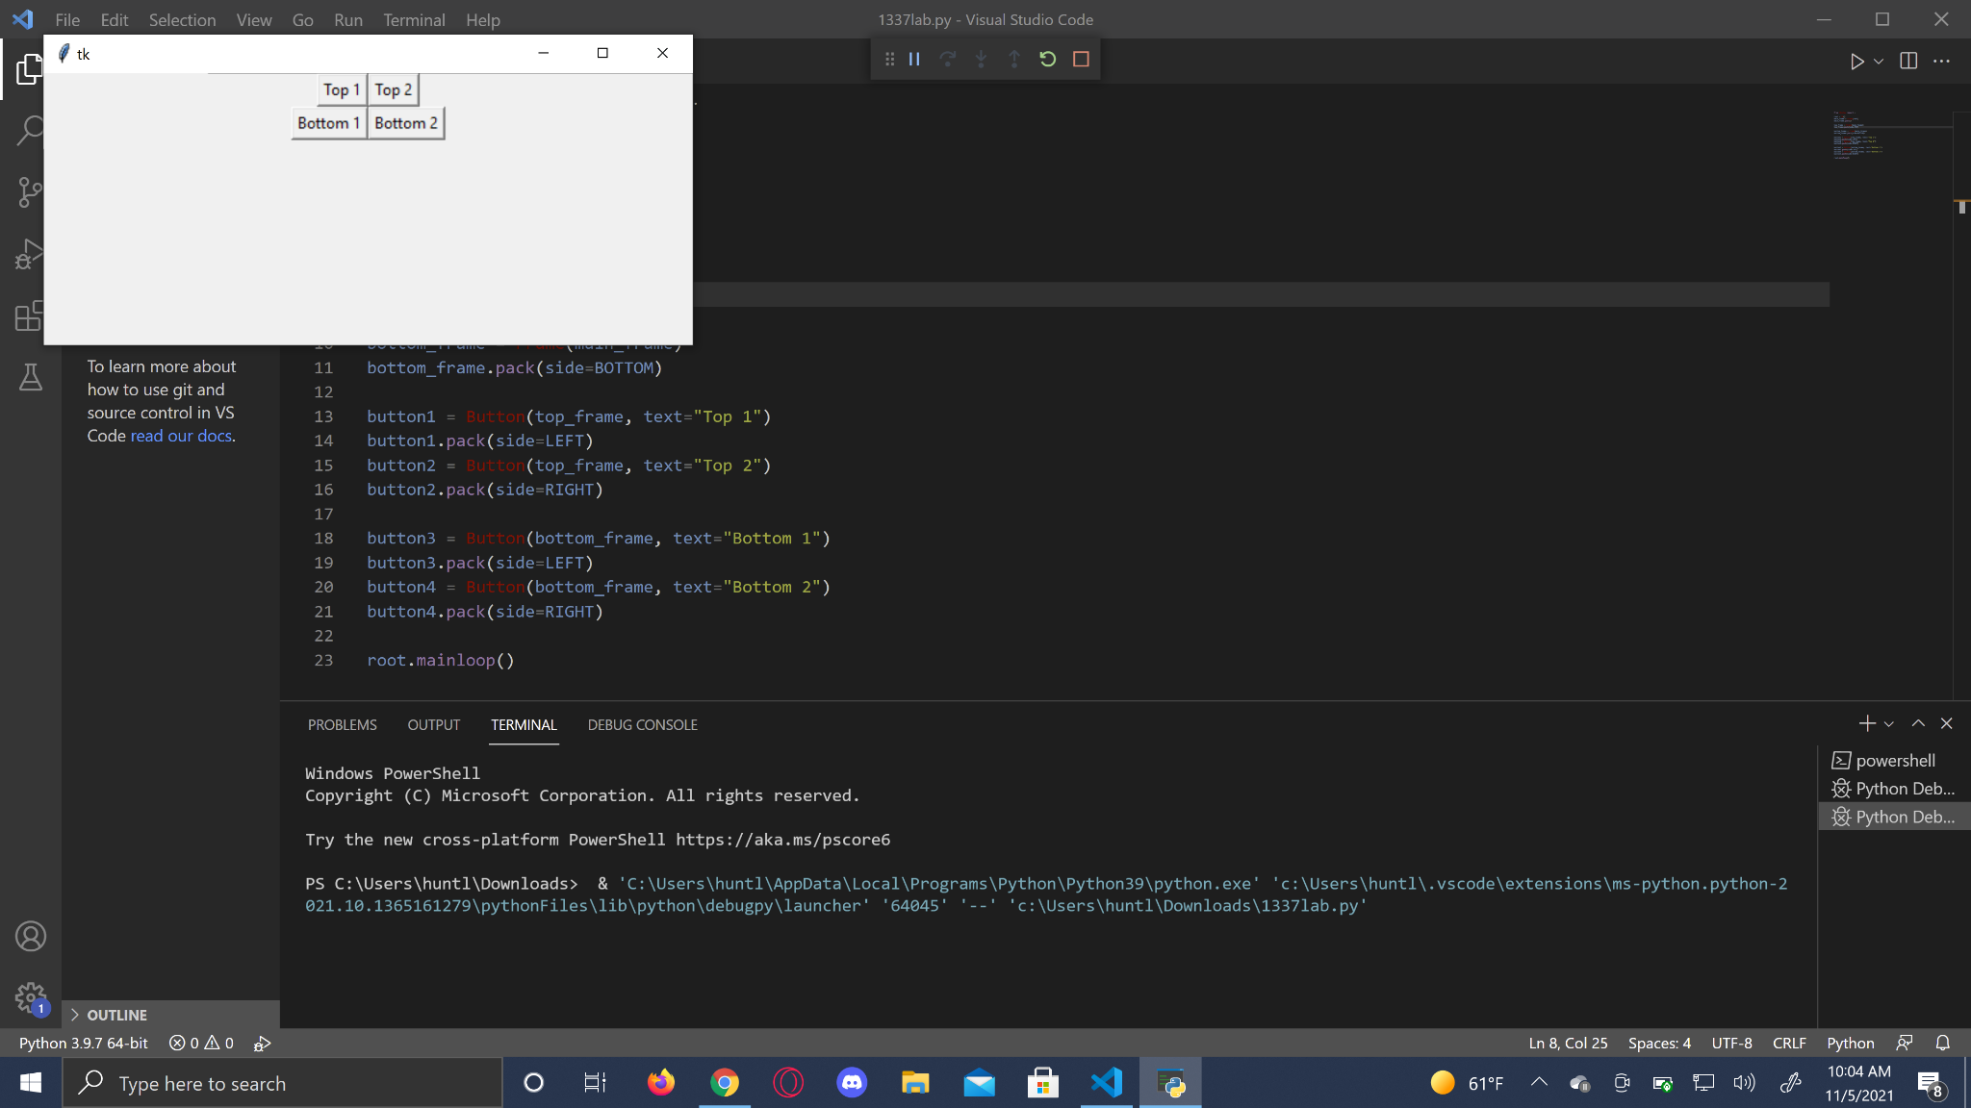

* **Running Tkinter programs using classes**

**from** tkinter **import** **\***

**class** **MyApp**(object):

**def** **__init__**(self, parent):

self**.**main_frame **=** Frame(parent)

self**.**main_frame**.**pack()

self**.**top_frame **=** Frame(self**.**main_frame)

self**.**top_frame**.**pack(side**=**TOP)

self**.**bottom_frame **=** Frame(self**.**main_frame)

self**.**bottom_frame**.**pack(side**=**BOTTOM)

self**.**button1 **=** Button(self**.**top_frame, text**=**"Top 1")

self**.**button1**.**pack(side**=**LEFT)

self**.**button2 **=** Button(self**.**top_frame, text**=**"Top 2")

self**.**button2**.**pack(side**=**RIGHT)

self**.**button3 **=** Button(self**.**bottom_frame, text**=**"Bottom 1")

self**.**button3**.**pack(side**=**LEFT)

self**.**button4 **=** Button(self**.**bottom_frame, text**=**"Bottom 2")

self**.**button4**.**pack(side**=**RIGHT)

**if** __name__ **==** "__main__":

root **=** Tk()

myapp **=** MyApp(root)

root**.**mainloop()

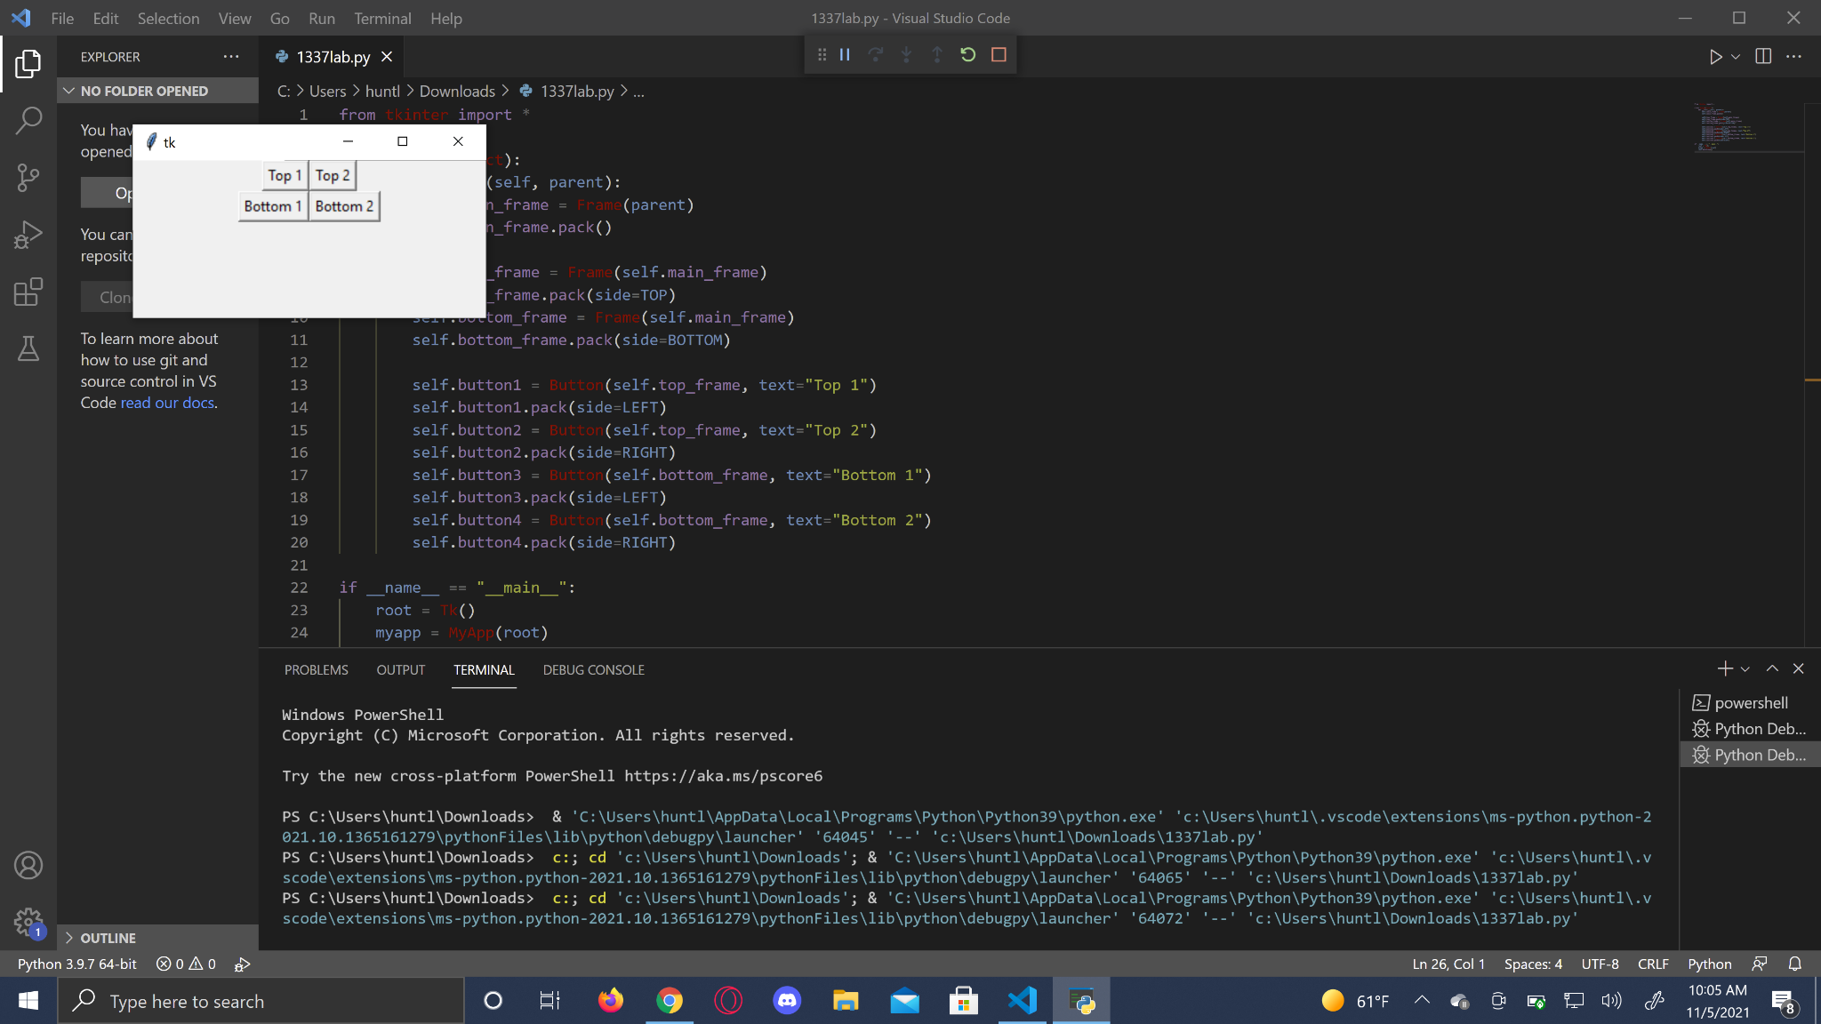

**References**:

https://www.cs.rpi.edu/~sibel/csci1100/fall2015/course_notes/lec22_tkinter.html