# **QA Standard Operating Procedure**

## **Work flow**

1. **Report daily tasks in slack group (slack) - before 15 mins of meeting time**

* Doing: As a QA, the tasks or status that you will do or still doing on that respective day would be written in the ‘Doing’ segment (e.g – Testing status, writing functional test case, making alignment or clarification with the respective project members or clients).
* Done: As a QA, the tasks or status that you did or have done last day or on that respective day would be written in the ‘Done’ segment.
* Blocker: As a QA, the tasks or status that were needed to align, clarify or discuss with the respective person or team would be written in the ‘Blocker’ segment.

1. **Do the host for daily meeting and inform daily meeting to other members in Slack and WhatsApp applications**

Detailed Explanation:

* Check whether all members are in the meeting or not
* Inform which members are taking a leave or couldn’t join meeting
* Remind meeting info in Slack and WhatsApp groups
* Call members one by one to report daily task (Start from Dev Team, Designer Team, QA Team)
* Manage to arrange follow up meetings if they have blockers

1. **Create and clean up tickets in Click Up such as status changes, set ticket tags (example – issue), assign a person for respective tasks, and set up due date.**

General Rules:

* OPNE tickets need to be followed by QA team and must assign to respective designers or developers. (Developers and Designers: please only start to implement the ticket which have due date). OPNE status tickets with no due date won’t be counted as to do.
* If the status is Doing, the assigned person should be the developer and must have a due date.
* (After Developer finished the task, he/she needs to change status into Ready to Deploy and assigned to DevOps team member)  
  2. If status is Ready to Deploy, the assigned person should be DevOps team member.  
  (After DevOps team member has merged the code, he needs to change status into Ready to Test and assigned to QA member).
* If the status is Ready to Test, the assigned person should be QA.  
  (When QA ensured the testing, he/she needs to comment that it has been tasted (with a screenshot) and change status to Verified). Please make sure you include the tag in every ticket for a better filter function (currently “Issue, Enhancement, Module, Sub-Module, Feature, UI” etc.. ).
* QA team members need to follow up to have the due date for “DOING” ticket by aligning with assigned developer.
* After QA tested one ticket, if the functions haven’t been completed, QA needs to change the status ticket into “OPEN” and assign respective developers back. The process will start again from No (1).
* If the feature tickets are having issues, QA needs to create issues tickets under parents having issues tickets. These all tickets should be in “OPEN” status and the process will start again from NO (1).

Will filter ticket in every daily meeting

1. **Write test cases for respective projects (one drive, clickup)**

Sample test cases and format

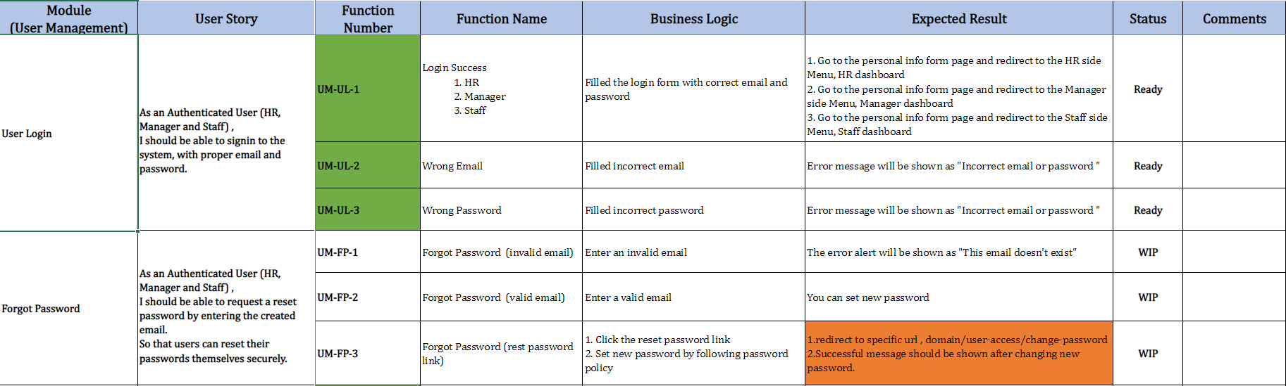

As a QA, we have to follow the above sample test cases format

* Module: Name of the main modules that involve in project
* User Story
* Function Number (short module name, short sub-module name-number)

1. **Write user stories for respective projects (OneDrive, Figma)**

Clients’ requirements are translated to user stories to build up functional specifications for the system. In the user story, persona and what they want to do in the system should clearly defined.

1. **Draw use case diagrams and site map for respective projects (StarUml, Draw.io, Lucid Chart, Visual Paradigm)**

Sample of Use Case

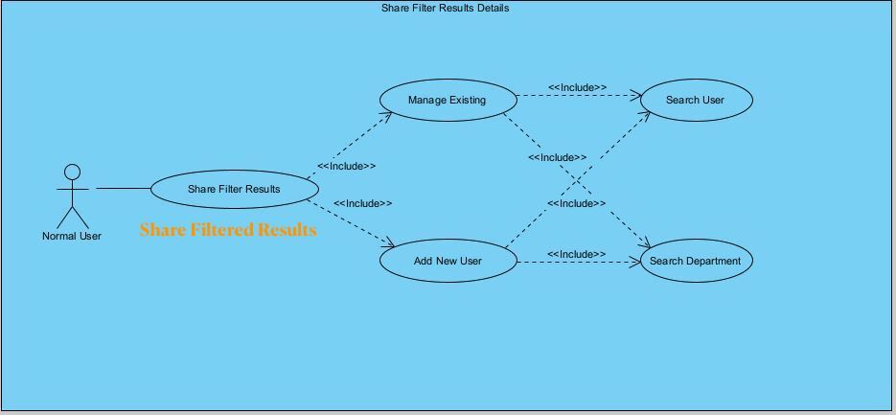

**Sample of Site Map**

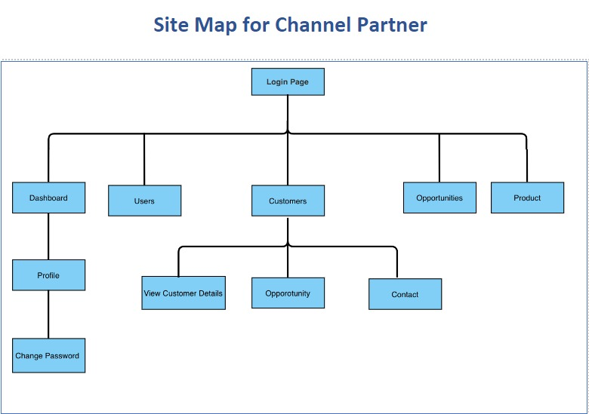

1. **Write user manual for respective projects (OneDrive)**

<https://1drv.ms/w/s!AhlUkNBvvrW_iMJIlen1falxwmgWgA?e=dEpHng>

1. **Meeting with clients for logic/UI confirmation**

As part of the job description, meeting with clients is a must for clarifying and confirming user stories, UI, and development matters. Depending on the project size or requirements. Meeting schedules could be varied depending on the project size or requirements. All changes and discussions during the meeting must keep on track and solve accordingly with respective stakeholder or team.

**9. Align with designers and developers for blockers solving and clarification**

As a QA, when the requirements are settled down, the next step is to discuss and align with designers for designing the project UI by Figma. After that, these UI(s) need to be confirmed again by Clients. As for the next step, QA aligns with the development team to start implementing these confirmed UI(s). If there are necessary to change the UI design, QA should realign and clarify with all stakeholders (clients, developers, designers) for the final product.

1. **Put explanation of how we discuss (Figma design, development status, blockers...etc.)**
2. **Automation**
3. **Docusaurus**

Tools

1. Slack and WhatsApp for communication

2. ClickUp for tickets --> may vary according to project (Jira)

3. Figma for uis and user stories

4. OneDrive for meeting notes, testcases, user stories and user manual

5. StarUML for use case diagrams and site map

6. Google Meet / Microsoft Team for meetings

7. Company VPN Account with OpenVPN Connect

***Demo recording for software user guide

<https://docusaurus.io/>

https://docusaurus.io/docs