端口开放：
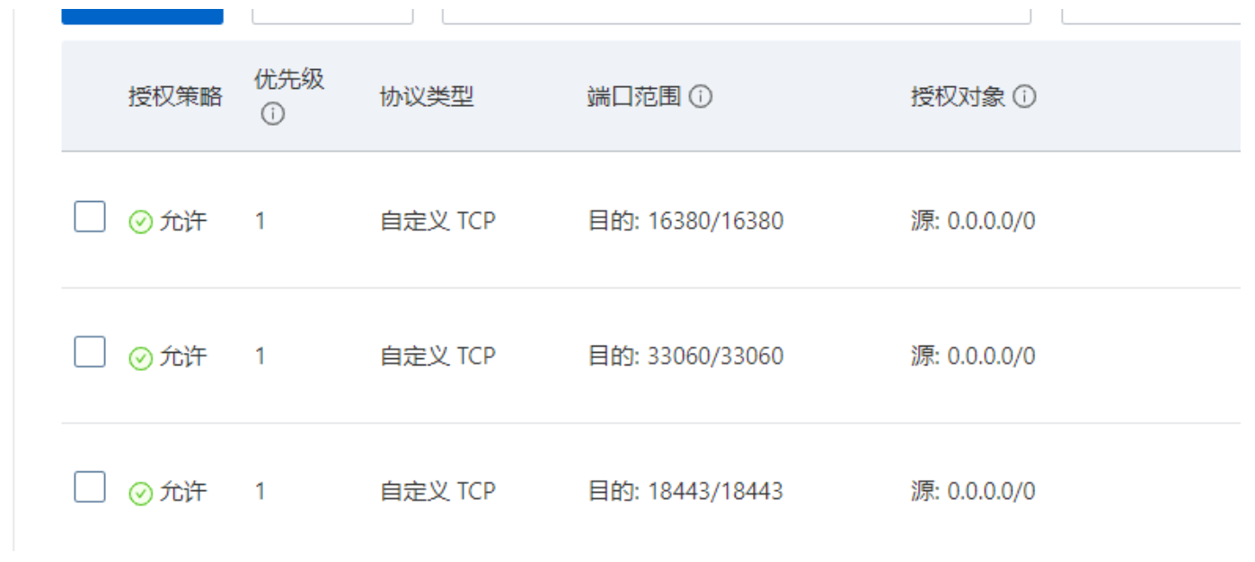
121.199.7.231(172.20.62.17)
16380
33060
18443

114.55.95.197(172.20.62.18)
18443

w2iRU2^LEtCad1DFoW05X6AMq5^!NeIK666666

server 121.199.7.231:18443 max_fails=3 fail_timeout=30s;

location ^~ /daneng/ {
proxy_pass https://daneng-server/daneng/;
root html;
index index.html index.htm;
}

