Long answer Questions
Chapter | Topics that are good to test for Long Answer Questions | All Questions begin with a scenario like this | Then you have to answer three questions like this: | What is the real concept they are testing? If you remember this:  - Take information from the scenario  - Explain it in your own words  - Use phrases we used in the course
6 – Interpersonal Communication | Stages of Interpersonal Relationships  - Initiating  - Maintaining  - Deteriorating | Layla and Noor lived next door to each other in Riyadh. They met when they were young and started talking while playing outside. They liked the same games and spent a lot of time together.  As they grew older, their friendship became stronger. They helped each other with schoolwork and shared their feelings. They spent weekends together, talking and laughing. They cared about each other and were always there when needed.  But later, things changed. Layla received messages from Noor that were not kind. Noor said things that hurt Layla's feelings. Layla felt sad and confused. She tried to talk to Noor, but Noor didn't listen. Their friendship became weak, and they stopped spending time together. | - How did Layla and Noor initiate their friendship? Write at least two sentences (2 marks)  - How did they maintain their friendship? Write at least two sentences (2 marks)  - What caused their friendship to deteriorate? Write at least two sentences (2 marks)  Choose one sentence from the text + explain it in your words and using words from the COM201 course. | Stages of interpersonal relationships from Chapter 6: See the slide below  Answers:  (1)  Layla and Noor lived next door to each other so they lived close as neighbors. This means that they initiated their friendship through proximity which is physical closeness.  (2)  Layla and Noor helped each other with schoolwork and shared their feelings, so they showed affection for each other. This means that they maintained their friendship through empathy and care.  (3)  Later in their friendship Layla received messages from Noor that were not kind, so this affected their relationship negatively. This means that their relationship deteriorated because of the hurtful messages.
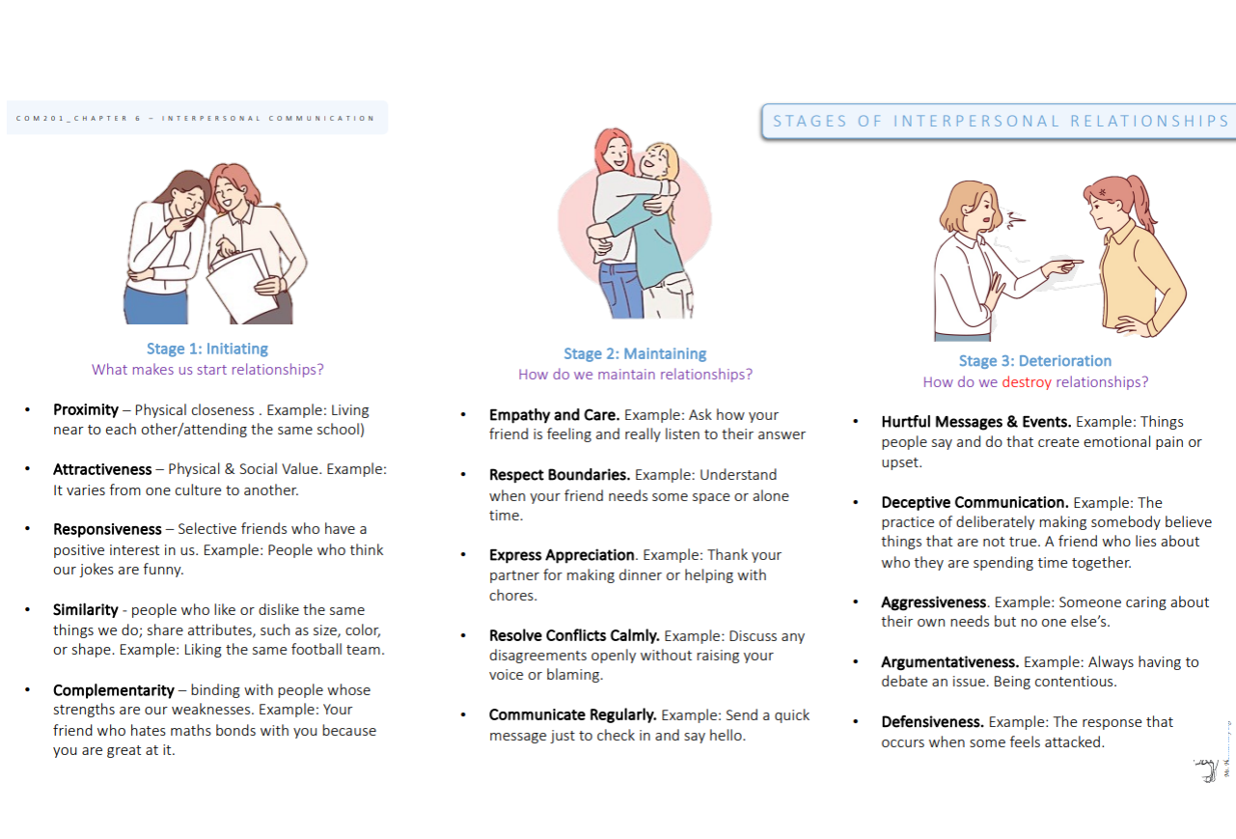
Chapter | Topics that are good to test for Long Answer Questions | All Questions begin with a scenario like this | Then you have to answer three questions like this: | What is the real concept they are testing? If you remember this:  - Take information from the scenario  - Explain it in your own words  - Use phrases we used in the course
7– Inclusive Communication | Theories of Inclusive Communication  - Social Identity Theory  - Communication Accommodation Theory  - Contact Theory | Fatimah is from Saudi Arabia. Noor is from Egypt. They meet in their first English class at university. Fatimah speaks slowly and uses easy English words when talking to Noor. Noor smiles and does the same.  After class, they sit together in the cafeteria. Fatimah says, “We are both Arab. That feels nice in a new place.” Noor nods, “Yes, I feel happy to see someone like me.”  Later, they work on a group project with students from other countries. At first, they speak only to each other. Then their teacher says, “Try to talk with everyone.” Fatimah and Noor start speaking more with the group. After a few weeks, they have new friends from different cultures. | - Which theory does this scenario show? Write at least two sentences (2 marks)  - What example shows the girls changing how they speak? Write at least two sentences (2 marks)  - How does the group project help them understand others? Write at least two sentences (2 marks)  Choose one sentence from the text + explain it in your words and using words from the COM201 course. | Stages of interpersonal relationships from Chapter 7: See the slide below  Answers:  - Fatimah and Noor are both Arab and speak English in a similar way. They feel happy when they meet. This shows they started their friendship through shared identity. This means they formed a bond because they saw similarities between themselves. This reflects the social identity theory.  - Fatimah speaks slowly and uses easy words when talking to Noor. Noor does the same. This shows they are adapting their speech. This means they used communication accommodation to help each other understand better. This reflects the communication accommodation theory.  - In the group project, Fatimah and Noor talked more with students from other cultures. They made new friends. This shows positive contact with others. This means they reduced barriers by working in a group and learning from new people. This reflects the contact theory in practice.
Chapter | Topics that are good to test for Long Answer Questions | All Questions begin with a scenario like this | Then you have to answer three questions like this: | What is the real concept they are testing? If you remember this:  - Take information from the scenario  - Explain it in your own words  Use phrases we used in the course
7– Inclusive Communication | Intersectionality | Amina is a woman who wears a hijab and uses a wheelchair. Some students stare at her in the hallway. In class, she is sometimes ignored. She feels people judge her because of her religion and disability.  Sara is a woman who works part-time. Her boss pays her less than the men. She feels angry because she is not treated fairly as a woman.  Leila is an international student from Somalia. She speaks English well, but some people say she “sounds different.” She also finds that people don’t talk to her much. She feels sad when people treat her unfairly because of her race and accent. | Does Amina experience intersectionality? Why or why not? Write at least two sentences (2 marks)  Does Sara experience intersectionality? Why or why not? Write at least two sentences (2 marks)  Does Leila experience intersectionality? Why or why not? Write at least two sentences (2 marks)  Choose one sentence from the text + explain it in your words and using words from the COM201 course. | - “She feels people judge her because of her religion and disability.”  Yes, Amina experiences intersectionality. She has two identities (Muslim and disabled), and she faces unfair treatment for both. This means she has multiple identities and faces discrimination in more than one way.  - “Her boss pays her less than the men.”  No, Sara does not experience intersectionality. She is treated unfairly because she is a woman, but it is only one identity. This is sexism, not intersectionality.  - “She feels sad when people treat her unfairly because of her race and accent.”  Yes, Leila experiences intersectionality. She is treated unfairly for two reasons—race and language background. This means she has overlapping identities and faces discrimination in more than one way.

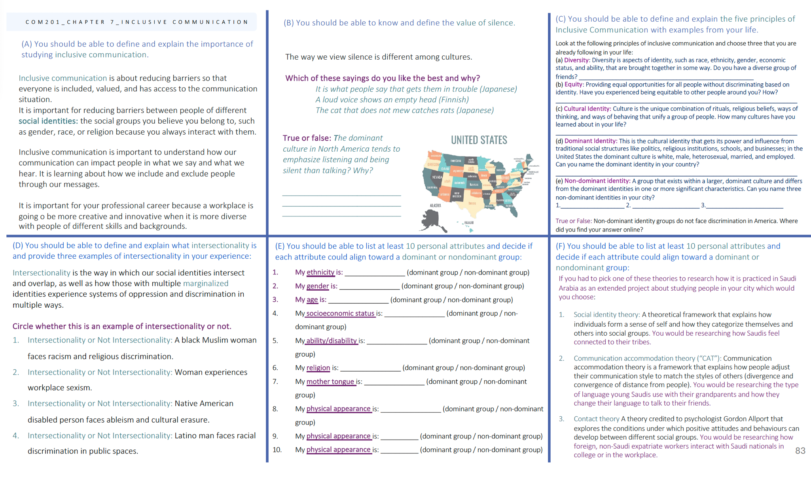

Chapter | Topics that are good to test for Long Answer Questions | All Questions begin with a scenario like this | Then you have to answer three questions like this: | What is the real concept they are testing? If you remember this:  - Take information from the scenario  - Explain it in your own words  - Use phrases we used in the course
Chapter 8 – small group Communication | Types and Functions of Small Groups | Omar, Noura, and Khalid are in a group project for their COM201 class. Their teacher put them together. Omar is the group leader because the teacher said so. He tells everyone what to do and checks the deadline. Noura likes to make people feel happy. She tells jokes and helps when someone is stressed. She was not given this job, but she does it anyway. Khalid and Noura become good friends. They enjoy working together and talking about their lives after class. | - What type of group formation is this? Write at least two sentences (2 marks)  - What role does Noura play in the group? Write at least two sentences (2 marks)  - What is the purpose of this group? Write at least two sentences (2 marks) | - This is an assigned group. The teacher assigned the students to work together, which means the group was created by someone outside of the group. This is different from an emergent group, where the group forms naturally without being assigned.  - Noura plays an informal role. She helps the group by making people feel happy and reducing stress. This role is not given to her by the teacher; it developed naturally based on her behavior and actions within the group.  - The purpose of this group is both task-oriented and relationship-oriented. The group works on completing a project (task-oriented), but they also build friendships and enjoy talking to each other (relationship-oriented). This shows that while they have a task to complete, they also focus on getting to know each other.
Chapter | Topics that are good to test for Long Answer Questions | All Questions begin with a scenario like this | Then you have to answer three questions like this: | What is the real concept they are testing? If you remember this:  - Take information from the scenario  - Explain it in your own words  - Use phrases we used in the course
Chapter 8 | Group think | Ahmed, Yasser, and Omar are in a group for their university project. They need to decide on a topic for their presentation. Ahmed suggests a topic about technology and the future, which he is very interested in. Yasser quickly agrees because he doesn't want to create problems. Omar also agrees but secretly thinks the topic is too broad and might be hard to cover. He feels that a more specific topic, like the impact of technology on education, would be better. However, Omar doesn’t say anything because he doesn’t want to disagree with the group. The three of them quickly move forward with the project, even though Omar is not happy with the topic. This situation is an example of a communication problem because they all agree without proper discussion, and Omar does not voice his concerns. | - Why did they not discuss the topic more?  - What is this communication problem? Use an example from the text with the technical definition.  - How can it be prevented? | - They did not discuss the topic more because they were focused on agreeing with each other to avoid conflict. No one wanted to disagree, so they moved quickly to agree on the topic without critically analyzing it.  - This communication problem is group think. It happens when the desire for agreement and harmony in the group overrides critical thinking. For example, in the scenario, Omar didn't speak up about his concerns because he didn’t want to disrupt the group, which shows the lack of open discussion and critical analysis.  - Group think can be prevented by encouraging everyone to share their opinions, even if they are different. Additionally, assigning someone to play the role of a “devil’s advocate” can help challenge ideas and prevent everyone from agreeing too quickly without proper discussion.
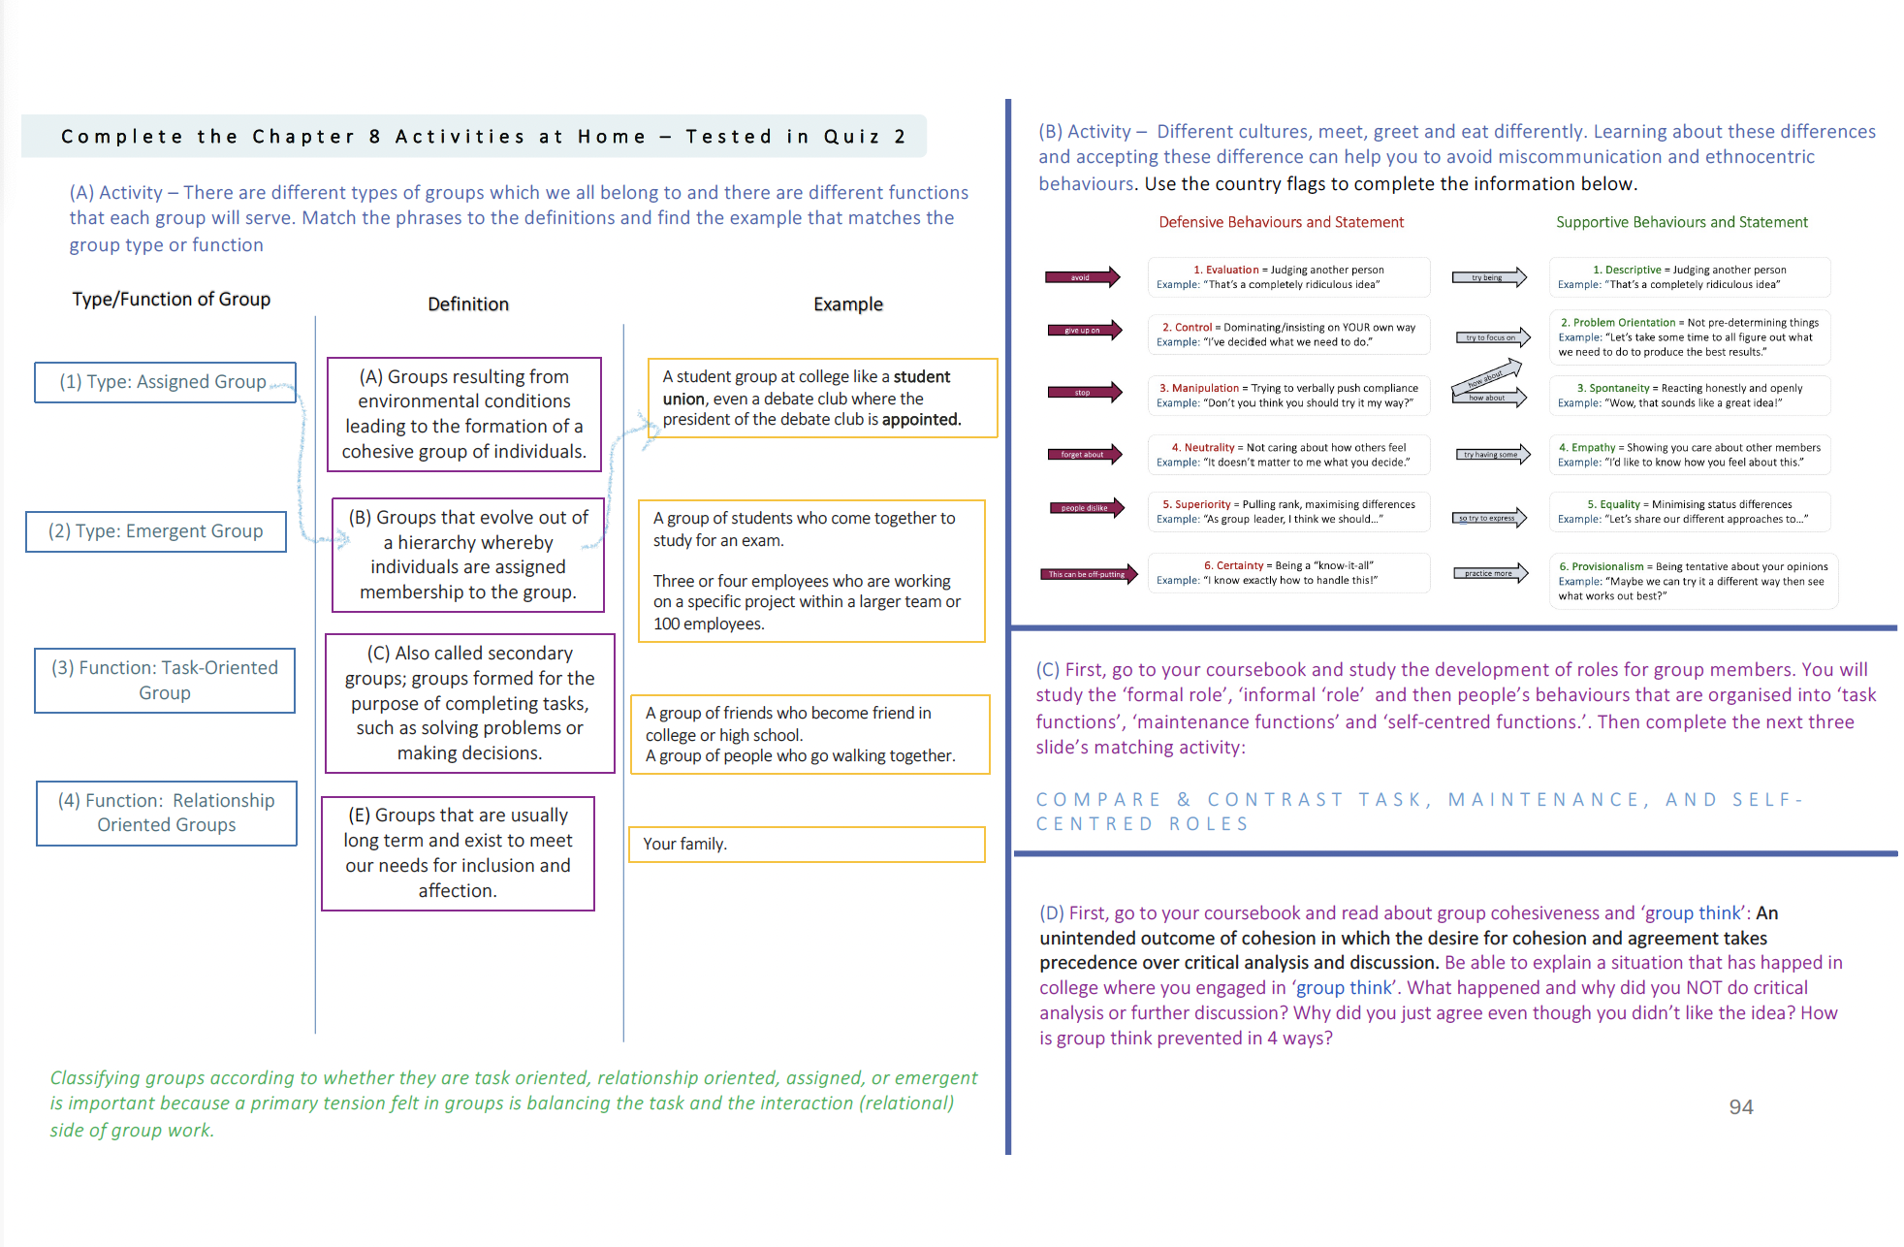

Chapter | Topics that are good to test for Long Answer Questions | All Questions begin with a scenario like this | Then you have to answer three questions like this: | What is the real concept they are testing? If you remember this:  - Take information from the scenario  - Explain it in your own words  - Use phrases we used in the course
Chapter 9 ي | Conflict Management Style | At university, three students—Ahmed, Yasser, and Omar—are working on a group project. They have a disagreement about the direction of the project. Ahmed wants to focus on technology, Yasser suggests focusing on environmental issues, and Omar feels that both ideas are too broad and wants a more specific topic. To avoid tension, Ahmed insists on his idea, while Yasser quietly agrees to avoid arguing. Omar, frustrated but not wanting to cause problems, agrees too, even though he doesn’t like the idea.  Afterward, the group faces issues with the project because they did not truly discuss their ideas, and the outcome is not as good as it could have been. The group struggles to move forward because they did not take the time to address the conflict properly. | - Which conflict management style is being used by Ahmed, Yasser, and Omar in this scenario?  Write at least two sentences. (2 marks)  - Is this conflict management style effective or ineffective? Why?  Write at least two sentences. (2 marks)  - Which conflict management style do you prefer, and why?  Write at least two sentences. (2 marks) | - The conflict management style used by Ahmed is competition, as he insists on his idea despite others' objections. Yasser and Omar use accommodation, agreeing to Ahmed's idea to avoid confrontation, even though they don’t agree with it.  - This conflict management style is ineffective because it does not allow for a proper discussion or resolution of the disagreement. By avoiding true discussion and agreeing without expressing their concerns, the group creates tension and poor outcomes in the project.  - I prefer the collaboration style because it encourages open communication and finding the best solution that everyone can agree on. Although it takes more time, it leads to a more creative and satisfying outcome for everyone involved.
Chapter | Topics that are good to test for Long Answer Questions | All Questions begin with a scenario like this | Then you have to answer three questions like this: | What is the real concept they are testing? If you remember this:  - Take information from the scenario  - Explain it in your own words  Use phrases we used in the course
Chapter 9 | Workplace Communication Skills | Three students, Huda, Aisha, and Mariam, are doing a group project at their college in Riyadh. Huda always smiles and uses kind words when speaking, which makes everyone feel comfortable in the group. Aisha listens carefully and always says things like, “I understand how you feel.” She helps the group feel supported. Mariam speaks clearly but sometimes uses words that can mean different things. One time, she said, “This part is interesting,” but didn’t explain what she meant. Still, the group stays organized because they take turns speaking and do not interrupt each other. They also use hand gestures and eye contact to keep the discussion flowing. | - How does Huda help the group feel connected?  - What kind of listener is Aisha? What does she say to show this?  - What problem can happen when Mariam speaks? Why? | - Huda helps the group feel connected by smiling and using kind words. This is called immediacy because she makes the group feel close and comfortable.  - Aisha is a supportive listener. She listens carefully and says things like “I understand how you feel,” which shows she has empathy and supports others.  - Mariam sometimes uses words that have more than one meaning. This is called strategic ambiguity, and it can cause confusion if the group doesn’t ask her to explain.
Chapter | Topics that are good to test for Long Answer Questions | All Questions begin with a scenario like this | Then you have to answer three questions like this: | What is the real concept they are testing? If you remember this:  - Take information from the scenario  - Explain it in your own words  Use phrases we used in the course
Chapter 9 | Metamorphosis 2 | Reem just started working at a new media company in Riyadh. On her first day, she listened to stories her team told about how they always help clients quickly. She understood this was part of the company culture. She also watched how her team spoke to clients and asked a coworker for tips. At first, Reem felt confused because the job tasks were different from what she expected. She talked to her manager and they made some changes. Reem also followed her team leader closely to learn how to behave at work. | - What did Reem do to learn the company culture?  - What did Reem do when the job was not what she expected?  - Who helped Reem learn how to act at work? | - Reem listened to team stories and watched her coworkers. This shows she interpreted messages and used indirect observation to learn company values.  - Reem felt confused, so she talked to her manager and they changed some tasks. She addressed unmet expectations by asking for support.  - Reem followed her team leader as a role model. She used socialization tactics to learn how to behave in her new workplace.

