Section 2.1: Frequency Distribution and Histograms
2.1 Given the following data, develop a frequency distribution:
5 | 3 | 2 | 6 | 6
7 | 3 | 3 | 6 | 7
7 | 9 | 7 | 5 | 3
12 | 6 | 10 | 7 | 2
6 | 8 | 0 | 7 | 4

2.3 A study is being conducted in which a variable of interest has 1000 observations. The minimum value in the data set is 300 points and the maximum is 2900 points.
a. Use the guideline to determine the minimum number of classes to use in developing a grouped data frequency distribution.

b. Based on the answer to part a, determine the class width that should be used (round up to the nearest 100 points).

2.7 You are given the following data:
6 | 10 | 6 | 4 | 9 | 5
5 | 5 | 5 | 7 | 6 | 2
5 | 5 | 5 | 4 | 5 | 7
6 | 7 | 8 | 6 | 8 | 4
7 | 5 | 5 | 5 | 5 | 7
8 | 7 | 6 | 7 | 5 | 4
6 | 4 | 4 | 7 | 4 | 6
6 | 7 | 8 | 6 | 7 | 6
7 | 8 | 5 | 6 | 5 | 7
3 | 6 | 4 | 7 | 4 | 4

- Construct a frequency distribution for these data.
- Based on the frequency distribution, develop a histogram.
- Construct a relative frequency distribution.
- Develop a relative frequency histogram.
- Compare the two histograms. Why do they look alike?

2.8 Using the data from problem 2.7,
- construct a grouped data relative frequency distribution of the data. Use the guideline to determine the number of classes.
- Construct a cumulative frequency distribution of the data.

2.2 Assuming you have data for a variable with 2000 values, using guideline, what is the smallest number of groups that should be used in developing a grouped data frequency distribution? (Self-study)

2.5 You have the following 60 data: (Self-study)
8 | 6 | 11 | 14 | 10
11 | 9 | 7 | 2 | 8
9 | 5 | 5 | 5 | 12
7 | 8 | 4 | 17 | 8
12 | 7 | 8 | 8 | 7
10 | 8 | 6 | 9 | 9
11 | 16 | 2 | 7 | 4
8 | 4 | 4 | 5 | 5
9 | 9 | 6 | 6 | 7
7 | 9 | 5 | 4 | 5
14 | 2 | 9 | 0 | 6
1 | 1 | 12 | 11 | 4
- Construct a frequency distribution for these data. Use the guideline to determine the number of classes to use.
- Develop a relative frequency distribution and cumulative frequency distribution using the classes you constructed in part a.
- Develop a histogram based on the frequency distribution you constructed in part a.

2.12 A shipping company recently selected a random sample of 49 airplane weight slips. The weights, measured in pounds, for the sampled crates are as follows: The data are sorted from smallest to largest (Self-study)
77 | 79 | 80 | 83 | 84 | 85 | 86
86 | 86 | 86 | 86 | 86 | 87 | 87
87 | 88 | 88 | 88 | 88 | 89 | 89
89 | 89 | 89 | 90 | 90 | 91 | 91
92 | 92 | 92 | 92 | 93 | 93 | 93
94 | 94 | 94 | 94 | 94 | 95 | 95
95 | 96 | 97 | 98 | 98 | 99 | 101

- Develop a frequency distribution using five classes having equal widths.
- Develop a histogram from the frequency distribution you created in part a.

2.2 Bar Charts, Pie Charts, and Stem and leaf diagrams
2.23 The following data reflect the percentage of employees with different level of education.
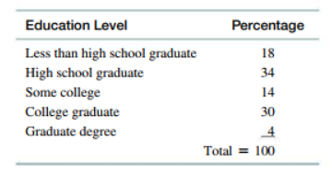

- Develop a Pie chart to illustrate these data.
- Develop a horizontal bar chart to illustrate these data.

2.24. Given the following data on the age of a group of people, construct a stem and leaf diagram. (Self-study)
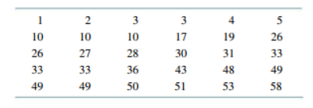

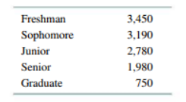
2.25 A University has the following number of students at each grade level.

- Construct a bar chart that effectively display these data
- Construct a Pie chart to display these data.
- Referring to these graphs constructed in parts a) and b) which one you would prefer as more effective way of presenting data.

2.28 The following data is the population of five major European countries in 2006
European country | Population (in Million) Year 2006 | Population (in Million) Year 2016
Germany | 81.8 | 82.3
Turkey | 62.3 | 73.4
France | 59.5 | 63.4
Italy | 56.8 | 59.1
United Kingdom | 58.1 | 60.9
 | Total = 318.5 | Total = 339.1

- Construct a bar chart for the five countries that compares the population in 2006 and 2016

2.29 A survey was carried to determine what is the most favorite students’ activity for the leisure time, the result is shown in the following pie chart
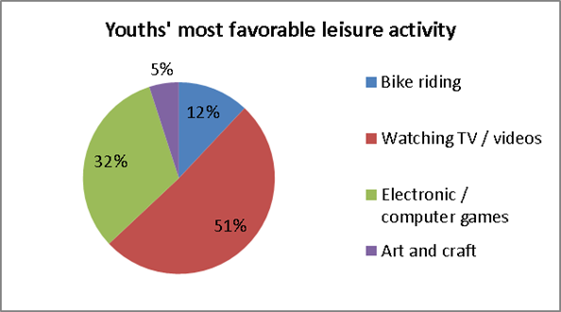
Answer the following:
- Which activity is the most favorable activity for leisure time?
- Which activity is least favorable for leisure time?

2.26. Given the following sales data for product category and sales region, construct at least two different bar charts that display the data effectively: (Self-study)
 |  |  | Region
 |  | East | West | North | South
 | xJ-6 Model | 200 | 300 | 50 | 170
Product Type | X-15-Y Model | 100 | 200 | 20 | 100
 | Craftsman | 80 | 400 | 60 | 200
 | Generic | 100 | 150 | 40 | 50
2.3 Line Charts and Scatter Diagrams
2-46. you have the following sales data for the past 12 months. Develop a line graph for these data
Month | Jan | Feb | Mar | Apr | May | Jun | Jul | Aug | Sep | Oct | Nov | Dec
Sales | 200 | 230 | 210 | 300 | 320 | 290 | 300 | 360 | 400 | 410 | 390 | 450

2.47. The following data have been selected for two varaibles, y and x. Construct a scatter diagram for these two variables and indiacte what type of relationship, if any, appears to be present.
Y | X
100 | 23.5
250 | 17.8
70 | 28.6
130 | 19.3
190 | 15.9
250 | 19.1
40 | 35.3

2.48 The year end net income ( in Millions) for a company for the years 2004-2015 are shown below. Develop a line chart that displays the income data over time.
Year | 2004 | 2005 | 2006 | 2007 | 2008 | 2009 | 2010 | 2011 | 2012 | 2013 | 2014 | 2015
Net Income | 25.9 | 31.5 | 31.7 | 31.7 | 34.5 | 36.8 | 64 | 101.3 | 77 | 87.1 | 118.6 | 172.5

2.48*Given the following data on the age of a group of people, construct a stem and leaf diagram
0.55 | 1.44 | 2.33 | 3.77
0.88 | 1.77 | 3.66 | 4.00
1.22 | 2.66 | 4.99 | 5.44
1.55 | 2.99 | 5.99 | 6.33
1.22 | 2.44 | 5.55 | 6.55
2.99 | 3.22

2.49* A stem and leaf diagram is an alternative to using which of the​ following?
- .a bar chart
- a pie chart
- an ogive
- a histogram

