Chapter 4.1 The basics of probability

Solve the following questions:
4.3 If two customers are asked to list their choice of ice cream flavor from among vanilla, chocolate, and strawberry, list the sample space showing the possible outcomes.

4.4. Use a tree diagram to list the sample space for the number of movies rented by three customers at a video store where customers are allowed to rent one, two, or three movies (assuming that each customer rents at least one movie).

4.8 The results of a census of 2,500 employees of a midsized company with 401 (k) retirement accounts are as follows:
Account Balance  (to nearest $) | Male | Female
Less than < $ 25,000 | 635 | 495
$ 25,000 to $ 49,000 | 185 | 210
$ 50,000 to $ 99,999 | 515 | 260
More than >$ 100,000 | 155 | 45

Suppose researchers are going to sample employees from the company for further study.
- What is the probability that a randomly selected employee will be a female?

- What is the probability that a randomly selected employee will have a 401(k) account balance, of between $25000 and $49999?

- Compute the probability that a randomly selected employee will be a female with an account balance between $50,000 and $99,999.

4.9 Cross County Bicycles makes two mountain bike models, the XB-50 and the YZ -99, in three distinct colors. The following table shows the production volumes for 1st week:
 | Color
Model | Blue | Brown | White
XB-50 | 302 | 105 | 200
YZ-99 | 40 | 205 | 130

- What is the probability that a mountain bike is brown?

- What is the probability that the mountain bike is a YZ-99?

- What is the probability that a randomly selected mountain bike is a YZ-99 and brown?

- Suppose a mountain bike is chosen at random. Consider the following two events: the event that model YZ-99 is chosen and the event that a white product is chosen. Are these two events mutually exclusive? Explain.

Chapter 4.2: The Rules of Probability

4-26 A study was conducted in a school on how students travel to school. Following are the data collected for three methods students travel to school:
Method | Number of Students
Carpool | 35
Drive | 14
Public Transport | 47

- Construct a relative frequency table for the data

- What is the probability the students is not driving to school?

- What is the probability that student use either carpool or drives to school?
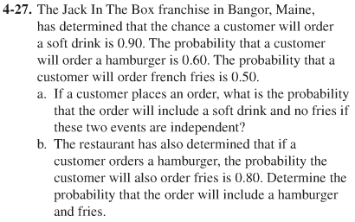

4.31: Three events occur with probabilities:
P(E1) = 0.35, P(E2) = 0.15, P(E3) = 0.40. If the event B occurs, the probability becomes
P(E1|B) = 0.25, P(B) = 0.30

- Compute P(E1 and B)

- Compute P(E1 or B)

- Assume E1, E2, E3 are independent event. Compute P(E1 and E2 and E3)

4.32.Hubble Construction Company has submitted a bid on a state government project that is to be funded by the federal​ government's stimulus money in Arizona. The price of the bid was predetermined in the bid specifications. The contract is to be awarded on the basis of a blind drawing from those who have bid. Five other companies have also submitted bids.What is the probability of the Hubble Construction Company winning the​ bid?

