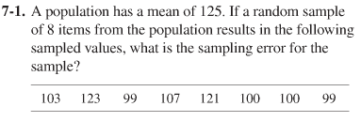

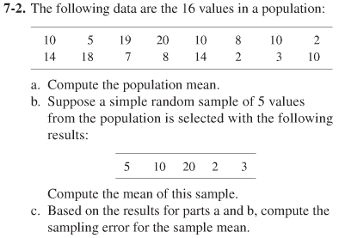

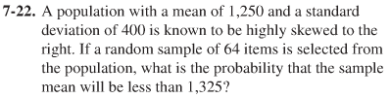

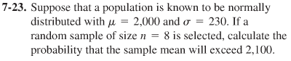

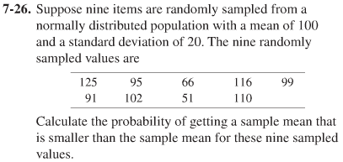

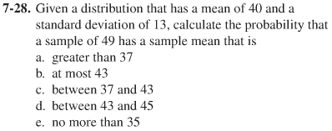

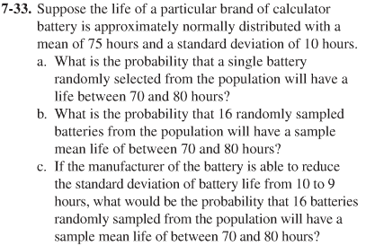

7.3 Sampling distribution of a Proportion

7.45 A population has a proportion equal to 0.30. Calculate the following probabilities with n=100:
a. P($\overline{p}$ ≤ 0.35)
b. P($\overline{p}$ > 0.40)
c. P(0.25 ≤ $\overline{p}$ ≤ 0.40)
d. P( ≥ 0.27)

7.46 If a random sample of 200 items is taken from a population in which the proportion of items having a desired attribute is p = 0.30. What is the probability that the proportion of successes in the sample will be less than or equal to 0.27?

7.48 Given a population in which the proportion of items having a desired attribute is p = 0.25, if a sample of 400 is taken,
a. What is the standard deviation of the sampling distribution of ?
b. What is the probability that the proportion of successes in the sample will be greater than 0.22?

7.57 According to the most recent Labor Department data, 10% of engineers (electrical, mechanical, civil and industrial ) were women. Suppose a random sample of 50 engineers is selected.
a. How likely is it that the random sample of 50 engineers will contain 8 or more women in these positions?
b. How likely is it that the random sample will contain fewer than 5 women in these positions?
c. If the random sample included 200 engineers, how would this change your answer to part b?

