Lab 01a: HTML Basics (Fall 2024)

Goal of this lab : Understand and practice VSCode and basic HTML tags and basic HTML coding style.
You will create your own web page by choosing a specific topic. You can use Wikipedia for example to get data about your chosen topic (talk about a technology, a city, a historical event, etc.).
The web page will look like this:
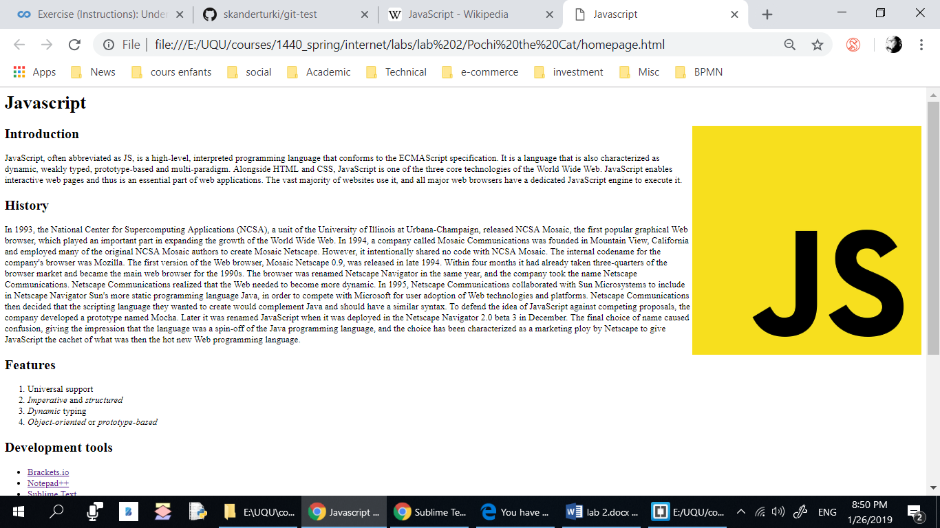
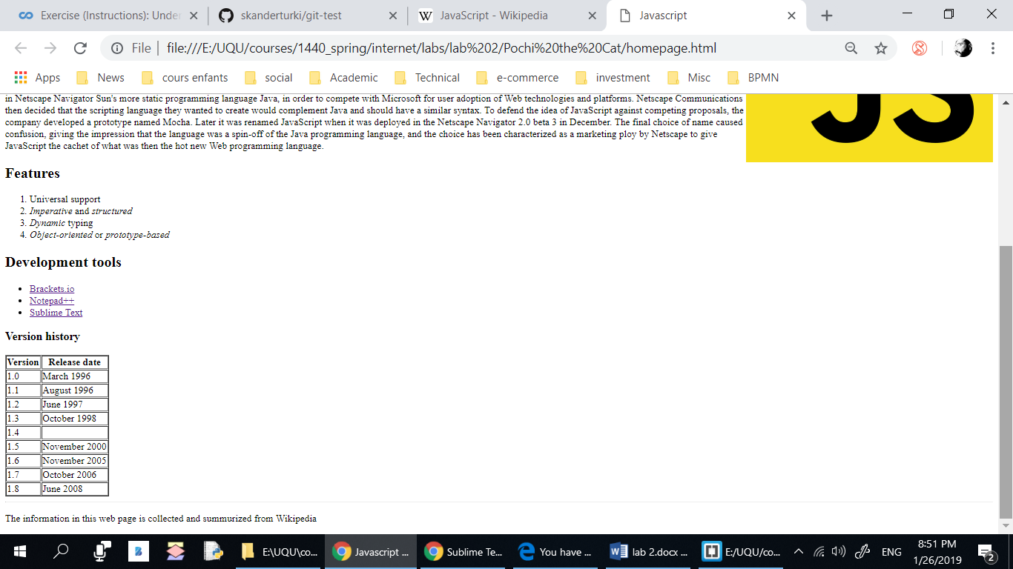

Development Tool:
Use Visual Studio Code + Google chrome.

Steps:

Quickly go through the three main HTML coding style rules in the annex at the end of this document and apply them in this project:
  - Indent by 2 spaces at a time.
  - Use only lowercase.
  - Use a new line for every block, list, or table element, and indent every such child element.
- Create a folder on your Desktop named lab_01a.
- Start your editor (VSCode).
- Create an empty file called index.html.
- Add the DOCTYPE tag.
- Start by creating the root html tag and specify the language of the page.
- Add a head section and a body section. Add a title tag (in the head section).
- Add the page encoding tag.
- Save your file and check if it is working by opening it in a browser using the “live server” extension (go to file->preferences->extensions to install live server).
- Add a heading h1 for the page.
- Add one or more paragraphs of text among the subheadings, making sure to put each of your paragraphs in p tags.
- Add a list under a subheading h2.
- Add a footer section using the Footer tag containing the author name and the date.
- Find an image on the web and save it to the folder where your web page is saved. Then include the image to your document using the img tag. Image files vary widely in size, so you might find that your image is too large on the page when viewed in a browser. In this case, you can modify its width attribute. Do not forget to specify the alt attribute (compulsory according to the google style guide).
- Use character entities (&lt; and &gt; ) to display this HTML code in the content of the page:
<p>This is a paragraph </p>

ANNEX: HTML simplified style guide:

Rule 1: Indentation
Indent by 2 spaces at a time.
Don’t use tabs or mix tabs and spaces for indentation.
<ul>
<li>Fantastic
<li>Great
</ul>

.example {
color: blue;
}

Rule 2: Capitalization
Use only lowercase.
All code has to be lowercase: This applies to HTML element names, attributes, attribute values (unless text/CDATA), CSS selectors, properties, and property values (with the exception of strings).
<!-- Not recommended -->
<A HREF="/">Home</A>
<!-- Recommended -->
<img src="google.png" alt="Google">

Rule 3: HTML General Formatting
Use a new line for every block, list, or table element, and indent every such child element.
Independent of the styling of an element (as CSS allows elements to assume a different role per display property), put every block, list, or table element on a new line.
Also, indent them if they are child elements of a block, list, or table element.
(If you run into issues around whitespace between list items it’s acceptable to put all li elements in one line. A linter is encouraged to throw a warning instead of an error.)
<blockquote>
<p><em>Space</em>, the final frontier.</p>
</blockquote>
<ul>
<li>Moe
<li>Larry
<li>Curly
</ul>
<table>
<thead>
<tr>
<th scope="col">Income
<th scope="col">Taxes
<tbody>
<tr>
<td>$ 5.00
<td>$ 4.50
</table>

Reference:
HTML Google style guide: https://google.github.io/styleguide/htmlcssguide.html
End

