Lab 3b: CSS fonts and forms (Solution steps)
Open the provided form (register.html) and (styles.css), Then, apply these steps:
Section 1: How To import font from outside (e.g. Google) and use it
- The first thing to do is to import the font from Google to be used throughout the rest of the page. Go to this page https://fonts.google.com/ and search Montserrat font. Click on the chosen font.
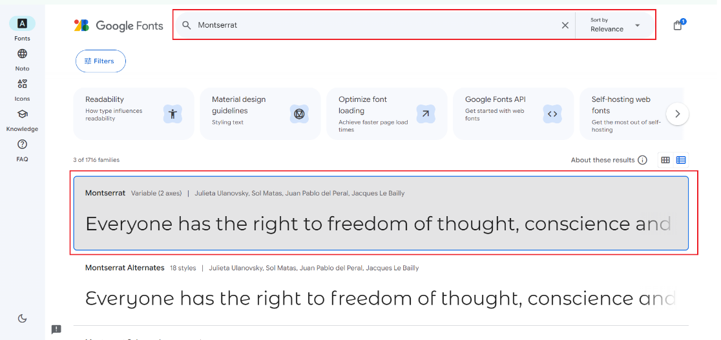
Click on the button “Get embed code”
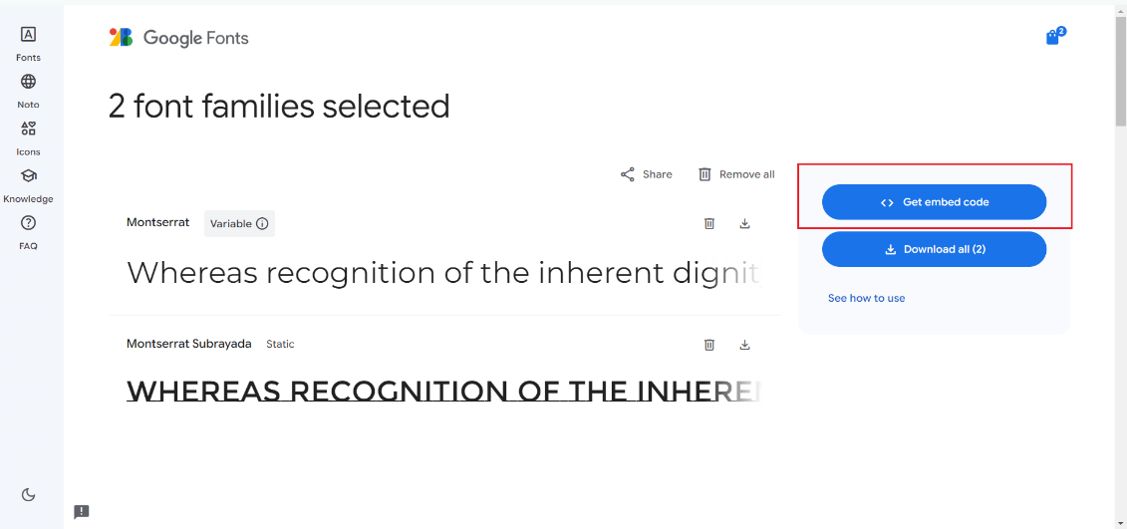
Copy the part frame in red and past it at the top of styles.css:
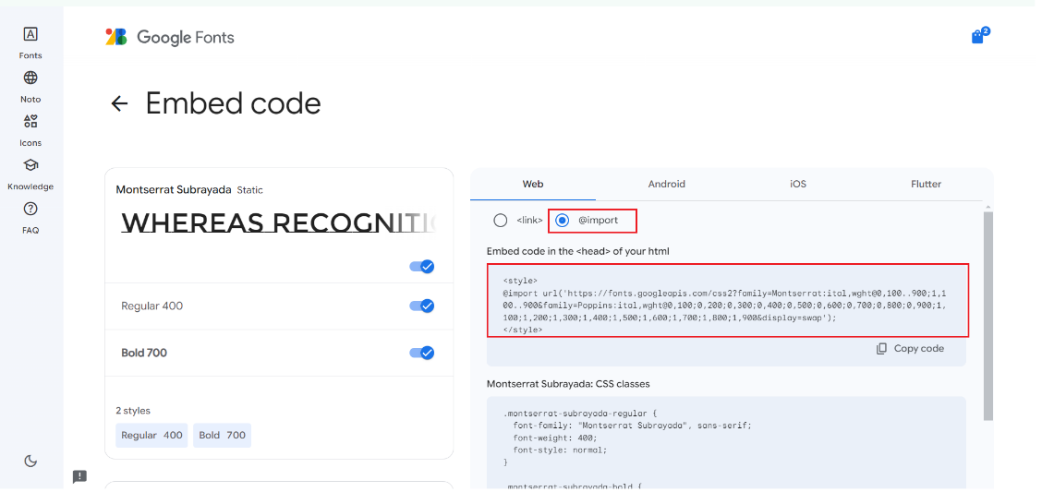

@import url('https://fonts.googleapis.com/css2?family=Montserrat:ital,wght@0,100..900;1,100..900&family=Poppins:ital,wght@0,100;0,200;0,300;0,400;0,500;0,600;0,700;0,800;0,900;1,100;1,200;1,300;1,400;1,500;1,600;1,700;1,800;1,900&display=swap');
Result: This step will not change anything in the style of the fonts because we have not yet used the font on the components:
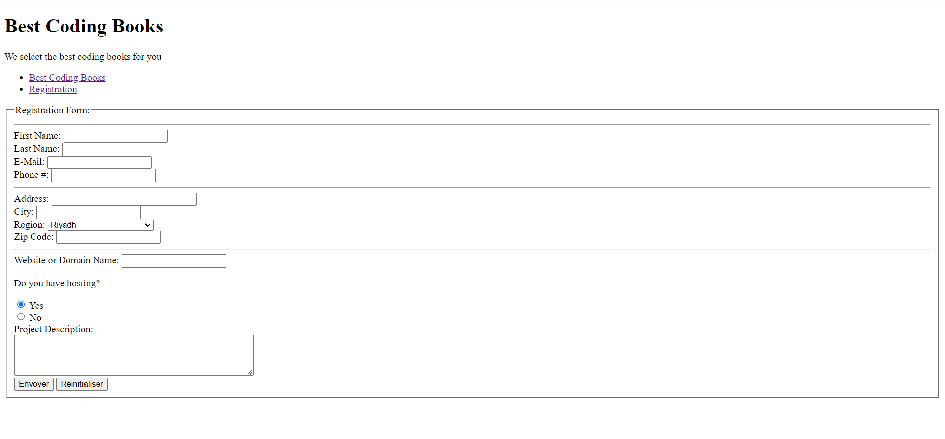
- Choose a font font-family and font-size for all text in this html page, choose font "Montserrat", sans-serif and size 20px you can choose any other font
html {
font-family: "Montserrat", sans-serif;
font-size: 20px;
}
Result: You can notice that the style and size of the text has changed.
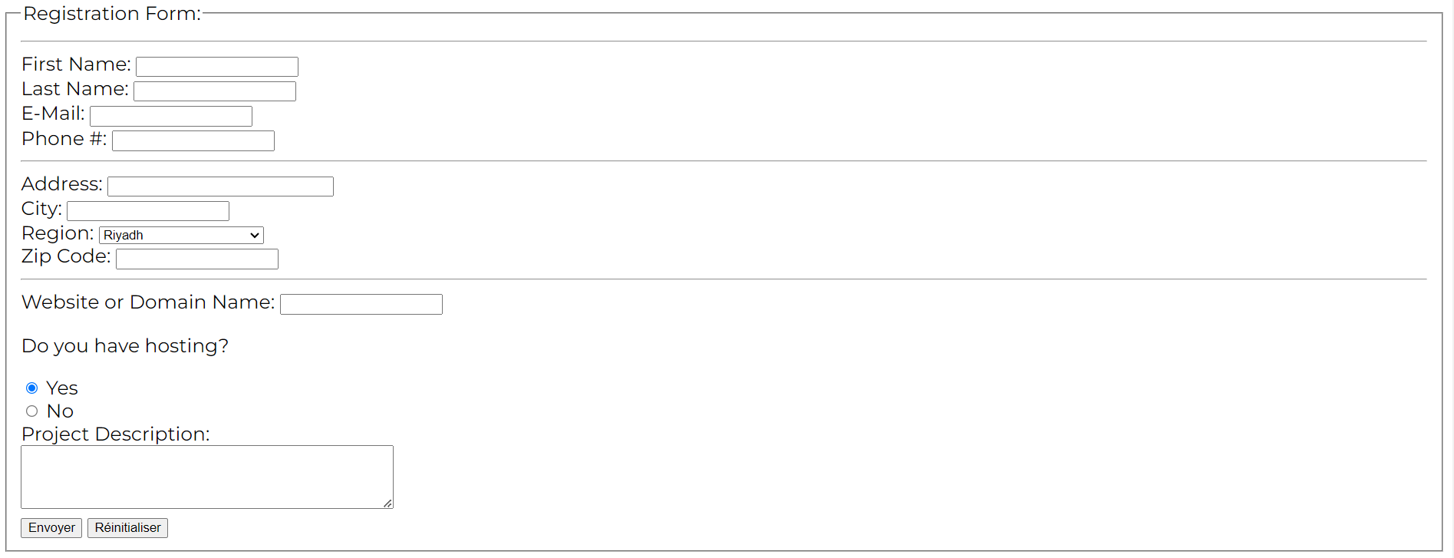

Section 2: How To set variables in :root
- To coordinate some styles on the entire page, we use the :root tag. We can consider that they are predefined styles. Let’s initiate a background color --bg-primary-color with this color rgb(212, 246, 239)
:root {
--bg-primary-color: rgb(212, 246, 239);
}
- For button we can make a primary color --btn-primary-color #a88309 and secondary color rgb(209, 206, 203).
:root {
--bg-primary-color: rgb(212, 246, 239);
--btn-primary-color: #a88309;
--btn-secondary-color: rgb(209, 206, 203);
}
- Radio button can have color for border --radio-border-color #8b8c89, when he is checked #274c77, or when mouse is hover on it #a3cef1. We can also set a background color in case the radio is disabled --radio-disabled-bg-color #d9d9d9.
:root {
--bg-primary-color: rgb(212, 246, 239);
--btn-primary-color: #a88309;
--btn-secondary-color: rgb(209, 206, 203);
--radio-border-color: #8b8c89;
--radio-checked-color: #274c77;
--radio-hover-color: #a3cef1;
--radio-disabled-bg-color: #d9d9d9;
}
Result: Same for the tag :root will not change anything in the page, because the predefined styles are not yet used.


Section 3: How To use background-color
- Use a background-color for the form, Choose color var(--bg-primary-color) already defined in :root
form {
background-color: var(--bg-primary-color);
}
Result: We notice that the background color of the form has changed with the value of --bg-primary-color that we defined in :root and that we used in form
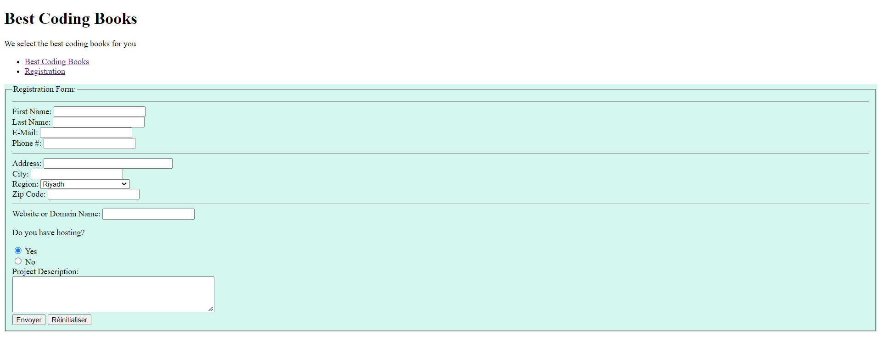

Section 4: How To use margin and padding
- To center the form and make it look nicer, give space 20px between the form and the rest of the page (margin) and add 20px between the form frame and the inputs/label (padding), Also increase size of text that is not a label (font-size) to 0.7rem.
form {
background-color: var(--bg-primary-color);
margin: 20px;
padding: 20px;
font-size: 0.7rem;
}
Result: The form was centered with the margin and padding, the font size had to change also in the form only.
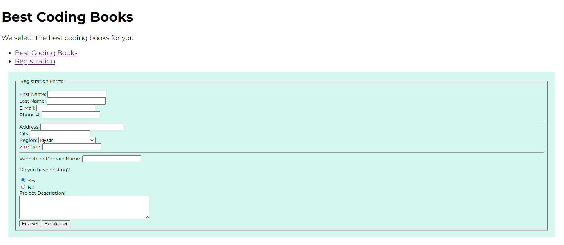

Section 5: How To set display mode
- To give more visibility to the labels, Use a block mode to display each label, add some margin space in top (10px) and bottom (5px) and increment font-size to 0.8rem.
label {
display: block;
margin: 10px 0 5px 0;
font-size: 0.8rem;
}
Result: The labels have displayed in a block shape and added space with the margin. The font size also had to change compared to the rest of the form.


Section 6: How To use border-bottom and width
- To all legends, add a 2px solid border bottom with color #2d0d79, 10px in margin top and bottom, increment font size by 0.9rem and make the width full.
legend {
border-bottom: solid 2px #2d0d79;
margin: 10px 0;
width: 100%;
font-size: 0.9rem;
}
Result: The legend “Registration form” has taken a border at the bottom with margin space and full width. The legend has also changed its font size.


Section 7: How To use margin-bottom
- To highlight the main label “Registration Form:”, attach it to a new class “main_label” then add a style to this class. To make the font larger add weight (800) and set size to 1.1rem, give more space (20px) in margin bottom.
.main_label {
font-weight: 800;
font-size: 1.1rem;
margin-bottom: 20px;
}
Result: We will change the style of the legend again, this time with the main_label class to add space at the bottom and make the font wider.


Section 8: How To set display mode inline
- To make the radio button labels (.label_radio) aligned with the radio, display it inline
.label_radio {
display: inline;
}
Result: Radio button labels (class label_radio) have been displayed in line (inline)
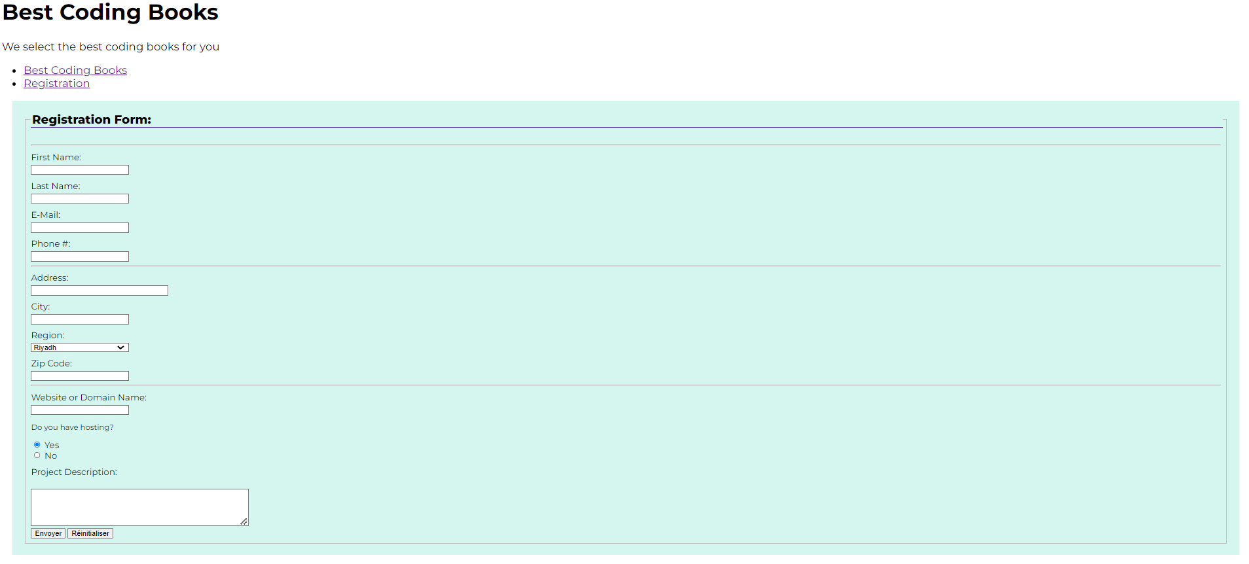

Section 9: How To set styles of multiple tags
- The components of the form (input, textarea, select) have common characteristics, such as a 90% in width, 10px in bottom space, 5px in padding top/bottom and 2px in padding right/left.
input, select, textarea {
margin-bottom: 10px;
width: 90%;
padding: 5px 2px;
}
Result: for inputs, select and textarea we have added margin at bottom with space in sides (padding) and specify width to 90%.
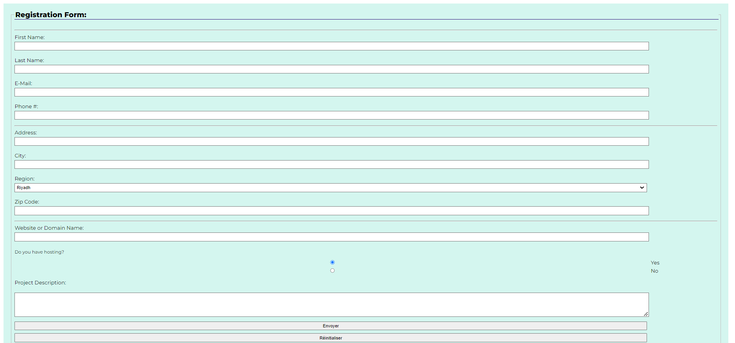

Section 10: How To set style to input with a specified type (including border, appearance)
- The radio input component has more particularities, it has 20px in width and height, 6px in margin, solid border with 2px, color var(--radio-border-color), percentage of border radius is 50%, no appearance
input[type="radio"] {
width: 20px;
height: 20px;
margin: 6px;
padding: 0;
border: 2px solid var(--radio-border-color);
border-radius: 50%;
appearance: none;
}
Result: We styled the radio input even more, added some space in margin / padding, added a border, specified the width and height.
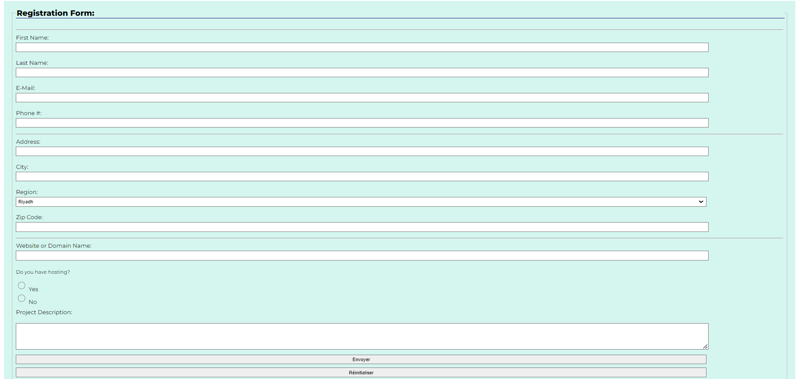

Section 11: How To control radio button styles
- Still with input radio, when the radio in checked and not disabled, set a border and background color var(--radio-checked-color), To define how radio background extends below the border box set a background clip content-box, add 2px space in padding. We can also set a background image using radial gradient, this radial should be circle and the same color gradient from 0% to 50% with transparent from 60% to 100%.
input[type="radio"]:not(:disabled):checked {
border-color: var(--radio-checked-color);
background-color: var(--radio-checked-color);
background-clip: content-box;
padding: 2px;
background-image: radial-gradient(
circle,
var(--radio-checked-color) 0%,
var(--radio-checked-color) 50%,
transparent 60%,
transparent 100%
);
}
Result: We added a bit more detail for the radio button, like the border and background color when checked and not disabled.
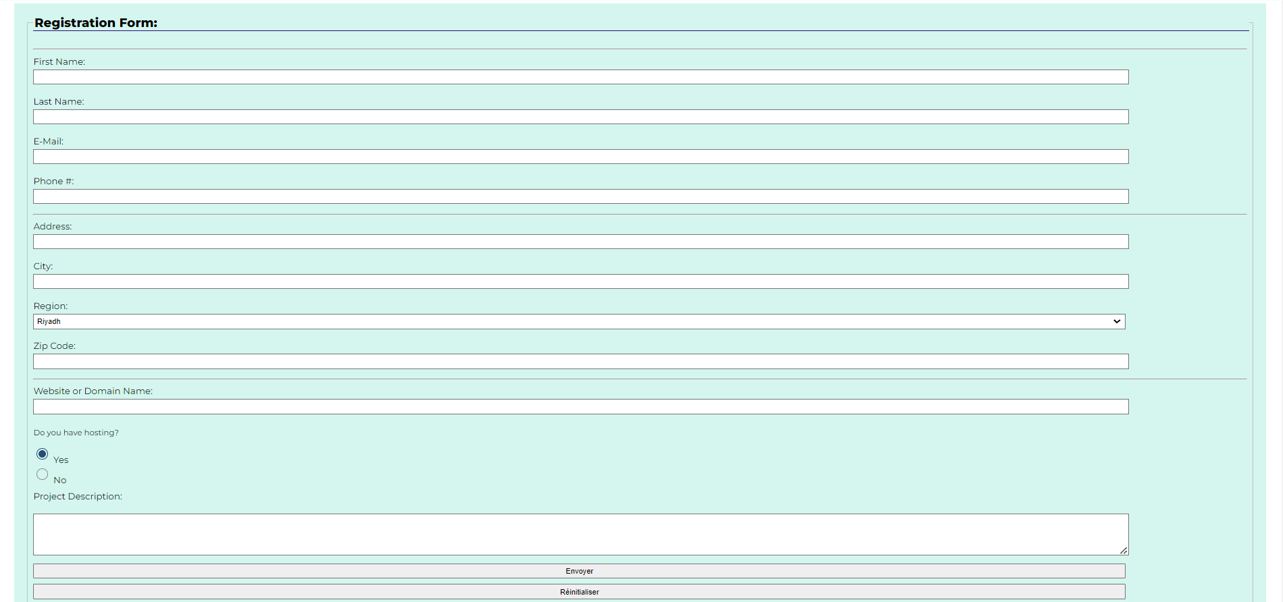

Section 12: How To set styles for tag button with specified types
- For button, input (reset type), input (submit type), specify a 200px in with, var(--btn-secondary-color) in background, without border, radius of default border 5px, add to top/bottom margin a 5px space and 20px for left/right.
button, input[type="reset"], input[type="submit"] {
width: 200px;
border: 0;
border-radius: 5px;
background-color: var(--btn-secondary-color);
margin: 5px 20px;
}
Result: For the buttons, we added margin space and a border radius in addition to specifying the width and background color.
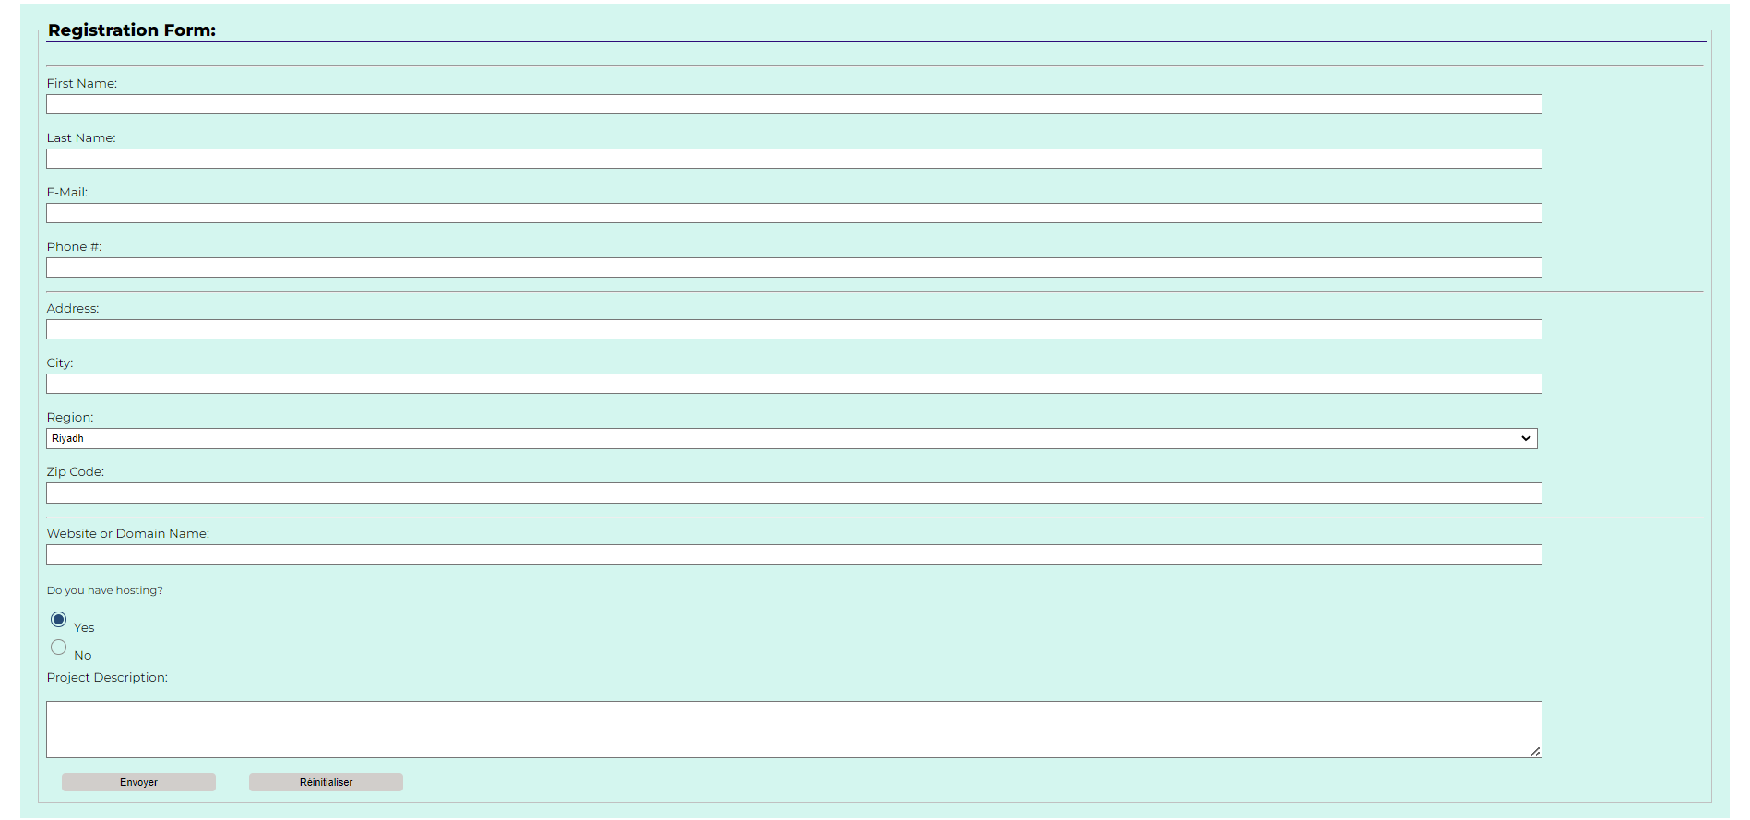

Section 13: How To set styles to class in tag input
- To make the “submit” button more interesting and more visible, use his class primary-action and set the text to white color and add a background color var(--btn-primary-color), enlarge the text weight with 900
input.primary-action {
color: white;
background-color: var(--btn-primary-color);
font-weight: 800;
}
Result: The submit button format has been modified to change the color to white, the background color and font weight have been changed.
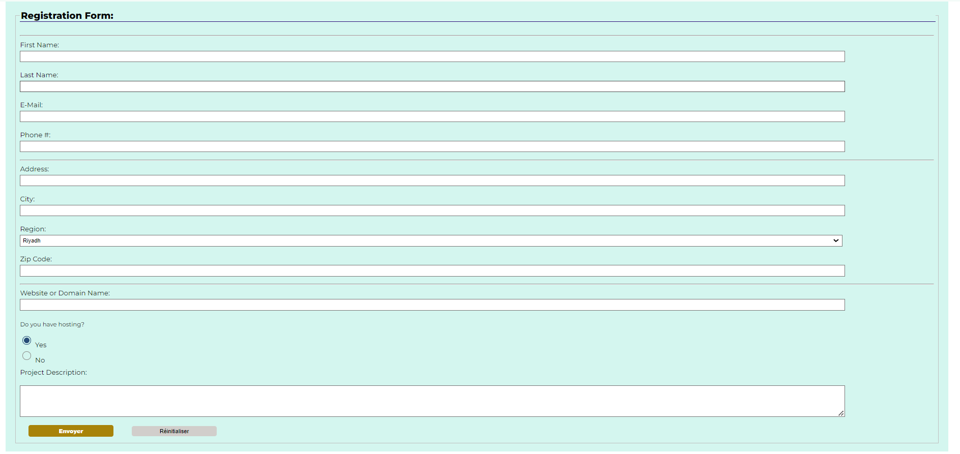

FINAL RESULT
