Lab 4: CSS Flex – Grid (Solution steps)

- Open the provided starting code. The given HTML displays commercial information about books. For each book, a picture, title, author and a buy button are included. Every group is in an article with a “card” class.
Section 1: Adjust the style of an article.
Apply the flex layout approach to each article to display the elements vertically. Add every style necessary to obtain a result that is similar to the following example:
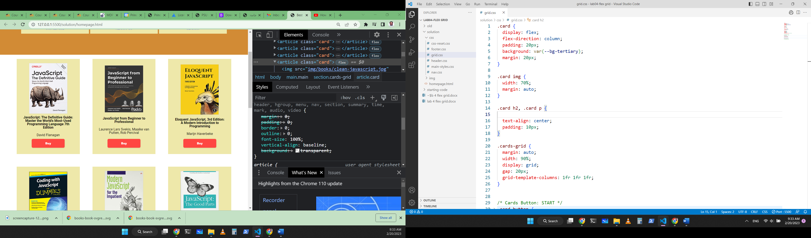
Fig. Example of one book flex box.

- Start by including all css files into html>head homepage.html with tag <link>
<link rel="stylesheet" href="css/css-reset.css">
<link rel="stylesheet" href="css/main-styles.css">
<link rel="stylesheet" href="css/header.css">
<link rel="stylesheet" href="css/nav.css">
<link rel="stylesheet" href="css/grid.css">
<link rel="stylesheet" href="css/footer.css">

Result: no changes observed following this step


- We will start with the card class; The CSS uses flexbox to create a vertical layout within the card element. display: flex; establishes the card as a flex container, allowing for flexible arrangement of its children. flex-direction: column; ensures that the children are stacked vertically, one on top of the other, within the card's boundaries.
.card {
display: flex;
flex-direction: column;
}
Result: The articles took up the entire space on the page.

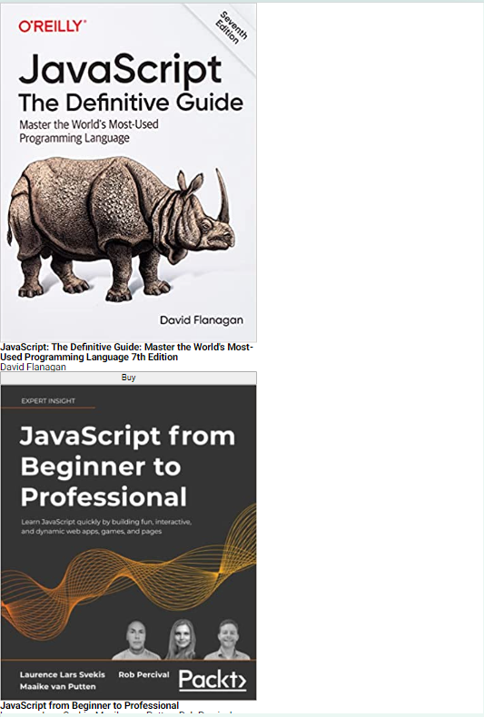

- Let’s add some adjustments to make the article look nicer, set a 20px margin around the card, 10px padding inside it, and uses the variable --bg-secondary to set the background color. Add a 1px solid black border and centers the content vertically using align-items: center.
.card {
display: flex;
flex-direction: column;
margin: 20px;
padding: 10px;
background-color: var(--bg-secondary);
border: solid 1px black;
align-items: center;
}
Result: We centered items and buttons, added borders and space for each card.
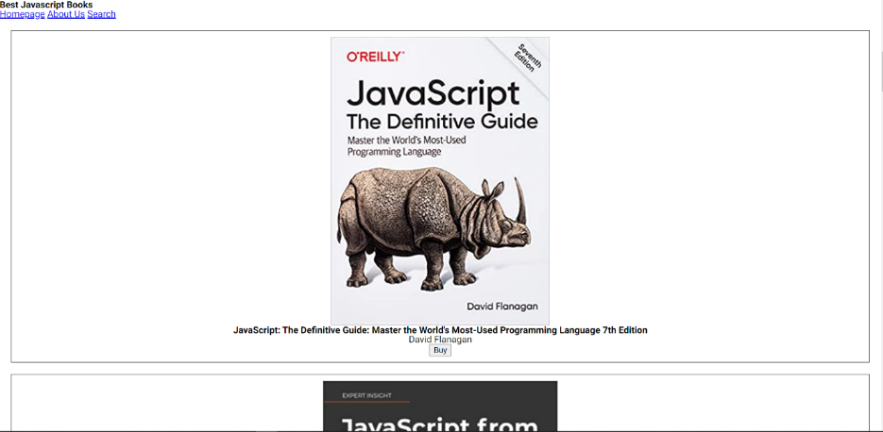

- Enlarge the image each card so that it occupies a width of 70%.
.card img {
width: 70%;
}

Result: The image therefore occupies 70% of the width of a card.
- For any button in card, removes the default button border, rounds the corners with a 5px radius, sets the background color to var(--bg-main), defines a width of 180px, adds 10px padding, aligns the button to the bottom of its container using margin-top: auto, and makes the text bold with a font weight of 800.
.card button {
border: 0;
border-radius: 5px;
background-color: var(--bg-main);
width: 180px;
padding: 10px;
margin-top: auto;
font-weight: 800;
}
Result: The button has taken the new style for all cards.

- Add space at the top (20px) and bottom (10px) of tags (h2, p1, button, img), we can symbolize all tags with a symbol “*”.
.card * {
margin-top: 20px;
margin-bottom: 10px;
}

Result: added some space between tags.
- Add class “books-grid” to section tag. To indicate that the section should be treated as a grid container, Set the display property to "grid".
.books-grid {
display: grid;
}
Result: The items will be displayed nicely in card form.
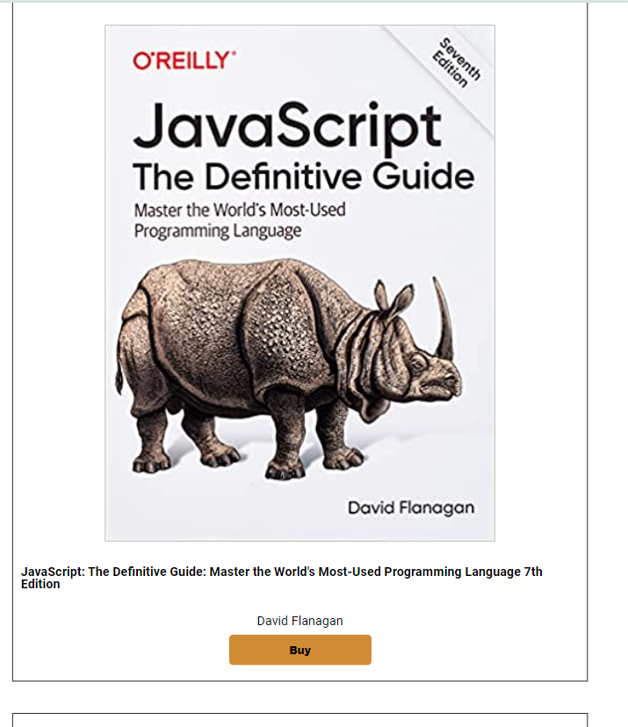

Section 2: Apply the grid approach.
Include all the articles in a section element. Then, apply the grid approach to organize the product cards in a grid that displays:
- at most three books per row for screen wider than 980px,
- two columns for screens wider than 680px
- and one column if the screen is smaller

- Use media queries to targeting small screens (max-width 679px), defines the layout of a book grid using a single column grid-template-columns: 1fr. Set .books-grid class to width: 100%, taking up the entire screen width. Individual book cards (.card) are then set to occupy 50% of the screen width and are centred horizontally within their container using justify-self: center.
@media screen and (max-width: 679px) {
.books-grid {
grid-template-columns: 1fr;
width: 100%;
}
.card {
width: 50%;
justify-self: center;
}
}

Result: We have a single card in each column and it takes 50% of the width in small screens.
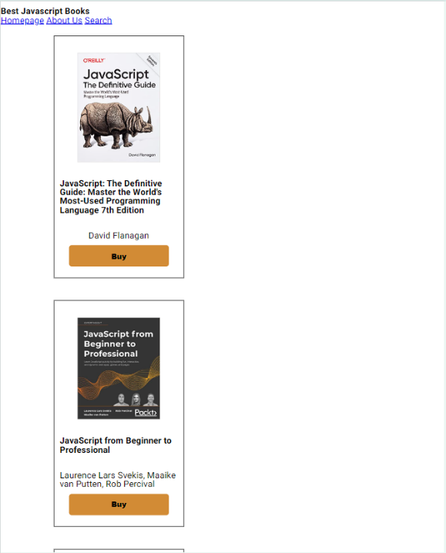

- Use media queries to create a responsive grid layout for a section and cards. On medium screens, it transitions to a grid layout, using grid-template-columns to arrange cards in 2 columns (1fr 1fr) for medium screens (min-width: 680px) and (max-width: 979px).
@media screen and (min-width: 680px) and (max-width: 979px) {
.books-grid {
grid-template-columns: 1fr 1fr;
}
}

Result: In medium screens.
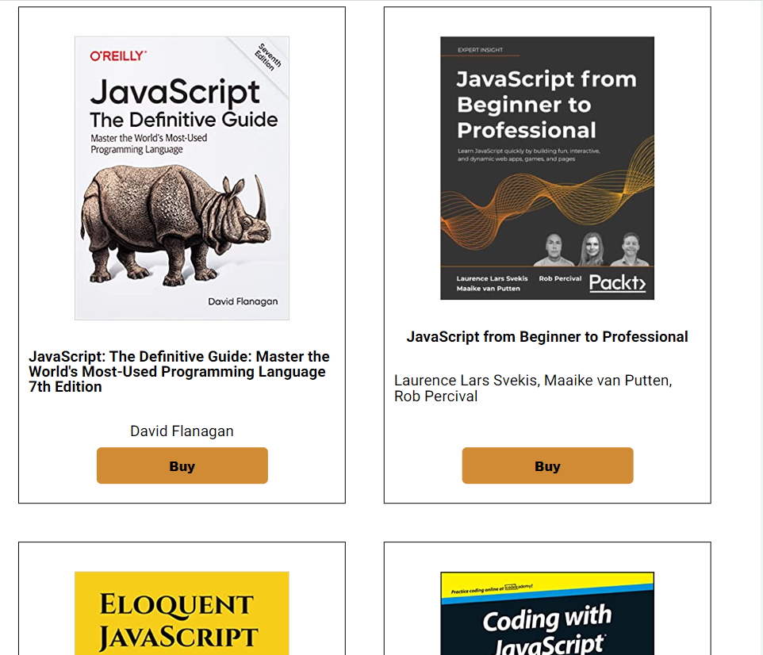

- Use media queries to create a responsive grid layout for a section and cards. On large screens, it transitions to a grid layout, using grid-template-columns to arrange cards 3 columns (1fr 1fr 1fr) for large screens (min-width: 980px).
@media screen and (min-width: 980px) {
.books-grid {
grid-template-columns: 1fr 1fr 1fr;
}
}

Result: In large screens.
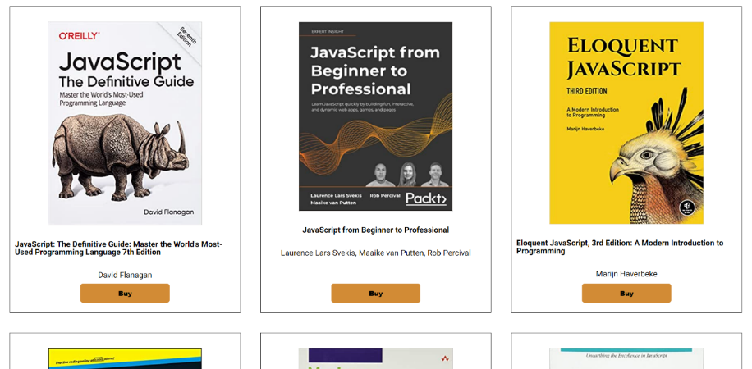

Section 3: Apply the grid approach in footer/header/nav.
Use flex boxes to adjust the header, nav and the footer of the page.
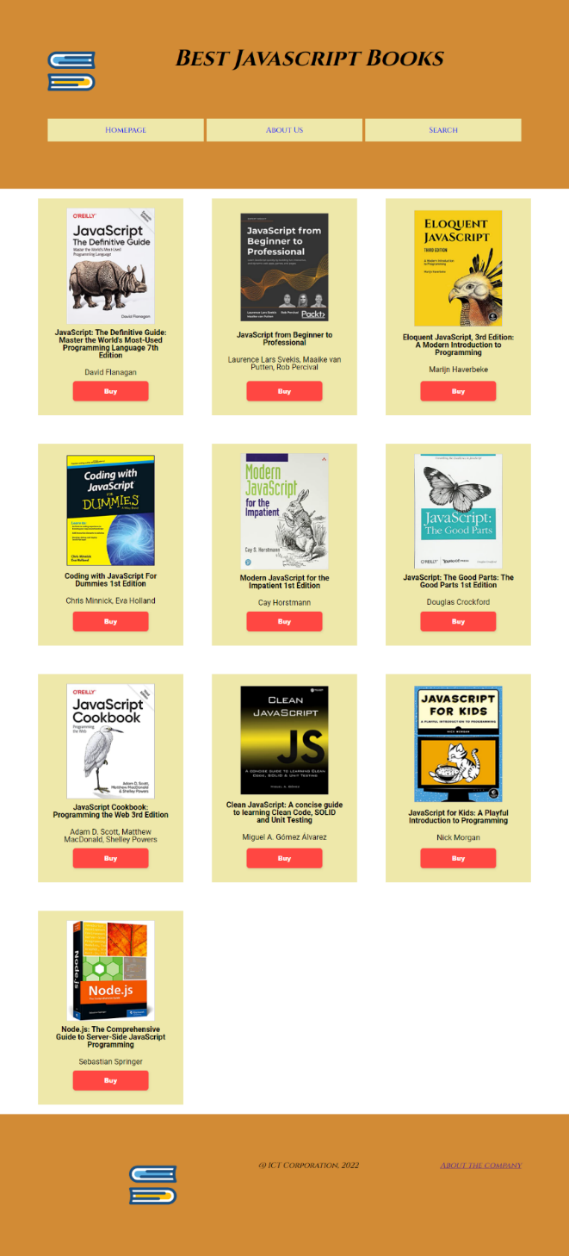

- Comme ce qu’on a fait pour les articles, Set a yellow background color (#f6cd19) for the header element. The .top class uses a grid layout to arrange content, with the number of columns adapting to screen size: a single column for screens smaller than 680px, two columns for screens between 680px and 979px, and three columns for screens larger than 980px. The code also styles images within the header, setting their width to 80px and adding margin and padding. Additionally, it styles the heading (h1) within the header, centering it with a specific padding (42px 28px) and large font size.
header{
background-color: #f6cd19;
}
.top {
display: grid;
}
.top img{
width:80px;
display: flex;
flex-direction: column;
margin: 20px;
padding: 10px;
}
.top h1{
display: flex;
flex-direction: column;
margin: 20px;
padding: 42px 28px;
align-items: center;
font-size: xx-large;
}
@media screen and (max-width: 679px) {
.top {
grid-template-columns: 1fr;
}
}
@media screen and (min-width: 680px) and (max-width: 979px) {
.top {
grid-template-columns: 1fr 1fr;
}
}
@media screen and (min-width: 980px) {
.top {
grid-template-columns: 1fr 1fr 1fr;
}
}
Result: The result shows that the logo is well placed on the left aligned with the title which is centered around it.
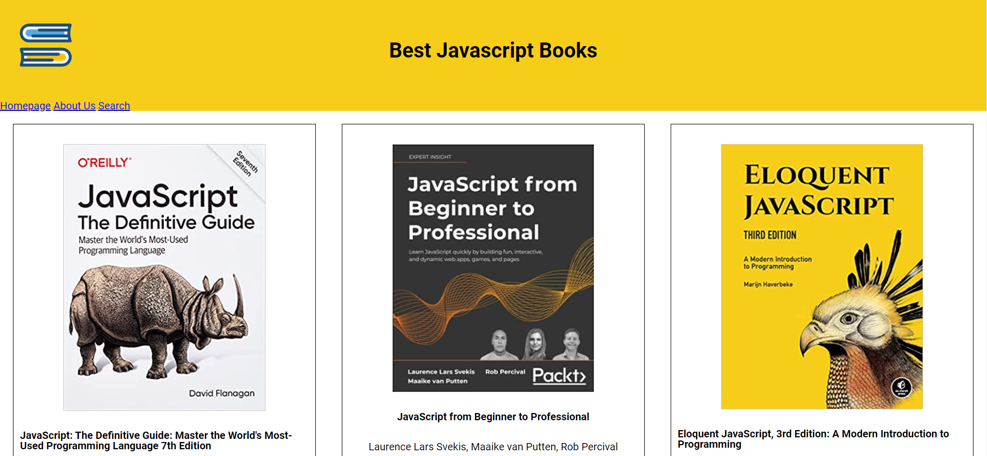

- Let’s do the navigation bar (nav) with responsive grid layout. Set a margin and padding of 10px for the navigation bar. The nav a style targets anchor tags within the navigation, styling them with a flexbox layout to center the content. Each anchor tag has a margin (3px), padding (10px), a black solid border, and a cornsilk background color. Like the previous code, the media queries adjust the grid layout based on screen size: one column (1fr) for screens smaller than 680px, two columns (1fr 1fr) for screens between 680px and 979px, and three columns (1fr 1fr 1fr) for screens larger than 980px.
nav{
display: grid;
margin: 10px;
padding: 10px;
}
nav a{
display: flex;
flex-direction: column;
align-items: center;
margin: 3px;
padding: 10px;
border: 1px solid black;
background-color: cornsilk;
}
@media screen and (max-width: 679px) {
nav {
grid-template-columns: 1fr;
}
}
@media screen and (min-width: 680px) and (max-width: 979px) {
nav {
grid-template-columns: 1fr 1fr;
}
}
@media screen and (min-width: 980px) {
nav {
grid-template-columns: 1fr 1fr 1fr;
}
}
Result: The result shows the links well aligned and each in its column.
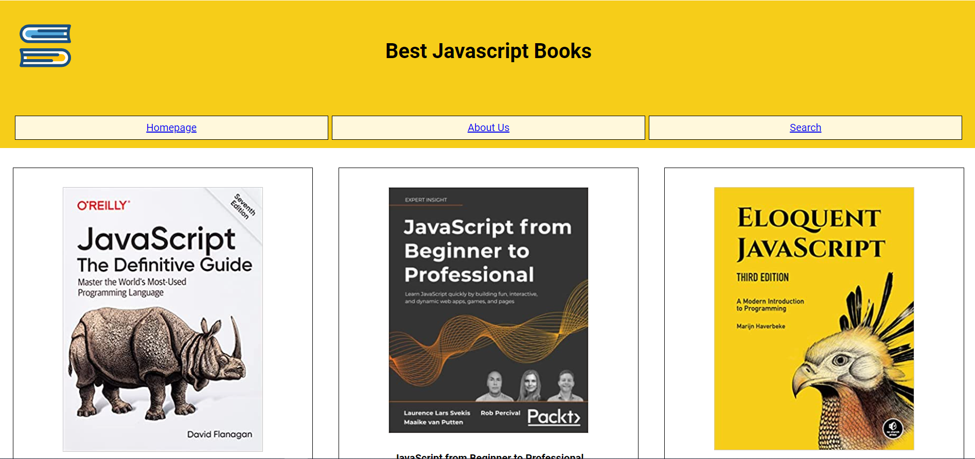

- The final part is footer, Set a brown background color (#d28b35) for the footer and uses a grid layout to organize the display content within it, similar to the header and navigation. Style images within the footer by setting their width to 80px and adding margin (70px) and padding (10px). Paragraphs (p) within the footer are also styled using flexbox, centering their content and adding padding (100px), Finally, media queries are used to adapt the grid layout based on screen size: one column for screens smaller than 680px, two columns for screens between 680px and 979px, and three columns (1fr 1fr 1fr) for screens larger than 980px.
footer {
display: grid;
background-color: #d28b35;
}
footer img{
width:80px;
display: flex;
flex-direction: column;
margin: 70px;
padding: 10px;
}
footer p{
display: flex;
flex-direction: column;
align-items: center;
padding: 100px;
}
@media screen and (max-width: 679px) {
footer {
grid-template-columns: 1fr;
}
}
@media screen and (min-width: 680px) and (max-width: 979px) {
footer {
grid-template-columns: 1fr 1fr;
}
}
@media screen and (min-width: 980px) {
footer {
grid-template-columns: 1fr 1fr 1fr;
}
}
Result: The footer elements are now aligned and each has taken a column
