Lab 5a: JavaScript intro

IDE: You need to work with a local IDE like VScode for this lab.
Summary of JavaScript google style guide (see annex at the end of this document for more details):
- File names must be all lowercase and may include underscores (_) or dashes (-)
- Braces are required for all control structures (i.e. if, else, for, do, while, as well as any others), even if the body contains only a single statement. The first statement of a non-empty block must begin on its own line.
- For nonempty blocks and block-like constructs:
- No line break before the opening brace.
- Line break after the opening brace.
- Line break before the closing brace.
Line break after the closing brace if that brace terminates a statement or the body of a function.
- Each time a new block or block-like construct is opened, the indent increases by two spaces.
One statement per line.

Instructions:
- Download the provided starter code from Moodle.

- Inspect the code that is provided. Notice the data that is in the data.js file.

In the following, never modify the data.js file.

- Open the page with live server. Click on ctrl+shift+i to open the developer tools of chrome.

- On the browser developer tools, open the “Sources” tab. Select the “lab05a.js” file then add a breakpoint on the first line and refresh the page. The debugger stops at the selected breakpoint.

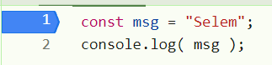

- In the debugger panel, expand the “Watch” element. Add two new expression in the watch list: document, and `${msg} there`.
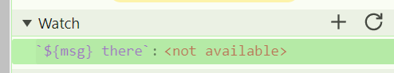
Refresh the page to check the watched expressions and move to the next instructions by using the right arrow of the debugger.
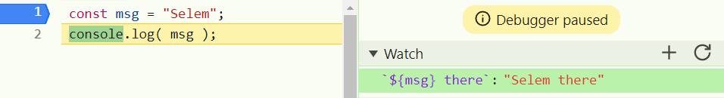

- In the file lab05a.js, write code to create an array of objects by parsing the given data using JSON.parse(). Check that your data is correctly parsed by using the debugger or a console.log().
  - Declare a new empty const array called (arrObj).
    - Initialization of an empty array by []
  - Iterate through each string in the input array data (declared in data.js file). Using forEach function.
  - Attempt to parse each string as JSON using JSON.parse().
  - Push the parsed object to arrObj using arrObj.push().
  - Iterate through each object in arrObj using forEach function.
  - Log each object to the console using console.log().
const arrObj = [];
data.forEach( str => {
arrObj.push( JSON.parse(str) );
});
arrObj.forEach(e=>{
console.log(e)
});
Result: The console shows the list of objects in the data array in JSON format
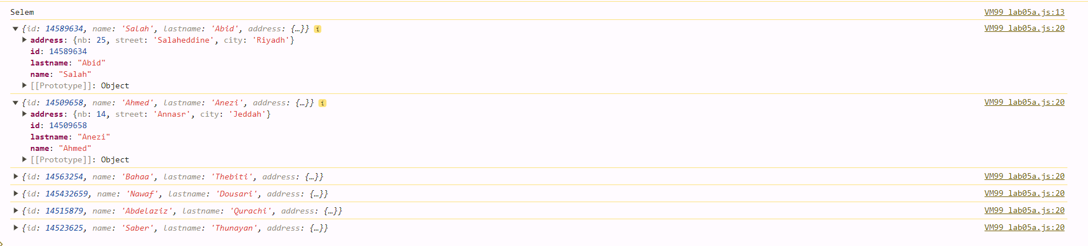

- Create a constructor function (Customer) to create new objects with the same structure. Create two new objects using this constructor function. Add these two new objects to the array containing the objects loaded from the data file.
Note: Arrow functions cannot be used as constructors
First approach: Steps
- Define a constructor Customer1 to create customer objects with id, name, lastname, addr_nb, addr_street, addr_city object.
  - Using function Customer1.
- Create a cust1 object using the Customer1 constructor with (15, "name1", "lastname1", 78, "street1", "city1").
- Push the cust1 object to the arrObj array.
function Customer1(id, name, lastname, addr_nb, addr_street, addr_city) {
this.id = id;
this.name = name;
this.lastname = lastname;
this.address = {};
this.address.nb = addr_nb;
this.address.street = addr_street;
this.address.city = addr_city;
}
const cust1 = new Customer1(15, "name1", "lastname1", 78, "street1", "city1");
arrObj.push(cust1);

Second approach: Steps
- Define a Customer2 constructor for creating customer objects with id, name, lastname, address.
- Define an Address constructor for creating address objects with nb, street, city.
- Create a Customer2 object (cust2) with the customer data and the inside constructor:
  - Create an Address object with the given address details with (78, "street5", "city6").
- Push the cust2 object to the arrObj array.
function Customer2(id, name, lastname, address) {
this.id = id;
this.name = name;
this.lastname = lastname;
this.address = address;
}
function Address(nb, street, city) {
this.nb = nb;
this.street = street;
this.city = city;
}
const cust2 = new Customer2(78, "name3", "lastname4", new Address(78, "street5", "city6"));
arrObj.push(cust2);

- Add an output function property that outputs a string representation for objects created using the Customer constructor.
  - In Customer constructor, add the code at the end.
  - Define a method output for the address object to format and return the address string with ${this.address.nb} ${this.address.street} ${this.address.city}
  - Define a method output for the customer object to format and return the entire customer information string in this order ${this.id}: ${this.name} ${this.lastname}, ${this.address.output()}.
this.address.output = () => {
return `${this.address.nb} ${this.address.street} ${this.address.city}`; };
this.output = () => {
return `${this.id}: ${this.name} ${this.lastname}, ${this.address.output()}`; };
Result: The console will display all the Customer informations including the address in the defined format.
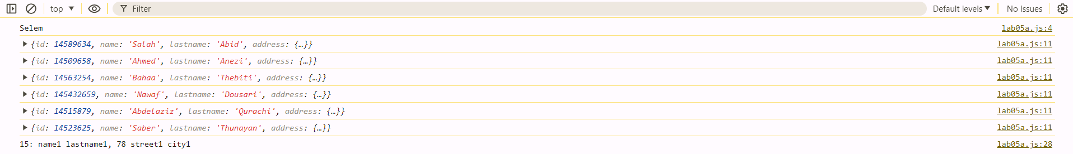

- Write a function that returns an array containing all the customers from a given city. Write some test code using console.log()
  - Define a function filterByCity that takes an array (arr) and a city name (city) as input.
  - Inside filterByCity, use the filter method to return a new array containing only the objects from arr where the address.city matches (===) the input city.
  - Call the filterByCity function, passing the arrObj array and the city "Riyadh".
  - Store the returned filtered array in the riyadhCustomers variable.
  - Print the riyadhCustomers array using the console.log().
const filterByCity = (arr, city) => {
return arr.filter(o => o.address.city === city)
}
const riyadhCustomers = filterByCity(arrObj, "Riyadh");
console.log(riyadhCustomers);
Result: The console shows the two customers who live in the city "Riyadh"
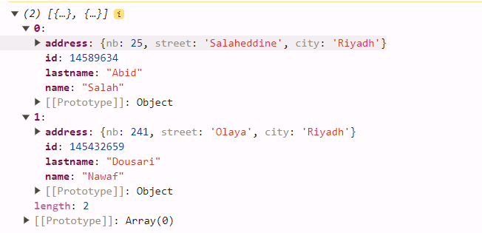

- Add the same output function to the objects that were parsed from the data file.
  - Using forEach function, Iterate through each object (obj) in the arrObj array.
  - Check if the output property (obj.output) of the current object is undefined or null.
  - If the output property is missing, define a new output method for the object that formats the full address information.
  - Define a new output method on the object that displays the customer id, name, lastname and formatted address in this order ${obj.id}: ${obj.name} ${obj.lastname}, ${obj.address.output().
  - Out of function and using and other forEach function, Iterate through each object again, calling the output method on each object and printing the result to the console using console.log().
arrObj.forEach( obj => {
if(obj.output === undefined || obj.output === null){
// Here we do not use "this" because in this context "this" is undefined
obj.address.output = () => {
return `${obj.address.nb} ${obj.address.street} ${obj.address.city}`; };
obj.output = () => {
return `${obj.id}: ${obj.name} ${obj.lastname}, ${obj.address.output()}`; };
}
});
arrObj.forEach(obj => console.log(obj.output()));
Result: The console displays all the cutomers of arrObj with the format predefined on the output function.
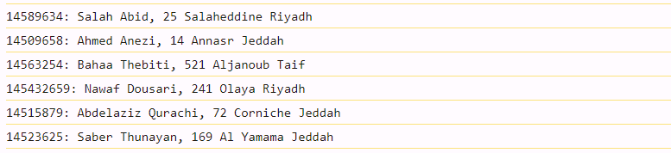

ANNEX: JavaScript Simplified Google Style Guide

File names
File names must be all lowercase and may include underscores (_) or dashes (-), but no additional punctuation. Follow the convention that your project uses. Filenames’ extension must be .js

Braces are used for all control structures
Braces are required for all control structures (i.e. if, else, for, do, while, as well as any others), even if the body contains only a single statement. The first statement of a non-empty block must begin on its own line.
Disallowed:
if (someVeryLongCondition())
doSomething();

for (let i = 0; i < foo.length; i++) bar(foo[i]);

Exception: A simple if statement that can fit entirely on a single line with no wrapping (and that doesn’t have an else) may be kept on a single line with no braces when it improves readability.
if (shortCondition()) foo();

Nonempty blocks:
For nonempty blocks and block-like constructs:
- No line break before the opening brace.
- Line break after the opening brace.
- Line break before the closing brace.
- Line break after the closing brace if that brace terminates a statement or the body of a function. Specifically, there is no line break after the brace if it is followed by else, catch, while, or a comma, semicolon, or right-parenthesis.
Example:
class InnerClass {
constructor() {}

/** @param {number} foo */
method(foo) {
if (condition(foo)) {
try {
// Note: this might fail.
something();
} catch (err) {
recover();
}
}
}
}

Block indentation: +2 spaces
Each time a new block or block-like construct is opened, the indent increases by two spaces. When the block ends, the indent returns to the previous indent level. The indent level applies to both code and comments throughout the block.

One statement per line
Each statement is followed by a line-break.

Reference:
JavaScript Google style guide: https://google.github.io/styleguide/jsguide.html

