Class Activity [Practice for upcoming quiz]
Make a folder with your full name inside 251-SE371Secxxx which exist on your desktop, save all your work inside your own folder. Once you completed your work create zip/archive folder of your folder. Submit the zip folder.
Question: - Create the index.html having following structure using table. (Italic style shows instructions)

Home | Biodata | Register | Favorites
Note:
Home is linked to index.html
Biodata is linked to Short bio section of the current page means index.html Register is linked to Register section of the current page means index.html Favorites is linked to Favorites section of the current page means index.html
Short Bio
Insert an Image here. Write 12 lines about you.
Also Make a table to show your qualification.
Degree | Institution | Year

Prepare registration form having email, radio buttons, password and repeat password as input. Register button will register user to the form action and clear button will clear the contents of form. Terms & privacy and Sign In are dummy hyperlinks.

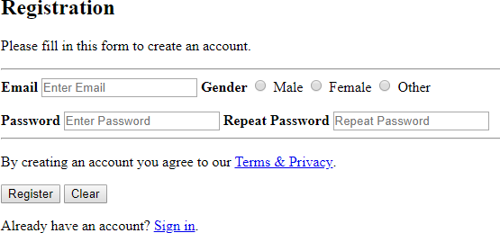
My Favorites
Here is list of favorites foods chains with small intro for each:
Create a descriptive list of your favorites foods chains. This list should have atleast four food chains intro.
Web Master Link to your email address

How you will be graded?
Each section will be based on:

Grade | Explanation
100% | Perfect work, no flaws
75% | Compliance with requirements with some flaws
50% | Few requirements are not met with few flaws
25% | Most Requirements are not met with few flaws

