Functions – Arrow Functions – Array Methods

Function:
A function is a block of reusable code that performs a specific task. It takes zero or multiple input (arguments), processes it, and optionally returns an output. The structure of a function is:
function function_name(param1, param2, param3…) {
// all logic code
// return (optional)
}
Use the starter code of lab5a, and edit in ‘lab05a.js’ file
Example 1: Write a function named (myFunction) to display "Hello World!" in alert, and open index.html in your navigator:
function myFunction() {
alert("Hello World!");
}
myFunction();
Result 1: Once the index.html page is open, an alert is showing the message Hello World!
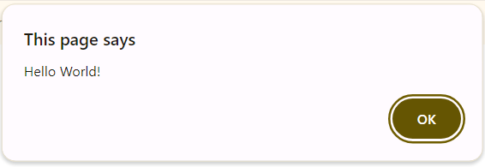
Example 2: Write a function named (greeting) with one parameter (name) to return "Hello, name!"
- Call the function by giving "Abdulaziz" as value of name and put the returned string in a variable message.
- Display message with console.log().
function greeting(name) {
return "Hello, " + name + "!";
}
let message = greeting("Abdulaziz"); // Output: "Hello, Abdulaziz!"
console.log(message);
Result 2: Once the index.html page is open, a log in console is showing the message Hello, Abdulaziz!
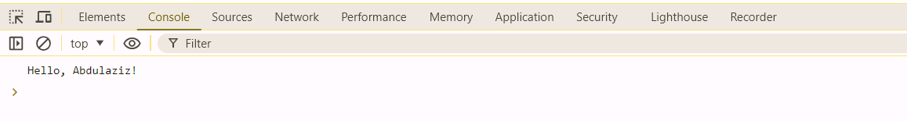

Arrow function: Arrow functions are a concise way to write functions, especially useful for short, simple functions. The structure of an arrow function is:
function_name = (param1, param2, parm3) => {
// logic of the function
// return (no return if we have only 1 line)
}
Example 3: Write an arrow function named (greeting) with one parameter (name) to return "Hello, name!"
- Call the function by giving "Abdulaziz" as value of name and put the returned string in a variable message.
- Display message with console.log().
greeting = (name) => {
return "Hello, " + name + "!";
}
let message = greeting("Abdulaziz"); // Output: "Hello, Abdulaziz!"
console.log(message);

Result 3: Once the index.html page is open, a log in console is showing the message Hello, Abdulaziz!

Example 4: Write an arrow function named (plus) with two parameters (nbr1, nbr2) to return the sum of numbers.
- Call the function by giving 22 as value of nbr1 and 403 as value of nbr2, put the returned value in a variable sum.
- Display sum with console.log().
plus = (nbr1, nbr2) => {
return nbr1 + nbr2;
}
let sum = plus(22,403); // Output: 425
console.log(sum);

We can simplify even more:
plus = (nbr1,nbr2) => nbr1 + nbr2;
console.log(plus(22,403));

Result 4: Once the index.html page is open, a log in console is showing the sum 425.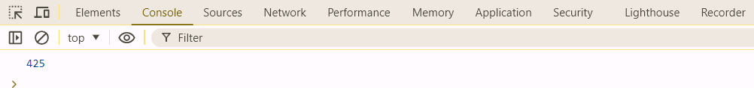

Array function: JavaScript offers numerous built-in methods to work with arrays. Here are some common ones and examples (includes(), push(), forEach(), toSorted(), find()) . The structure of an array function is:
array_name.function_name(param1,param2...);

Example 5: Consider an array named (cars):
const cars = ["BMW", "Mercedes", "Volkswagen", "Toyota"];
Use array function includes() with one parameter "Volkswagen" to check if this car is in array. Display the return in console.log()
console.log("BMW included in array ? "+cars.includes("Volkswagen"));
Result 5: In console we can see the message “BMW included in array ? true”
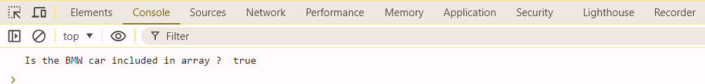
Example 6: Consider the same array (cars), Use array function push(param) with one parameter "Renault" to add new element in array. Display cars in console.log()
const cars = ["BMW", "Mercedes", "Volkswagen", "Toyota"];
cars.push("Renault");
console.log(cars)

Result 6: In console we can see the new element “Renault” in array.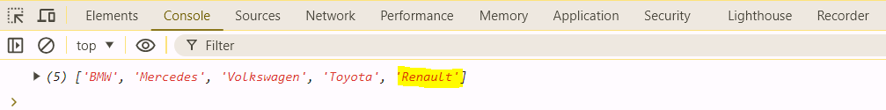
Example 7: Consider the same array (cars), Use array function forEach(), to loop on cars and display every car in console.log()
const cars = ["BMW", "Mercedes", "Volkswagen", "Toyota"];
cars.forEach(car => {
console.log(car)
});

Result 7: In console we can see every car displayed in separated line.
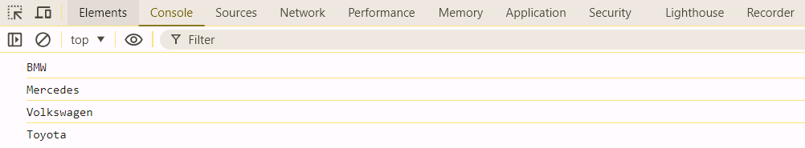
Example 8: Consider this array (names):
const names = ["Mohammad", "Ahmad", "Omar", "Abdulaziz", "Nabil"];

Use array function toSorted(), to sort alphabetically names and put result in variable named namesSorted, log sorted list in console.log()
const namesSorted = names.toSorted();
console.log(namesSorted);

Result 8: In console we can see list sorted alphabetically.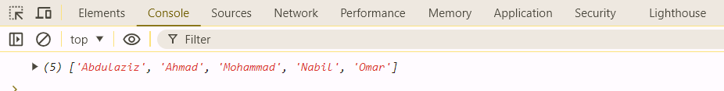
Example 9: Consider the same array (names):
Use array function find(), to check if "Rasheed" is in names array, if the function return true display ‘Rasheed found in the array’ else ‘Rasheed not found’ in console.log()
const searchTerm = "Rasheed";
let found = names.find(element => element === searchTerm);
if (found) {
console.log(`${searchTerm} found in the array`);
} else {
console.log(`${searchTerm} not found`);
}

Result 9: In console we can see that Rasheed is not found in names.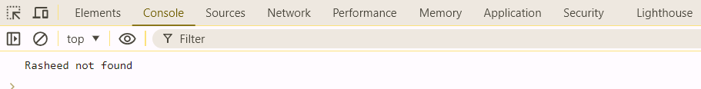

END

