Exercise: Car Search Application

Objective:
Create a simple web page that allows the user to search for a car from a predefined list of cars using an input box and a button as shown below:
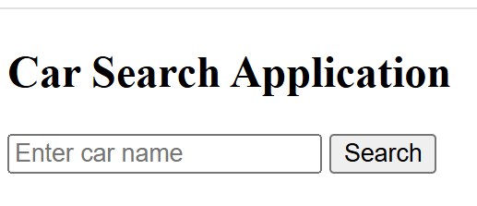

Expected Output Example:
When the user enters 'Tesla' and presses Search, the page should display:
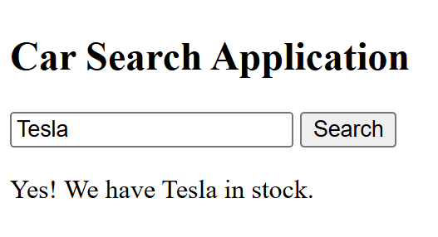
If the user enters 'Nissan', it should display:
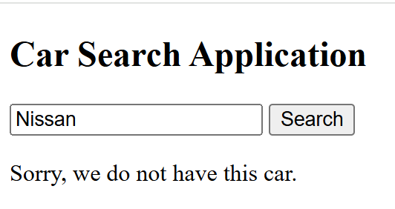

Instructions:
1. Create an HTML file (index.html) that includes:
- A text input field for entering the car name.
- A button labeled 'Search'.
- A paragraph (or div) to display the search result.
2. Create a JavaScript file (script.js) that contains:
- An array named cars with a list of car names.
Example:
const cars = ["Toyota", "Honda", "BMW", "Ford", "Chevrolet", "Tesla"];
- A function called searchCar() that:
• Reads the value entered by the user.
• Checks if the car exists in the array.
• Displays a message such as:
'Yes! We have BMW in stock.' or 'Sorry, we don’t have this car.'
3. Connect your JavaScript file to the HTML file using a <script> tag.

Key Code Parts and Explanation:
1. Creating an Array of Cars
You will define a list (array) in JavaScript that contains the car names you want to search through.
Example:
const cars = ["Toyota", "Honda", "BMW", "Ford", "Chevrolet", "Tesla"];
2. Reading Input Value
Use document.getElementById("id_of_input") to read the value that the user types in the input field.
Example:
const input = document.getElementById("carInput").value;
3. Checking if the Car Exists
You can use the JavaScript array method includes() to check if the input value matches one of the items in the array.
Example:
if (cars.includes(input)) { /* show success message */ }

4. Displaying the Result on the Web Page
Use document.getElementById("id_of_html_part_to_show_result") again to access the paragraph element and display a message to the user.
Example:
document.getElementById("result").textContent = "Yes! We have " + input + " in stock.";

