CSS Tutorial for Styling Tables
Step 1: Styling Table Header, Body, and Footer with Embedded CSS
You can style your table directly in the <style> section of your HTML file. Here, we’ll add background colors to the table header (thead) and footer (tfoot).
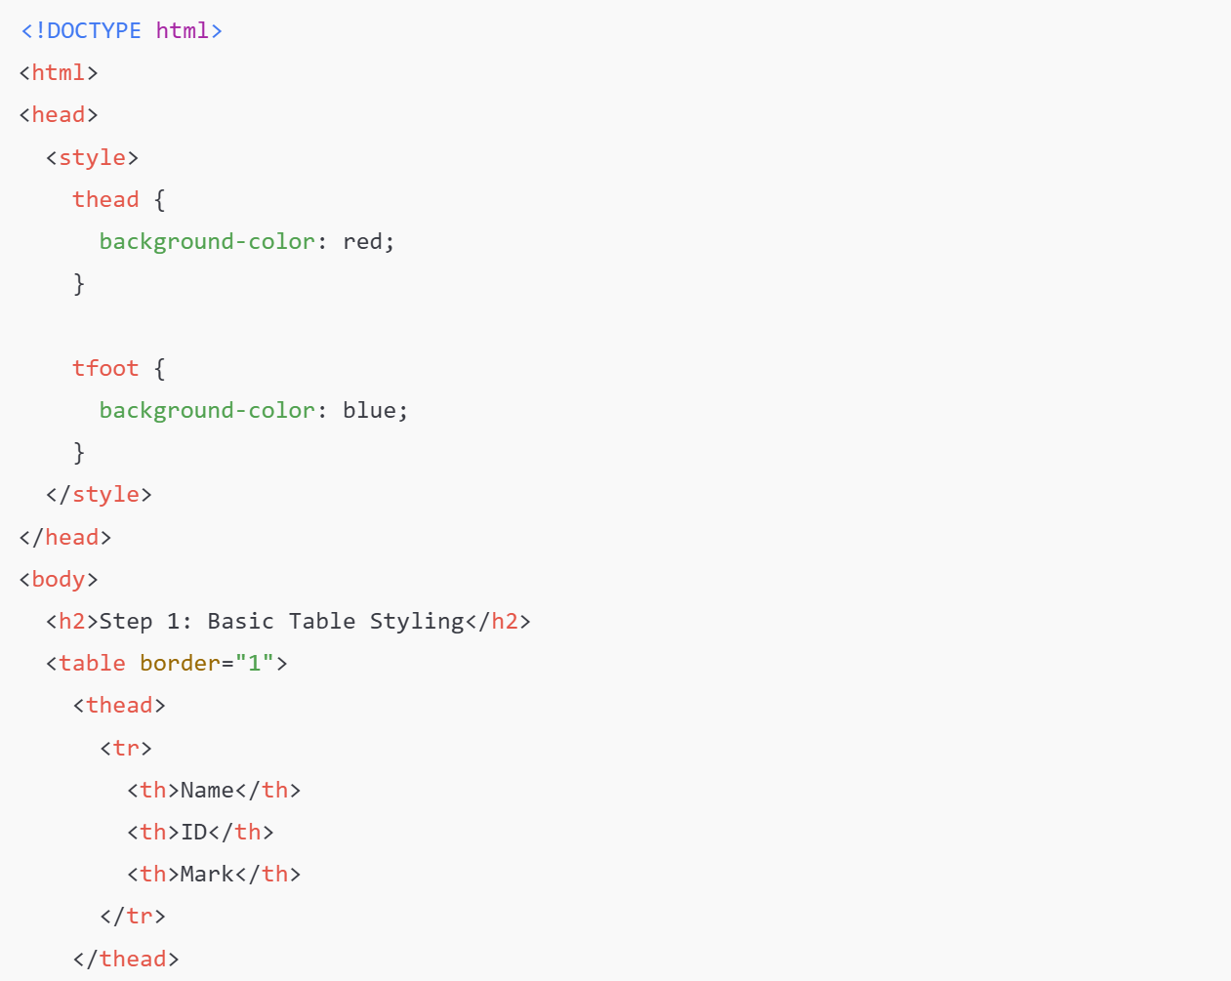
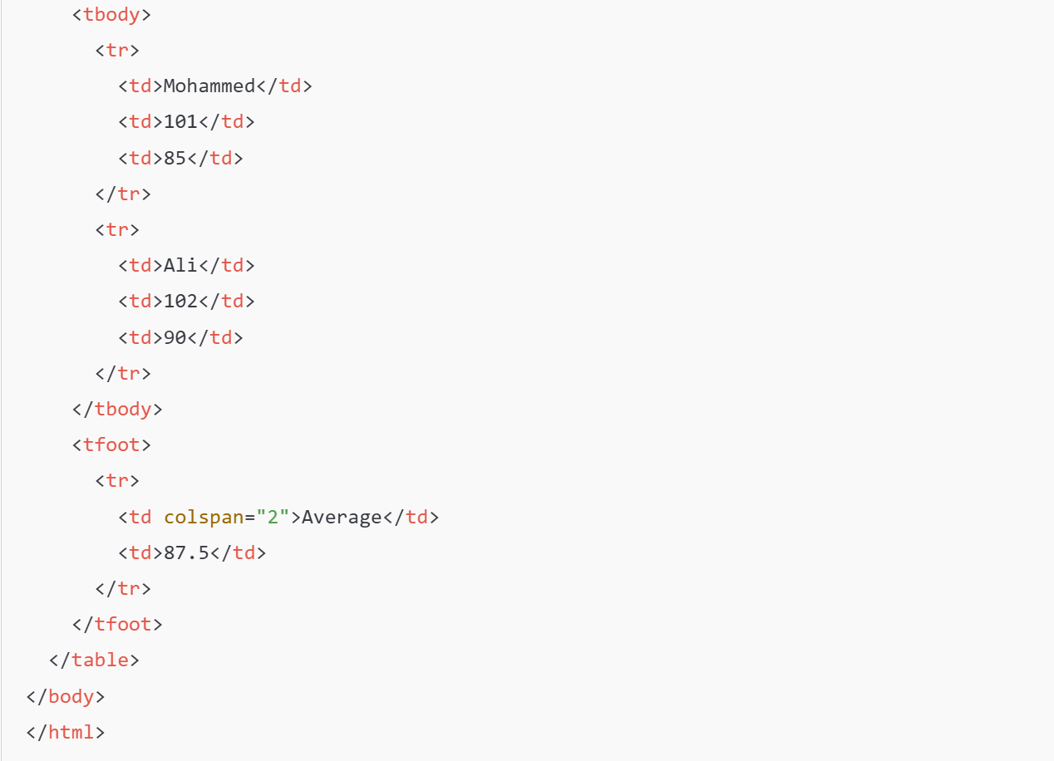

Exercise: Run the code above and post the screen shot of the resulting HTML page below:

Step 2: Applying Styles to All Tables on the Page
The CSS rules above apply to any table because they are based on the thead and tfoot tags. Add another table, and the styles will apply to it automatically.
Exercise: Add another table to the same HTML page and post the screen shot of the resulting HTML page below:

Step 3: Using CSS Classes to Override Tag Styles
You can create specific styles using a class and apply them to some tables as shown below:
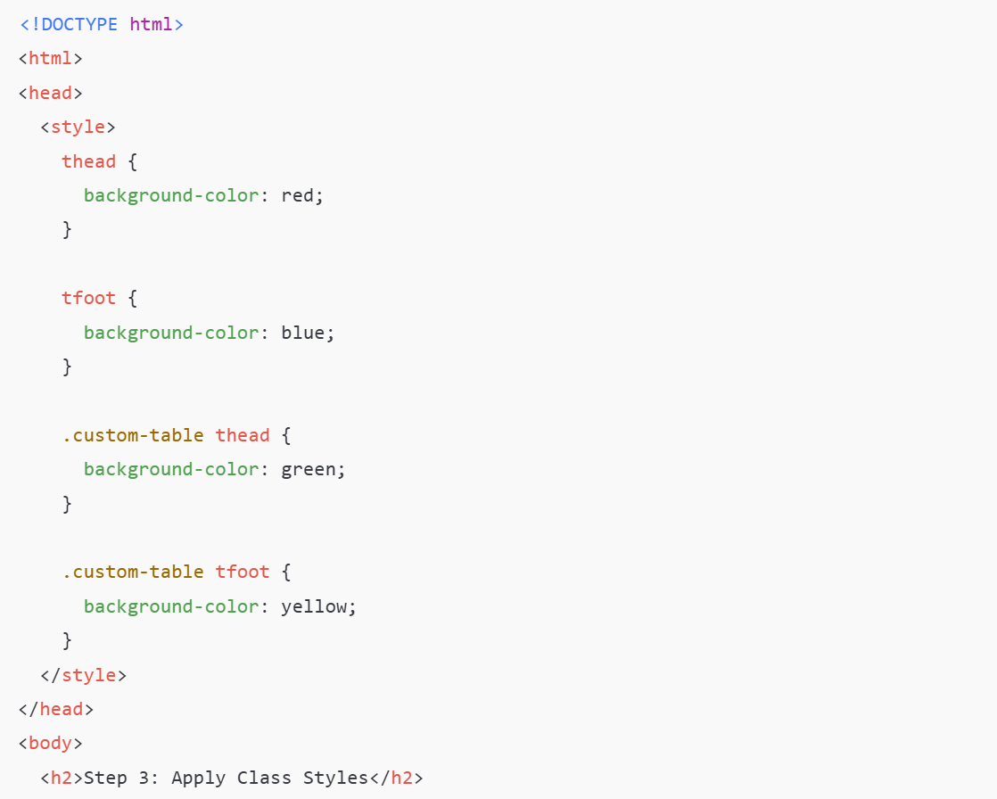
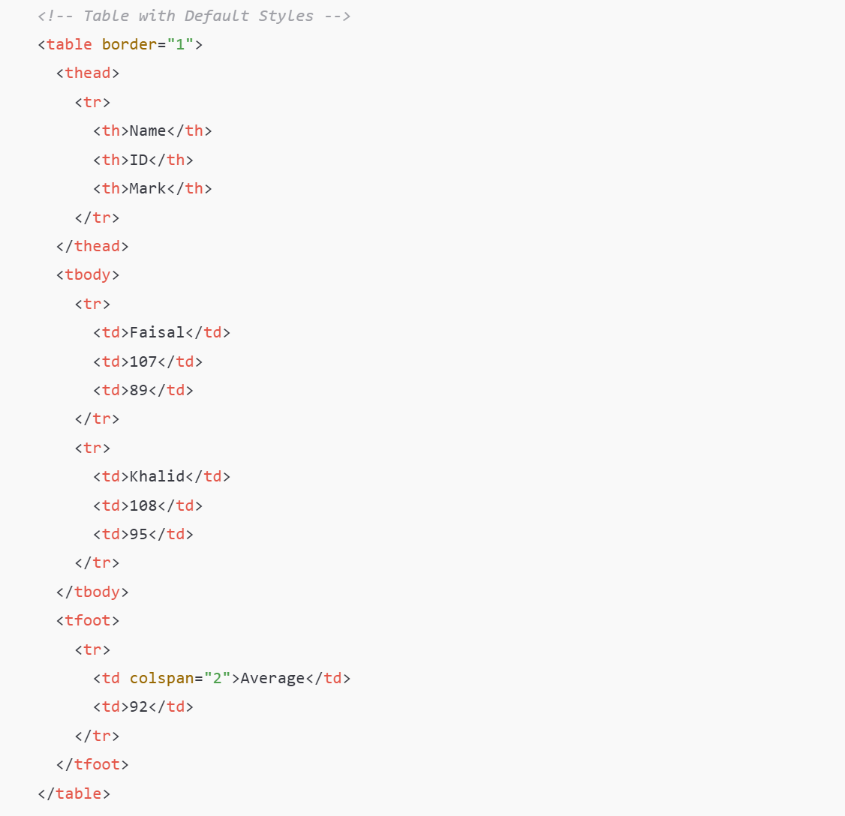
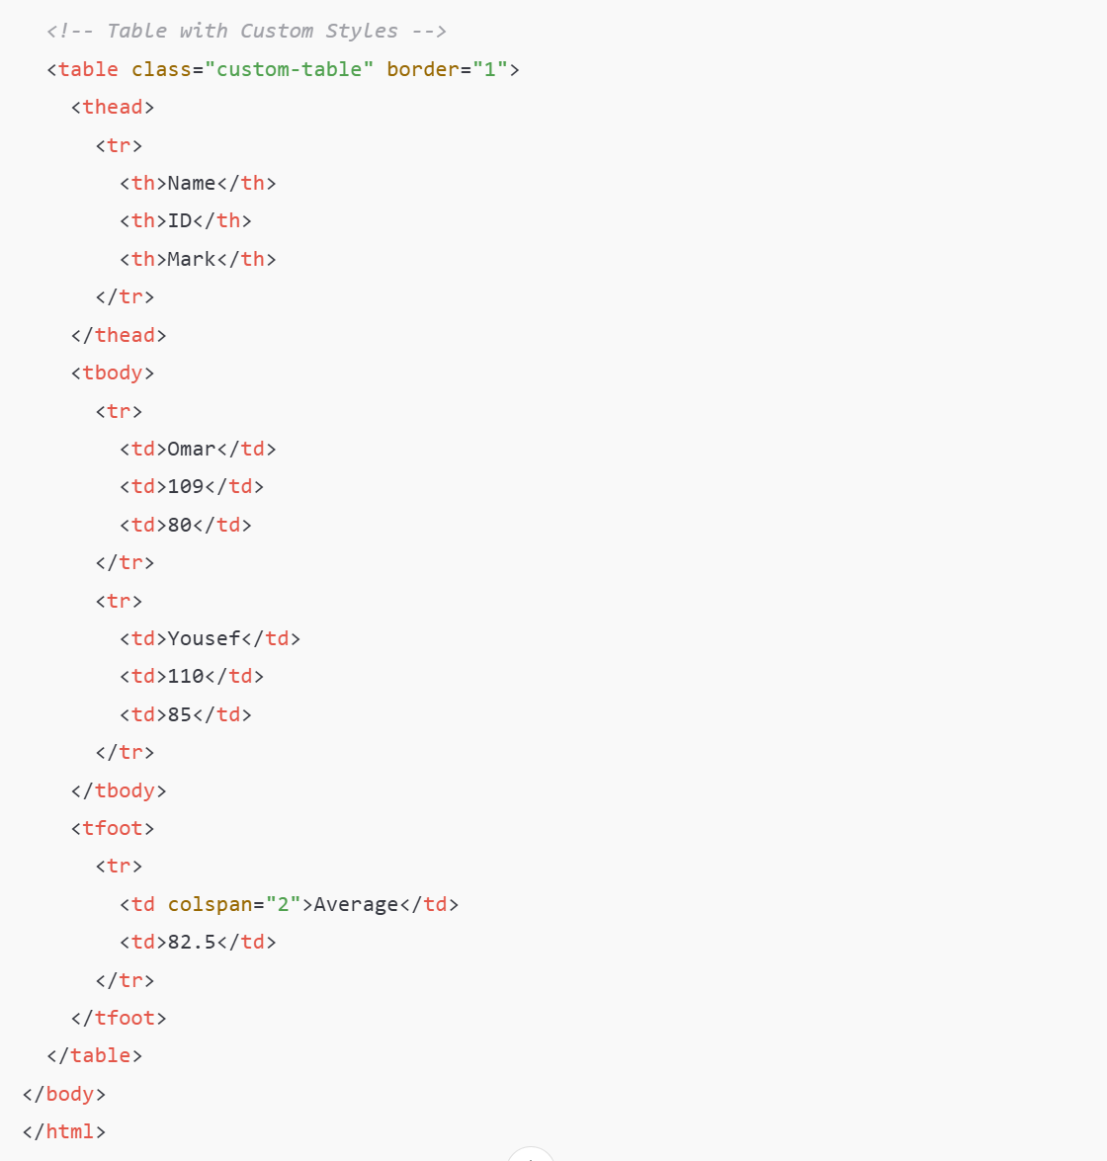

Step 4: Using IDs to Override Class Styles
IDs have higher priority than classes. You can style a specific table or element.
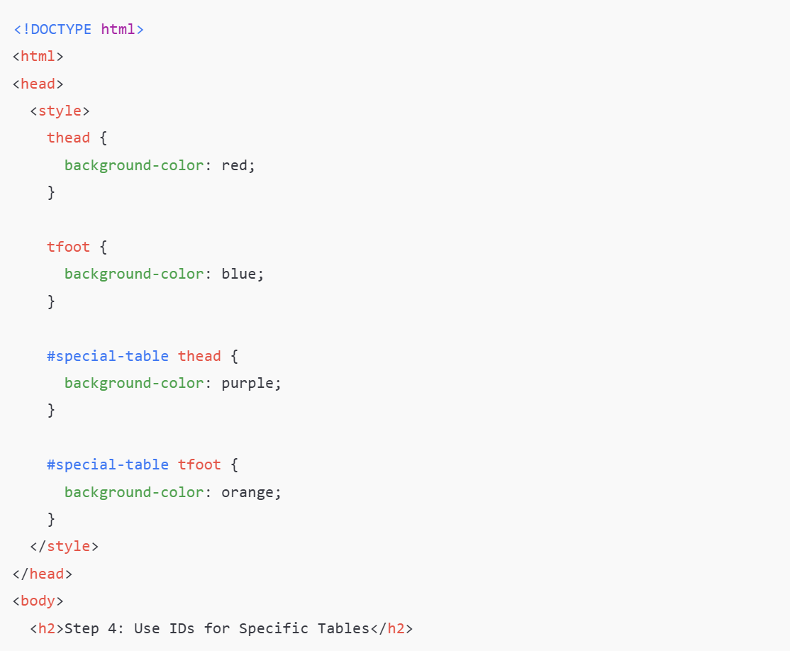
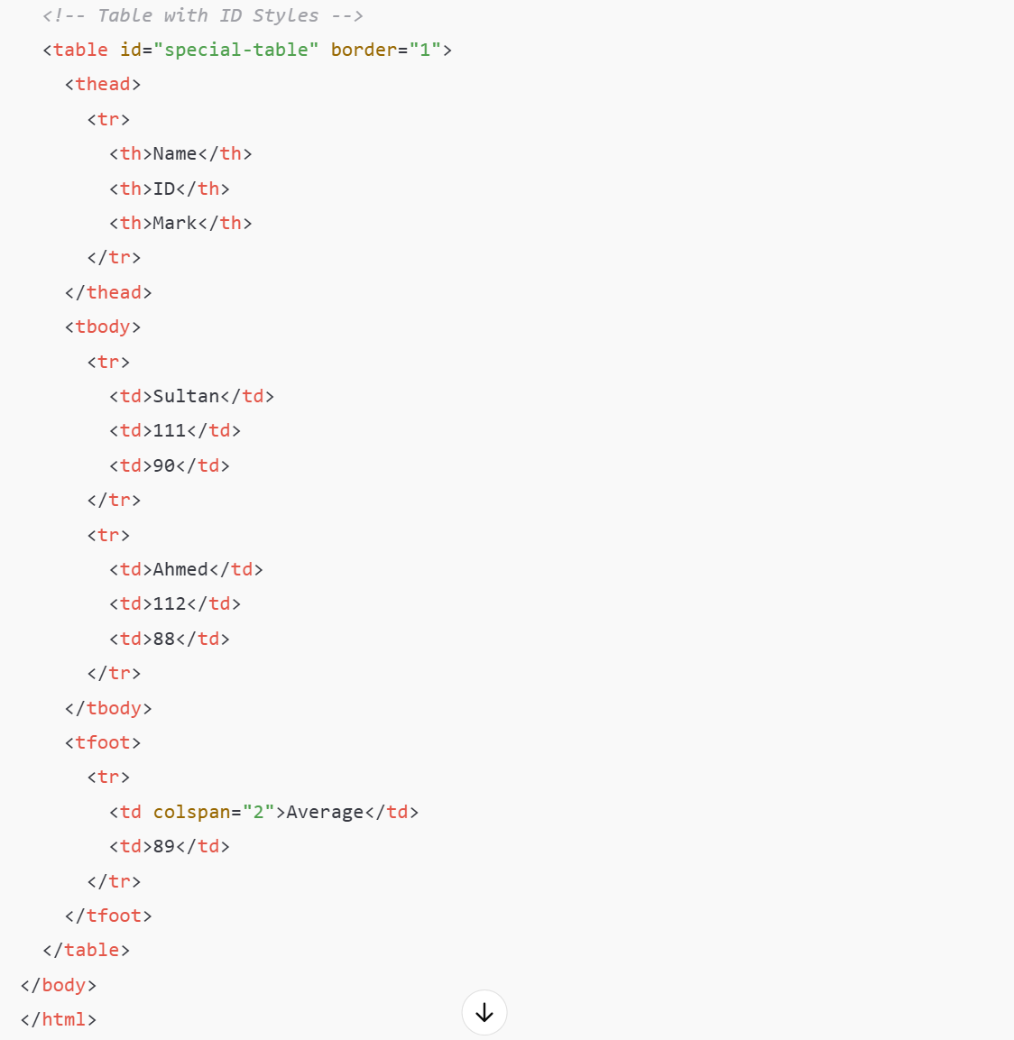

Step 5: Apply Styles Using an External CSS File
To apply the same styles across multiple pages, save the CSS in an external file.
- Create a file named styles.css:
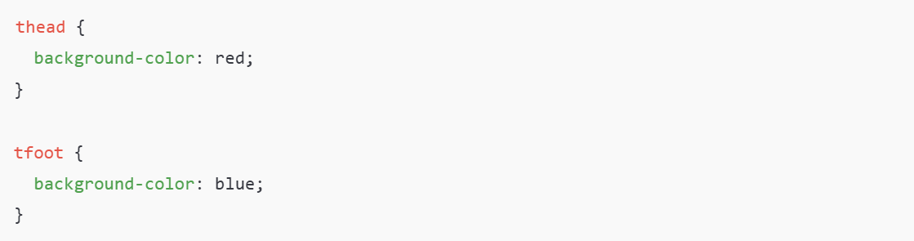
- Link the CSS file in your HTML:
Now all pages linked to styles.css will share the same styles for thead and tfoot.
