PSU CTF
Competition Report
2026

1. Competition Overview
This report summarizes the results and statistics from the PSU CTF competition. A total of 11 teams participated across a range of challenges spanning multiple categories and difficulty levels.

Key Highlights:
Total Teams Participating: 11
Total Challenges: 16+
Total Submissions: 852 (89 solves / 763 fails)
Overall Solve Rate: 10.4%
Winning Team: HZ with 3,800 points

2. Competition Analytics

2.1 Score Distribution
The score distribution chart below shows how teams were distributed across score brackets during the competition.
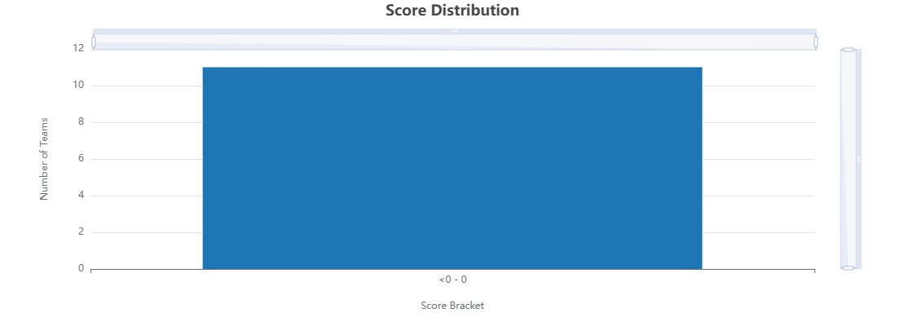

2.2 Submission Percentages
Of all 852 total submissions, 10.4% (89) resulted in successful flag captures, while 89.6% (763) were failed attempts.
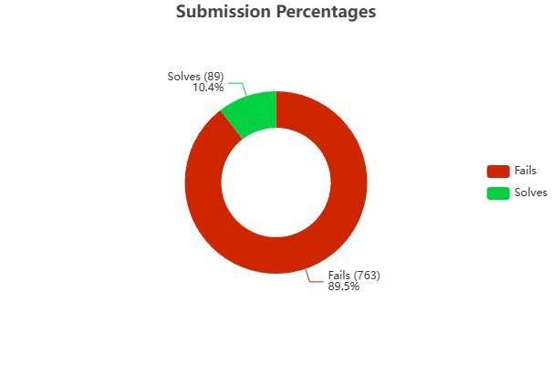

2.3 Solve Counts per Challenge
The chart below shows how many teams solved each challenge. Challenges like Rusty Archive and Job Portal were the most widely solved, while several challenges remained unsolved or near-unsolved.
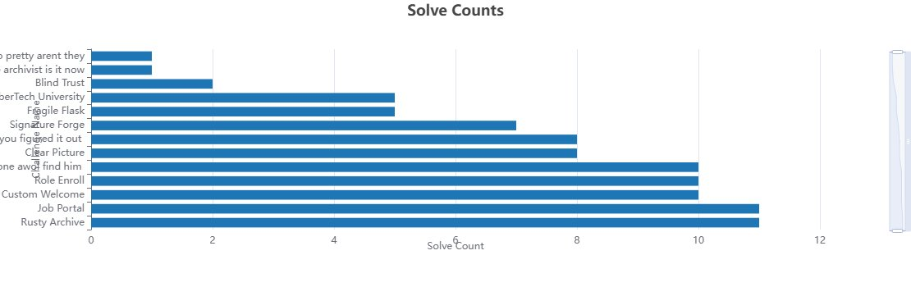

2.4 Solve Percentages per Challenge
Rusty Archive and Job Portal achieved 100% solve rates, while some challenges such as News Letter and 'Is This The End' saw zero solves across all teams.
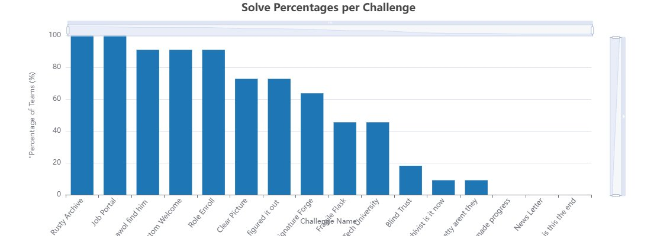

2.5 Category Breakdown
Challenges were distributed across multiple categories and difficulty levels. The competition featured 16 challenges ranging from Very Easy to Insane difficulty, with categories including forensics, cryptography, OSINT, and general web/binary challenges.
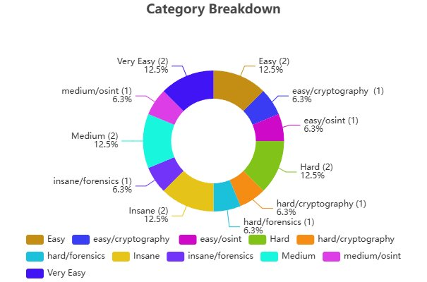

2.6 Point Breakdown
The total point pool was distributed across difficulty tiers. Insane challenges (1,000 pts) represented the highest single category, followed by Hard and insane/forensics challenges at 800 pts each.
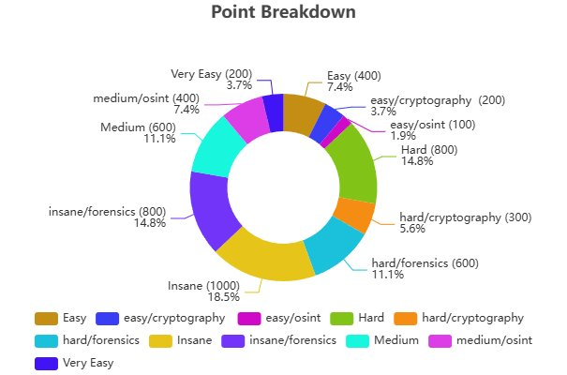

3. Final Leaderboard
The table below shows the final standings at the close of the competition.

Place | Team Name | Score
#1 | HZ | 3,800
#2 | TheVault | 2,800
#3 | ZERO DAY | 2,100
#4 | Gotcha_flag | 2,000
#5 | ASM | 1,900
#6 | checkmate | 1,900
#7 | Aha | 1,300
#8 | Cybercrackers | 1,300
#9 | 404 | 1,000
#10 | MAM | 900
#11 | Red Team | 800

4. Team Details
This section provides a breakdown of each leaderboard team and the member names verified against the registration workbook.

1. HZ
Score:
3,800 points
Members: Hasan Belal Farhat, Hazim Khalid Alhatim

2. The Vault
Score:
2,800 points
الأعضاء: الجوهره الجبير، الشيماء بابعير، جودي وسيم آل حسان

3. Zero Day
Score:
2,100 points
Members: Omar Fahad Alkhalifah, Abdullah Alanazi

4. Gotcha Flag
Score:
2,000 points
Members: Meshal Raed Alhuwairini, Ziyad Saleh Alsalamah

5. ASM
Score:
1,900 points
Members: Ammar Akhdar, Saud Almarshad, Mohammed Alsalem

6. CheckMate
Score:
1,900 points
Members: Mansour Bader Albader, Mohammed Almgren

7. Aha
Score:
1,300 points
Members: Abdullah Alafari, Fahad Aljabr, Abdulrahman Tarek Jalal

8. Cybercrackers
Score:
1,300 points
Members: Khalid Alferdoos, Nouf Almuhaya

9. 404
Score:
1,000 points
Members: Abdullah Almughamis, Tamim Alburaidi

10. MAM
Score:
900 points
Members: Abdullah Basim Mona, Mohammad Alibrahim

11. Red Team
Score:
800 points
Members: Layan Naif Alzahrani, Ibrahim Alnasser, Alanoud Almufayrij

