Activity 09

Scheduling
2025-2026

Objective
Creating, analyzing, and optimizing a project schedule.

Scenario: Project "Wishlist"
You are the new project manager for a small e-commerce company. Your team is tasked with developing a new "Wishlist" feature for the website. You have three developers, each with a specialty:
- Salah (Backend)
- Ahmed (Frontend)
- Zyed (DB/QA)
Project Brief: Task List (WBS)
Here is the high-level task list your team has compiled.
Task ID | Task Name | Duration (Days) | Resource(s) | Predecessor(s)
A | Kickoff Meeting | 1 | Salah, Ahmed | -
B | Define Feature Specs | 2 | Salah, Ahmed , Zyed | A
C | Build API | 4 | Salah | B
D | Implement DB Schema | 3 | Zyed | B
E | Design UI Mockups | 3 | Ahmed | B
F | Build UI Components | 5 | Ahmed | E
G | Write Test Cases | 3 | Zyed | B
H | Integrate API & DB | 2 | Salah, Zyed | C, D
I | Final Integration & System Test | 3 | Ahmed, Zyed | F, G, H
J | Deploy to Production | 1 | Salah | I

Activity Steps

Initial Network Diagram & Critical Path
First, let's map out the project as-is.
- Draw the Diagram: Using an online whiteboard, create an network diagram based on the task list. For nodes use a six-compartment box.
- Calculate Schedule: Perform a Forward Pass and Backward Pass to determine the Early Start (ES), Early Finish (EF), Late Start (LS), and Late Finish (LF) for every task.
- Find the Critical Path:
  - What is the total project duration?
  - Identify the critical path (or paths) by finding the sequence of tasks with zero slack (Slack = LS - ES).

What-If Analysis - Leads & Lags
Modify your diagram from Part 1 to reflect these new scenarios.
- Scenario 1 (Lag): The team decides that Task G (Write Test Cases) can only begin after the UI mockups are finished and approved. This adds a 1-day lag after Task E. The new dependency for G is E (FS+1d).
- Scenario 2 (Lead/Fast-Tracking): To speed things up, Task F (Build UI Components) can start when Task E (Design UI Mockups) is 2/3 complete. Task E takes 3 days, so Task F can start 1 day before E finishes. This is a Finish-to-Start with a 1-day lead (FS-1d).
Task: Re-calculate the ES, EF, LS, LF, and the critical path with these new dependencies.
- Has the total project duration changed?
- Has the critical path changed?

Resource Visualization
- Create Gantt chart: Draw a Gantt-style chart, but create three horizontal "swimlanes," one for each team member: Salah, Ahmed , and Zyed. (Tasks with multiple resources should be duplicated: Task T becomes Task Ta and Tb with a start to start constraint).
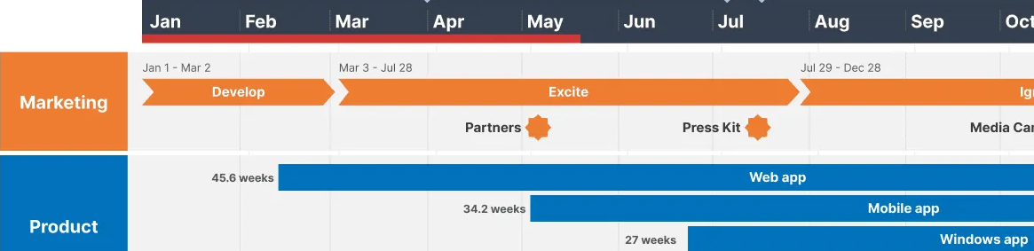
- Plot the Schedule: Using your (updated) schedule from Part 2, draw each task as a bar on its Earliest Start (ES) date in the correct resource's swimlane.
- Identify Conflicts: Examine your swimlane chart. Do you see any days where a single resource (e.g., Zyed) is assigned to two or more tasks simultaneously?

Resource Leveling
- Analyze the Conflict:
  - Which resource is over-allocated?
  - Which tasks are in conflict?
  - Look at the slack for the conflicting tasks.
- Propose a Solution: Apply resource leveling. The easiest way is to delay the start of one of the conflicting tasks until the other is finished.
  - Which task should you delay? Hint: Always try to delay the task with the most slack first, as it's less likely to affect the critical path.
- Create a New Schedule: Implement your solution by adding a new precedence (e.g., Task D must finish before Task G can start).
- Re-compute: Recalculate the ES, EF, LS, LF, and slack for all tasks based on this new, leveled schedule.

Final Analysis & Report
Conclude the activity by analyzing the results of your leveling.
- Final Critical Path: What is the new critical path and the new final project duration?
- Impact: Did leveling the resources extend the project? Why or why not?
- What If...: What if your leveling did extend the project, but management insists on the original deadline? Based on your lecture, name one schedule compression technique (like crashing or fast-tracking) you could apply to the new critical path to shorten it.

Submission
Be sure to include all group members' names in your submission.

