Question

Analyze the architecture and design of the Java classes in the new notification system, then answer the following and the output will be
Notifying with message: {"notification": "System is operational"}

- Identify the design pattern used in this example. If its Adapter design pattern the code below is Class-based Structural Version OR Object-based Structural Version?

- Write the code of the other Object-based Structural Version if the original code if Class-based Structural Version? And vice versa?

- Draw a UML diagram for the given Java class design.

- Mention one advantage and one disadvantage of the identified design pattern.

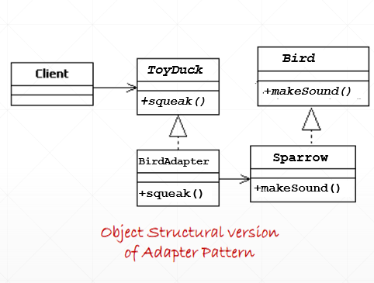
AdvancedNotifier
NotificationSystem
+sendInNewFormat ()
+sendInNewFormat ()
<<Interface>>
NewNotifier
+sendNotification()
-formatToNewSystem()

NotificationBridge
+sendNotification()

<<Interface>>
LegacyNotifier

Object Adapter:

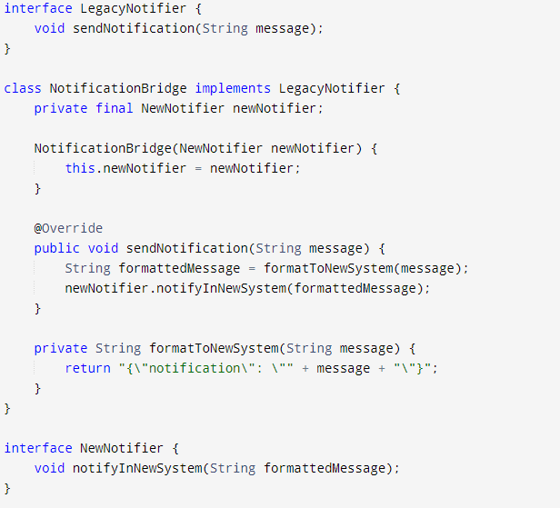

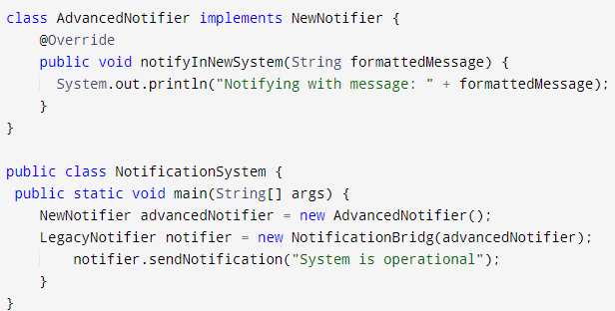

Classes Adapter:

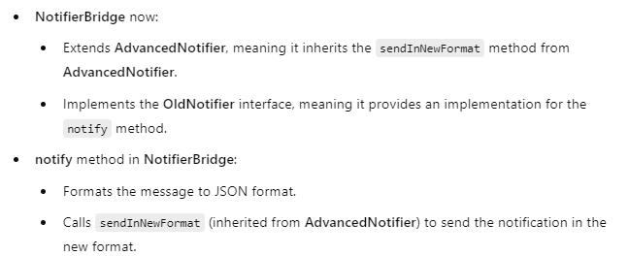

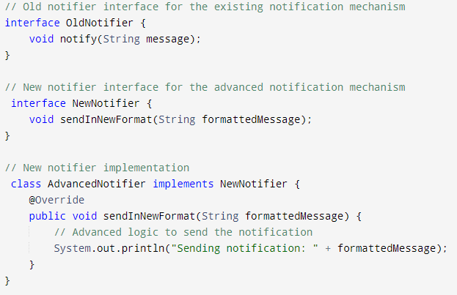

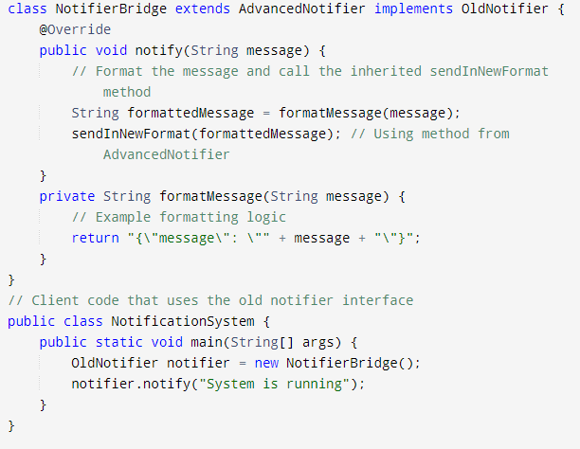

The output:
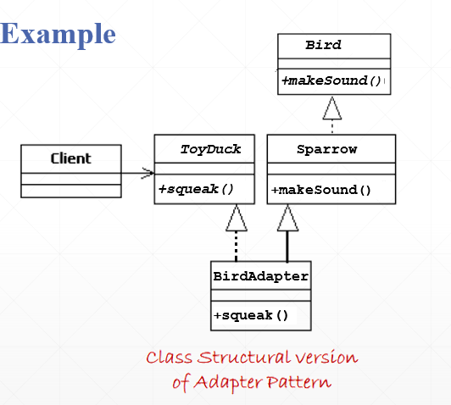

<<Interface>>
NewNotifier

+sendNotification()

AdvancedNotifier
+sendInNewFormat ()
+sendInNewFormat ()
+sendNotification()
-formatToNewSystem()

NotificationBridge
<<Interface>>
LegacyNotifier

NotificationSystem

