Dr.Sally- Observor Pattern Example

Basic Weather Station system will have a WeatherData class which acts as the Subject, and a single Observer, and a Concrete Observer CurrentConditionsDisplay, which displays the current temperature and humidity.

1. Subject Interface

This interface allows attaching and notifying observers.
java
import java.util.ArrayList;
import java.util.List;
public interface Subject {
void registerObserver(Observer o); void removeObserver(Observer o); void notifyObservers();
}

WeatherData (Concrete Subject)
Implements the Subject interface and holds temperature and humidity data.

java

public class WeatherData implements Subject {
private List<Observer> observers observers = new ArrayList<>();
private float temperature; private float humidity;

public void registerObserver(Observer o) { observers.add(o);
}

public void removeObserver(Observer o) { observers.remove(o);
}

public void notifyObservers() {
for (Observer observer : observers) { observer.update(temperature, humidity);
}}

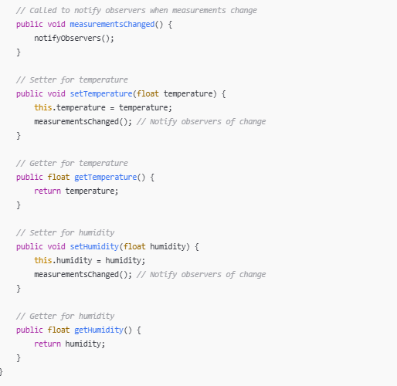

Observer Interface
Deﬁnes an update method that observers must implement.

java
public interface Observer {
void update(float temperature, float humidity);
}

CurrentConditionsDisplay (Concrete Observer)
Implements the Observer interface to display the current conditions.
java
public class CurrentConditionsDisplay implements Observer { private float temperature;
private float humidity;
@Override
public void update(float temperature, float humidity) { this.temperature = temperature;
this.humidity = humidity; display();
}
public void display() {
System.out.println("Current conditions: " + temperature + "F degrees and " + humidity + "% humidity");
}
}

Weather Station (Main Application)
Demonstrates the interaction between the subject and observer.
java
public class WeatherStation {
public static void main(String[] args) { WeatherData weatherData = new WeatherData();
CurrentConditionsDisplay currentDisplay = new CurrentConditionsDisplay();
weatherData.registerObserver(currentDisplay);
weatherData. setTemperature (20.0);
weatherData.setHumidity (30.0);
}
}
WeatherData

