Wireshark Lab
Weightage : 3 marks

Instructions:
- This is an individual work.
- Submit on Moodle:
  - A soft copy of your Cisco packet tracer file with your names. (.pkt file) [0.25 Mark]
  - Word document with network design details, all snapshots requested and answer. [2.25 Mark]

Steps
1. Install Wireshark
2. Start up the Wireshark software. You will initially see a window similar to that shown below:
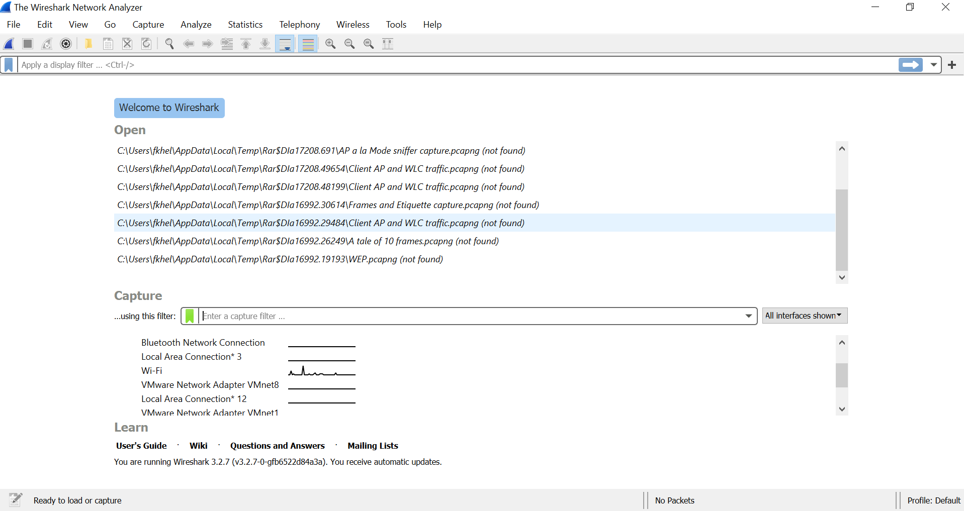

Active Interface

3. To begin packet capture, highlight the active interface, then press the start capturing button 

- Once you begin packet capture, a window similar to that shown below will appear.

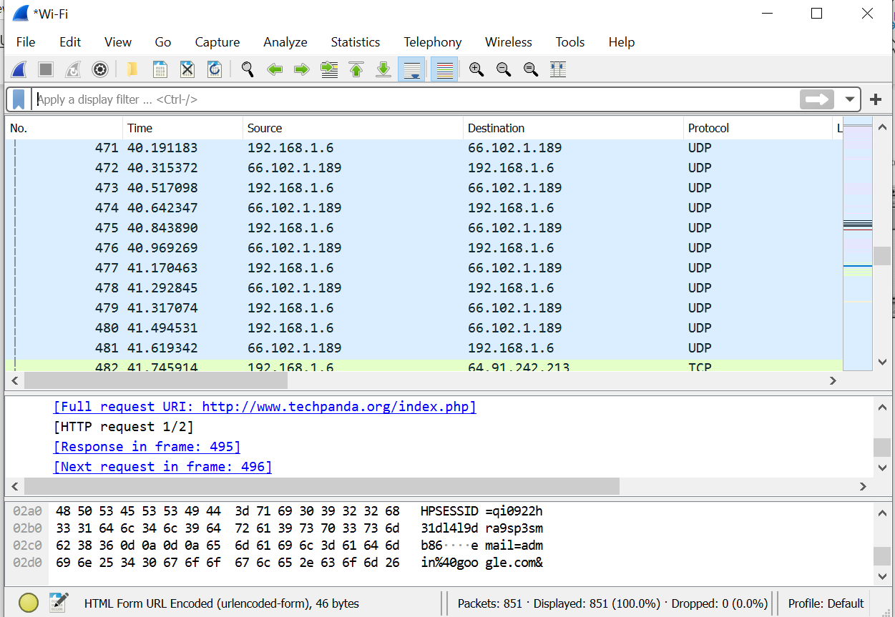
Command Menu

Display Filter

Capture Packets List

Details of Selected Packet

Selected Packet
Content in Hexadecimal

- Before you start Wireshark, Go the windows command prompt and issue the following command which will display your ip and MAC addresses
ipconfig /all
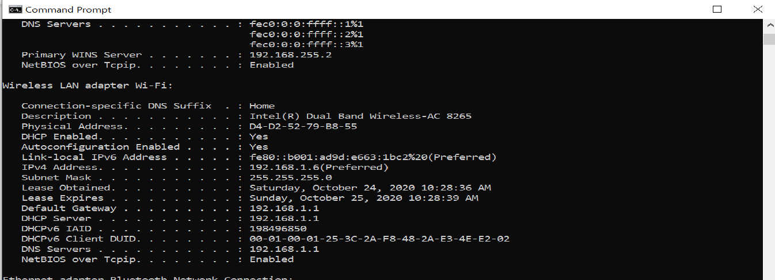

- Write down the MAC address of your Wifi/active interface (the one you used for capturing) or the active interface card and its ip address

- Start Capturing on your active interface……

- While Wireshark is running, enter the URL: www.psu.edu.sa After your browser has displayed home page of the University page stop Wireshark packet capture by selecting stop in the Wireshark capture window or pressing the stop capture button

Display Filter Operators
English | C-like | Description | Example
eq | == | Equal | ip.src == 10.0.0.5
ne | != | Not equal | ip.src !=10.0.0.5
gt | > | Greater than | frame.len > 10
lt | < | Less than | frame.len < 128
ge | >= | Greater than or equal to | frame.len ge 0x100
le | <= | Less than or equal to | frame.len <= 0x20

Display Filter Logical Operations
English | C-like | Description | Example
and | && | Logical AND | ip.src==10.0.0.5 and tcp.flags.fin
or | || | Logical OR | ip.src==10.0.0.5 or ip.src==192.1.1.1
not | ! | Logical NOT | not dns

- Type in “http” (without the quotes, and in lower case – all protocol names are in lower case in Wireshark) into the display filter specification window at the top of the main Wireshark window. Then either press enter key or press the arrow  (to the right of where you entered “http”). This will cause only HTTP message to be displayed in the packet-listing window as shown below:

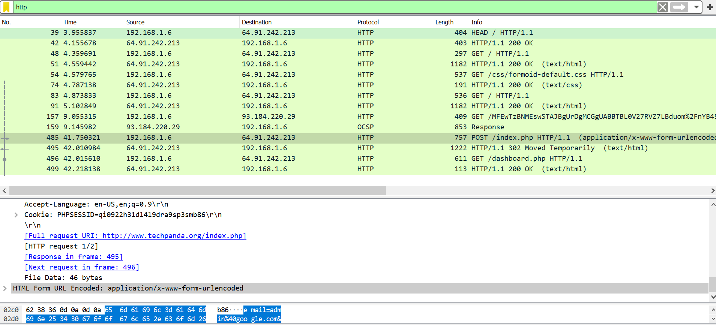

- Press the button clear to the right of the filter window

We want to use filter commands to filter certain captured packets: in the display filter specification window
- Filter all packets that has IP address equal to the IP address of your machine (x.y.z.w) as either source or destination
Type ip.addr == x.y.z.w
- Filter all packets that has source IP address equal to the IP address of your machine (x.y.z.w)
Type ip.src == x.y.z.w
- Filter all packets that has destination IP address equal to the IP address of your machine (x.y.z.w)
Type ip.dst == x.y.z.w
- Filter all packets that belong to http protocol
Type http
- Filter all packets that has destination IP address equal to the IP address of your machine (x.y.z.w) and carry http message
Type ip.dst == x.y.z.w and http
- Filter all packets that carry http message or dns message
Type dns or http

For detailed reference on Display filter expressions refer to https://www.wireshark.org/docs/wsug_html_chunked/ChWorkBuildDisplayFilterSection.html

Name: ID: Section:
Packet Filtering Practice:
Open the Command Window
Type nslookup Google.com.sa 8.8.8.8 then press enter
- Write down the ip address of Google.com.sa ___________________
Start Capturing
In the command Window type: ping -4 Google.com.sa then press enter
Wait for the Ping to finish
Stop Capturing
Answer the following:
- What is the time for the first Echo packet? _______________________
- Fill the following table regarding your active interface:
MAC address
IP Address
- Filter Packets that belong to ICMP protocol and with source IP address of Google.com.sa (ICMP protocol is part of the network layer protocols that is used by the Ping command).
(Write down the filter used for this) ___________________________________________
- Clear the filter. Write a filter just to filter all ICMP packets. _______________________
- How many packets are filtered for ICMP? ________________________________________
- How many packets with Source IP equal to your machine IP address? ______________
- How many packets with Source IP equal the IP address of Google.com.sa address? ______
Using the first Echo request packet with your machine IP address as source address: Answer the following:
- Write the Frame Source and Destination Addresses? _____________________

- Is the destination MAC address the address of Google.com.sa? Explain why?

- What is the value of the Type field in the Ethernet frame? What does this value refer to?

- What is the Source and Destination IP addresses?

- How much time did it take for the Echo response packet to arrive for the first Echo request message? Show your work? Is it approximately the same as the one you wrote in Q2?

