SE322: Software Design and Architecture
Activity 6: Principles of Detailed Design

Objective: In this activity, the students will learn how to analyze an existing software architecture or design to check if the code violates principles or not

Expected Outcome: After completing this exercise, the students will be able to:
- Analyze code to check if the code violates principles or not
- Analyze class diagram to check if the diagram violates principles or not

Course Learning Outcome:
- CLO 1: Recognize the principles, strategies, and process of software design and architecture.
- CLO 2: Analyze an existing software architecture or design.

Question1:

- Consider the class diagram does it violate the design principles?
- If it is violated, redraw the diagram in a way to comply with the principles.

Proposed Solution
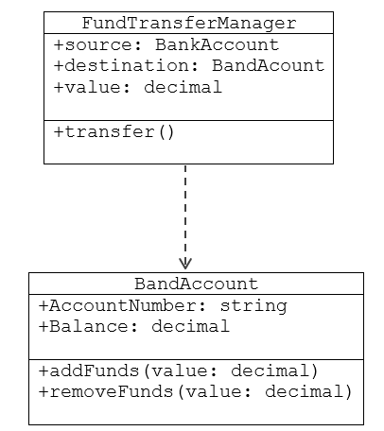

Violated Principle is:

Question2:

- Consider the class diagram does it violate the design principles?
- If it is violated, redraw the diagram in a way to comply with the principles.

Proposed Solution
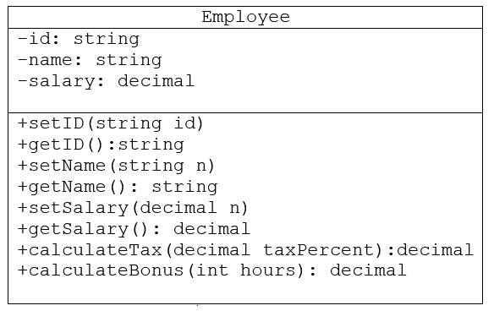

Violated Principle is:

ere’s a step-by-step approach to solve each question:
- Analyze the Class Diagram: Review each class and its relationships, looking for potential design principle violations. Typical design principles to consider include:
  - Single Responsibility Principle: Each class should have one reason to change.
  - Open/Closed Principle: Classes should be open for extension but closed for modification.
  - Liskov Substitution Principle: Derived classes should be substitutable for their base classes.
  - Interface Segregation Principle: Clients should not be forced to depend on methods they do not use.
  - Dependency Inversion Principle: High-level modules should not depend on low-level modules; both should depend on abstractions.
- Identify Violations: Document any principle violations. For example:
  - If a class has multiple responsibilities, it might violate the Single Responsibility Principle.
  - If a derived class does not fully substitute its base class, it may violate the Liskov Substitution Principle.
- Propose Redesigns: Modify the class diagram to correct these issues. Redrawing the diagram could involve:
  - Splitting classes that have multiple responsibilities.
  - Introducing interfaces or abstract classes for better abstraction.
  - Redesigning relationships to follow dependency inversion.
- Document Violations: Clearly state which principle was violated and explain the redesign.
If you upload the class diagram in question, I can provide a more specific analysis and redesign suggestions based on the identified violations.
Share


You said:
SE322_Activity 8.docx
Document
solve it

ChatGPT said:
ChatGPT
It looks like Activity 8 from the SE322: Software Design and Architecture document involves analyzing a class diagram to identify whether it violates design principles and, if so, making modifications to adhere to these principles.
Here’s a step-by-step approach to solve each question:
- Analyze the Class Diagram: Review each class and its relationships, looking for potential design principle violations. Typical design principles to consider include:
  - Single Responsibility Principle: Each class should have one reason to change.
  - Open/Closed Principle: Classes should be open for extension but closed for modification.
  - Liskov Substitution Principle: Derived classes should be substitutable for their base classes.
  - Interface Segregation Principle: Clients should not be forced to depend on methods they do not use.
  - Dependency Inversion Principle: High-level modules should not depend on low-level modules; both should depend on abstractions.
- Identify Violations: Document any principle violations. For example:
  - If a class has multiple responsibilities, it might violate the Single Responsibility Principle.
  - If a derived class does not fully substitute its base class, it may violate the Liskov Substitution Principle.
- Propose Redesigns: Modify the class diagram to correct these issues. Redrawing the diagram could involve:
  - Splitting classes that have multiple responsibilities.
  - Introducing interfaces or abstract classes for better abstraction.
  - Redesigning relationships to follow dependency inversion.
- Document Violations: Clearly state which principle was violated and explain the redesign.
If you upload the class diagram in question, I can provide a more specific analysis and redesign suggestions based on the identified violations.
4o

You said:
No i need exactly answer the questions and explain why it violat and how we can solve it redraw the class digrams for both questions

ChatGPT said:
ChatGPT
To provide an exact answer with a corrected class diagram, I'll need to see the specific class diagrams referenced in the questions to identify the violations in detail. The document doesn’t include the diagrams directly, so if you have images or can describe the structure of the diagrams (classes and relationships), please share them.
In general, here’s how the analysis and solution process would look:
- Identify the Violation: Examine each class and its relationships. If a class violates a principle, note which one and why. Common issues include classes handling too many responsibilities, inappropriate inheritance, and tight coupling.
- Redraw for Compliance: Modify the design to adhere to principles:
  - For Single Responsibility Principle: Split the class into multiple classes, each handling a single responsibility.
  - For Dependency Inversion Principle: Introduce interfaces or abstract classes to reduce dependency on concrete implementations.
- Explanation: For each correction, provide an explanation of why it resolves the violation.
If you can upload the specific class diagrams or provide further details, I can guide you through the exact corrections and redraw the diagrams accordingly.
4o

You said:

Solbe these questions and draw the class diagram after prevent the violation

ChatGPT said:
ChatGPT
Let’s address each question based on the images provided:

Question 1: FundTransferManager and BankAccount

Identified Violation:
The FundTransferManager class directly uses BankAccount for both the source and destination accounts in the transfer process. This tight coupling violates the Dependency Inversion Principle because FundTransferManager depends on the concrete BankAccount class instead of an abstraction (e.g., an interface).

Solution:
- Introduce an Interface: Create an interface, say IAccount, which declares methods like addFunds() and removeFunds().
- Implement Interface in BankAccount: Make BankAccount implement IAccount.
- Update FundTransferManager: Modify FundTransferManager to depend on the IAccount interface rather than the BankAccount class.

Revised Class Diagram:
Here’s how the revised class diagram would look:
- IAccount (Interface)
  - +addFunds(value: decimal)
  - +removeFunds(value: decimal)
- FundTransferManager
  - +source: IAccount
  - +destination: IAccount
  - +value: decimal
  - +transfer()
- BankAccount (implements IAccount)
  - +AccountNumber: string
  - +Balance: decimal
  - +addFunds(value: decimal)
  - +removeFunds(value: decimal)
This design decouples FundTransferManager from the concrete BankAccount class, adhering to the Dependency Inversion Principle.

Question 2: Employee Class

Identified Violation:
The Employee class has multiple responsibilities, including setting and getting ID, name, and salary, as well as calculating tax and bonus. This violates the Single Responsibility Principle as it should only be responsible for employee data, not for calculations.

Solution:
- Separate Responsibilities: Create separate classes for handling calculations.
  - TaxCalculator class for calculateTax().
  - BonusCalculator class for calculateBonus().
- Modify Employee: Remove calculateTax() and calculateBonus() from the Employee class and add references to TaxCalculator and BonusCalculator if needed.

Revised Class Diagram:
The revised class diagram could look like this:
- Employee
  - -id: string
  - -name: string
  - -salary: decimal
  - +setID(id: string)
  - +getID(): string
  - +setName(name: string)
  - +getName(): string
  - +setSalary(salary: decimal)
  - +getSalary(): decimal
- TaxCalculator
  - +calculateTax(employee: Employee, taxPercent: decimal): decimal
- BonusCalculator
  - +calculateBonus(employee: Employee, hours: int): decimal
This revised structure gives each class a single responsibility, thus adhering to the Single Responsibility Principle. The Employee class now only manages employee data, while tax and bonus calculations are handled by their respective classes.

