Software Requirement Specifications

Secure Web-Based Online Voting System



Submitted by
S23BINFT1M01091

Submitted to
Dr. Asad Ullah

Department of Information Technology
Faculty of Computing
The Islamia University of Bahawalpur

Meeting Details
Sr No | Details | Date | Supervisor Signature
01. | Presented the initial concept for the final year project.

Summary
This document presents the Software Requirements Specification (SRS) for the Secure Web-Based Online Voting System, a platform designed to digitize and enhance the traditional voting process through a secure and efficient web-based solution.
In many organizations and institutions, traditional voting systems are still widely used, which often involve manual processes, long queues, high operational costs, and risks of human error or vote manipulation. These limitations highlight the need for a reliable digital system that ensures transparency, accessibility, and accuracy in the voting process.
Analysis of current digital solutions shows that while some electronic voting systems exist, many lack proper security measures, user accessibility, or real-time result processing. Therefore, there is a strong need for a system that combines ease of use with robust security and data integrity.
The proposed system introduces a centralized web-based platform where authorized users can securely participate in elections. It ensures that each voter can cast only one vote while maintaining complete confidentiality and preventing unauthorized access. The system also provides administrative control for managing elections, candidates, and voter records efficiently.
Core system requirements include:
- A role-based architecture consisting of Admin and Voter modules
- A secure authentication system to verify user identity
- An intuitive interface for voters to view candidates and cast votes
- A controlled mechanism ensuring one user can vote only once
- A real-time vote counting and result generation system
- A secure database system to maintain data integrity and confidentiality
The system aims to provide a scalable, user-friendly, and secure solution that improves the efficiency and reliability of the voting process while reducing manual effort and operational risks.

Table of Contents
1. Introduction 6
1.1. Purpose 6
1.2. Scope 7
1.3. Product Perspective 7
1.4. User Characteristics 8
1.5. Similar apps and systems/Literature Review 9
The Identified Gap 9
1.6. Proposed Technologies 10
2. Requirements 11
2.1. Function Requirements 11
2.1.1 User Registration 11
2.1.2 Login 12
2.1.3 Election Creation 12
2.1.4 Candidate Management 12
2.1.5 Vote Casting 12
2.1.6 Result Generation 13
2.1.7 Voter Management (Optional Enhancement) 13
2.2. Non-Functional Requirements 13
2.2.1 System Performance and Response Time 13
2.2.2 Data Security and Privacy 14
2.2.3 Usability and Interface Accessibility 14
2.2.4 Reliability and Availability 14
3. Use Cases and Flow of Processes 15
3.1. Use Case 1 15
Basic Flow: 16
Exceptions: 16
3.2. Use Case 2: 16
Basic Flow: 16
Exceptions: 17
3.3. Use Case 3: 17
Basic Flow: 17
Exceptions: 17
3.4. Use Case 4: 17
Basic Flow: 18
3.5. Use Case 5: 18
Basic Flow: 18
3.6. Use Case 6: 18
Basic Flow: 19
3.7. Use Case 7: 19
Basic Flow: 19
3.8. Use Case 8: 19
Basic Flow: 19
20
4. References 21

- Introduction
This project is developed as a web-based solution aimed at modernizing the traditional voting process through a secure, accessible, and efficient digital platform. Designed for use in universities, organizations, and small-scale elections, the system enables participants to cast their votes remotely while maintaining transparency, accuracy, and trust in the electoral process. By transitioning from manual to digital voting, the platform reduces operational complexity, minimizes human error, and enhances overall election efficiency.
The system is structured around a secure, role-based architecture that distinguishes between voters and administrators. Registered users can authenticate themselves and participate in elections through an intuitive interface, while administrators are provided with comprehensive control over election management, including candidate handling, voter verification, and result monitoring. The platform enforces strict validation mechanisms to ensure that each voter can cast only one vote, thereby preserving the integrity and fairness of the election.
The current development scope focuses on the core modules of secure authentication, election management, vote casting, and real-time result processing. The system integrates these components into a unified workflow where votes are recorded instantly, stored securely, and processed efficiently. This ensures that election outcomes are accurate, tamper-resistant, and readily available without delays. By combining usability with robust security practices, the proposed system establishes a reliable digital environment for conducting fair and transparent elections.
  - Purpose
The traditional voting process, widely used in universities and organizations, is often associated with inefficiencies, security concerns, and limited accessibility. Manual voting methods require significant time and resources, are prone to human error, and may lack transparency in vote counting and result declaration. These limitations create a need for a reliable and secure digital alternative.
The purpose of the Secure Web-Based Online Voting System is to provide a centralized, automated platform that ensures a fair, transparent, and efficient voting process. The system is designed to eliminate manual complexities by enabling users to cast their votes online while maintaining strict security and data integrity standards.
By incorporating secure authentication, controlled access, and real-time result processing, the platform ensures that each vote is accurately recorded and counted without the risk of duplication or manipulation. Ultimately, the system aims to enhance trust in the voting process while improving overall efficiency, accessibility, and user experience.
  - Scope
The scope of the Secure Web-Based Online Voting System focuses on developing a secure, role-based digital platform that facilitates the entire voting process in an efficient and transparent manner. The system will establish a controlled environment that distinguishes between voters and administrators, ensuring that each user interacts with the platform according to their assigned role.
The core system will include functionalities such as secure user registration and authentication, election creation and management, candidate administration, and online vote casting. The platform will also incorporate validation mechanisms to ensure that each registered voter can cast only one vote. Additionally, the system will provide real-time vote counting and result generation, enabling administrators to monitor election progress and outcomes instantly.
The system will be designed with a user-friendly interface to ensure ease of use for individuals with basic technical knowledge. It will also implement security measures such as encrypted authentication and secure data handling to maintain confidentiality and integrity throughout the voting process.
Conversely, certain features will remain outside the scope of the current system to maintain simplicity and focus. These include advanced authentication mechanisms such as biometric verification, blockchain-based voting infrastructure, and dedicated mobile applications. Furthermore, the system will not include financial transaction modules, third-party integrations for payment processing, or large-scale governmental election support in its initial version.

  - Product Perspective
The Secure Web-Based Online Voting System is designed as a centralized web application operating within a client-server architecture. The system’s core modules—specifically authentication management, election control, vote processing, and result generation—function as the central processing layer that connects the user interface with the underlying database infrastructure.
Positioned between the frontend interface and the backend database, the system acts as a secure intermediary that manages all user interactions and data transactions. When a user submits credentials or casts a vote, the system first validates the request through authentication and authorization mechanisms. Once verified, the request is processed according to predefined business logic and securely stored in the database.
The vote processing module plays a critical role by ensuring that each voter can cast only one vote and that all votes are recorded accurately without duplication or manipulation. Simultaneously, the election management module allows administrators to configure elections, manage candidates, and monitor system activity in real time. The result generation module retrieves stored vote data and computes results dynamically, providing immediate and accurate outcomes.
Overall, the system serves as an integrated operational bridge that connects user-facing components, secure backend logic, and persistent data storage, ensuring a reliable, transparent, and efficient voting environment.

  - User Characteristics
The Secure Web-Based Online Voting System is designed for individuals with basic computer literacy and access to the internet. To ensure a secure and well-managed voting environment, the system defines two primary human roles, along with system-level operations, each having distinct responsibilities and interaction patterns:

Voters
Background:
University students, staff members, or authorized participants who are eligible to take part in elections.
Characteristics:
Voters typically possess basic technical skills and require a simple, intuitive interface to interact with the system. They prioritize ease of use, clarity, and quick access to voting functionalities without requiring advanced technical knowledge.
System Interaction:
Voters interact with the system through the user interface to register, log in, view available elections and candidates, and cast their vote. They also receive confirmation after successfully submitting their vote.
Administrators
Background:
System managers or authorized personnel responsible for overseeing and controlling the election process.
Characteristics:
Administrators are technically competent users with a clear understanding of system operations. They require efficient tools to manage elections, monitor system activity, and ensure the integrity of the voting process.
System Interaction:
Administrators access a secure admin panel to create and manage elections, add or remove candidates, manage voter records, and monitor voting results. They also ensure that the system operates smoothly and securely.

  - Similar apps and systems/Literature Review
The domain of voting systems includes a variety of traditional and digital approaches; however, existing solutions often exhibit limitations that affect efficiency, transparency, and security. A review of current systems highlights their strengths as well as critical shortcomings that this proposed project aims to address.
Traditional Paper-Based Voting Systems
Conventional voting methods rely on physical ballots and manual counting procedures. While widely used, these systems are inherently time-consuming and resource-intensive. They require significant manpower for supervision and vote counting, which increases the likelihood of human error. Additionally, the process lacks real-time result generation and may raise concerns regarding transparency and vote integrity.
Electronic Voting Machines (EVMs)
Electronic voting machines have been introduced to improve efficiency and reduce manual effort. These systems enable faster vote recording and counting compared to paper-based methods. However, they often operate in isolated environments with limited accessibility, restricting participation to specific physical locations. Furthermore, concerns related to security vulnerabilities, lack of auditability, and potential tampering have been raised in various implementations.
Online Voting Systems (Existing Platforms)
Some web-based voting platforms have been developed to allow remote participation. While these systems improve accessibility and convenience, many lack robust security mechanisms such as strong authentication, encryption, and proper validation controls. In some cases, these systems do not adequately enforce one-vote-per-user constraints or fail to provide transparent and real-time result processing.

The Identified Gap
The analysis of existing systems indicates that current voting solutions often require a trade-off between accessibility, security, and transparency. Traditional systems offer reliability but lack efficiency, while some digital systems provide convenience but fall short in ensuring strong security and data integrity.
There is a clear need for a secure, web-based voting platform that integrates ease of access with robust authentication, controlled voting mechanisms, and real-time result generation. The proposed Secure Web-Based Online Voting System addresses this gap by providing a centralized, reliable, and user-friendly solution that ensures fairness, accuracy, and transparency in the voting process.

  - Proposed Technologies
The Secure Web-Based Online Voting System is designed as a modern web application that emphasizes security, scalability, and efficient data processing. To ensure reliable performance and ease of development, the system will be implemented using the following technologies:
- Frontend Technologies:
HTML, CSS, JavaScript, and Bootstrap will be used to develop the user interface. These technologies provide a responsive and user-friendly design, enabling smooth interaction for both voters and administrators across different devices and screen sizes.
- Backend Framework:
Django (Python-based framework) will serve as the core backend infrastructure. It offers a secure and structured environment for handling business logic, managing user authentication, processing votes, and enforcing system rules such as one-vote-per-user constraints.
- Database Management System:
MySQL will be used as the relational database to store system data, including user information, election records, candidate details, and voting results. It ensures data integrity, consistency, and efficient query handling.
- Version Control System:
GitHub will be utilized for version control and project management. It allows efficient tracking of code changes, collaboration, and maintenance of the project throughout the development lifecycle.

- Requirements
The core functionality of the Secure Web-Based Online Voting System revolves around a secure and streamlined workflow of user authentication, election management, vote casting, and result processing. The system begins by managing role-based access, allowing users to register and authenticate as either voters or administrators through a secure login mechanism.
Once authenticated, voters interact with the system through a dedicated interface where they can view available elections and candidate details. The voting module ensures that each user can cast their vote only once by enforcing strict validation rules. Upon submission, the system securely records the vote in the database while maintaining confidentiality and preventing duplication or manipulation.
On the administrative side, the system provides a centralized dashboard that allows administrators to create and manage elections, add or remove candidates, and monitor voting activities in real time. The system continuously processes incoming votes and updates results dynamically, ensuring accurate and immediate result generation.
Overall, the platform integrates authentication, data validation, secure storage, and real-time processing into a cohesive workflow, ensuring a reliable, transparent, and efficient online voting experience.
  - Function Requirements
The following are the functional requirements of the system:

2.1.1 User Registration
- Name: FR001
- Purpose:
The registration process allows a user to become a verified voter in the system.
- User(s): Voter
- Input:
  - Name: Full name of the user
  - Email Address: A valid email for account creation and communication
  - Password: Must be at least 8 characters long and include a number and special character
- Output:
The user account is successfully created, and the user is able to log in to the system.

2.1.2 Login
- Name: FR002
- Purpose:
Authenticates users to securely access the system and their respective dashboards.
- User(s): Voter, Admin
- Input:
  - Email Address: Registered email
  - Password: Account password
- Output:
User is authenticated, a secure session is created, and the user is redirected to their dashboard.

2.1.3 Election Creation
- Name: FR003
- Purpose:
Allows the administrator to create and configure new elections.
- User(s): Admin
- Input:
  - Election Title
  - Start Date
  - End Date
- Output:
Election is successfully created and made available to voters.

2.1.4 Candidate Management
- Name: FR004
- Purpose:
Allows the administrator to add, update, or remove candidates for an election.
- User(s): Admin
- Input:
  - Candidate Name
  - Candidate Details (optional description)
- Output:
Candidate list is updated and displayed to voters.

2.1.5 Vote Casting
- Name: FR005
- Purpose:
Allows a registered voter to cast a vote in an active election.
- User(s): Voter
- Input:
  - Selected Candidate
- Constraints:
  - Each voter can vote only once per election
- Output:
Vote is securely recorded in the database and a confirmation message is displayed.

2.1.6 Result Generation
- Name: FR006
- Purpose:
Automatically calculates and displays election results based on recorded votes.
- User(s): Admin
- Input:
  - Stored vote data
- Output:
Accurate election results are generated and displayed in real time.

2.1.7 Voter Management (Optional Enhancement)
- Name: FR007
- Purpose:
Allows the administrator to manage voter records.
- User(s): Admin
- Input:
  - Voter details (add/remove/update)
- Output:
Updated voter database ensuring only authorized users can participate.

  - Non-Functional Requirements
The following are the non-functional requirements of the system:

2.2.1 System Performance and Response Time
- Name: NFR001
- Purpose:
Ensures that the system remains responsive and efficient during user interactions such as login, vote casting, and result viewing.
- User(s): Voter, Admin
- Input:
  - Page Request: User accesses dashboards, candidate lists, or results
  - Vote Submission: Voter casts a vote during an active election
- Output:
  - Standard pages should load within 2 seconds
  - Vote submission and confirmation should be processed within 1–2 seconds under normal server conditions

2.2.2 Data Security and Privacy
- Name: NFR002
- Purpose:
Ensures protection of user credentials, voting data, and overall system integrity.
- User(s): Voter, Admin
- Input:
  - Authentication Data: Email and password during login/registration
  - Voting Data: User vote selection and election records
- Output:
  - Passwords must be securely hashed (e.g., using Django’s built-in hashing mechanism)
  - All communication must be secured using HTTPS/SSL encryption
  - Voting data must be stored securely to prevent unauthorized access or manipulation

2.2.3 Usability and Interface Accessibility
- Name: NFR003
- Purpose:
Ensures that the system is easy to use and accessible to users with basic technical knowledge.
- User(s): Voter, Admin
- Input:
  - Device Type: Desktop, laptop, or mobile browser
  - User Interaction: Navigation through system features
- Output:
  - The interface must be responsive across different screen sizes
  - Navigation should be simple and intuitive
  - Clear instructions and feedback messages should be provided to users

2.2.4 Reliability and Availability
- Name: NFR004
- Purpose:
Ensures the system operates consistently without failures during critical operations such as voting.
- User(s): All Users
- Input:
  - Continuous system usage during election periods
- Output:
  - System should maintain high uptime during elections
  - No loss of voting data should occur
  - Backup mechanisms should be in place for data recovery

- Use Cases and Flow of Processes

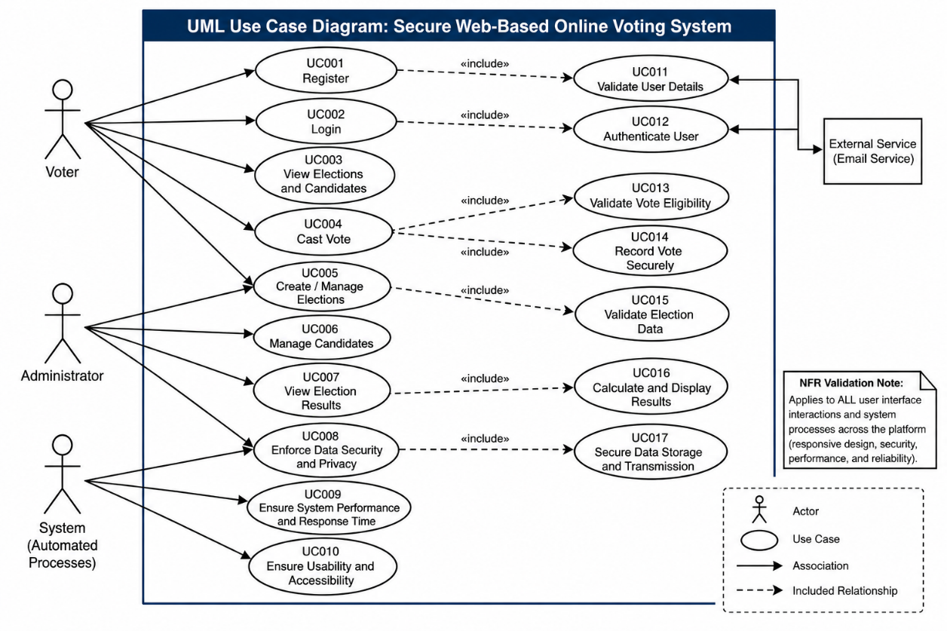
Figure 1: System Level Use Case Diagram

  - Use Case 1
ID | UC001
Name | User Registration
Description | This use case describes the process of a new voter registering in the system.
Requirement(s) | FR001
Actor(s) | Voter
Precondition | User must not already be registered.
Postcondition | User account is created successfully.
Basic Flow | Basic Flow  Basic Flow:  - User enters registration details  - System validates inputs  - System creates account  Exceptions:  - Invalid email format  - Password does not meet criteria  - Email already exists

  - Use Case 2:
ID | UC002
Name | Login
Description | This use case describes user authentication to access the system.
Requirement(s) | FR002
Actor(s) | Voter, Admin
Precondition | User must have a registered account
Postcondition | User is logged in and redirected to dashboard
Basic Flow | Basic Flow:  - User enters email and password  - System validates credentials  - System grants access  Exceptions:  - Incorrect login details  - Unauthorized user  .

  - Use Case 3:
ID | UC003
Name | Vote Casting
Description | Allows a voter to cast a vote in an election.
Requirement(s) | FR003
Actor(s) | Voter
Precondition | User must be logged in and election must be active
Postcondition | Vote is stored securely
Basic Flow | Basic Flow:  - User views candidates  - User selects candidate  - User submits vote  - System records vote  Exceptions:  - User already voted  - Election is closed

  - Use Case 4:
ID | UC004
Name | Election Management
Description | Allows admin to create and manage elections.
Requirement(s) | FR004
Actor(s) | Admin
Precondition | Admin must be logged in
Postcondition | Election is created or updated
Basic Flow | Basic Flow:  - Admin enters election details  - System validates input  - Election is created

  - Use Case 5:
ID | UC005
Name | Candidate Management
Description | Allows admin to manage candidates.
Requirement(s) | FR005
Actor(s) | Admin
Precondition | Admin logged in
Postcondition | Candidate list updated
Basic Flow | Basic Flow:  - Admin adds/removes candidates  - System updates database

  - Use Case 6:
ID | UC006
Name | Result Generation
Description | Displays election results based on votes.
Requirement(s) | FR006
Actor(s) | Admin
Precondition | Votes must exist
Postcondition | Results are displayed
Basic Flow | Basic Flow:  - System counts votes  - System displays results

  - Use Case 7:
ID | UC007
Name | Enforce Data Security and Privacy
Description | Ensures secure handling of user and voting data.
Requirement(s) | NFR001
Actor(s) | System
Precondition | None
Postcondition | none
Basic Flow | Basic Flow:  - System encrypts sensitive data  - System ensures secure communication (HTTPS)

  - Use Case 8:
ID | UC008
Name | System Performance Handling
Description | Ensures system responds efficiently under load.
Requirement(s) | NFR002
Actor(s) | System
Basic Flow | Basic Flow:  - System processes request  - System returns response within time limit

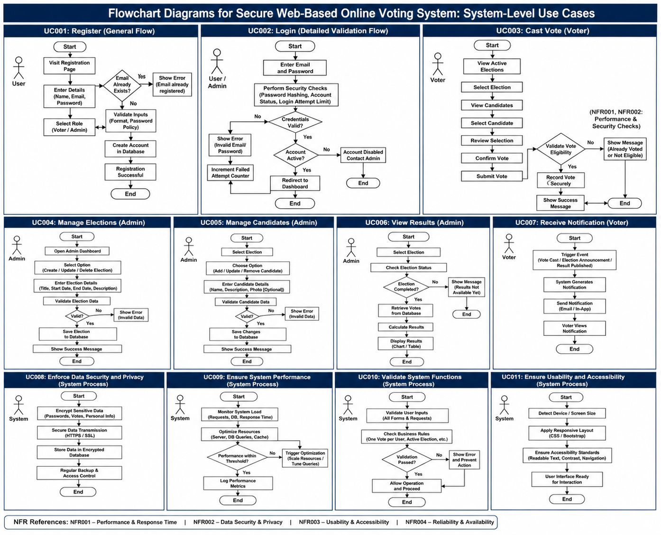

- References
- [1] Django Software Foundation. “Django: The Web Framework for Perfectionists with Deadlines.” Django Project. https://www.djangoproject.com/ (accessed Apr. 30, 2026).
- [2] Oracle Corporation. “MySQL: The World’s Most Popular Open Source Database.” MySQL. https://www.mysql.com/ (accessed Apr. 30, 2026).
- [3] W3C. “HTML Standard.” World Wide Web Consortium. https://html.spec.whatwg.org/ (accessed Apr. 30, 2026).
- [4] W3C. “CSS Cascading Style Sheets.” World Wide Web Consortium. https://www.w3.org/Style/CSS/ (accessed Apr. 30, 2026).
- [5] Mozilla Foundation. “JavaScript Guide.” MDN Web Docs. https://developer.mozilla.org/en-US/docs/Web/JavaScript (accessed Apr. 30, 2026).
- [6] Bootstrap Team. “Bootstrap: The Most Popular CSS Framework.” https://getbootstrap.com/ (accessed Apr. 30, 2026).
- [7] IEEE. “IEEE Recommended Practice for Software Requirements Specifications.” IEEE Standards Association. https://ieeexplore.ieee.org/ (accessed Apr. 30, 2026).

