Software Design Document

Secure Web-Based Online Voting System



Submitted by
MUHAMMAD SHOUKAT (S23BINFT1M01191)

Submitted to
Dr. Asad Ullah

Department of Information Technology
Faculty of Computing
The Islamia University of Bahawalpur

Meeting Details
Sr No | Details | Date | Supervisor Signature
01. | Presented the initial concept for the final year project.

Summary
This Software Design Document (SDD) presents the design and architectural details of the Secure Web-Based Online Voting System. The purpose of this document is to translate the requirements defined in the Software Requirements Specification (SRS) into a structured technical design that guides the implementation and deployment of the system.
The Secure Web-Based Online Voting System is designed to provide a reliable, transparent, and secure digital platform for conducting elections. The system addresses the limitations of traditional voting methods by enabling authorized users to participate in elections remotely while ensuring vote confidentiality, integrity, and accuracy. Through role-based access control, the platform distinguishes between voters and administrators, providing each user with appropriate functionalities and permissions.
Several design considerations were taken into account during the development of this system. Security serves as a primary concern, requiring secure authentication mechanisms, encrypted data transmission, and protection against unauthorized access. Scalability and performance are also important factors to ensure that the system can efficiently handle multiple users and voting requests simultaneously. Additionally, usability has been emphasized to provide an intuitive and responsive user interface that can be easily used by individuals with varying levels of technical expertise.
The application follows a client-server architecture consisting of a frontend interface, a backend application layer, and a relational database management system. The frontend is responsible for user interaction and presentation, while the backend manages authentication, election processing, vote validation, and result generation. The database serves as the central repository for storing user accounts, election records, candidate information, and voting data.
The system's data model is structured to maintain data consistency and integrity while supporting efficient retrieval and processing of election-related information. Furthermore, the user interface is designed to provide seamless navigation for both voters and administrators, ensuring a smooth and efficient voting experience.
Overall, this document outlines the architectural design, database structure, system components, and user interface specifications required to implement a secure, scalable, and user-friendly online voting platform.

Table of Contents
1. Application Architecture 5
1.1. Architecture Overview 5
1.2. MVT Components 7
1.3. Controllers 8
1.4. APIs and Libraries 9
1.5. UML Diagram 9
1.6. Codding Conventon 10
2. Data Model Schema 12
2.1. User Entity 12
2.2 Election Entity 13
2.3 Candidate Entity 13
2.4 Vote Entity 14
2.5 Result Entity 15
2.6 Entity Relationship Diagram 15
2.7 Database Design Consideration 16
ER Diagram: 17
3. Use Interface 18
3.1. Design Philosphy 18
3.2 Screen List 19
3.3 Registration Page 19
3.4 Login Page 20
3.5 User Dashboard 20
3.6 Election Detail Page 21
3.7 Candidate Section Page 22
3.8 Vote Conformation Page 22
3.9 Result Page 23
3.10 Admin Dashboard 24
3.11 Election Management Page 24
3.12 Candidate Management Page 25
3.13 Use Interface Desgin Consideration 25
4. References 26

- Application Architecture
The Secure Web-Based Online Voting System follows a layered client-server architecture that separates the presentation layer, application logic layer, and data storage layer. This architectural approach improves maintainability, scalability, security, and ease of development. The system is implemented using the Django framework, which follows the Model-View-Template (MVT) architectural pattern. MVT is conceptually similar to the Model-View-Controller (MVC) pattern and provides a clear separation of responsibilities among system components.

1.1 Architectural Overview
The architecture consists of the following layers:

Presentation Layer (Frontend)
The presentation layer provides the graphical user interface through which users interact with the system. It is developed using:
- HTML5
- CSS3
- JavaScript
- Bootstrap
This layer is responsible for displaying election information, candidate lists, voting forms, authentication pages, and administrative dashboards.

Application Layer (Backend)
The application layer is developed using Django and contains the business logic of the system. It handles:
- User authentication
- Election management
- Candidate management
- Vote validation
- Vote processing
- Result generation
- Security enforcement
This layer acts as an intermediary between the frontend and the database.

Data Layer (Database)
The data layer uses MySQL as the primary database management system.
It stores:
- User accounts
- Election records
- Candidate information
- Voting records
- System logs
The database ensures data consistency, integrity, and efficient retrieval of information.

1.2 MVT (MVC) Components

Models
The Models represent the database structure and business entities of the system.
Proposed Models:
- User
- Election
- Candidate
- Vote
- Result
These models define relationships between system entities and are responsible for data persistence.

Views
Views handle incoming requests, process business logic, and generate responses for users.
Proposed Views:
- Registration View
- Login View
- Election View
- Candidate View
- Voting View
- Result View
- Admin Dashboard View

Templates
Templates define the user interface presented to voters and administrators.
Proposed Templates:
- Registration Page
- Login Page
- Dashboard Page
- Election Page
- Candidate Page
- Voting Page
- Results Page
- Admin Panel

1.3 Controllers (Business Logic Components)
The following controllers manage the core functionality of the system:

Authentication Controller
Functions:
- registerUser()
- loginUser()
- logoutUser()
- resetPassword()
Purpose:
Manages user authentication and authorization.

Election Controller
Functions:
- createElection()
- updateElection()
- deleteElection()
- viewElection()
Purpose:
Handles election creation and management.

Candidate Controller
Functions:
- addCandidate()
- updateCandidate()
- deleteCandidate()
- viewCandidates()
Purpose:
Manages candidate-related operations.

Voting Controller
Functions:
- castVote()
- validateVote()
- checkVotingEligibility()
Purpose:
Processes votes and ensures one-vote-per-user enforcement.

Result Controller
Functions:
- calculateResults()
- generateResults()
- publishResults()
Purpose:
Processes voting data and generates election results.

1.4 APIs and Libraries

Internal APIs
The system will expose internal APIs for communication between frontend components and backend services.
Examples:
- User Authentication API
- Election Management API
- Candidate Management API
- Voting API
- Result Generation API

External Libraries
The following libraries will be used:

Django
Provides:
- Authentication system
- ORM functionality
- URL routing
- Security features

Bootstrap
Provides:
- Responsive design
- UI components
- Cross-device compatibility

MySQL Connector
Provides:
- Database connectivity
- Query execution
- Data persistence

1.5 UML Diagrams
The following UML diagrams will be used to represent the system design:
- Use Case Diagram
- Class Diagram
- Sequence Diagram
- Activity Diagram
- Entity Relationship Diagram (ERD)
These diagrams provide a visual representation of system interactions, data flow, and structural relationships.

1.6 Coding Conventions
To maintain code quality and consistency, the following coding conventions will be followed:

Python (Django)
- Follow PEP-8 standards
- Use meaningful variable and function names
- Apply proper indentation (4 spaces)
- Use comments where necessary
- Separate business logic into reusable functions

HTML/CSS
- Use semantic HTML elements
- Maintain consistent naming conventions
- Follow responsive design principles

JavaScript
- Use camelCase naming convention
- Avoid code duplication
- Write modular and reusable functions

Database
- Use meaningful table and column names
- Apply primary and foreign key constraints
- Follow database normalization principles
These conventions improve readability, maintainability, and collaboration throughout the development lifecycle.

- Data Model Schema
The Secure Web-Based Online Voting System relies on a relational database structure designed to ensure data integrity, consistency, and efficient retrieval of election-related information. The database schema consists of several interconnected entities that collectively support user authentication, election management, candidate administration, vote processing, and result generation.
The conceptual data model establishes relationships between users, elections, candidates, and votes while enforcing business rules such as one-vote-per-user and secure vote storage. The following entities form the core of the database design.

2.1 User Entity
The User entity stores information about all registered users of the system, including voters and administrators.

Attributes

Attribute | Data Type | Description
user_id | Integer (PK) | Unique identifier of user
full_name | Varchar(100) | User full name
email | Varchar(100) | User email address
password | Varchar(255) | Encrypted password
role | Varchar(20) | User role (Admin/Voter)
created_at | DateTime | Account creation date

Purpose
This entity is responsible for authentication and authorization throughout the system.

Relationships
- One User can cast multiple Votes across different Elections.
- One User belongs to exactly one role.

2.2 Election Entity
The Election entity stores information related to elections created by administrators.

Attributes
Attribute | Data Type | Description
election_id | Integer (PK) | Unique election identifier
title | Varchar(150) | Election title
description | Text | Election description
start_date | DateTime | Election starting date
end_date | DateTime | Election ending date
status | Varchar(20) | Active, Upcoming, Completed

Purpose
This entity manages election information and controls voting availability.

Relationships
- One Election contains multiple Candidates.
- One Election receives multiple Votes.

2.3 Candidate Entity
The Candidate entity stores information about election candidates.

Attributes
Attribute | Data Type | Description
candidate_id | Integer (PK) | Candidate identifier
election_id | Integer (FK) | Associated election
candidate_name | Varchar(100) | Candidate name
description | Text | Candidate profile
image | Varchar(255) | Candidate photo path (optional)

Purpose
Represents individuals participating in elections.

Relationships
- One Candidate belongs to one Election.
- One Candidate can receive multiple Votes.

2.4 Vote Entity
The Vote entity stores voting records submitted by voters.

Attributes
Attribute | Data Type | Description
vote_id | Integer (PK) | Vote identifier
user_id | Integer (FK) | Voter reference
candidate_id | Integer (FK) | Selected candidate
election_id | Integer (FK) | Election reference
vote_time | DateTime | Time of vote submission

Purpose
Stores all votes cast within the system.

Relationships
- One Vote belongs to one User.
- One Vote belongs to one Election.
- One Vote is assigned to one Candidate.

Business Rule
A voter can cast only one vote per election.

2.5 Result Entity
The Result entity stores summarized election results.

Attributes
Attribute | Data Type | Description
result_id | Integer (PK) | Result identifier
election_id | Integer (FK) | Election reference
candidate_id | Integer (FK) | Candidate reference
total_votes | Integer | Number of votes received

Purpose
Stores processed voting results for reporting and display purposes.

Relationships
- One Result belongs to one Election.
- One Result belongs to one Candidate.

2.6 Entity Relationship Diagram (ERD)
The Entity Relationship Diagram illustrates the relationships among the core entities of the system.

Relationship Summary
- User (1) ---- (M) Vote
- Election (1) ---- (M) Candidate
- Election (1) ---- (M) Vote
- Candidate (1) ---- (M) Vote
- Election (1) ---- (M) Result
- Candidate (1) ---- (M) Result

ERD Structure
User
│
├──< Vote >── Candidate
│ │
│ │
└──────────── Election
│
│
Result
The ERD demonstrates how users participate in elections by casting votes for candidates. The collected voting data is processed and summarized within the Result entity to generate election outcomes.

2.7 Database Design Considerations
The database schema has been designed according to normalization principles to minimize redundancy and improve data consistency.
The design incorporates:
- Primary Key constraints for unique identification.
- Foreign Key constraints for referential integrity.
- One-to-Many relationships between major entities.
- Secure storage of authentication credentials.
- Efficient querying for vote counting and result generation.
This schema ensures reliable system operation while supporting scalability and future enhancements.

ER-DIAGRAM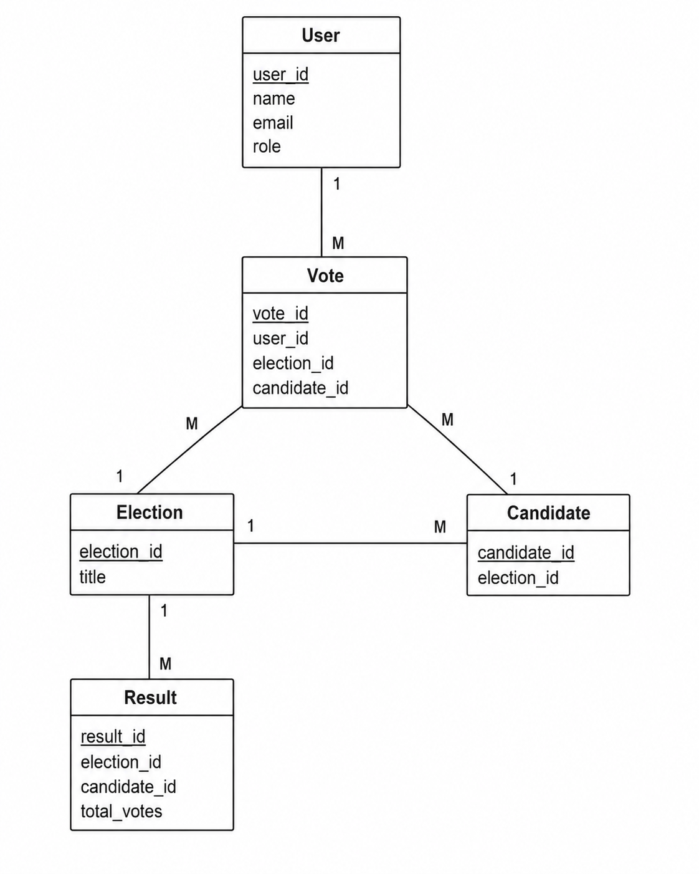

- User Interface
The Secure Web-Based Online Voting System is designed with a focus on simplicity, accessibility, security, and usability. The user interface aims to provide a seamless experience for both voters and administrators while ensuring that all critical actions, such as authentication and vote submission, can be performed efficiently and without confusion.

3.1 Design Philosophy
The system follows a modern and minimalistic web design approach that prioritizes clarity and ease of navigation. The interface is designed to reduce user errors during the voting process while maintaining a professional appearance.

Color Scheme
The proposed color palette consists of:
- Primary Color: Dark Blue (#1E3A8A)
- Secondary Color: Light Blue (#3B82F6)
- Background Color: White (#FFFFFF)
- Success Color: Green (#22C55E)
- Warning/Error Color: Red (#EF4444)
The color scheme is selected to convey trust, security, and professionalism.

Typography
The system will utilize modern web fonts such as:
- Poppins
- Roboto
- Arial (Fallback)
Font sizes will be optimized for readability across all devices.

Responsiveness
The interface will follow responsive web design principles to ensure compatibility across:
- Desktop Computers
- Laptops
- Tablets
- Mobile Devices
Bootstrap will be used to implement responsive layouts and adaptive screen behavior.

3.2 Screen List
The system consists of the following screens:
- Registration Page
- Login Page
- Voter Dashboard
- Election Details Page
- Candidate Selection Page
- Vote Confirmation Page
- Results Page
- Admin Dashboard
- Election Management Page
- Candidate Management Page

3.3 Registration Page

Purpose
Allows new users to create an account.

Data Displayed
- Registration Form
- Validation Messages

Controls
Control | Type | Purpose
Full Name | Textbox | User's full name
Email Address | Textbox | User email
Password | Password Field | User password
Confirm Password | Password Field | Password verification
Register | Button | Submit registration form

Input Constraints
- Name cannot be empty.
- Email must follow valid email format.
- Password must contain at least:
  - 8 characters
  - 1 number
  - 1 special character
- Password and Confirm Password must match.

3.4 Login Page

Purpose
Allows registered users to access the system.

Data Displayed
- Login Form
- Error Messages

Controls
Control | Type | Purpose
Email | Textbox | User email
Password | Password Field | User password
Login | Button | Authenticate user

Input Constraints
- Email must exist in the system.
- Password must match registered credentials.

3.5 Voter Dashboard

Purpose
Provides voters access to available elections and voting activities.

Data Displayed
- Active Elections
- Election Status
- Voting History

Controls
Control | Type | Purpose
View Election | Button | Open election details
Cast Vote | Button | Start voting process
Logout | Button | End session

Input Constraints
- User must be authenticated.
- Election must be active.

3.6 Election Details Page

Purpose
Displays information regarding a selected election.

Data Displayed
- Election Title
- Description
- Start Date
- End Date
- Candidate List

Controls
Control | Type | Purpose
View Candidates | Button | Display candidate details
Back | Button | Return to dashboard

Input Constraints
- Election must exist in database.

3.7 Candidate Selection Page

Purpose
Allows voters to select a candidate.

Data Displayed
- Candidate Name
- Candidate Description
- Candidate Image (Optional)

Controls
Control | Type | Purpose
Select Candidate | Radio Button | Choose candidate
Submit Vote | Button | Cast vote

Input Constraints
- Only one candidate can be selected.
- User must not have voted previously in the same election.

3.8 Vote Confirmation Page

Purpose
Confirms successful vote submission.

Data Displayed
- Confirmation Message
- Election Information

Controls
Control | Type | Purpose
Return Dashboard | Button | Navigate back

Input Constraints
- Accessible only after successful vote submission.

3.9 Results Page

Purpose
Displays election results.

Data Displayed
- Candidate Names
- Total Votes
- Winner Information
- Vote Statistics

Controls
Control | Type | Purpose
View Results | Button | Display election results
Export Results | Button | Download report (optional)

Input Constraints
- Results available only after election completion.

3.10 Admin Dashboard

Purpose
Provides administrators with complete system control.

Data Displayed
- Total Elections
- Total Voters
- Total Candidates
- Election Statistics

Controls
Control | Type | Purpose
Manage Elections | Button | Election management
Manage Candidates | Button | Candidate management
View Results | Button | Access reports
Logout | Button | End session

Input Constraints
- Only administrators can access this page.

3.11 Election Management Page

Purpose
Allows administrators to create and manage elections.

Controls
Control | Type | Purpose
Election Title | Textbox | Election name
Description | Text Area | Election details
Start Date | Date Picker | Election start date
End Date | Date Picker | Election end date
Save Election | Button | Store election

Input Constraints
- End date must be greater than start date.
- Election title cannot be empty.

3.12 Candidate Management Page

Purpose
Allows administrators to manage election candidates.

Controls
Control | Type | Purpose
Candidate Name | Textbox | Candidate name
Description | Text Area | Candidate details
Upload Image | File Upload | Candidate photo
Add Candidate | Button | Save candidate

Input Constraints
- Candidate name is required.
- Image file must be in supported format (.jpg, .png).

3.13 User Interface Design Considerations
The user interface has been designed according to the following principles:
- Simplicity and ease of navigation.
- Consistent layout across all pages.
- Responsive design for multiple screen sizes.
- Clear validation messages.
- Secure user interaction.
- Accessibility and readability.
- Minimal learning curve for first-time users.
These design considerations ensure that voters and administrators can interact with the system efficiently while maintaining security and usability standards.

4. References
[1] Django Software Foundation. "Django: The Web Framework for Perfectionists with Deadlines." Django Project. https://www.djangoproject.com/ (accessed Apr. 30, 2026).
[2] Oracle Corporation. "MySQL: The World's Most Popular Open Source Database." MySQL. https://www.mysql.com/ (accessed Apr. 30, 2026).
[3] Bootstrap Team. "Bootstrap: Powerful, Extensible, and Feature-Packed Frontend Toolkit." https://getbootstrap.com/ (accessed Apr. 30, 2026).
[4] Mozilla Foundation. "JavaScript Guide." MDN Web Docs. https://developer.mozilla.org/en-US/docs/Web/JavaScript (accessed Apr. 30, 2026).
[5] W3C. "HTML Standard." World Wide Web Consortium. https://html.spec.whatwg.org/ (accessed Apr. 30, 2026).
[6] W3C. "CSS Cascading Style Sheets." World Wide Web Consortium. https://www.w3.org/Style/CSS/ (accessed Apr. 30, 2026).
[7] Object Management Group (OMG). "Unified Modeling Language (UML)." https://www.uml.org/ (accessed Apr. 30, 2026).
[8] IEEE Computer Society. "IEEE Recommended Practice for Architectural Description of Software-Intensive Systems." IEEE Standards Association. https://ieeexplore.ieee.org/ (accessed Apr. 30, 2026).
[9] Ian Sommerville. Software Engineering, 10th Edition. Pearson Education, 2015.
[10] Elmasri, R., & Navathe, S. B. Fundamentals of Database Systems, 7th Edition. Pearson Education, 2016.
[11] Gamma, E., Helm, R., Johnson, R., & Vlissides, J. Design Patterns: Elements of Reusable Object-Oriented Software. Addison-Wesley, 1994.
[12] Pressman, R. S., & Maxim, B. R. Software Engineering: A Practitioner's Approach, 9th Edition. McGraw-Hill Education, 2019.
[13] Nielsen, J. Usability Engineering. Morgan Kaufmann Publishers, 1993.
[14] Krug, S. Don't Make Me Think: A Common Sense Approach to Web Usability, 3rd Edition. New Riders Publishing, 2014.

