How to Create Scene/Map And Use in lg simulator

This document provides you the information to create a map/scene file and how it can be use in lg simulator with PolyVerif framework.

Pre-requisite for creating the 3D scene/map for lg simulator-

* Blender tool
* Map box plugin
* Unity
* Lg simulator source code

**Map/Scene can be created by the below following steps-**

1. Need to create the 3D model of the required city. You can use the below links for creating the 3D model using the Blender and map box tool.

<https://www.youtube.com/watch?v=Mj7Z1P2hUWk&t=352s>

<https://www.youtube.com/watch?v=NW_djQS_N8U>

1. Once the 3D model is prepared using the above tools, Export the scene in FBX .fbx format and save it to the any folder.
2. Now open the LG Simulator project in Unity.
3. Create a new project and import the FBX .fbx file in the project.

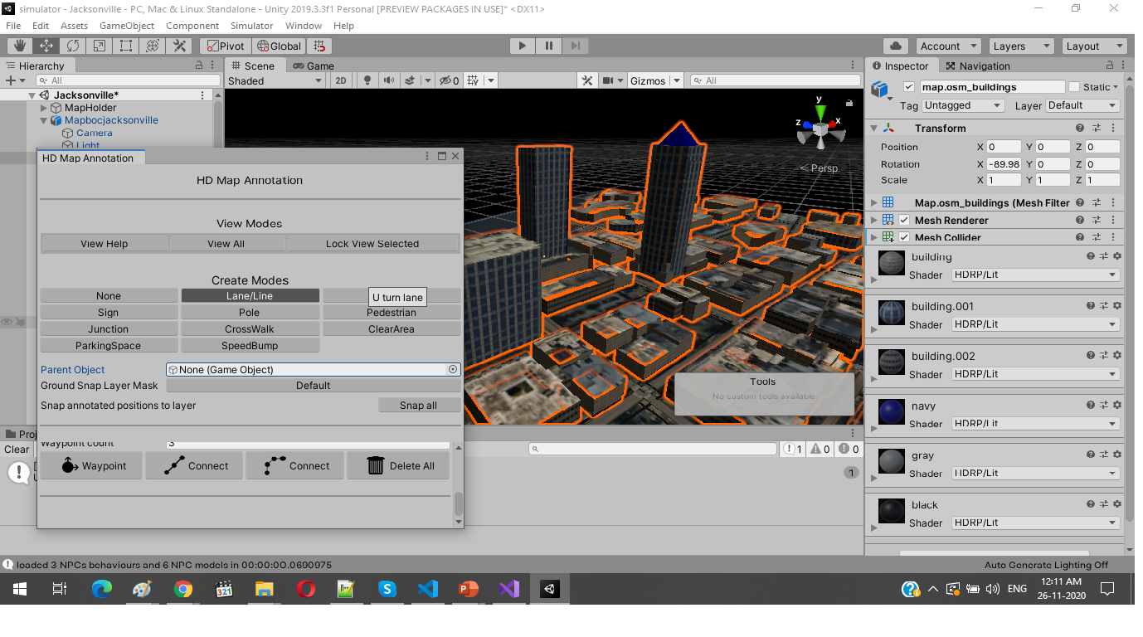

1. Add Spawn Info and map origin into the map.
2. Annotate the lane, parking, building etc using the lg simulator annotation tool.



Annotate all the objects in Scene using the HD Map Annotation of simulator project

1. Build the scene. Once the build is success it will create the 3D scene file with name of **environment_<project_name>. i.e environment_TalTech**
2. Now start the lg simulator, click on the web browser and enter localhost:8080.
3. Now add the created scene in the simulation and test if it is working fine or not, below are the steps to add the scene/map in simulator.

**Steps to add the scene/map in lg simulator-**

1. Run Simulator using the below command

**$ sudo ./lg_sim_06/**[**lgsvlsimulator-linux64-2020.06**](https://github.com/lgsvl/simulator/releases/download/2020.06/lgsvlsimulator-linux64-2020.06.zip)**/simulator**

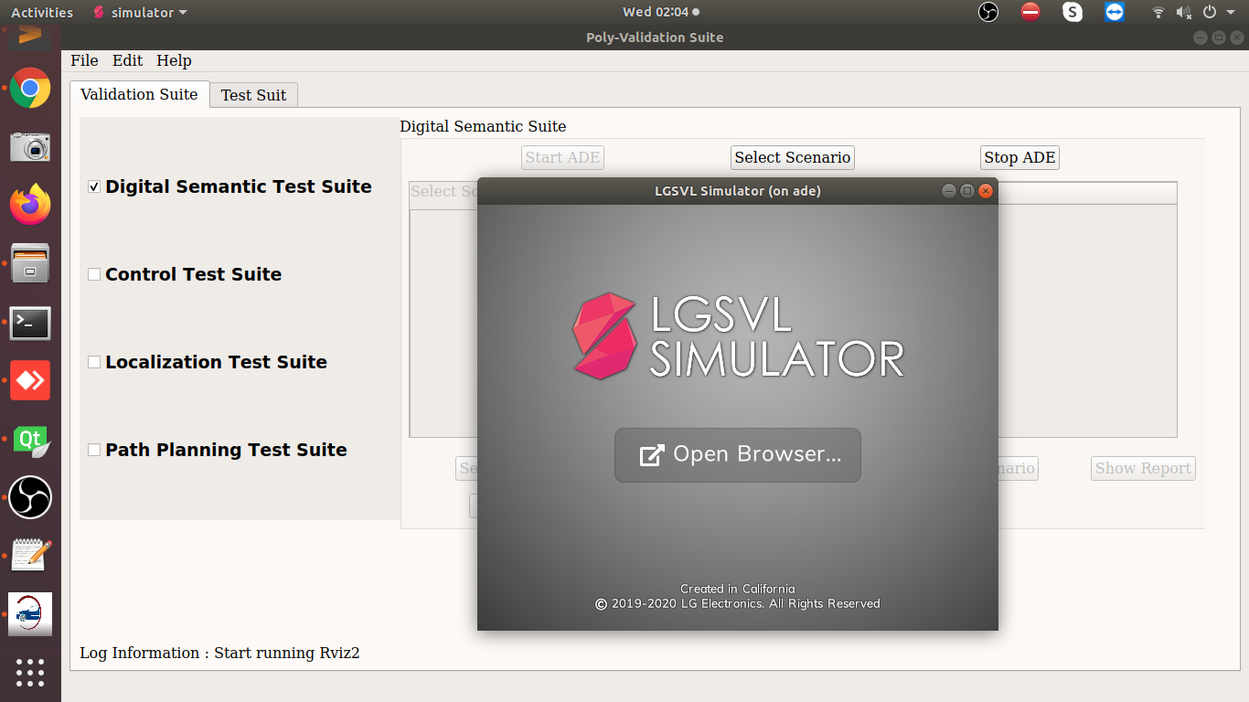

1. Then click open browser or open any browser, enter localhost:8080 in address bar

**Note:** If it asked for any registration then register it and login with the same credential.

1. Once it is sign-in successfully, you will find the 4-tab in the left corner which are Maps, Vehicles, Clusters, Simulations.

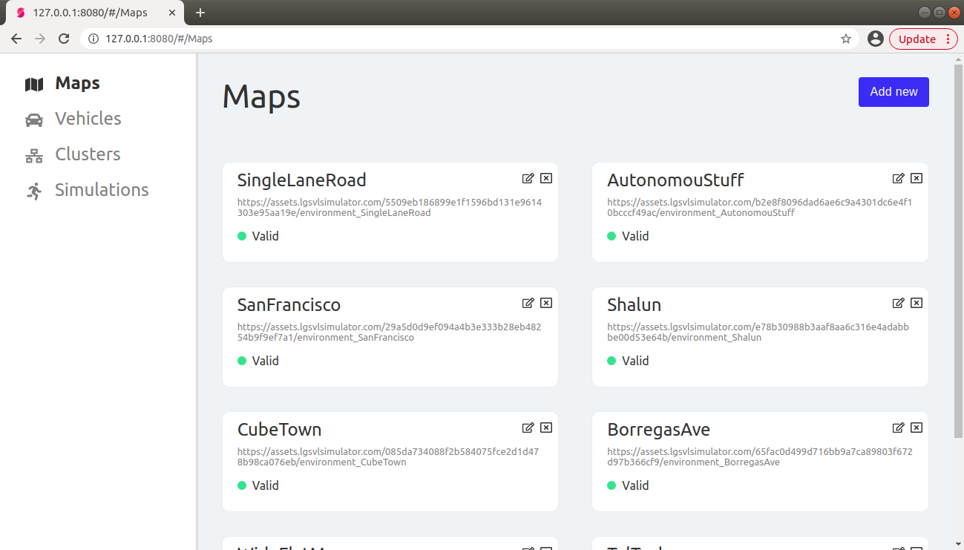

1. In the Maps tab, Add new map with the URL to an environment asset bundle or use below string to add the TalTech or any other map
   * + Name - **TalTech**
     + Asset Bundle String- **https://<path_of_the_TalTech_map_file >/environment_TalTech**

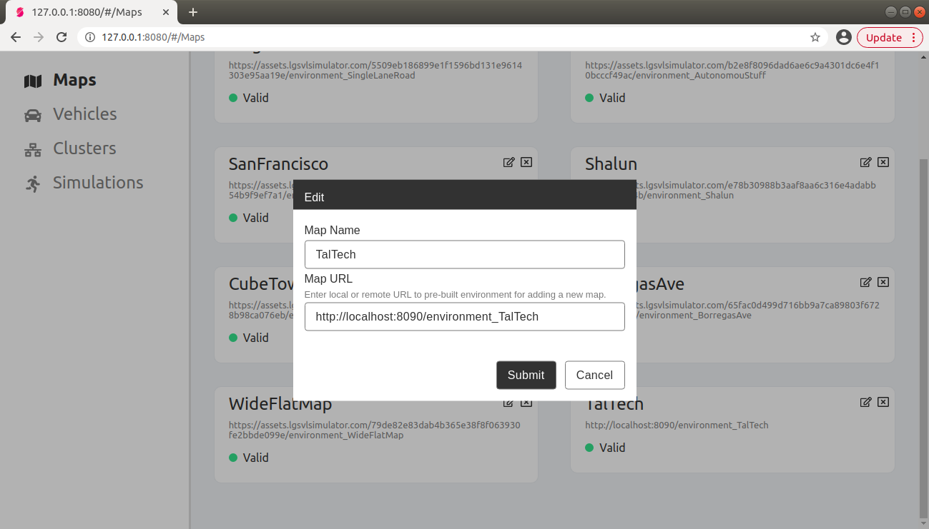

1. Click on the Submit, once it is successfully imported it is ready to use in the simulation.
2. Now add the build scene polyVerif framework list-
   1. Please open **adehome/Test_Case/scene.txt file.**
   2. Add the generated scene (i.e., **TalTech** with the same name is mentioned in the Map Name filed of the above screenshot) in the end of the list and this list will be show in the polyVerif framework UI.