**HOW TO CREATE FBX FILE**

We need HD photos of map area in sequential manner for creation 3D fbx file with the help of **Metashape.**

For HD photos we used **Google Earth Pro**.

Link to download: <https://www.techspot.com/downloads/1018-google-earth.html>

Steps to follow for hd photos:

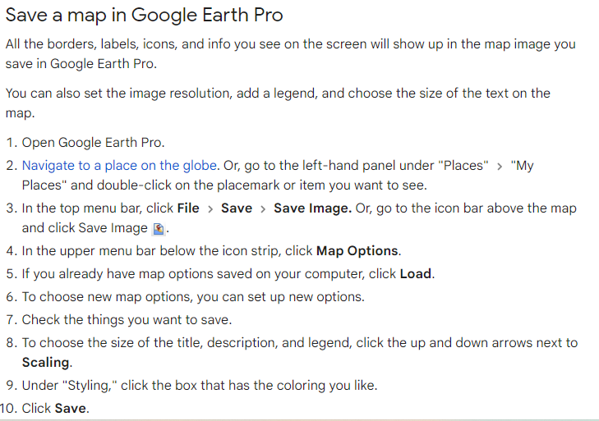

Note: 1.Take pictures in such a manner that road surface is clearly visible and every angles should be covered.

2.Tress and terrain option should be disable because later we manually add that in fbx file.

When we are ready with images we need **Agisoft Metashape** for fbx creation.

**General work flow:**

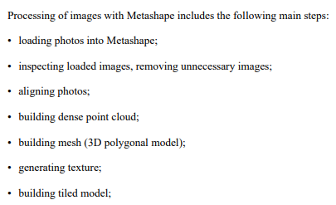

After building model we need to export as .FBX format.

Note: Exported fbx file is not as per original scale so we need to change scale size of model in unity.

Note: We need to do segmentation of fbx file in cloud compare software. For that refer any video of segmentation with cloud compare.