**HOW TO USE LANLET2 AND PCD MAP IN POLYVERIF**

To use the lanelet2 map in avp demo, user need to modify the avp demo, below are the steps to add the lanelet2 map and build.

* Go to the **avp_demo** in adehome/avp_demo.
* Put **JTA_R1.osm** file in the adehome/avp_demo/data path.
* Put generated **JTA_R1.pcd** file in the adehome/avp_demo/data path.
* Now open the adehome/avp_demo/param/lanelet2_map_provider.param.yaml file and change map_osm_file parameter path to **JTA_R1.osm** file.

Also you need to change offset latitude and longitude value.

For that you need to calculate offset values.

**Offset_latitude = JTA_R1_latitude & autonomous_stuff_parking_latitude**

**Offset_longitude = JTA_R1_longitude & autonomous_stuff_parking_longitude**

Note: All latitude and longitude values will shown on left bottom corner when you open osm file on JOSM

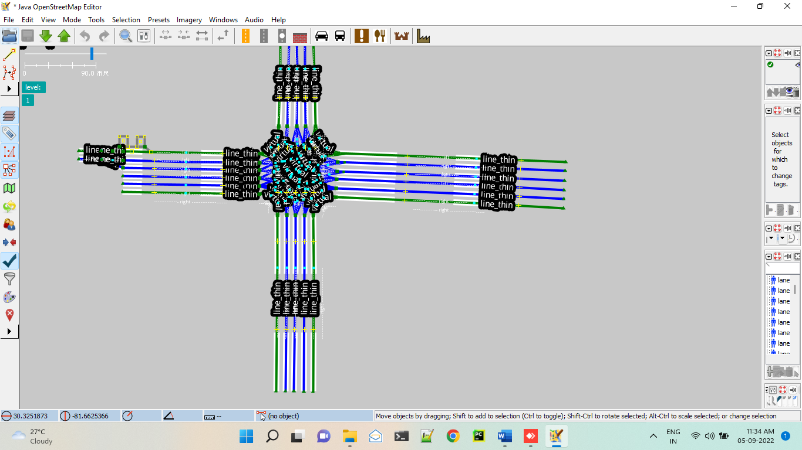

* Now open the adehome/avp_demo/param/map_publisher.param.yaml file and change map_pcd_file parameter path to **JTA_R1.pcd**.
* Open the adehome/avp_demo/param/map_publisher_vehicle.param.yaml file and change map_pcd_file parameter path to **JTA_R1.pcd**.
* Now open the adehome/avp_demo/data/**autonomoustuff_parking_lot.yaml** and enter latitude and longitude of your own lanelet2 map
* Once all the changes made successfully, build the **avp_demo** using **colcon build** command.
* Now run the **avp_demo** and check if the generated lanelet2 map and pcd map are reflected on the rviz2.
* For proper aligned with pcd you need to move lanelet map in jsom and check again on rviz that map is showing or not. It is a trial and error process so need to do manually.
* If you are not able to find the changes in rviz, please go through the below links for the references.

**Reference link-**

* <https://answers.ros.org/question/376240/how-to-build-correct-lanelet2-map-for-autowareauto/>
* <https://gitlab.com/autowarefoundation/autoware.auto/AutowareAuto/-/issues/676>
* [https://answers.ros.org/question/376880/cannot-plan-trajectory-by-lanelet2_global_planner-with-own-map/?answer=377358#post-id-377358](https://answers.ros.org/question/376880/cannot-plan-trajectory-by-lanelet2_global_planner-with-own-map/?answer=377358" \l "post-id-377358)
* <https://tools.tier4.jp/vector_map_builder_ll2/>
* <https://autowarefoundation.gitlab.io/autoware.auto/AutowareAuto/avpdemo.html>

**How to set initial and goal position in avp_demo**

For avp_demo we need to set initial and goal position. For that follow below steps:

* Open rviz by click on avp button in polyverif window
* After opening, you see rviz screen and on top right corner there is “**Publish point**” button. Use that button to know x,y coordinates of start postion and goal position.

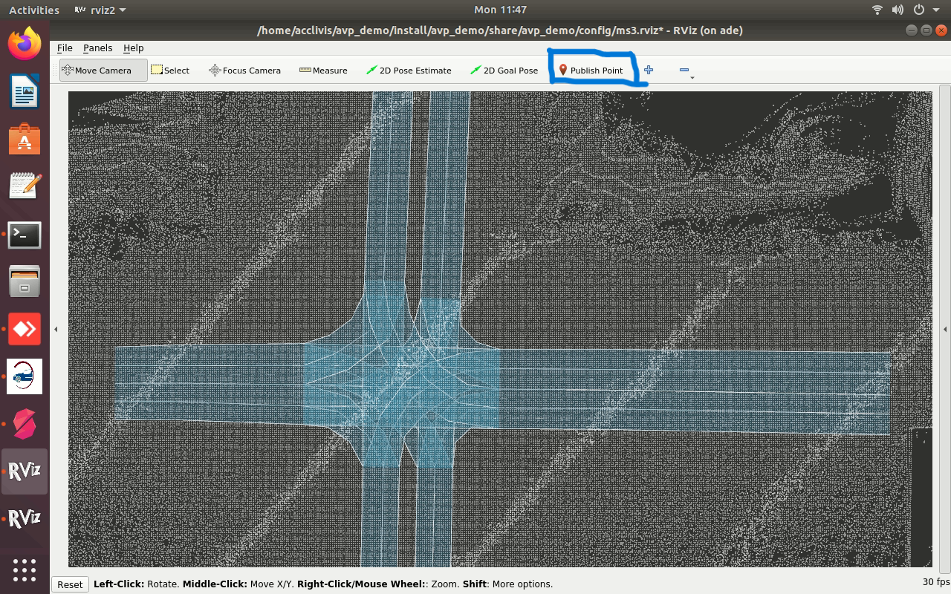

Just you need to click on button and move cursor to desired location which you want to know x,y coordinates.

* Now open adehome/Poly_Suite/Support_files/initialPos.sh and put values of x ,y in position key shown below:



**Note:** For orientation just run simulator and on imu sensor in simulator window and note down orientation.

Same follow for adehome/Poly_Suite/Support_files/goalPos.sh and set goal position

* Set JTA_R1 = true in config.ini file (adehome/Poly_Suite/config.ini)

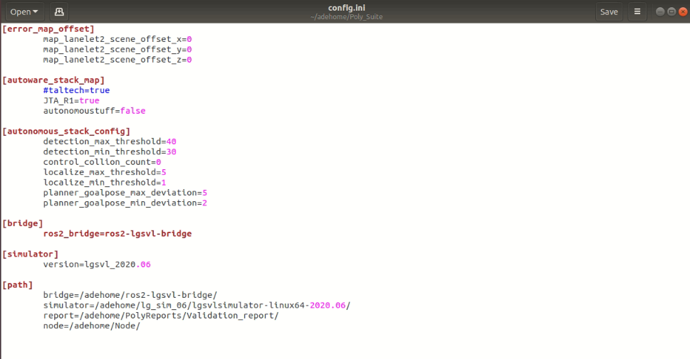

**Known issues**

When you run simulation if your vehicle get stuck or hit on some obstacle then you need to change spawn position of vehicle in script.

This is autoware error because in avp vehicle only travel straight direction. So we need to spawn our vehicle on straight on road.

For that open adehome/Test_cases/JTA_R1/NPC_Actions/AVP_JTA_R1.py

Change **state.transform.position** according to your requirement

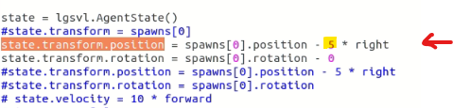

**HOW TO ADD JTA_R1 SCRIPTS IN POLYVERIF**

Create JTA_R1 folder in adehome/Test_Cases/ directory and put all scripts in that folder.

Change scene.txt – In scene.txt file add JTA_R1 map and save it

File path – adehome/Test_Cases/scene.txt

