

**Rajshahi university of engineering and technology**

**Course No:** CSE 2201

**Course Title:** Sessional Based on CSE-2201

**Submitted by:**

**Md Al Amin Tokder Shoukhin ,**

**Roll:** 1803078, **Section:** B

Department of Computer Science and Engineering,

Rajshahi University of Engineering and Technology

**Submitted to:**

**Biprodip Pal**

Assistant Professor ,

Department of Computer Science and Engineering

Rajshahi University of Engineering and Technology

**Problem Name: Dijkstra Algorithm**

**Source Code (Using BinaryHeap + Adjacency List ) :**

|  |
| --- |
| **package algorithm;**  **import java.util.LinkedList;**  **import java.util.Scanner;**  **public class dijkstra_heap_1803078{**  **static class Edge{**  **int source;**  **int destination;**  **int weight;**  **public Edge(int source,int destination,int weight){**  **this.source=source;**  **this.destination=destination;**  **this.weight=weight;**  **}**  **}**  **static class HeapNode{**  **int vertex;**  **int distance;**  **}**  **static class Graph{**  **int vertices;**  **LinkedList<Edge>[] adjacencylist;**  **Graph(int vertices){**  **this.vertices=vertices;**  **adjacencylist=new LinkedList[vertices];**  **for(int i=0;i<vertices;i++){**  **adjacencylist[i]=new LinkedList<>();**  **}**  **}**  **public void addEdge(int source,int destination,int weight){**  **Edge edge=new Edge(source,destination,weight);**  **adjacencylist[source].addFirst(edge);**  **edge=new Edge(destination,source,weight);**  **adjacencylist[destination].addFirst(edge); //for undirected graph**  **}**  **public void dijkstra_GetMinDistances(int sourceVertex,int end){**  **int INFINITY=Integer.MAX_VALUE;**  **boolean[] SPT=new boolean[vertices];**  **HeapNode[] heapNodes=new HeapNode[vertices];**  **for(int i=0;i<vertices;i++){**  **heapNodes[i]=new HeapNode();**  **heapNodes[i].vertex=i;**  **heapNodes[i].distance=INFINITY;**  **}**  **heapNodes[sourceVertex].distance=0;**  **MinHeap minHeap=new MinHeap(vertices);**  **for(int i=0;i<vertices;i++){**  **minHeap.insert(heapNodes[i]);**  **}**  **while(!minHeap.isEmpty()){**  **HeapNode extractedNode=minHeap.extractMin();**  **int extractedVertex=extractedNode.vertex;**  **SPT[extractedVertex]=true;**  **LinkedList<Edge> list=adjacencylist[extractedVertex];**  **for(int i=0;i<list.size();i++){**  **Edge edge=list.get(i);**  **int destination=edge.destination;**  **if(SPT[destination]==false){**  **int newKey=heapNodes[extractedVertex].distance+edge.weight;**  **int currentKey=heapNodes[destination].distance;**  **if(currentKey>newKey){**  **decreaseKey(minHeap,newKey,destination);**  **heapNodes[destination].distance=newKey;**  **}**  **}**  **}**  **}**  **printDijkstra(heapNodes,sourceVertex,end);**  **}**  **public void decreaseKey(MinHeap minHeap,int newKey,int vertex){**  **int index=minHeap.indexes[vertex];**  **HeapNode node=minHeap.mH[index];**  **node.distance=newKey;**  **minHeap.bubbleUp(index);**  **}**  **public void printDijkstra(HeapNode[] resultSet,int sourceVertex,int end){**  **System.out.println("Smallest distance from Vertex: "+(sourceVertex+1)+" to vertex "+end+" distance: "+resultSet[end-1].distance);**  **}**  **}**  **static class MinHeap{**  **int capacity;**  **int currentSize;**  **HeapNode[] mH;**  **int[] indexes;**  **public MinHeap(int capacity){**  **this.capacity=capacity;**  **mH=new HeapNode[capacity+1];**  **indexes=new int[capacity];**  **mH[0]=new HeapNode();**  **mH[0].distance=Integer.MIN_VALUE;**  **mH[0].vertex=-1;**  **currentSize=0;**  **}**  **public void insert(HeapNode x){**  **currentSize++;**  **int idx=currentSize;**  **mH[idx]=x;**  **indexes[x.vertex]=idx;**  **bubbleUp(idx);**  **}**  **public void bubbleUp(int pos){**  **int parentIdx=pos/2;**  **int currentIdx=pos;**  **while(currentIdx>0&&mH[parentIdx].distance>mH[currentIdx].distance){**  **HeapNode currentNode=mH[currentIdx];**  **HeapNode parentNode=mH[parentIdx];**  **indexes[currentNode.vertex]=parentIdx;**  **indexes[parentNode.vertex]=currentIdx;**  **swap(currentIdx,parentIdx);**  **currentIdx=parentIdx;**  **parentIdx=parentIdx/2;**  **}**  **}**  **public HeapNode extractMin(){**  **HeapNode min=mH[1];**  **HeapNode lastNode=mH[currentSize];**  **indexes[lastNode.vertex]=1;**  **mH[1]=lastNode;**  **mH[currentSize]=null;**  **sinkDown(1);**  **currentSize--;**  **return min;**  **}**  **public void sinkDown(int k){**  **int smallest=k;**  **int leftChildIdx=2*k;**  **int rightChildIdx=2*k+1;**  **if(leftChildIdx<heapSize()&&mH[smallest].distance>mH[leftChildIdx].distance){**  **smallest=leftChildIdx;**  **}**  **if(rightChildIdx<heapSize()&&mH[smallest].distance>mH[rightChildIdx].distance){**  **smallest=rightChildIdx;**  **}**  **if(smallest!=k){**  **HeapNode smallestNode=mH[smallest];**  **HeapNode kNode=mH[k];**  **indexes[smallestNode.vertex]=k;**  **indexes[kNode.vertex]=smallest;**  **swap(k,smallest);**  **sinkDown(smallest);**  **}**  **}**  **public void swap(int a,int b){**  **HeapNode temp=mH[a];**  **mH[a]=mH[b];**  **mH[b]=temp;**  **}**  **public boolean isEmpty(){**  **return currentSize==0;**  **}**  **public int heapSize(){**  **return currentSize;**  **}**  **}**  **public static void main(String[] args){**  **Scanner ob=new Scanner(System.in);**  **int v=ob.nextInt();**  **int e=ob.nextInt();**  **Graph graph=new Graph(v);**  **for(int i=0;i<e;i++){**  **int u1=ob.nextInt();**  **int v1=ob.nextInt();**  **int c=ob.nextInt();**  **graph.addEdge(u1-1,v1-1,c);**  **}**  **System.out.println("Enter start node: ");**  **int start=ob.nextInt();**  **System.out.println("Enter end node: ");**  **int end=ob.nextInt();**  **//long t1=System.nanoTime();**  **double t11=System.currentTimeMillis();**    **graph.dijkstra_GetMinDistances(start-1,end);**  **double t22=System.currentTimeMillis();**  **//long t2=System.nanoTime();**  **System.out.println("Time take : "+(t22-t11)+" mili sec");**  **}**  **}** |

**Sample Input and Output:**

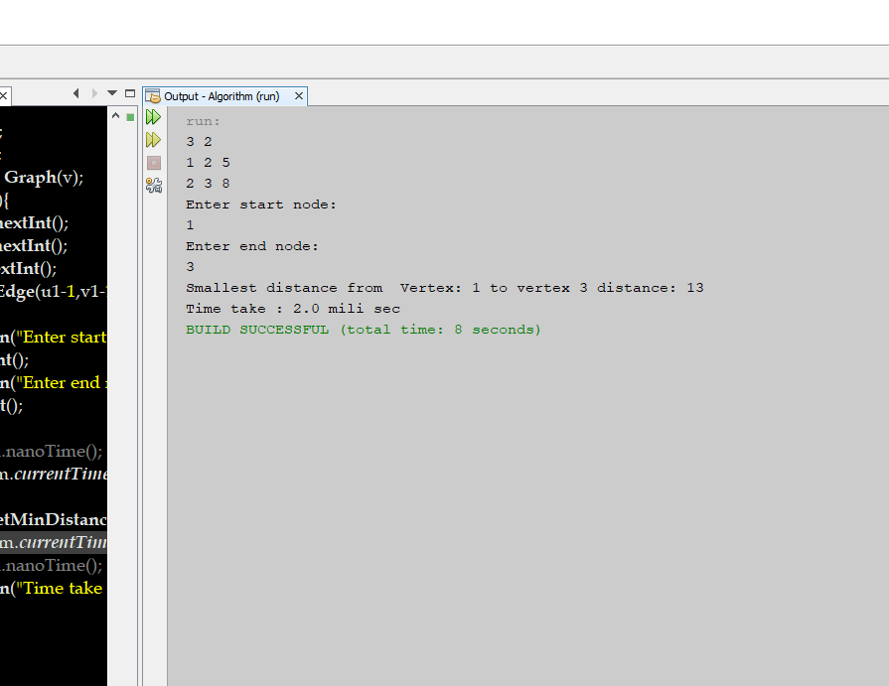

**Source Code (Using Priority Queue + Adjacency Matrix ) :**

|  |
| --- |
| **package algorithm;**  **import java.util.Scanner;**  **public class Dijkstra{**  **public static void dijkstra(int[][] graph,int source,int start_node,int end_node){**  **int count=graph.length;**  **boolean[] visitedVertex=new boolean[count+1+1];**  **int[] distance=new int[count];**  **for(int i=1;i<count;i++){**  **visitedVertex[i]=false;**  **distance[i]=Integer.MAX_VALUE;**  **}**    **distance[source]=0;**  **for(int i=1;i<count;i++){**  **int u=findMinDistance(distance,visitedVertex);**  **visitedVertex[u]=true;**  **for(int v=1;v<count;v++){**  **if(!visitedVertex[v]&&graph[u][v]!=0&&(distance[u]+graph[u][v]<distance[v])){**  **distance[v]=distance[u]+graph[u][v];**  **}**  **}**  **}**  **System.out.println("Shortest distance from node "+start_node+"th to node "+ end_node+"th is : "+distance[end_node]);**  **}**  **private static int findMinDistance(int[] distance,boolean[] visitedVertex){**  **int minDistance=Integer.MAX_VALUE;**  **int minDistanceVertex=-1;**  **for(int i=1;i<distance.length;i++){**  **if(!visitedVertex[i]&&distance[i]<minDistance){**  **minDistance=distance[i];**  **minDistanceVertex=i;**  **}**  **}**  **return minDistanceVertex;**  **}**  **public static void main(String[] args){**  **Scanner ob=new Scanner (System.in);**  **int v=ob.nextInt();**  **int e=ob.nextInt();**  **int graph[][]=new int[v+1][v+1];**      **for(int j=0;j<e;j++)**  **{**  **int v1=ob.nextInt();**  **int v2=ob.nextInt();**  **int cost=ob.nextInt();**  **graph[v1][v2]=cost;**  **graph[v2][v1]=cost;**    **}**    **System.out.println("matrix representation is : ");**  **for(int i=1;i<graph.length;i++)**  **{**  **for(int j=1;j<graph[0].length;j++)**  **{**  **System.out.print(graph[i][j]+" ");**  **}**  **System.out.println();**  **}**  **Dijkstra T=new Dijkstra();**  **System.out.print("enter start node :");**  **int start_node =ob.nextInt();**  **System.out.print("enter end node: ");**  **int end_node=ob.nextInt();**  **long t11=System.nanoTime();**  **//long t1=System.currentTimeMillis();**  **T.dijkstra(graph,start_node,start_node,end_node);**  **//long t2=System.currentTimeMillis();**  **long t22=System.nanoTime();**  **System.out.println("Time taken : "+(t22-t11)+" nano sec");**  **}**  **}** |

**Sample output:**

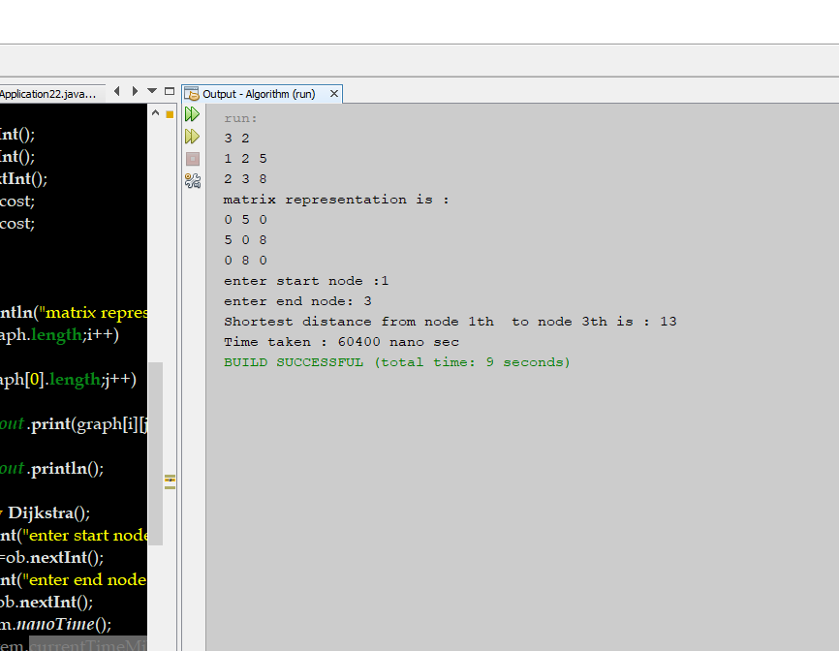

**Source Code (Using Priority Queue + Adjacency List ) :**

|  |
| --- |
| **package algorithm;**  **import javafx.util.Pair;**  **import java.util.Comparator;**  **import java.util.LinkedList;**  **import java.util.PriorityQueue;**  **import java.util.Scanner;**  **public class Dijksta_PQ{**  **static class Edge{**  **int source;**  **int destination;**  **int weight;**  **public Edge(int source,int destination,int weight){**  **this.source=source;**  **this.destination=destination;**  **this.weight=weight;**  **}**  **}**  **static class Graph{**  **int vertices;**  **static LinkedList<Edge>[] adjacencylist;**  **Graph(int vertices){**  **this.vertices=vertices;**  **adjacencylist=new LinkedList[vertices];**    **for(int i=0;i<vertices;i++){**  **adjacencylist[i]=new LinkedList<>();**  **}**    **}**  **public void addEdge(int source,int destination,int weight){**  **Edge edge=new Edge(source,destination,weight);**  **adjacencylist[source].addFirst(edge);**  **edge=new Edge(destination,source,weight);**  **adjacencylist[destination].addFirst(edge);**  **}**      **public void dijkstra_GetMinDistances(int sourceVertex,int start,int end){**  **boolean[] SPT=new boolean[vertices];**    **int[] distance=new int[vertices];**    **for(int i=0;i<vertices;i++){**  **distance[i]=Integer.MAX_VALUE;**  **}**    **PriorityQueue<Pair<Integer,Integer>> pq=new PriorityQueue<>(vertices,new Comparator<Pair<Integer,Integer>>(){**    **public int compare(Pair<Integer,Integer> p1,Pair<Integer,Integer> p2){**    **int key1=p1.getKey();**  **int key2=p2.getKey();**  **return key1-key2;**  **}**  **});**    **distance[0]=0;**  **Pair<Integer,Integer> p0=new Pair<>(distance[0],0);**    **pq.offer(p0);**  **while(!pq.isEmpty()){**    **Pair<Integer,Integer> extractedPair=pq.poll();**  **int extractedVertex=extractedPair.getValue();**  **if(SPT[extractedVertex]==false){**  **SPT[extractedVertex]=true;**  **LinkedList<Edge> list=adjacencylist[extractedVertex];**  **for(int i=0;i<list.size();i++){**  **Edge edge=list.get(i);**  **int destination=edge.destination;**    **if(SPT[destination]==false){**    **int newKey=distance[extractedVertex]+edge.weight;**  **int currentKey=distance[destination];**  **if(currentKey>newKey){**  **Pair<Integer,Integer> p=new Pair<>(newKey,destination);**  **pq.offer(p);**  **distance[destination]=newKey;**  **}**  **}**  **}**  **}**  **}**  **printDijkstra(distance,sourceVertex,start,end);**  **}**  **public void printDijkstra(int[] distance,int sourceVertex,int start,int end){**    **System.out.println("Shortest distance from "+start+"th to "+end+"th is : "+distance[end-1]);**    **}**  **public static void main(String[] args){**  **Scanner ob=new Scanner(System.in);**    **int v=ob.nextInt();**  **int e=ob.nextInt();**  **Graph graph=new Graph(v);**  **for(int i=0;i<e;i++)**  **{**  **int u1=ob.nextInt();**  **int v1=ob.nextInt();**  **int c=ob.nextInt();**    **graph.addEdge(u1-1,v1-1,c);**  **}**    **System.out.println("enter start node:");**  **int start=ob.nextInt();**  **System.out.println("enter end node:");**  **int end=ob.nextInt();**  **double t1=System.currentTimeMillis();**  **graph.dijkstra_GetMinDistances(start-1,start,end);**  **double t2=System.currentTimeMillis();**  **System.out.println("Time take: "+(t2-t1)+" mili sec ");**    **}**  **}**  **}** |

**Sample output:**

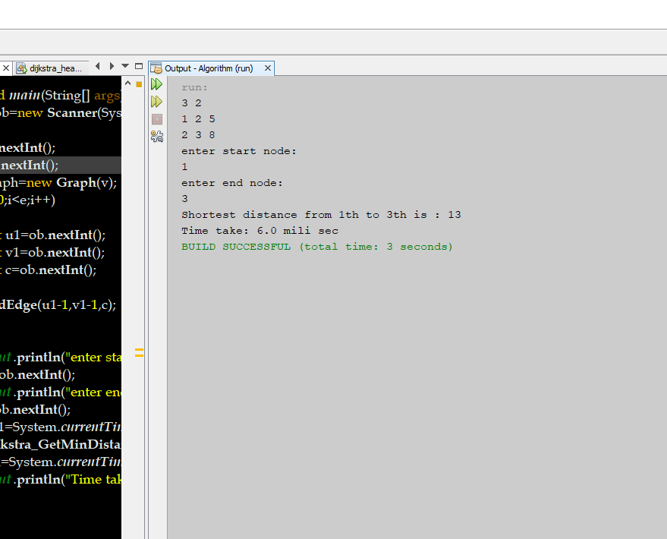

**Source Code (Using Unsorted + Adjacency Matrix ) :**

|  |
| --- |
| **package algorithm;**  **import java.util.Scanner;**  **public class Dijkstra{**  **public static void dijkstra(int[][] graph,int source,int start_node,int end_node){**  **int count=graph.length;**  **boolean[] visitedVertex=new boolean[count+1+1];**  **int[] distance=new int[count];**  **for(int i=1;i<count;i++){**  **visitedVertex[i]=false;**  **distance[i]=Integer.MAX_VALUE;**  **}**    **distance[source]=0;**  **for(int i=1;i<count;i++){**  **int u=findMinDistance(distance,visitedVertex);**  **visitedVertex[u]=true;**  **for(int v=1;v<count;v++){**  **if(!visitedVertex[v]&&graph[u][v]!=0&&(distance[u]+graph[u][v]<distance[v])){**  **distance[v]=distance[u]+graph[u][v];**  **}**  **}**  **}**  **System.out.println("Shortest distance from node "+start_node+"th to node "+ end_node+"th is : "+distance[end_node]);**  **}**  **private static int findMinDistance(int[] distance,boolean[] visitedVertex){**  **int minDistance=Integer.MAX_VALUE;**  **int minDistanceVertex=-1;**  **for(int i=1;i<distance.length;i++){**  **if(!visitedVertex[i]&&distance[i]<minDistance){**  **minDistance=distance[i];**  **minDistanceVertex=i;**  **}**  **}**  **return minDistanceVertex;**  **}**  **public static void main(String[] args){**  **Scanner ob=new Scanner (System.in);**  **int v=ob.nextInt();**  **int e=ob.nextInt();**  **int graph[][]=new int[v+1][v+1];**      **for(int j=0;j<e;j++)**  **{**  **int v1=ob.nextInt();**  **int v2=ob.nextInt();**  **int cost=ob.nextInt();**  **graph[v1][v2]=cost;**  **graph[v2][v1]=cost;**    **}**    **System.out.println("matrix representation is : ");**  **for(int i=1;i<graph.length;i++)**  **{**  **for(int j=1;j<graph[0].length;j++)**  **{**  **System.out.print(graph[i][j]+" ");**  **}**  **System.out.println();**  **}**  **Dijkstra T=new Dijkstra();**  **System.out.print("enter start node :");**  **int start_node =ob.nextInt();**  **System.out.print("enter end node: ");**  **int end_node=ob.nextInt();**  **//long t11=System.nanoTime();**  **long t1=System.currentTimeMillis();**  **T.dijkstra(graph,start_node,start_node,end_node);**  **long t2=System.currentTimeMillis();**  **//long t22=System.nanoTime();**  **System.out.println("Time taken : "+(t2-t1)+" mili sec");**  **}**  **}** |

**Sample output:**

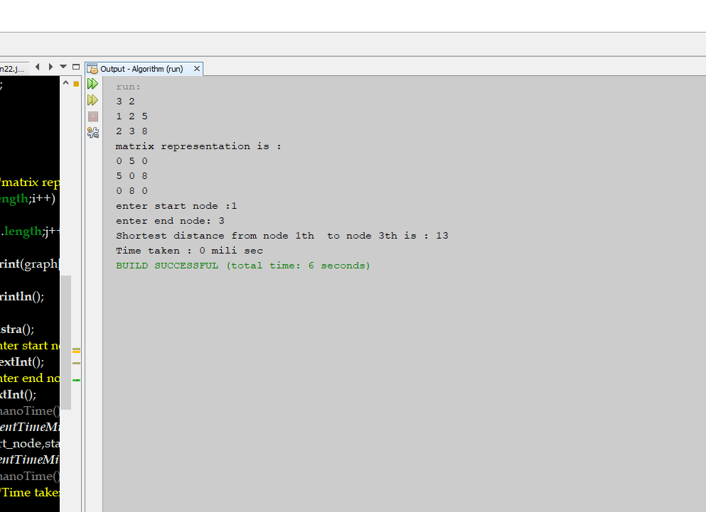

**Performance table:(for vertex=100)**

|  |  |  |
| --- | --- | --- |
| **Priority Queue Data Structure** | **Adjacency list** | **Adjacency matrix** |
| **Binary Heap** | **0.12 mili sec** | **2.103 mili sec** |
| **Unsorted Array** | **1.001 mili sec** | **2.989 mili sec** |

**Problem: Longest Common Subsequence (Dynamic programming)**

**Source Code:**

|  |
| --- |
| **package algorithm;**  **import java.util.Scanner;**  **public class LCS_1803078 {**  **public static void main(String[] args){**  **Scanner ob=new Scanner(System.in);**  **String A=ob.next();**  **String B=ob.next();**  **int m=A.length(), n=B.length();**  **int[][] ans=new int[m+1][n+1];**  **for(int i=0;i<m;i++){**  **ans[i][0]=0;**  **}**  **for(int j=0;j<n;j++){**  **ans[0][j]=0;**  **}**  **for(int i=1;i<=m;i++){**  **for(int j=1;j<=n;j++){**  **if(A.charAt(i-1)==B.charAt(j-1)){**  **ans[i][j]=ans[i-1][j-1]+1;**  **}else{**  **ans[i][j]=Math.max(ans[i-1][j],ans[i][j-1]);**  **}**  **}**  **}**  **System.out.println(ans[m][n]);**  **}**  **}** |

**Output:**

