

**Rajshahi university of engineering and technology**

**Course No:** EEE 2252

**Course Title:** Sessional Based on EEE-2251

Lab Report : 2, 5 and 6

**Submitted by:**

**Md Al Amin Tokder Shoukhin ,**

**Roll:** 1803078, **Section:** B

Department of Computer Science and Engineering,

Rajshahi University of Engineering and Technology

**Submitted to:**

**Md Firoz Mahmud**

lecturer ,

Department of Electrical and Electronic and Engineering

Rajshahi University of Engineering and Technology

**Experiment no:2**

**Experiment name:** Speed control of a DC motor (using field weakening method and armature voltage control method).

**Theory:**

When a DC motor is first started ,there will be no counter emf in the armature conductor . So the excessive current can damage the armature. That’s why a started is connected in series with the armature of a DC motor to limit the armature current as the armature resistance is very small (less than one ohm).

The speed of the motor depends on the flux . The equation canbe expressed as follows

E=kФS

* S= $\frac{E}{kФ}$
* S= $\frac{{V_{t}-I}_{a}R_{a}}{kФ}$
* S ∝ $\frac{1}{Ф}$

Here ,S=speed of the motor

E=induced voltage

Ф= flux

$V_{t}$ = Terminal voltage

As the flux(Ф) of the main field is directly dependent on the field current ${( I}_{f})$ So the speed of the machine is inversely proportional to the field current ${( I}_{f})$.

Again the speed is directly proportional to the induced voltage .

**Required Apparatus :**

1.DC motor(${220V, I}_{f}=1A,1500 rpm$)

2.3-point starter

3. Ammeter

4.Tachometer

5.Connecting wire

**Circuit Diagram:**

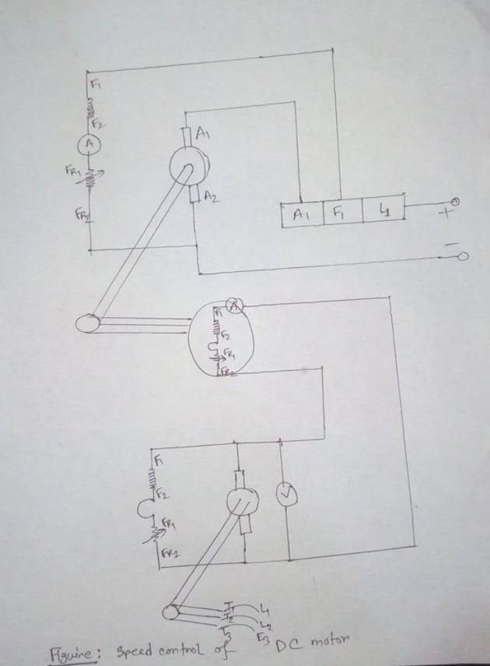

**Data Table:**

**Table-1: (Field weakening method)**

|  |  |  |
| --- | --- | --- |
| **Field Current**  **(Ampere)** | **Terminal Voltage** ( $V_{t})$ | **Motor Speed (rpm)** |
| 0.37 | 100 | 1545 |
| 0.42 | 110 | 1545 |
| 0.50 | 126 | 1545 |
| 0.55 | 140 | 1545 |
| 0.60 | 152 | 1545 |
| 0.65 | 164 | 1545 |
| 0.70 | 176 | 1545 |
| 0.80 | 196 | 1545 |

**Table-2: (Voltage control method)**

|  |  |  |
| --- | --- | --- |
| **Field Current**  **(Ampere)** | **Terminal Voltage** ( $V_{t})$ | **Motor Speed (rpm)** |
| 0.63 | 196 | 1477 |
| 0.67 | 184 | 1427 |
| 0.73 | 176 | 1424 |
| 0.79 | 164 | 1261 |
| 0.86 | 158 | 1244 |

**Conclusion:**

A shunt or separately excited dc motor has a torque-speed characteristic whose speed drops linearly with increasing load torque. Its speed can be controlled by changing its field current, its armature voltage or its armature resistance.

In this two method the first method (field weakening) is use when we need to increase the speed above the base speed.

Again the voltage control method is use when we need to decrease the speed from base speed.

**Experiment no:5**

**Experiment name:** Extension of Ammeter Range

**Theory:**

It is possible to extend the range of an ammeter by using a shunt. A shunt is a low-value resistance having minimum temperature co-efficient and is connected in parallel with the ammeter whose range is to be extended. The combination is connected in series with the circuit whose current is to be measured.

This shunt provides a bypath for extra current because it is connected across (i.e. in parallel with) the instrument.

These shunted instruments can be used to measure currents many times greater than their normal full-scale deflection currents.

The ratio of maximum current (with shunt) to the full-scale deflection current (without shunt) is known as the ‘multiplying power’ or ‘multiplying factor’ of the shunt.

Rsh = Rm / (m-1) where m>1 m=multiplying factor

Shunt resistance can be calculated by this equation

**Required Apparatus :**

1. Voltmeter (0-450 V) (3-pieces)

3. Variac (1 pics)

5. Connecting wire

2. Ammeter (0-10A) (2-pieces)

4. AC Power supply

6. Resistors (108 Ω & 37 Ω)

**Circuit Diagram:**

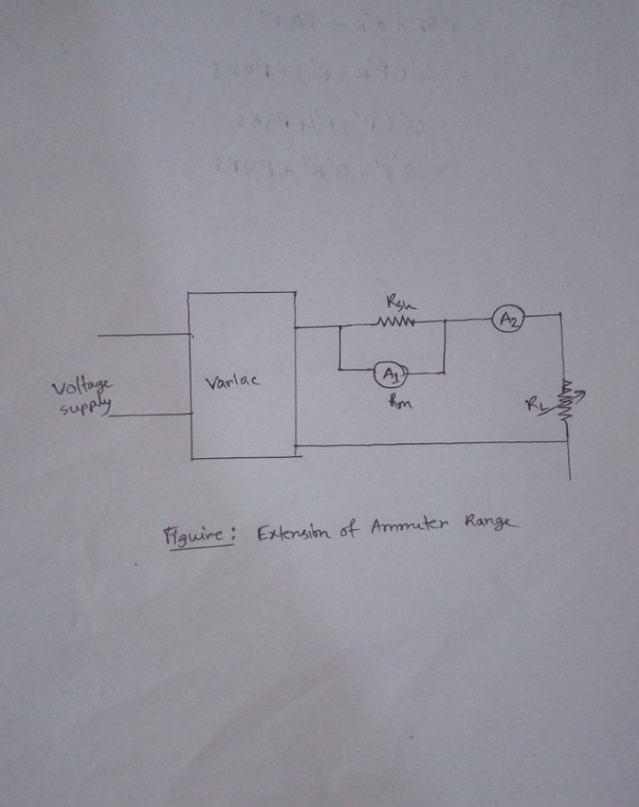

**Data Table:**

|  |  |  |  |  |  |  |
| --- | --- | --- | --- | --- | --- | --- |
| **No of**  **Ob.** | **Supply voltage in volts(VS)** | **Ammeter**  **A1(amp)** | **Ammeter**  **A2 (amp)** | **Multiplying Factor(m)** | **Calculated Current (A2C)**  **from equation** | **Error = (A2-A2C)/A2** |
| 1 | 100 | 0.9 | 2.4 | 2.67 | 2.403 | 0.1 |
| 2 | 50 | 1.4 | 2.9 | 2.07 | 2.60 | 11.54 |
| 3 | 50 | 1.9 | 3.7 | 1.95 | 3.57 | 3.64 |
| 4 | 50 | 1.6 | 3.1 | 1.94 | 3.12 | 0.64 |

**Conclusion:**

This shunt provides a bypath for extra current because it is connected across (i.e. in parallel with) the instrument. Thus the large range of the current passing through the circuit and measured without any problem.

**Experiment no:6**

**Experiment name:** Extension of Voltmeter Range

**Theory:**

Range extension of any measuring instrument is a technique by which you can increase the instrument's measuring capability to measure a much larger value than what the instrument is actually designed for.

Multipliers are used for the range extension of voltmeters. The multiplier is a non-inductive high-value resistance connected in series with the instrument whose range is to be extended. The combination is connected across the circuit whose voltage is to be measured.

To measure high voltage using a voltmeter, multiplier technique is adopted. In this method, a resistor is connected in series with the voltmeter and its value can be determined as,

Rs = (m-1)*Rm

where m is called multiplying factor and R m is the internal resistance of the meter.

**Required Apparatus :**

1. Voltmeter (0-450 V) (3-pieces)

3. Variac (1 pics)

5. Connecting wire

2. Ammeter (0-10A) (2-pieces)

4. AC Power supply

6. Resistors (108 Ω & 37 Ω)

**Circuit Diagram:**

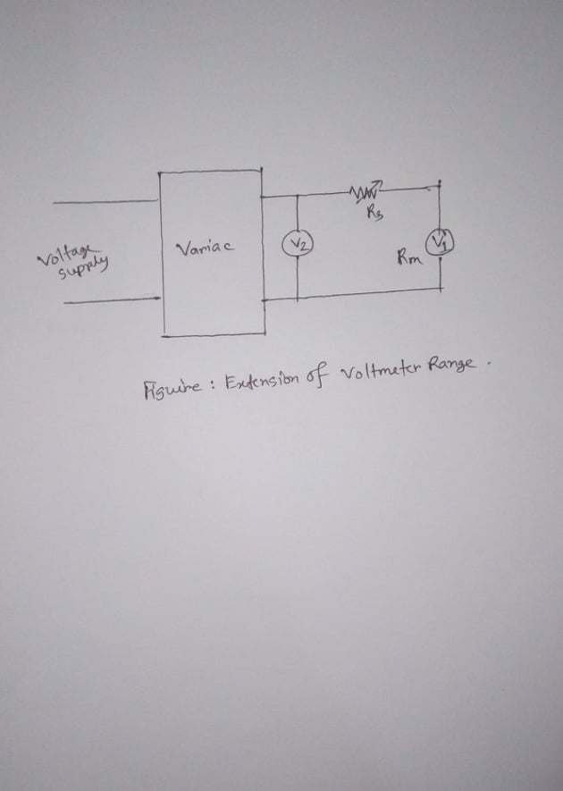

**Data Table:**

|  |  |  |  |  |  |  |
| --- | --- | --- | --- | --- | --- | --- |
| **No of**  **Obs.** | **Supply voltage in volts (Vs)** | **Voltmeter**  **V1 (volt)** | **Voltmeter**  **V2 (volt)** | **Multiplying Factor**  **(m)** | **Calculated voltage**  **(volt)** | **error $$(\%)$$** |
| 1 | 80 | 22 | 80 | 3.63 | 79.86 | 0.17 |
| 2 | 100 | 30 | 100 | 3.33 | 99.90 | 0.10 |
| 3 | 120 | 35 | 120 | 3.42 | 119.70 | 0.25 |

**Conclusion:**

The range of a voltmeter is extended by connecting a high resistance (multiplier) in series with it. The multiplier is a non-inductive high-value resistance connected in series with the instrument whose range is to be extended. Thus a voltmeter range will extended without any burnt out.