

**Rajshahi university of engineering and technology**

**Course No:** EEE 2252

**Course Title:** Sessional Based on EEE-2251

Lab Report : 3 and 4

**Submitted by:**

**Md Al Amin Tokder Shoukhin ,**

**Roll:** 1803078, **Section:** B

Department of Computer Science and Engineering,

Rajshahi University of Engineering and Technology

**Submitted to:**

**Md Razon Chowdhury**

lecturer ,

Department of Electrical and Electronic and Engineering

Rajshahi University of Engineering and Technology

**Experiment no:3**

**Experiment name:** Ratio test and no-load current observation of a single-phase transformer

**Theory:**

A single-phase transformer is an electrical device that accepts single-phase AC power and outputs single-phase AC. This is used in the distribution of power in non-urban areas as the overall demand and costs involved are lower than the 3-phase distribution transformer. They are used as a step-down transformer to decrease the home voltage to a suitable value without a change in frequency. For this reason, it is commonly used to power electronic appliances at residences.

For step up transformer turns ratio is **a= $\frac{E_{s}}{E_{p}}$ = $\frac{N_{s}}{N_{p}}$ = $\frac{I_{p}}{I_{s}}$**

In the case of no load there shouldn’t pass any current (theoretically).But practically there flow a few amount of current which is called no load current .

This current produce because of the core loss.

**Required Apparatus :**

1. Transformer

2. Wire

3. Ac supply voltage

4. Multimeter

5. Resistance (108 ohm)

6. Ammeter

**Circuit Diagram:**

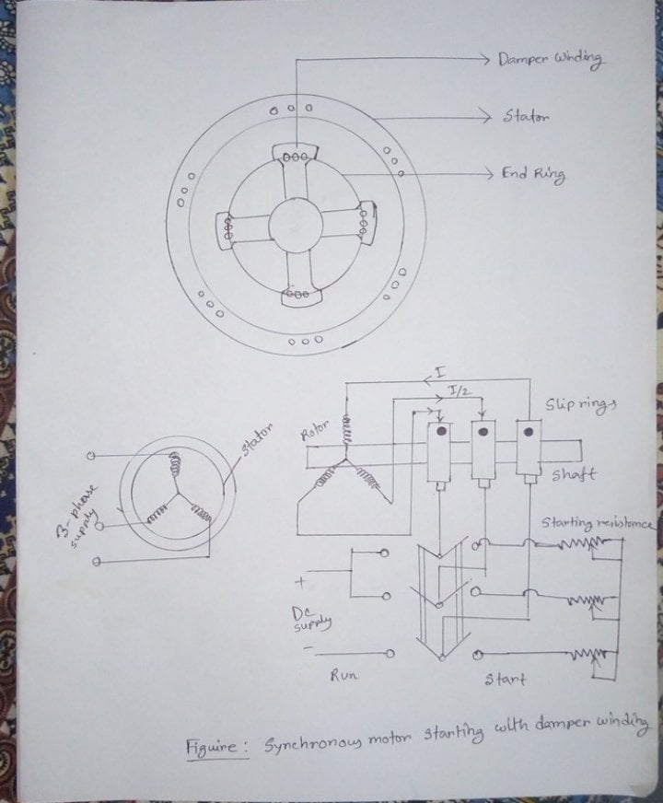

**Data Table:**

|  |  |  |
| --- | --- | --- |
| **Ratio Test** | | |
| Voltage (primary side) volt | Voltage (secondary side) volt | Ratio |
| 40 | 76.3  (theoretically=80) | 1.9075  (theoretically =2) |
| **Ratio Test** | | |
| Current (primary side) Ampere | Current (secondary side) Ampere | Ratio |
| 0.72  (theoretically=0.68) | 0.34 | 2.11  (theoretically =2) |

Here in this transformer

 Primary rated voltage = 150V

 Secondary rated voltage = 2*150 V

 = 300 V

 So, Turns ratio = 2

|  |  |
| --- | --- |
| **No load Current** | |
| Voltage Rated  (primary side) Volt | No load Current (Ampere) |
| 150 | 0.11 |

Here No load current 0.11A produce due to core loss.

**Conclusion:**

In this experiment no load current should be zero in the secondary side .But we can find a few amount of current . This current is around 11% of the rated current 1A. The no load current is produced because of the core loss of the transformer.

**Experiment No:** 04

**Experiment Name:** Experimental starting of a synchronous motor

**Theory:**

A synchronous motor is an AC motor in which, at steady state, the rotation of the shaft is synchronized with the frequency of the supply current. Synchronous motor is not start itself.

There are 3 process for starting a synchronous motor.

1. reduction of supply frequency
2. Starting with the help of an External Prime Mover
3. Starting with the help of Damper Windings

Here we use damper winding to start that synchronous motor.

Damper Windings is the most widely used method to start a synchronous motor. A Damper Winding consists of heavy copper bars inserted in the slots of the pole faces of the rotor.

These copper bars are short-circuited by end rings at both ends of the rotor. Thus, these short-circuited Bars form a squirrel cage winding. When a three phase supply is connected to the stator, the synchronous motor with Damper Winding will start. It works as a three-phase induction motor. As soon as the motor approaches the synchronous speed, the DC excitation is applied to the field windings. As a result, the rotor of the motor will pull into step with the stator magnetic field.

**Required apparatus:**

1. Synchronous motor

2. Variac

3. DC supply voltage

4. Ammeter

5. Multimeter

**Circuit Diagram:**

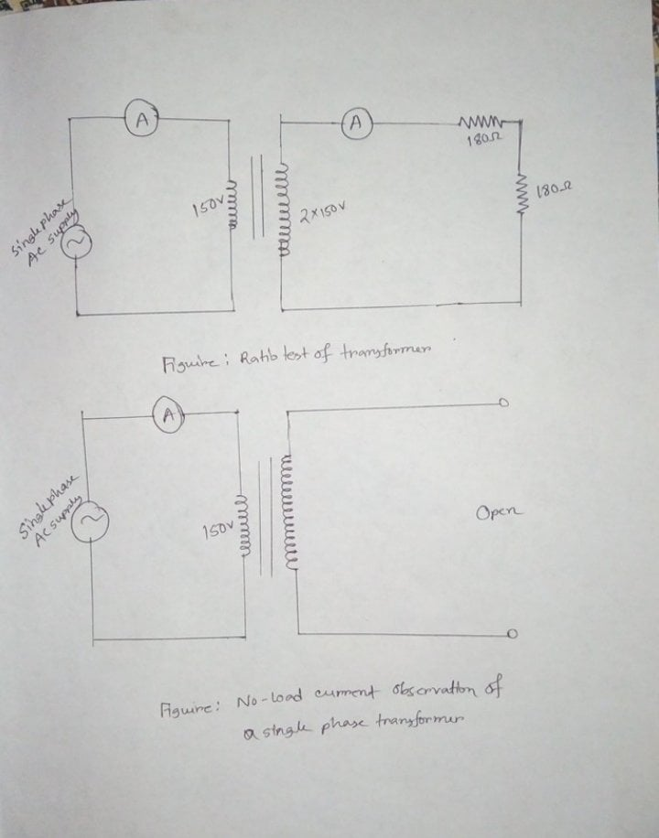

**Data Table and Analysis:**

|  |  |  |  |
| --- | --- | --- | --- |
| **Input**  **Frequency**  **(Hz)** | **Number of Pole** | **Before applying DC voltage**  **Synchronous Speed** | **After applying DC voltage**  **Synchronous Speed** |
| 50 | 4 | 1457 | 1512 |

Here ,

Input frequency,*f* = 50 Hz

Number of poles, p = 4

So, Synchronous speed is, *Ns* = 120*f* / p =1500 rpm

 = 1500 rpm

Here, slip will be,

*%s* = *(Ns - N) / Ns*

*=((1500-1457)/1500)*100*

= 2.86 *%*

After applying DC voltage supply, the speed of rotor becomes, N = 1512 rpm.

**Conclusion:**Damper windings helps the synchronous motor to start on its own (self starting machine) by providing starting torque .When the motor speed is less than the synchronous speed it work like as an induction motor. After applying DC voltage the motor is magnetically interlocked and run as a synchronous motor.