DFD Level 0

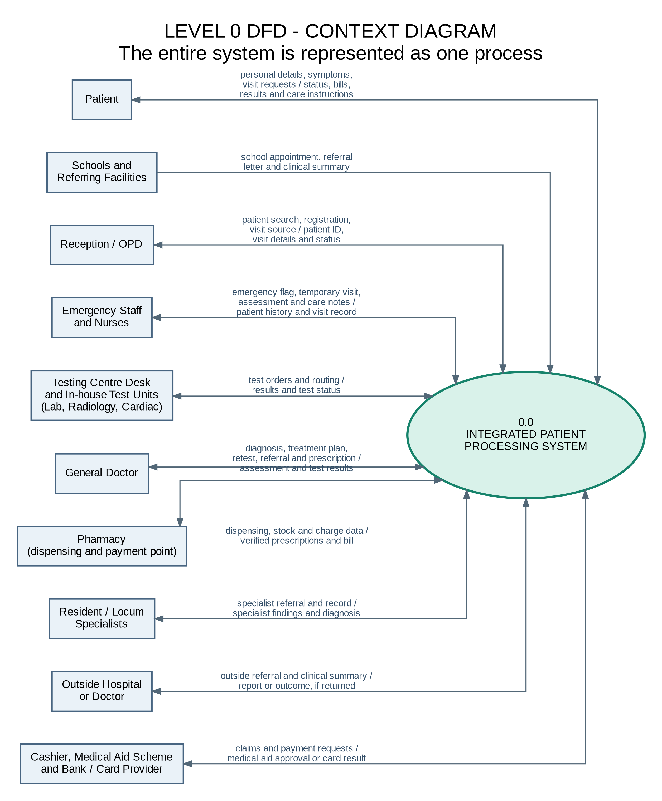

DFD Explanations
Level 0 DFD Explanation (Context Diagram)
The Level 0 diagram models the system as a single overarching process: 0.0 Integrated Patient Processing System.
- Inputs to the System: External entities (Patients, Reception, Emergency Staff, Testing Units, Doctors, Specialists, and Financial/Medical Aid entities) feed data into the system, including registration details, symptoms, triage notes, test orders, and payment authorizations.
- Outputs from the System: The system returns care instructions, prescriptions, test results, hospital bills, referral letters, and clinical summaries back to the respective stakeholders.

DFD Level 1
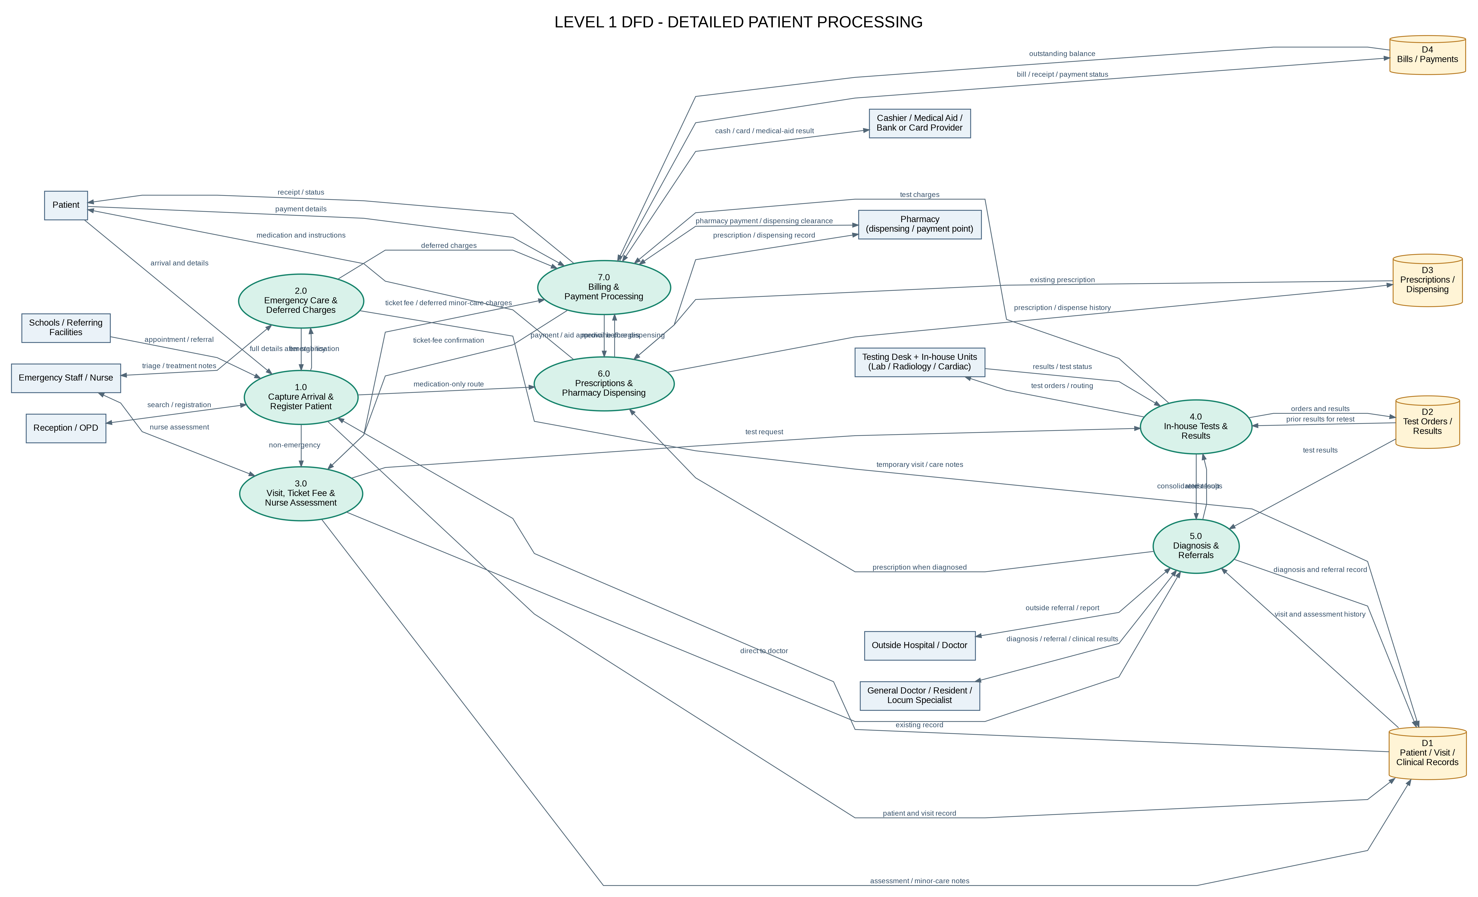

Level 1 DFD Breakdown & Process Flow Explanation
The Level 1 DFD decomposes the system into 7 core sub-processes interacting with 4 key data stores:
- Data Stores:
  - D1 Patient / Visit / Clinical Records: Stores patient demographic data, visit history, and clinical notes.
  - D2 Test Orders & Results: Manages laboratory, radiology, and cardiac test orders and results.
  - D3 Prescriptions / Dispensing: Tracks medication history, active prescriptions, and stock dispensing.
  - D4 Bills / Payments: Records outstanding balances, payment statuses, and transaction details.
- Core Sub-Processes:
  - 1.0 Capture Arrival & Register Patient: Handles walk-in or referred patient check-ins, searching existing records or registering new patient profiles in D1.
  - 2.0 Emergency Care & Deferred Charges: Triggered when an emergency flag is raised. Staff create temporary visit records, stabilize the patient, and record deferred charges in D4.
  - 3.0 Visit, Ticket Fee & Nurse Assessment: Manages non-emergency visits, collects ticket/consultation fees, and routes the patient for nurse assessments (recording vital signs and complaints).
  - 4.0 In-house Tests & Results: Routes test orders to the Testing Centre Desk, processes specimens/imaging (Lab, Radiology, Cardiac), and updates D2.
  - 5.0 Diagnosis & Referrals: General doctors, resident specialists, or locum specialists review clinical data from D1, establish diagnoses, write internal treatment plans, or generate outside referrals.
  - 6.0 Prescriptions & Pharmacy Dispensing: Verifies prescriptions against D3, checks medication stock, and calculates medicine charges.
  - 7.0 Billing & Payment Processing: Consolidates consultation fees, test fees, medication charges, and deferred balances into a final bill, processing payments via Cash, Card, or Medical Aid (D4).

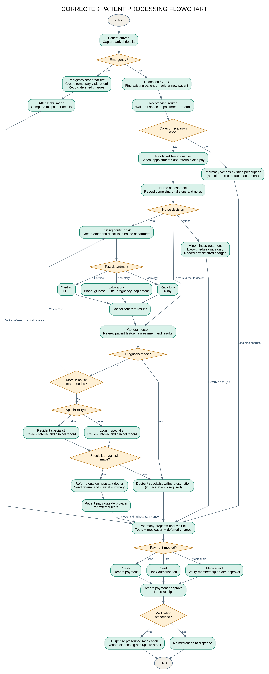
Process flow means the sequence and logic of activities that transform inputs into outputs. It describes how work moves through a process: what happens first, what happens next, where decisions branch, who performs each step, and what triggers or completes the process.

UML diagram



