SYSTEM DESIGN AND ARCHITECTURE

1. System Architecture Diagram
The Hospital Management System will use a three-tier client-server architecture consisting of the presentation layer, application layer and data layer. The system will be developed as one integrated application with different functional modules for hospital departments.

1.1 System Architecture Diagram
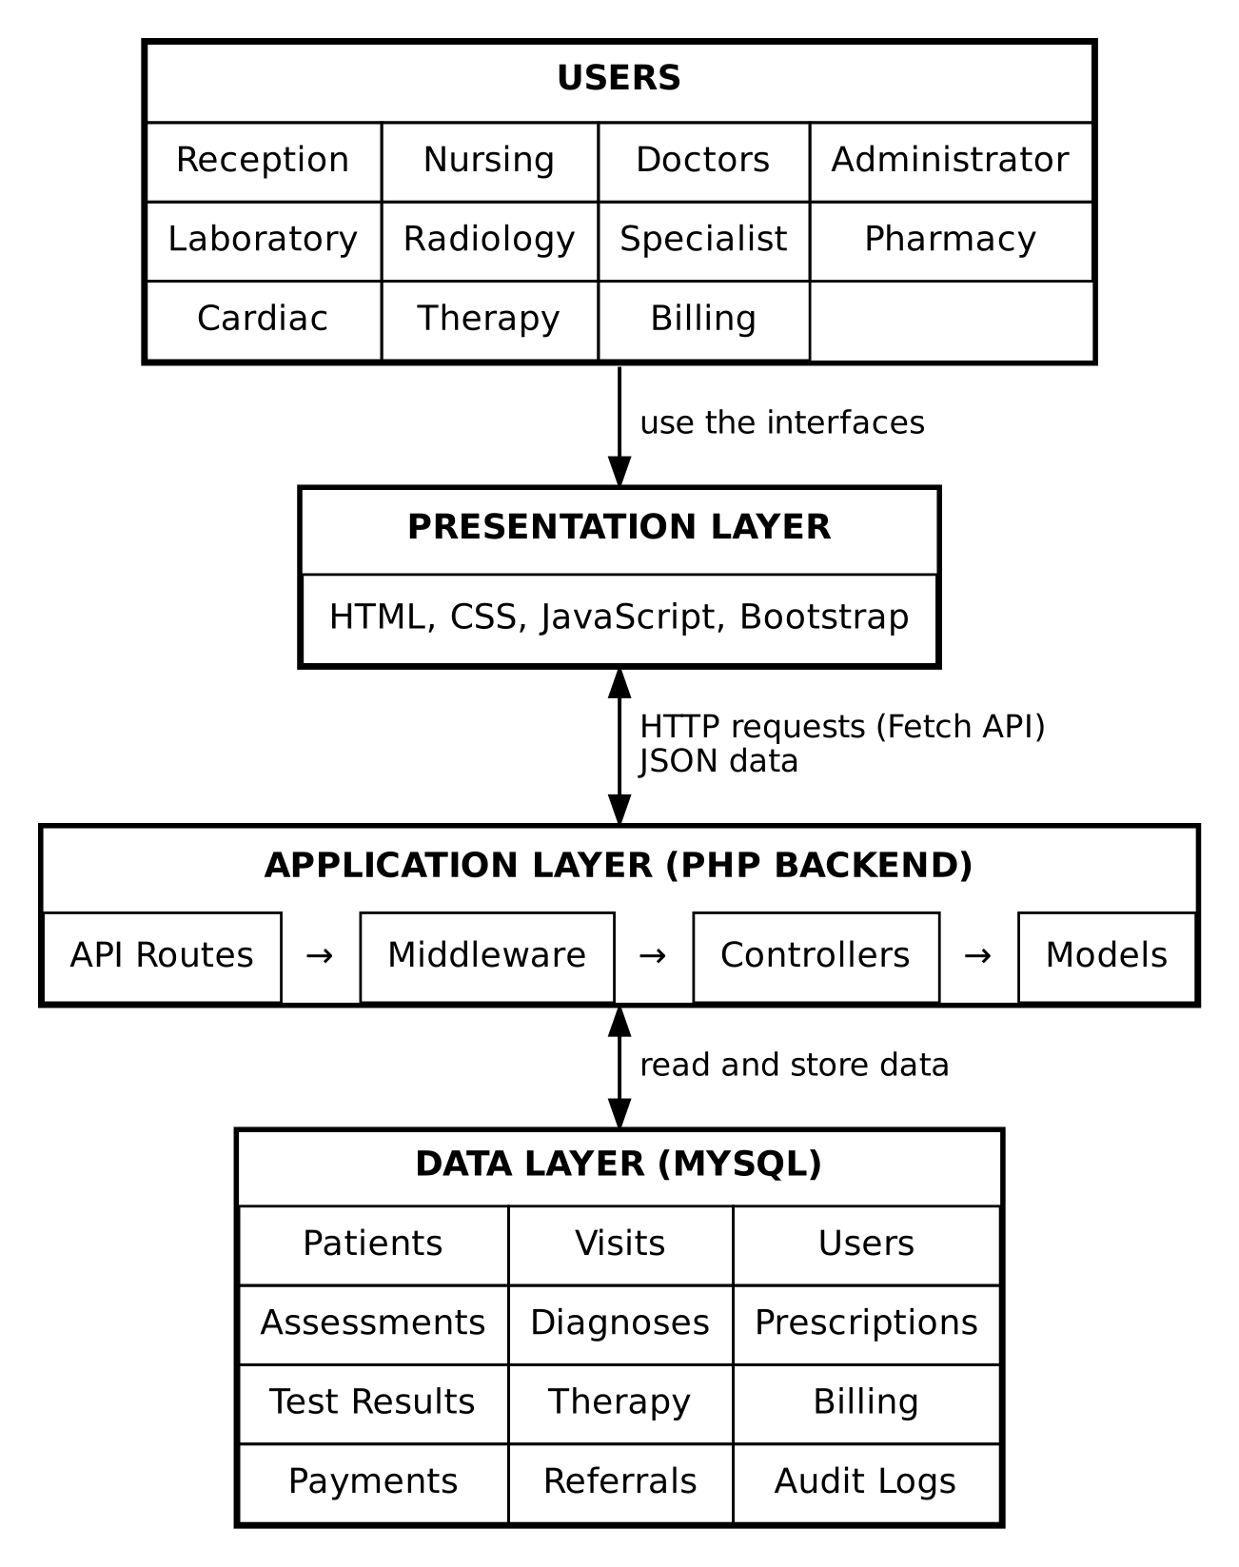
Figure 1: Three-tier system architecture

1.2 Architecture Description
- Presentation Layer: Provides the user interfaces through which receptionists, nurses, doctors, specialists, laboratory staff, radiology staff, cardiac staff, therapists, pharmacists, billing staff and administrators interact with the system.
- Application Layer: Contains the PHP backend responsible for processing requests, applying business rules, validating information and communicating with the database.
- Data Layer: Uses MySQL to store and manage patient records, visits, appointments, medical assessments, diagnoses, prescriptions, test results, therapy records, billing information and user accounts.

All functional modules communicate with the same central backend and shared database.

2. REST Architecture Design
The system will use Representational State Transfer (REST) principles to facilitate communication between the frontend and backend.
REST APIs will allow the different frontend modules to request, submit, retrieve and update information through HTTP requests. The backend will process these requests and return responses in JSON format.

2.1 Frontend and Backend Communication
The communication process will follow these steps:
- A user performs an action on a frontend interface, such as registering a patient.
- JavaScript uses the Fetch API to send an HTTP request to the PHP backend.
- The PHP API route receives the request and directs it to the appropriate controller.
- The controller validates the submitted information and applies the required business logic.
- The model communicates with the MySQL database to retrieve or store information.
- The backend returns a JSON response to the frontend.
- The frontend displays the result to the user.

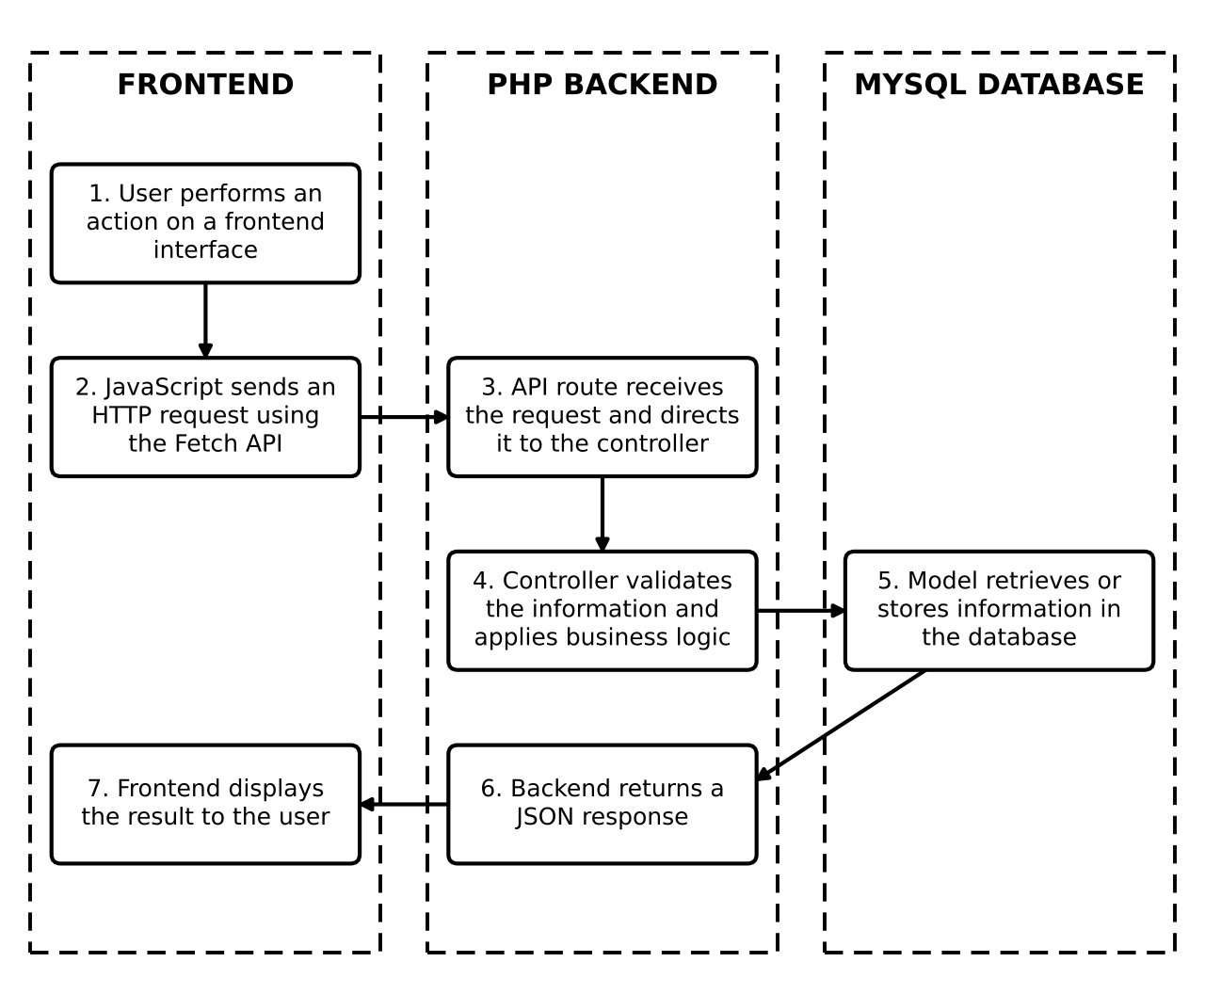
Figure 2: Frontend and backend communication flow

2.2 REST HTTP Methods
HTTP Method | Purpose | Example
GET | Retrieve information | Retrieve patient records
POST | Create new information | Register a patient
PUT | Update existing information | Update patient details
PATCH | Update selected information | Change visit status
DELETE | Remove information where permitted | Delete an appointment

2.3 Example of REST Communication
Scenario: Patient Registration
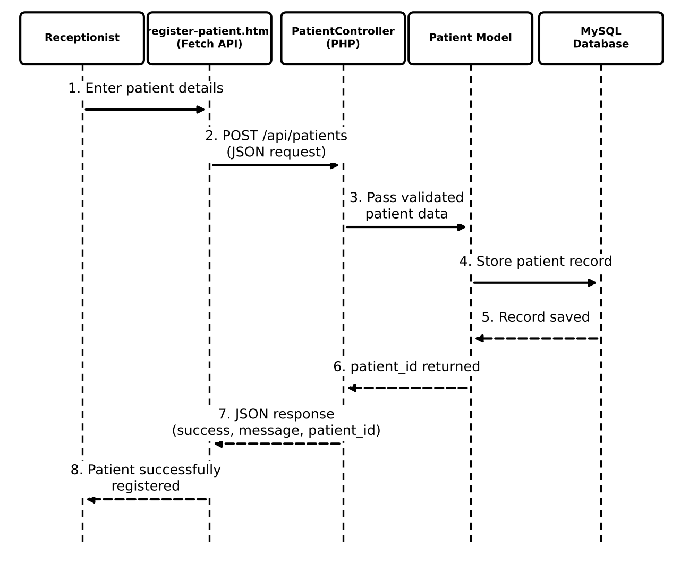
Figure 3: Patient registration REST communication
Example JSON request:
{
"first_name": "John",
"last_name": "Dlamini",
"date_of_birth": "1998-05-12",
"gender": "Male",
"phone": "76000000"
}

Example JSON response:
{
"success": true,
"message": "Patient successfully registered.",
"patient_id": 101
}

2.4 REST Design Principles
The API design will follow these principles:
- Client-server separation: The frontend and backend will operate separately and communicate through API requests.
- Stateless communication: Each request must contain the information required for the backend to process it, including authentication information where required.
- Resource-based URLs: Endpoints will represent system resources such as patients, visits, prescriptions and payments.
- JSON data exchange: JSON will be used as the standard format for sending and receiving data.
- HTTP status codes: Appropriate status codes will indicate whether requests were successful or encountered errors.
- Separation of concerns: Routes, controllers, models and middleware will have distinct responsibilities.

3. API Specifications
The system will expose REST API endpoints for the different functional modules. Each endpoint will allow authorised users to perform specific operations.
The following table presents the proposed API specifications.
Module | HTTP Method | API Endpoint | Description
Authentication | POST | /api/login | Authenticate users
Authentication | POST | /api/logout | Log out users
Administration | GET | /api/users | Retrieve system users
Administration | POST | /api/users | Create user accounts
Administration | PUT | /api/users/{id} | Update user information
Reception | POST | /api/patients | Register a new patient
Reception | GET | /api/patients | Retrieve patient records
Reception | GET | /api/patients/{id} | Retrieve a specific patient
Reception | PUT | /api/patients/{id} | Update patient details
Reception | POST | /api/visits | Create a patient visit
Reception | GET | /api/visits/{id} | Retrieve visit information
Nursing | POST | /api/assessments | Record a nursing assessment
Nursing | GET | /api/visits/{id}/assessments | Retrieve assessments for a visit
General Doctor | POST | /api/consultations | Record a doctor consultation
General Doctor | POST | /api/diagnoses | Record a diagnosis
General Doctor | POST | /api/prescriptions | Create a prescription
Laboratory | GET | /api/laboratory/orders | Retrieve laboratory test orders
Laboratory | POST | /api/laboratory/orders | Create a laboratory test order
Laboratory | POST | /api/laboratory/results | Record laboratory results
Radiology | GET | /api/radiology/orders | Retrieve radiology orders
Radiology | POST | /api/radiology/orders | Create a radiology order
Radiology | POST | /api/radiology/results | Record radiology results
Cardiac | GET | /api/cardiac/orders | Retrieve cardiac test orders
Cardiac | POST | /api/cardiac/orders | Create a cardiac test order
Cardiac | POST | /api/cardiac/results | Record cardiac test results
Specialist | GET | /api/specialist/referrals | Retrieve specialist referrals
Specialist | POST | /api/specialist/referrals | Create a specialist referral
Specialist | POST | /api/specialist/consultations | Record specialist consultations
Specialist | POST | /api/specialist/diagnoses | Record specialist diagnoses
Therapy | GET | /api/therapy/appointments | Retrieve therapy appointments
Therapy | POST | /api/therapy/appointments | Schedule a therapy appointment
Therapy | POST | /api/therapy/records | Record therapy sessions
Pharmacy | GET | /api/prescriptions | Retrieve prescriptions
Pharmacy | PUT | /api/prescriptions/{id}/status | Update prescription status
Pharmacy | POST | /api/dispensing | Record medication dispensing
Billing | GET | /api/visits/{id}/bill | Retrieve a visit bill
Billing | POST | /api/bills | Generate a bill
Billing | POST | /api/payments | Record a payment
Billing | GET | /api/payments/{id} | Retrieve payment information

Note: These endpoints are proposed specifications. They will be finalised with the backend and frontend developers to ensure consistency with the implemented system

3.1 API Security and Access Control
The API will implement authentication and role-based access control to ensure that users only access functions permitted for their roles.
For example:
- Receptionists can register patients and create visits.
- Nurses can record assessments and vital signs.
- General doctors can record consultations, diagnoses and prescriptions.
- Specialists can access assigned referrals and record specialist consultations.
- Laboratory, radiology and cardiac staff can manage their respective test orders and results.
- Therapists can manage therapy appointments and records.
- Pharmacists can access prescriptions and record medication dispensing.
- Administrators can manage users and system access.

3.2 API Response and Error Handling
The API will use standard HTTP status codes to communicate request outcomes.
Status Code | Meaning | Application
200 | OK | Request completed successfully
201 | Created | New record successfully created
400 | Bad Request | Invalid request format
401 | Unauthorized | User is not authenticated
403 | Forbidden | User lacks permission
404 | Not Found | Requested record does not exist
409 | Conflict | Duplicate or conflicting record
422 | Unprocessable Entity | Submitted information fails validation
500 | Internal Server Error | Unexpected server error

4. Non-Functional Requirements
Requirement | Description
Security | The system must protect patient and medical information through authentication, role-based access control, secure password storage and appropriate data protection measures.
Performance | The system should process requests and retrieve records within a reasonable time to support efficient hospital operations.
Reliability | The system should perform consistently and minimise interruptions during hospital operations.
Availability | The system should be accessible to authorised users whenever required, subject to server and network availability.
Usability | The interfaces should be simple, consistent and easy for hospital staff to understand and operate.
Maintainability | The system should use modular components to make it easier to identify errors, update functionality and maintain the application.
Scalability | The system should support the addition of users, records and functional modules as hospital requirements grow.
Data Integrity | The system must maintain accurate and consistent records and prevent invalid or unauthorised data modifications.
Interoperability | The frontend and backend must communicate using standard HTTP requests and JSON data formats.
Error Handling | The system should detect errors, validate submitted information and provide meaningful feedback to users.
Auditability | Important activities, such as record updates, user actions and payment transactions, should be logged for accountability and tracking.
Backup and Recovery | The database should be backed up regularly, with a recovery process to reduce the risk of permanent data loss.

5. Technology Stack Justification Report
The following technologies have been selected for the development of the Hospital Management System based on their suitability, functionality, compatibility and ease of implementation.
Technology | Purpose in the System | Justification
PHP | Backend development | PHP is suitable for server-side development and supports the creation of REST APIs, database operations, authentication and business logic.
MySQL | Database management | MySQL provides a relational database for storing structured hospital information, including patients, visits, consultations, prescriptions and payments.
HTML5 | Frontend structure | HTML5 provides the structure for the different user interfaces and forms used throughout the system.
CSS | Frontend styling | CSS3 is used to style interfaces and improve the presentation and layout of the system.
JavaScript | Frontend functionality | JavaScript enables interactive interfaces, form validation and communication with the backend through the Fetch API.
Bootstrap | Frontend framework | Bootstrap provides reusable interface components and responsive layouts, reducing the amount of custom CSS required.
REST API | System communication | REST provides a standard approach for communication between the frontend and PHP backend using HTTP methods.
JSON | Data exchange format | JSON provides a lightweight and readable format for transferring information between the frontend and backend.
Fetch API | HTTP communication | The Fetch API allows JavaScript to send asynchronous HTTP requests and receive responses without reloading the entire page.
Apache | Web server | Apache will host and serve the PHP application and process incoming HTTP requests.
XAMPP | Local development environment | XAMPP provides a convenient local environment containing Apache, MySQL and PHP for development and testing.
Postman | API testing | Postman allows developers to test API endpoints, submit requests, inspect responses and identify communication errors.
GitHub | Version control and collaboration | GitHub allows group members to collaborate, share project files and manage development contributions.
Visual Studio Code | Code editor | Visual Studio Code provides an environment for writing, editing and organising PHP, HTML, CSS and JavaScript code.
phpMyAdmin | Database administration | phpMyAdmin provides a graphical interface for managing MySQL databases, tables and records.

6. System Design and Architecture

6.1 Overall System Design
The proposed modules include:
- Administration Module: Manages user accounts, roles and system access.
- Reception Module: Registers patients, retrieves patient records and creates patient visits.
- Nursing Module: Records patient assessments, vital signs and nursing interventions.
- General Doctor Module: Manages consultations, diagnoses, treatment decisions and prescriptions.
- Laboratory Module: Manages laboratory test orders and results, including blood, glucose, urine, pregnancy and pap smear tests.
- Radiology Module: Manages radiology requests and results, including X-ray examinations.
- Cardiac Module: Manages cardiac investigations, including ECG tests.
- Specialist Module: Manages referrals and consultations conducted by resident and locum specialists.
- Therapy Module: Manages therapy appointments and treatment records.
- Pharmacy Module: Manages prescriptions, medication dispensing and medication-related records.
- Billing Module: Manages patient bills, payments and outstanding charges.

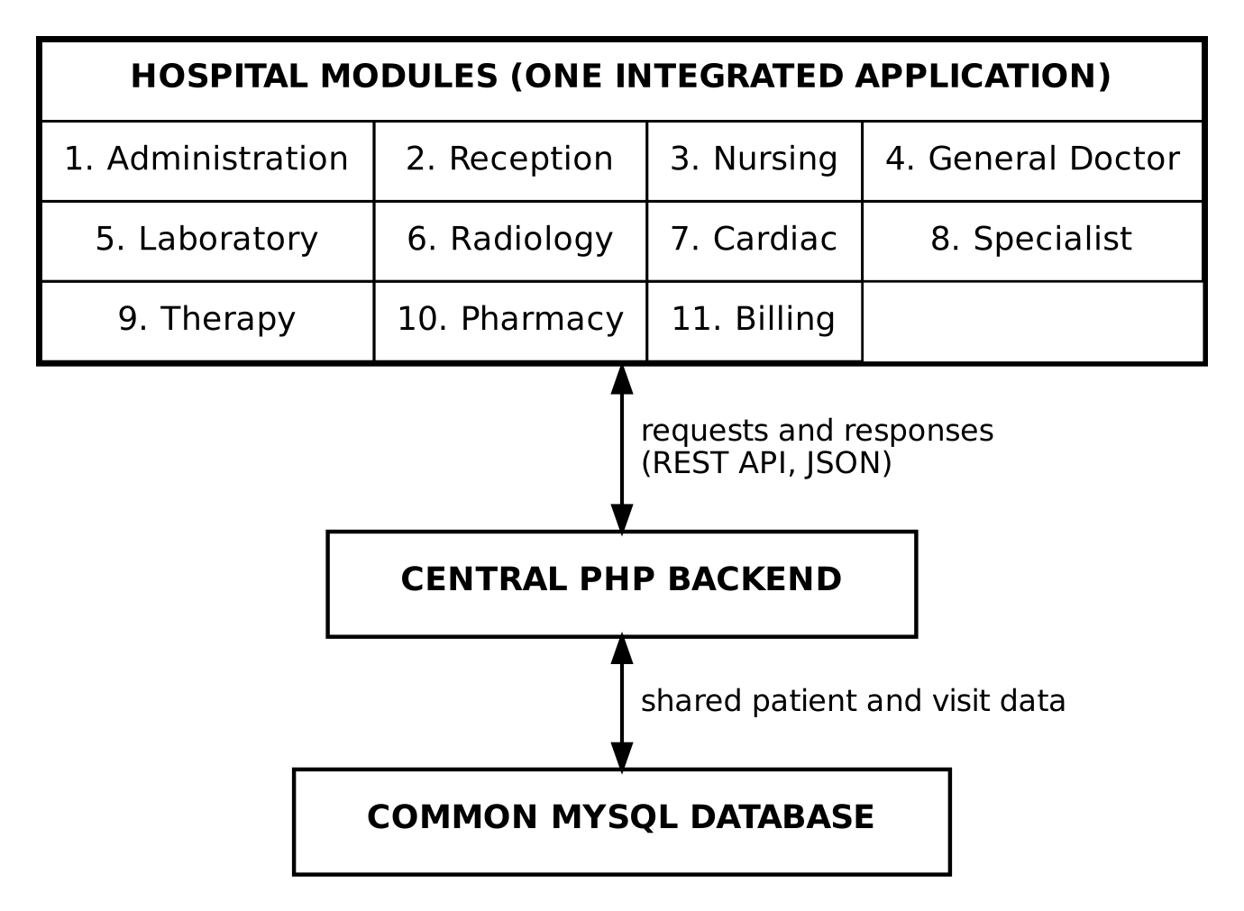

6.2 Patient Information and Visit Management
The system will maintain a central patient record for each registered patient. When a patient visits the hospital, a new visit record will be created and linked to the patient's existing record.
Each visit will have a unique visit identifier. This will allow the system to associate the patient's nursing assessments, consultations, test orders, test results, prescriptions and billing information with the correct visit.
A patient may have multiple visits over time, while their personal information remains stored in the central patient record.

6.3 Integration Between Hospital Modules
The modules will share relevant information through the central backend and database.
For example:
- Reception registers a patient and creates a visit.
- Nursing accesses the patient's visit information and records an assessment.
- The general doctor reviews the assessment and may request diagnostic tests.
- Laboratory, radiology or cardiac staff record the requested test results.
- The general doctor reviews the results and may issue a diagnosis or refer the patient to a specialist.
- The specialist records consultation findings and may issue a diagnosis or prescription.
- The pharmacy accesses prescriptions and records medication dispensing.
- Billing manages the charges and payments associated with the visit.

The system must also accommodate emergency cases, where treatment can begin before normal registration and payment procedures are completed. Emergency prescriptions must be recorded, and applicable charges can be settled later according to the hospital's payment process.
Medication-only visits must also be recorded and include the required payment before medication is dispensed.

6.4 Database Design Considerations
The system will use a shared MySQL relational database. The database will contain related tables for the different functional modules.
Proposed database tables include:
Database Table | Purpose
users | Stores system user accounts
roles | Stores user roles and access categories
patients | Stores patient personal information
visits | Stores patient visit information
appointments | Stores appointment records
assessments | Stores nursing assessments
vital_signs | Stores patient vital signs
consultations | Stores doctor consultation records
diagnoses | Stores patient diagnoses
prescriptions | Stores prescribed medication information
test_orders | Stores diagnostic test requests
test_results | Stores laboratory, radiology and cardiac results
specialist_referrals | Stores specialist referral information
specialist_consultations | Stores specialist consultation records
therapy_appointments | Stores therapy appointments
therapy_records | Stores therapy session information
medications | Stores medication information
dispensing_records | Stores medication dispensing records
bills | Stores patient billing information
bill_items | Stores individual charges associated with bills
payments | Stores payment transactions
audit_logs | Stores records of important system activities

The database will use primary keys and foreign keys to establish relationships between records and maintain data integrity. For example, patient visits will be linked to patient records, while test orders and prescriptions will be associated with the relevant visit.
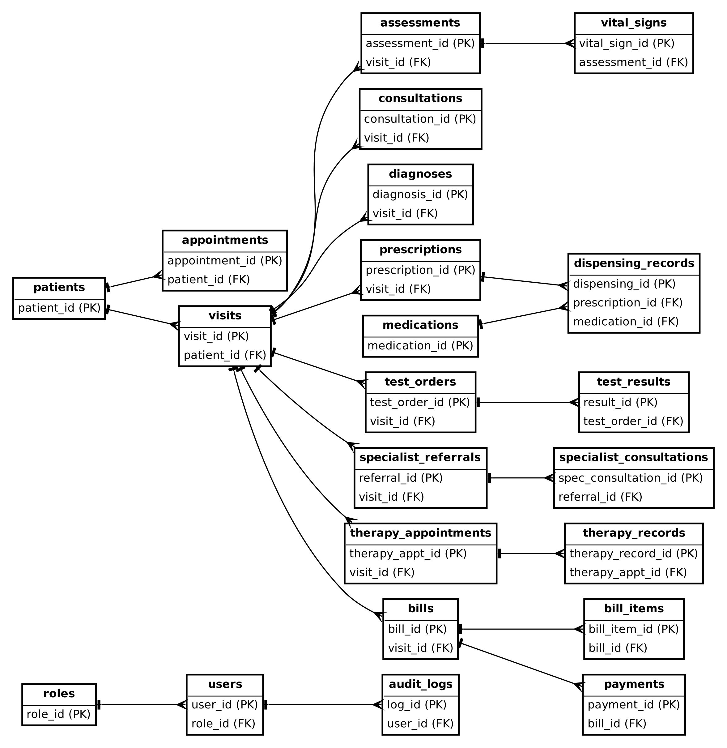
Figure 6: Entity relationship diagram of the proposed database tables

6.5 Design Considerations
The following considerations will guide the implementation of the system:
- Centralised information: Patient information will be stored in one shared database to reduce duplication.
- Modular development: Each department will have its own module, making the system easier to develop and maintain.
- Access control: Users will only be permitted to access functions relevant to their assigned roles.
- Visit tracking: Activities performed during a patient visit will be linked through a unique visit identifier.
- Data consistency: Database relationships and validation will help maintain accurate patient and medical records.
- Integration: Modules will exchange information through the central PHP backend rather than operating as independent systems.

