**The AdWeb Project**

The project is open sourced: <https://github.com/Shoumik-Gandre/adweb-project>

**Problem we’re trying to remedy:**

Advertisements are the daily driver of the internet economy.

How can we deliver advertisements to websites over the internet?

**The solution:**

Make a website that deals with Advertisers and Advertisement Displayers

(Adclient is the jargon we would like to use).

It should:

* authenticate users
* allow people to add advertisements
* delivers ads when the Adclient Requests for them.

Technology Stack:

Utils: git

Backend:

* Python – Django
* Sqlite3 (for Prototyping)
* MySql

Frontend:

* HTML, CSS, JavaScript
* Bootstrap 4.0
* Chart.js
* Particle.js

The Use case Diagram:

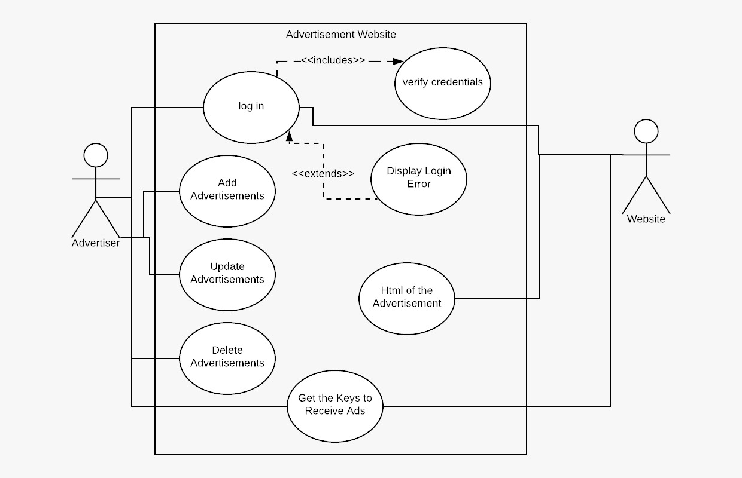

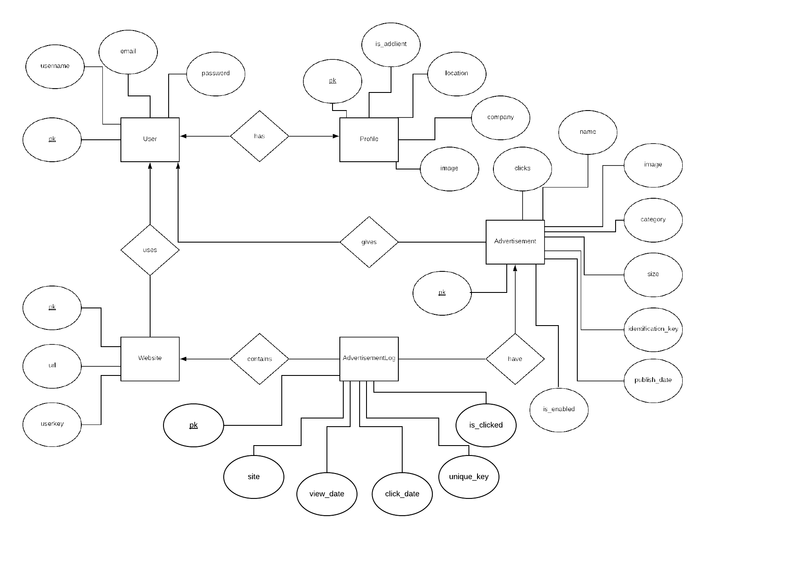The ER Diagram:

Implementation:

This is a backend to backend Advertisement Delivery System.

The User Model has both Advertiser and AdClient modes.

When Advertiser Adds a new Ad it is saved in fileserver (local machine in prototype ‘media’ folder)

When Adclient Wants to show ads on his website, they registers them in Adclient table. He receives a 32 character long key (chars: a-z, A-Z, 0-9). Being 32 bit it can hold 3262 (2 x 1096) entries

When Adclient requests for advertisement, they send get request on the following url:

http://<Domain name of this site>/<Size of advertisement>/<key>

| **size name** | **pixels** |
| --- | --- |
| leaderboard | (728x90px) |
| medium rectange | (300x250px) |
| large rectangle | (336x280px) |
| half page | (320x600px) |
| free size | -infinity to +infinity |
|  |  |

They receive a json of the advertisement. An AdvertisementLog is made.

When the Audience click on an advertisement they are redirected to a url on AdWeb’s website which registers the click and sets the is_adclient field of AdvertisementLog with that pk and unique_key to True and sets unique_key to ‘1’, making it unclickable again, then redirects to the url the ad intends to redirect to.

Instructions:

Want to Advertise?

Follow the steps below

1. If you don't have an account:  
   Register an account and Login  
   If you have an account login
2. Click on New Ad on nav-bar
3. Fill details about the advertisement then click Upload
4. Done! now the advertisement can be displayed

Want to Receive Ads?

Follow the steps below

1. If you don't have an account:  
   Register an account and Login  
   If you have an account login
2. Click on Adclient on nav-bar
3. Enter the website url you want to display ads on and then click activate
4. Now you can add all the websites you want ads on

NOTE: keep your Keys a secret

1. To Receive Advertisements, copy your key and send a get request to  
   *http://<Domain name of this site>/<Size of advertisement>/<your key>*

| **size name** | **pixels** |
| --- | --- |
| leaderboard | (728x90px) |
| medium rectange | (300x250px) |
| large rectangle | (336x280px) |
| half page | (320x600px) |
| free size | -infinity to +infinity |

for Example: try typing this in command prompt curl "http://<Domain name of this site>/api/<Size of advertisement>/<your key>"

(Substitute the values)

You will receive an html of the advertisement in JSon

You can use requests module in python and node.js to send a get request to the url (It comes in JSon format so parse it)

Python code to receive ads (advertisement_html has the advertisement)

Get Request:

import requests

DOMAIN = '<Domain name of this site>'

SIZE = '<size of the advertisement you want>'

KEY = '<Your Key>'

r = requests.get(f"http://{DOMAIN}/api/{SIZE}/{KEY}")

advertisement_html = r.json()

Post Request:

import requests

DOMAIN = '<Domain name of this site>'

SIZE = '<size of the advertisement you want>'

KEY = '<Your Key>'

data = {

'size': SIZE,

'key': KEY

}

r = requests.post(f"http://{DOMAIN}/api/", data=data)

advertisement = r.json()

Screen Shots of UI:

