Preparation

## Glossary

**AC-Coupling**

A measurement mode of a probe. By filtering a signal, having both a DC and an AC component, with a high pass filter RC – with an extremely low cutoff frequency – only the AC component is measured by the probe.

By removing the DC offset, the resolution and the scale of the measurement is more accurate.

**DC-Coupling**

The signal, ac and dc, get measured untouched by the probe.

**Rise – Fall time**

The time in which the signal rises from xl% (10% usually) of the amplitude – measured from the lowest value – to the xh% (90%) of its total step hight is its rise time and viceversa for the fall time.

**Pulse duration**

It’s the time that a signal is above a determined reference point in a single period.

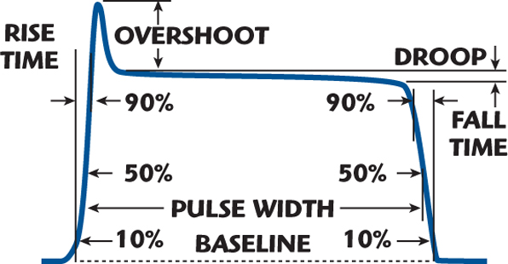

**VDR – Voltage Dependent Resistance**

A non-linear resistance. When the applied voltage is low, the resistance is high, and decreases for high voltages, much like a diode but allowing both current direction.

It is used in a parallel configuration to prevent high current from damaging sensitive components, by providing a low resistance path at high voltages.