EE2 – LAB 3  
Introduction to Measurement Automation (Part 1)

Goal

The goal of this experiment is to get acquainted with the LabVIEW measurements automation environment and develop an interface with the lego mindstorm to evaluate the capabilities of the ultrasonic sensor.

Hardware setup

We set up the lego NXT and ultrasonic sensor and connected them using a USB interface to our LabVIEW platform.

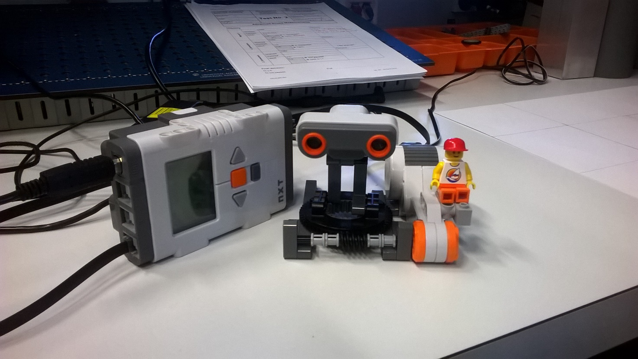

Task “Hello World”

We then proceeded to create a small “hello world” application to test the connection with the unit.

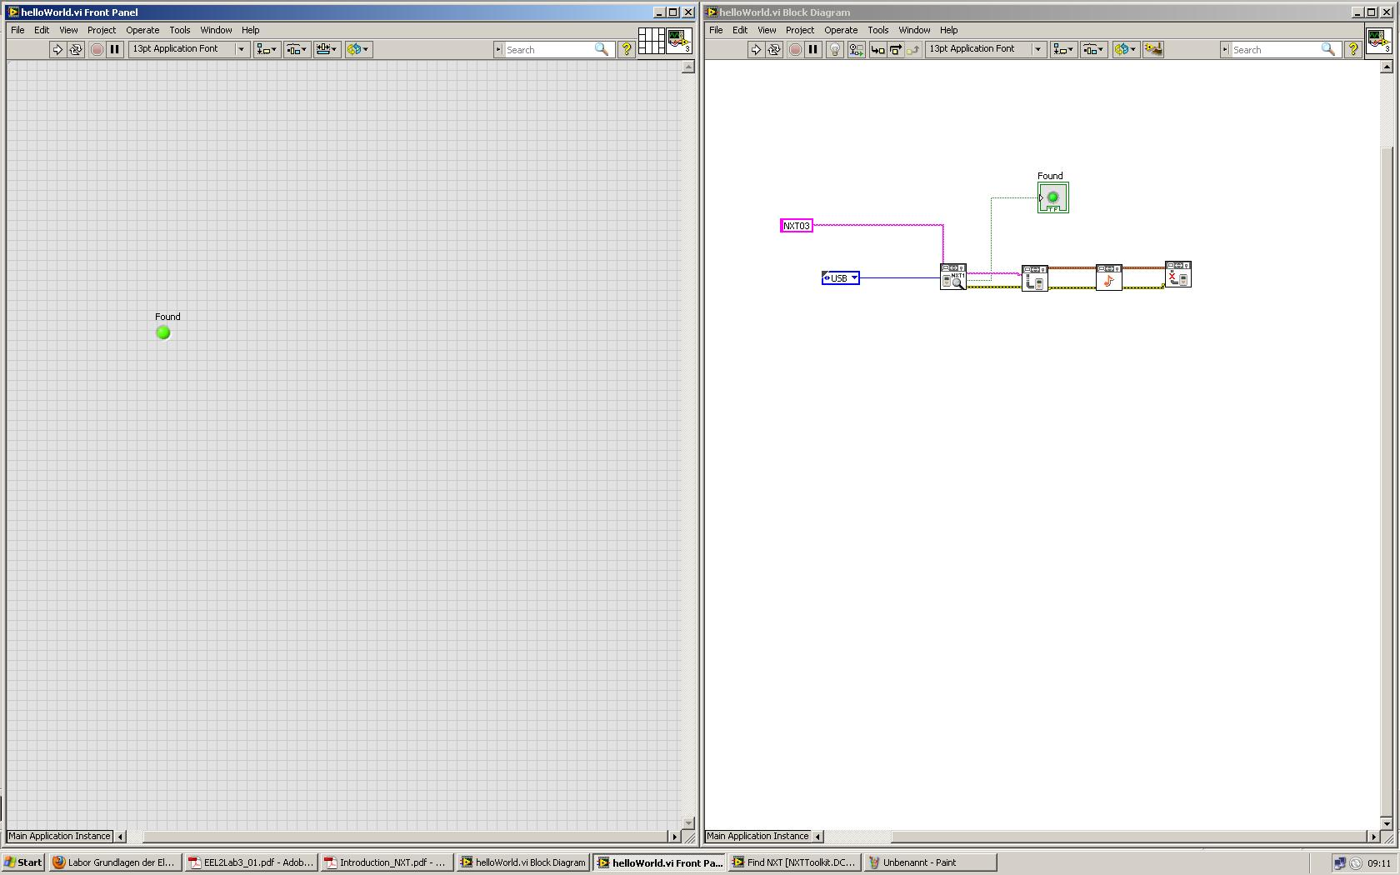1. What is the difference between the 4 blocks in a line and the upper block?

While the 4 blocks below function as an interface with the NXT brick (and consequently no interaction with the user is required) the upper block is a led indicator, which output a Boolean value to the user via a component on the GUI.

2. Find out what information is transferred by the data flows.

The four blocks dedicated to interface with the LEGO NXT bricks transfer the following informations between each other:

* VISA Resource String: unique string that identifies a NXT object
* Error Boolean: each block operation can incur in a error while carring out an operation with the external NXT object. If it does happen, this Boolean value assures that the next block receives the information regarding the error itself and, in the case of this program, skip its execution
* NXT Object: the actual instance of the NXT object, created after a successful connection, with which is possible to access the function of the brick features
* Additionally we got other datatatypes, such as ConnectionType, a String constant and another Boolean value

3. Find out the block names and explain how the program is working.

The program works as follows:

1. Find NXT: does a scan for NXT and then looks for an NXT in the Array of resource strings (in this cas just a single String constant) with the right name and Connection Type, and returns the appropriate VISA resource string
2. TF boolean control: turns on a LED on the GUI if the NXT is recognized.
3. Create NXT Object: takes the VISA String and makes the connection to the NXT. Outputs the nXT Object instance
4. Play Tone: plays a tone via the NXT speakers
5. Destroy NXT: disconnect the NXT and frees the connection’s resources.

Task 2

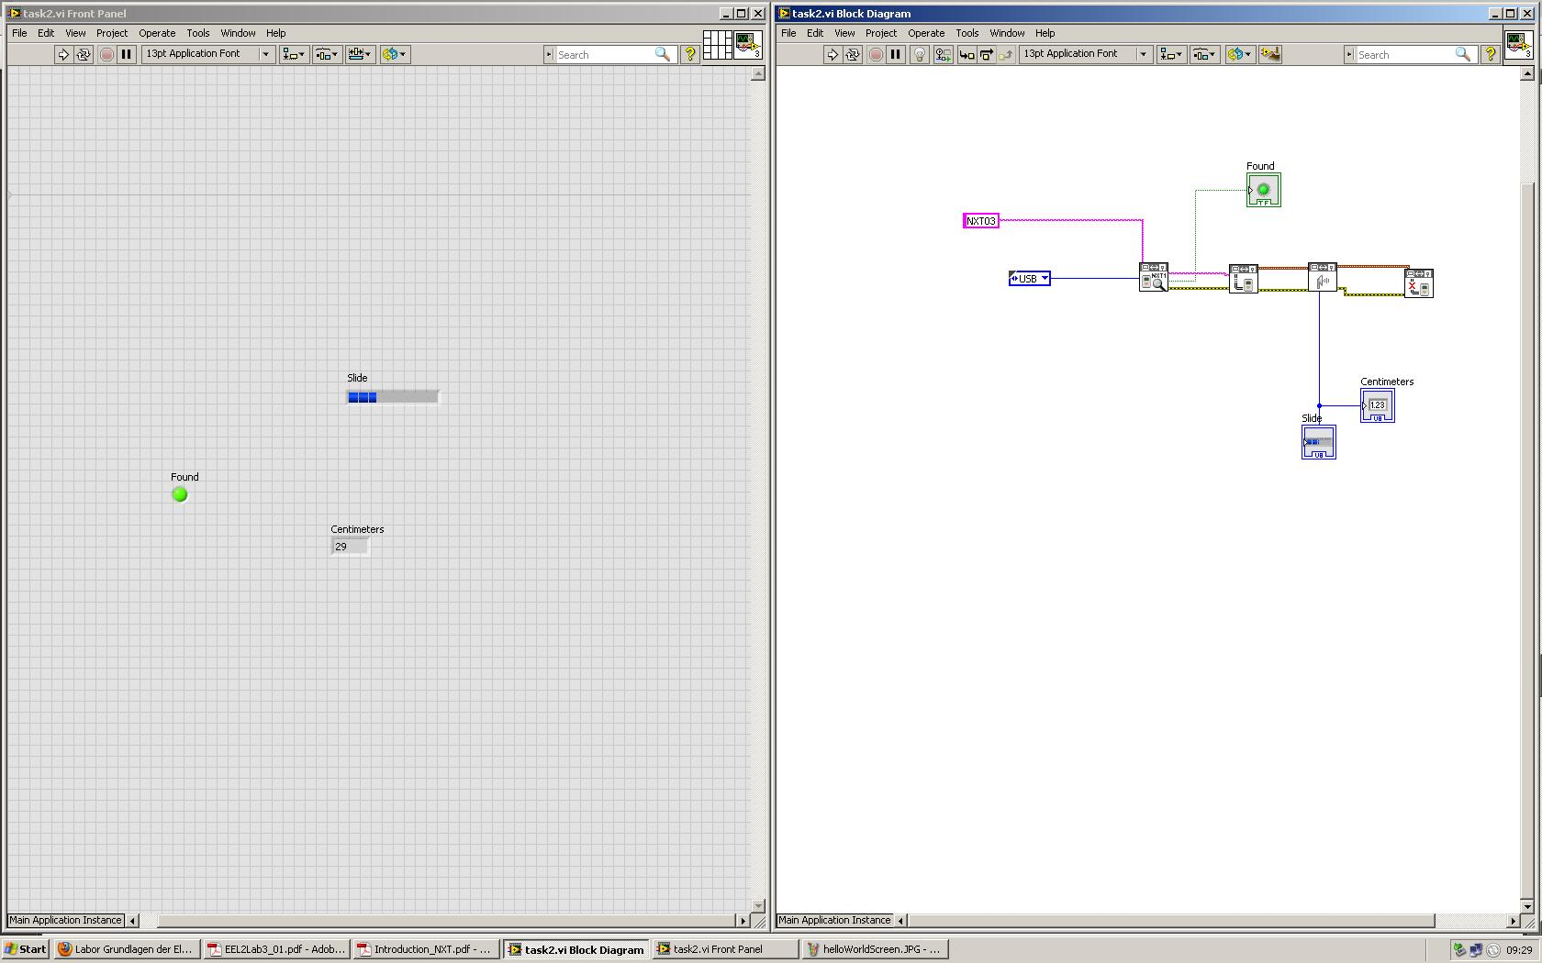

We added a block “GetUltrasonicReading” that allow to get informations from the Ultrasonic Sensor device of the NXT, outputting once the distance in cm to the cloasest object in its proximity, detected in a 255 cm range.

We then added a horizontal bar and a numerical indicator to display the value.

Task 3

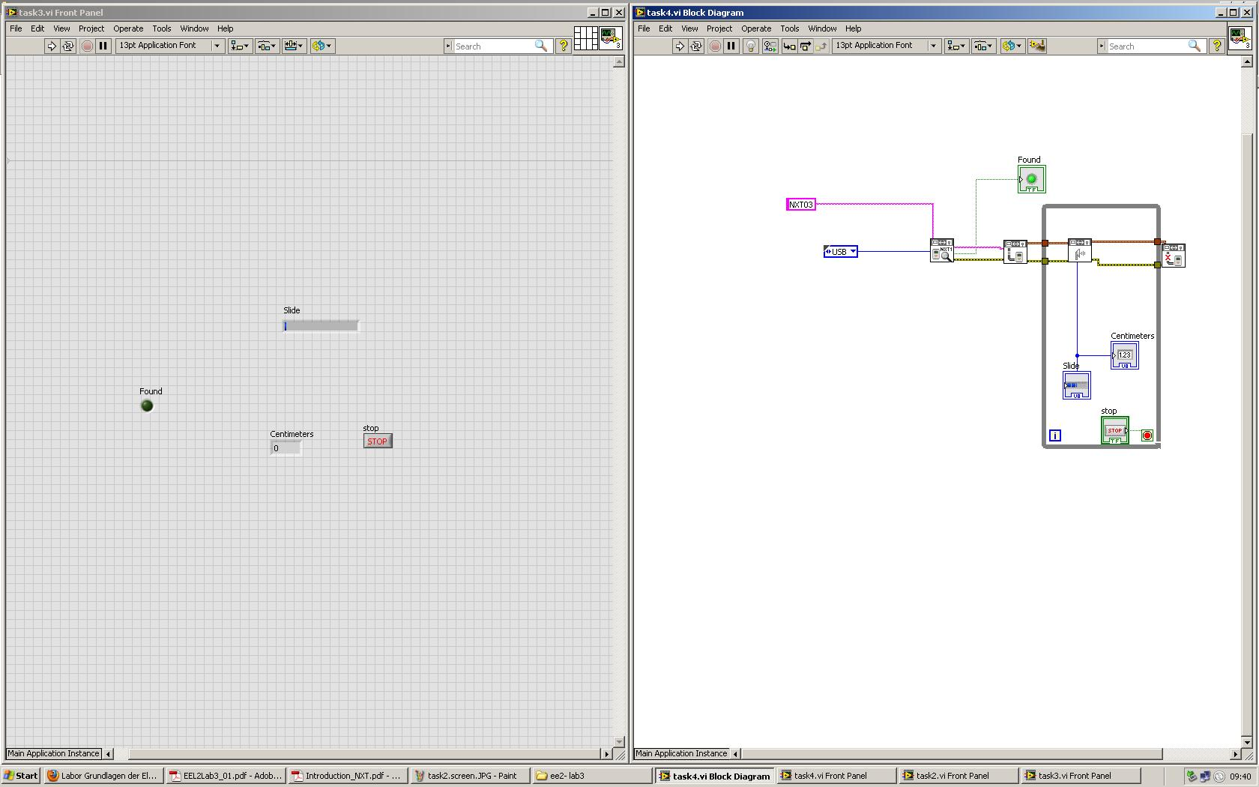

We enclosed the sensor measurement in a while loop, controlled by a stop button control on the GUI, thus allowing a seamless measurement of the distance until the user stops the execution.

Task 4

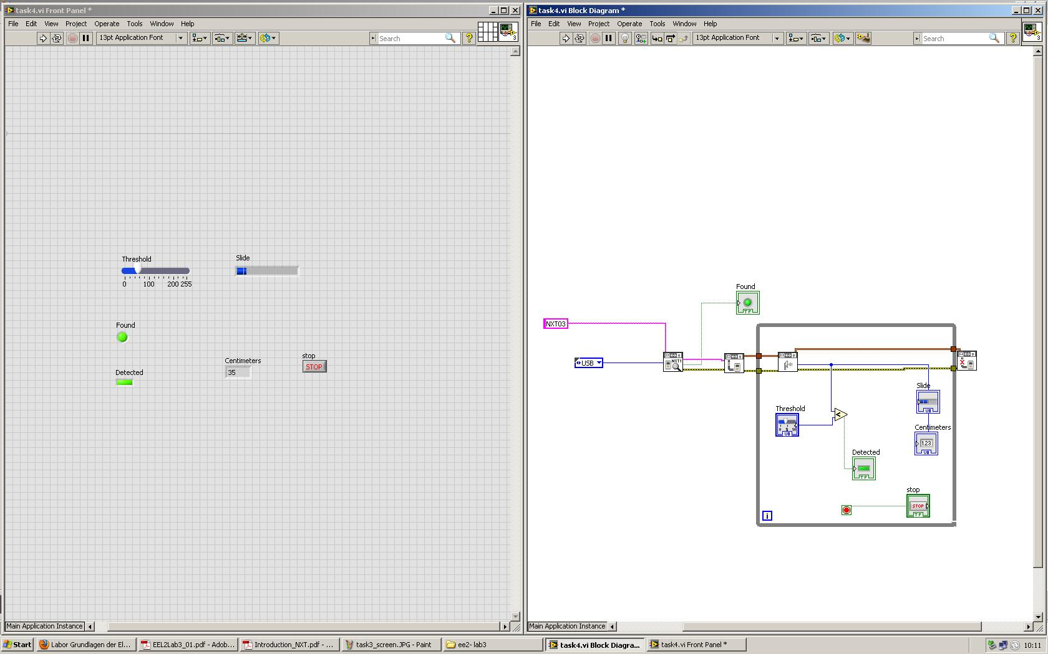

With the addition of a SlidingBar control on the GUI, the user can set the desired range in which the object is to be detected. If the distance is less than the set range, a newly added led signals the successful detection.

Task 5

We then proceeded to evaluate empirically the range and the detection characteristics of the LEGO ultrasonic sensor by placing 3 differently shaped object on various distances and angles from the sensor.

Measurements

Detection for cilinders

100cm

|  |  |  |  |  |  |  |  |  |  |  |
| --- | --- | --- | --- | --- | --- | --- | --- | --- | --- | --- |
|  |  |  |  |  |  |  |  |  |  |  |
|  |  |  |  |  |  |  |  |  |  |  |
|  |  |  |  |  |  |  |  |  |  |  |
|  |  |  |  |  |  |  |  |  |  |  |

40cm

For a cylindrical object, we observed a remarkable detection ratio spread all around the grid, with an accuracy of 30/40.

Detections for squares

|  |  |  |  |  |  |  |  |  |  |  |
| --- | --- | --- | --- | --- | --- | --- | --- | --- | --- | --- |
|  |  |  |  |  |  |  |  |  |  |  |
|  |  |  |  |  |  |  |  |  |  |  |
|  |  |  |  |  |  |  |  |  |  |  |
|  |  |  |  |  |  |  |  |  |  |  |

For a square object, positioned with the flat faces aligned to the grid lines, the detection is concentrated in front of the field of vision of the sensor. The accuracy rate is of 24/40.

Detections for angled squares

|  |  |  |  |  |  |  |  |  |  |  |
| --- | --- | --- | --- | --- | --- | --- | --- | --- | --- | --- |
|  |  |  |  |  |  |  |  |  |  |  |
|  |  |  |  |  |  |  |  |  |  |  |
|  |  |  |  |  |  |  |  |  |  |  |
|  |  |  |  |  |  |  |  |  |  |  |

We angled the squares 45° wrt the grid lines and observed a very poor detection rate of 5/40, concentrated on the sides near the sensor itself.

RULES for reliable ultrasonic detection

* round objects are more likely to get detected in a wide range
* squares detection rate is highly dependent on the orientation (and presumably the material) of the object itself
* flat surfaces are more likely to get detected if oriented perpendicularly wrt the sensor
* if the edge is placed in front of the sensor, the ultrasound are going to be deflected, thus compromising the detection
* short sided sensor (dacci un occhio Nicola, che mi pare Lehmann ne abbia parlato, ma non trovo niente a riguardo, altrimenti depenna)