Lab preparation:

1. With Upp = 6.0V and DC offset = 0.

|  |  |  |  |
| --- | --- | --- | --- |
|  | Effective Value | Mean Value | Rectified Value |
| Sine wave | 2.1213 | 0 | 12 / T |
| Triangle wave | 1.7320 | 0 | 1.5 |
| Square wave | 3 | 0 | 3 |

1. Bode plot of transfer function

|  |  |  |  |  |
| --- | --- | --- | --- | --- |
| f(Hz) | Ω | A(Ω) | A(Ω) in dB | Phase |
| 100 | 0,045615925 | 0,998961 | -0,009027466 | -0,04558 |
| 200 | 0,091231851 | 0,995864 | -0,035997815 | -0,09098 |
| 300 | 0,136847776 | 0,990766 | -0,080579505 | -0,136 |
| 400 | 0,182463701 | 0,983758 | -0,142234883 | -0,18048 |
| 500 | 0,228079627 | 0,974963 | -0,220241268 | -0,22424 |
| 600 | 0,273695552 | 0,964526 | -0,313718023 | -0,26715 |
| 700 | 0,319311477 | 0,952614 | -0,421657592 | -0,30908 |
| 800 | 0,364927403 | 0,939403 | -0,542958384 | -0,34991 |
| 900 | 0,410543328 | 0,925075 | -0,676457478 | -0,38956 |
| 1000 | 0,456159253 | 0,909813 | -0,820961491 | -0,42796 |
| 1100 | 0,501775179 | 0,893792 | -0,97527429 | -0,46507 |
| 1200 | 0,547391104 | 0,87718 | -1,138220739 | -0,50084 |
| 1300 | 0,593007029 | 0,860135 | -1,308666061 | -0,53526 |
| 1400 | 0,638622955 | 0,842798 | -1,485530777 | -0,56834 |
| 1500 | 0,68423888 | 0,825296 | -1,667801452 | -0,60007 |
| 1600 | 0,729854805 | 0,807743 | -1,854537676 | -0,63048 |
| 1700 | 0,775470731 | 0,790235 | -2,044875806 | -0,6596 |
| 1800 | 0,821086656 | 0,772856 | -2,238030046 | -0,68747 |
| 1900 | 0,866702581 | 0,755676 | -2,433291429 | -0,71411 |
| 2000 | 0,912318507 | 0,738752 | -2,630025207 | -0,73958 |
| 2100 | 0,957934432 | 0,722132 | -2,827667122 | -0,76392 |
| 2200 | 1,003550357 | 0,705853 | -3,02571893 | -0,78717 |
| 2300 | 1,049166283 | 0,689942 | -3,223743492 | -0,80939 |
| 2400 | 1,094782208 | 0,674422 | -3,421359682 | -0,83061 |
| 2500 | 1,140398133 | 0,659308 | -3,618237294 | -0,8509 |
| 2600 | 1,186014059 | 0,644608 | -3,814092083 | -0,87029 |
| 2700 | 1,231629984 | 0,630327 | -4,008681034 | -0,88882 |
| 2800 | 1,277245909 | 0,616467 | -4,20179792 | -0,90655 |
| 2900 | 1,322861835 | 0,603027 | -4,39326919 | -0,92351 |
| 3000 | 1,36847776 | 0,590001 | -4,582950183 | -0,93974 |

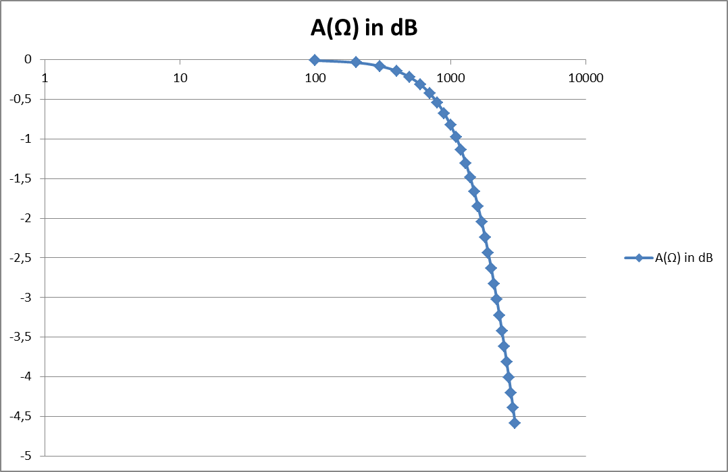 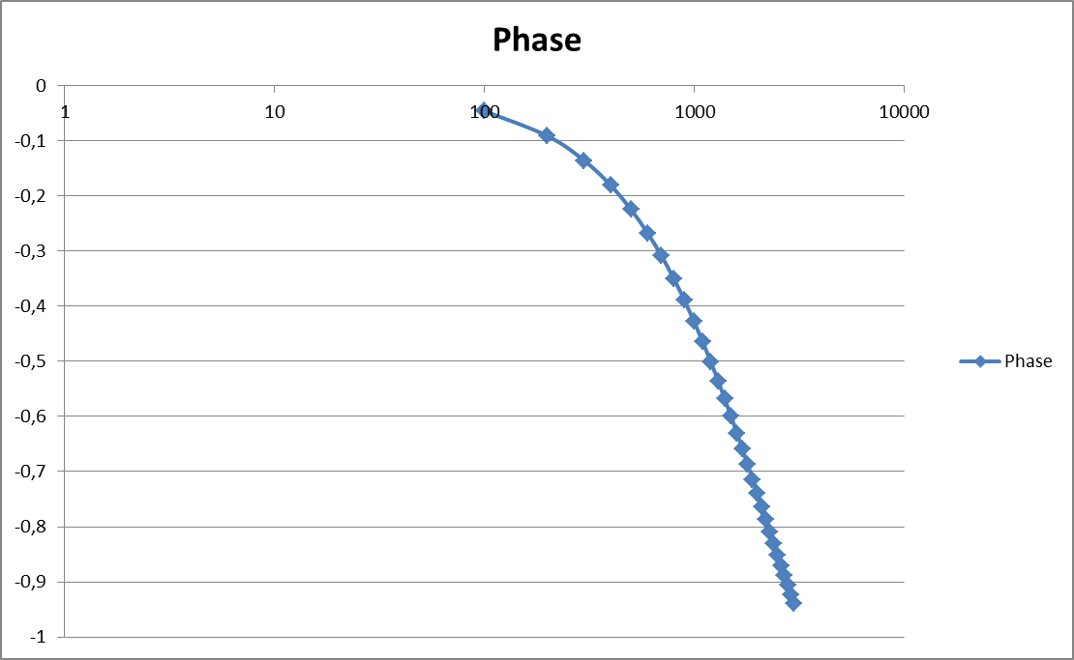

Figure 1: Amplitude of the transfer function Figure 2: Phase response of the transfer function

Cutoff frequency fc = 2192.22 Hz

Experiment:

1. Voltage measurement
   1. Time measurement and adjustment of frequencies with a scopea. and b.

Display a sine wave with f0 = 800 Hz and Upp = 6 V:

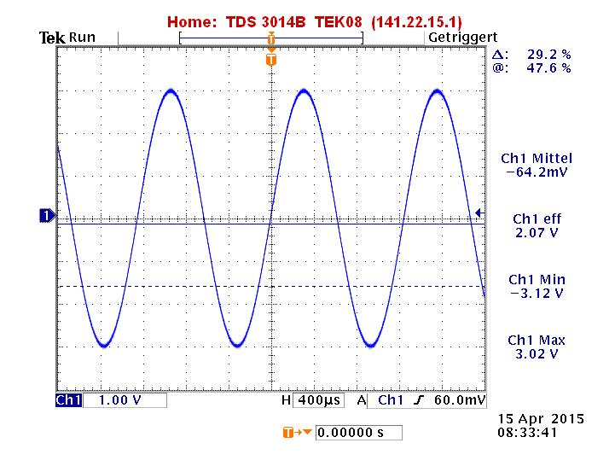

Figure 3: sine wave with f0 = 800 Hz and Upp = 6 V

* 1. Non-sinusoidal signals

1. Generate a sine wave, triangle wave and square wave with a peak to peak voltage given above. Display these signals and take a screen shot.

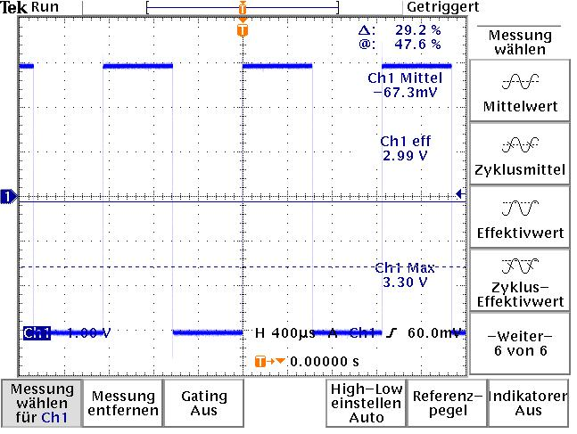

Figure 4: Sine wave Figure 5: Square wave

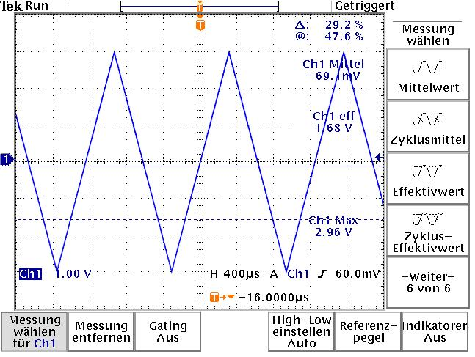

Figure 6: Triangle wave

1. Measure the RMS and Mean values of all signals with the digital voltmeter and the function “Measure” of the scope and compare the results of the scope, the voltmeter and the precalculation.

With voltmeter:

|  |  |  |
| --- | --- | --- |
| Wave | Mean value | RMS value |
| Sine | -7.7 mV | 2.121 V |
| Square | -12.3 mV | 3.002 V |
| Triangle | -6.9 mV | 1.734 V |

With Oscillocope:

|  |  |  |
| --- | --- | --- |
| Wave | Mean value | RMS value |
| Sine | -64.2 mV | 2.07 V |
| Square | -67.3 mV | 2.99 V |
| Triangle | -57.2 mV | 1.68 V |

Comment: Both measurement methods are approximately equal to the pre-calculation but the values which measured with the voltmeter are more accurate.

1. Set the function generator to square wave, 6 Vpp with a DC offset of 3V so that the signal changes between 0V and 6V. Measure the True RMS, RMS and mean value and compare them to the theoretical value.

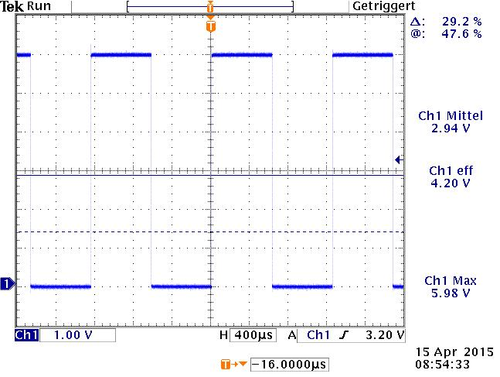

Figure 7: Square wave with DC offset of 3 V

Measured values:

|  |  |  |  |
| --- | --- | --- | --- |
| Value | Voltmeter | Scope | Theorical |
| RMS | 3.004 | 4.20 | 4.243 |
| Mean | 2.99 | 2.94 | 3 |
| True RMS | 4.245 | 5.161 | 5.186 |

Comment:

The values which were measured approximately equal to the theorical values but the RMS value which was measured with the Scope is more accurate.

* 1. 2-channel-mode and RC low-pass filter
     1. Sine wave in the frequency range of f = 500...3000 Hz

|  |  |
| --- | --- |
| Figure 8: Sine wave of the Ch 1 | Figure 9: Sine wave of the Ch2 |

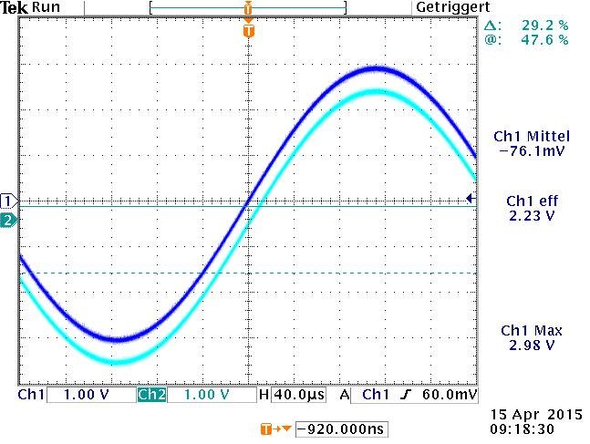

Figure 10: Sine waves of both chanel

1. The time delay between two waves is 3.087 microsecond => phase = 0.04267

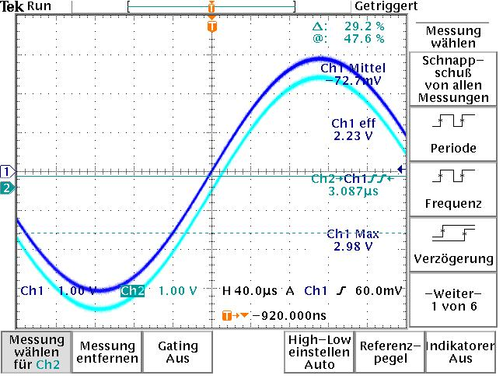

Figure 11: Time delay between 2 waves is 3.087 microsecond

Compare: it is much more smaller than the pre-calculation (phase = 0.78717)

|  |  |  |  |
| --- | --- | --- | --- |
| f | Vpp | time shift | phase |
| 440 | 5,92 | 0,0000153 | 0,042298403 |
| 1100 | 5,92 | 0,0000059 | 0,040777873 |
| 4400 | 5,92 | 0,0009108 | 25,17999078 |
| 11000 | 5,92 | 0,0009097 | 62,87395041 |