**Preparation:**

1. **Determine the effective value, the mean value, and the rectified value of a sine wave, a square wave and a triangle wave with a peak-to peak-value of UPP= 6.0 V and no DC offset and put these values into a table.**

**Sine wave:**

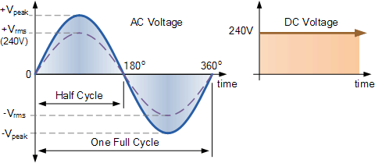

**The mean value:**

For a periodic waveform, the area above the horizontal axis is positive while the area below the horizontal axis is negative. The result is that the average or mean value of a symmetrical alternating quantity is zero

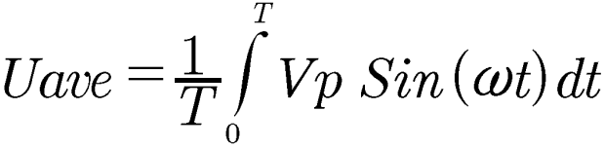

**The effective value:**

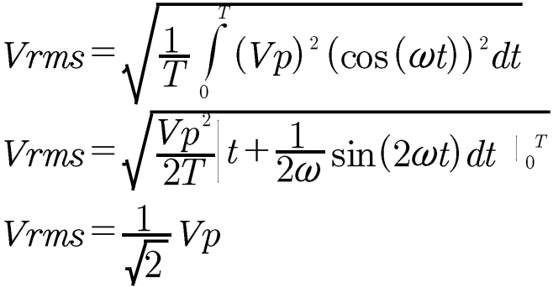

**The rectified value:**

The negative part of the cycle becomes zero

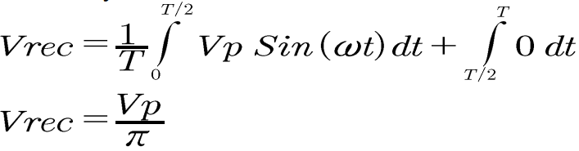

**Square Wave:**

**The mean value:**

The result is that the average or mean value of a symmetrical alternating quantity

is zero.

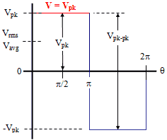

**The effective value:**

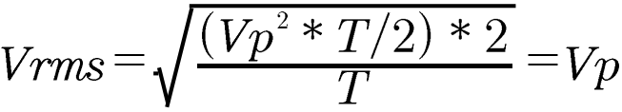

**The rectified value:**

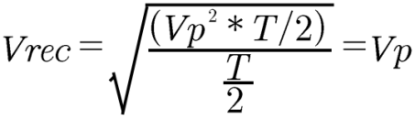 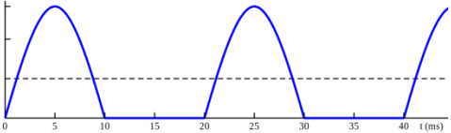

**Triangle Wave:**

**The effective value:**

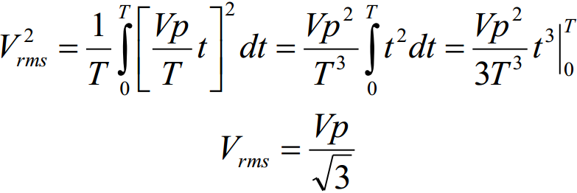

**The rectified value:**

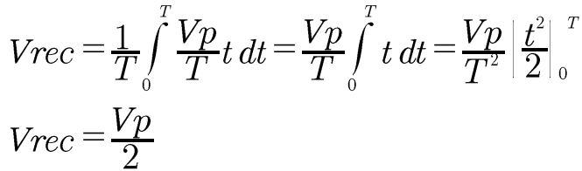

**Table 1: Calculations**

|  |  |  |  |
| --- | --- | --- | --- |
| **Sine wave** | **Effective value** |  | 2.121 V |
| **Mean value** | 0 | 0 |
| **Rectified value** |  | 0.955 V |
| **Square wave** | **Effective value** | Vp | 3 |
| **Mean value** | 0 | 0 |
| **Rectified value** | Vp | 3 |
| **Triangle wave** | **Effective value** |  | 1.731 V |
| **Mean value** | 0 | 0 |
| **Rectified value** |  | 1.5 |

1. **Calculate the voltage ratio F(f) = Uc/U0 of a low–pass filter with R = 2.2k and a capacitance C = 33nF in the frequency-range of 100 Hz to 3 kHz and make a Bodeplot of F(f). For Bode plots read the explanation in the current script. Determine the cutoff frequency fb.**

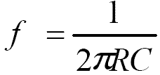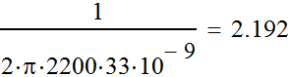

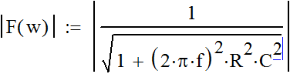 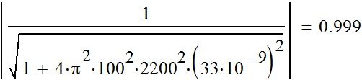

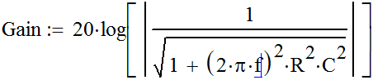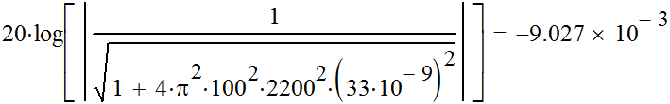



**Table 2: Calculations**

|  |  |  |  |
| --- | --- | --- | --- |
| R | 2200,00 | Ohm |  |
| C | 3.30E-09 | F |  |
|  |  |  |  |
| f (Hz) | |F(w)| | Gain (dB) | Phase(◦) |
| 100,00 | 0.999 | -0.009 | 2.60 |
| 200,00 | 0.996 | -0.036 | 5.21 |
| 500,00 | 0.975 | -0.220 | 12.85 |
| 1000,00 | 0.910 | -0.821 | 24.52 |
| 2192,00 | 0.707 | -3.012 | 45.01 |
| 2200,00 | 0.706 | -3.026 | 45.10 |
| 3000,00 | 0,590 | -4,583 | 53,84 |
|  |  |  |  |
| fc Hz | 2192,00 |  |  |

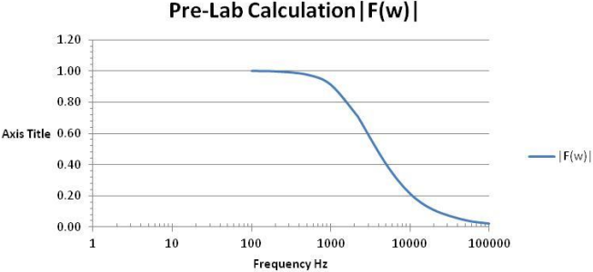

**Figure 1: |F(w)| and frequency**

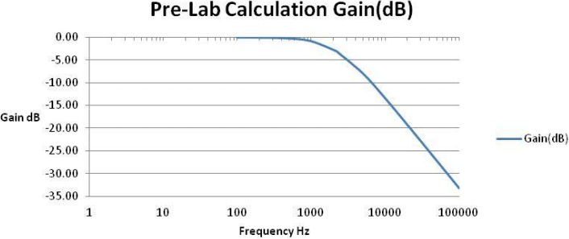

**Figure 2: Gain (dB) and frequency**

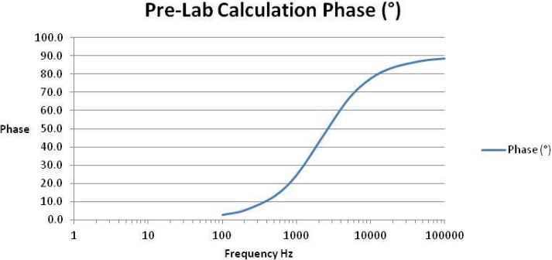

**Figure 3: Phase and frequency**

**Experiments**

**Experiment 1: Time measurement and adjustment of frequencies with a scope**

**Used devices:**

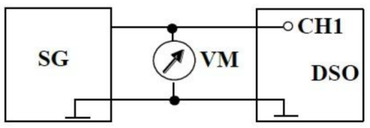

Digital voltmeter: MetraHit 18S Nr1850

Oscilloscope Inv.Nr 1990

Signal generator: ROHDE & SCHWARZ HM8150

**Table 3: Practical values taken in lab**

|  |  |  |  |  |  |  |
| --- | --- | --- | --- | --- | --- | --- |
| DC-offset | 0 |  |  |  |  |  |
| U peak-to-peak | 6 |  |  |  |  |  |
| Upeak | 3 |  |  |  |  |  |
|  |  |  |  |  |  |  |
| Measured | Sine Wave | | Square Wave | | Triangle Wave | |
| Device | Oscilloscope | Voltmeter | Oscilloscope | Voltmeter | Oscilloscope | Voltmeter |
| Effective value | 2.07 | 2.116 | 2.99 | 2.986 | 1.69 | 1.727 |
| Mean value | 0.0188 | -0.0095 | 0.0154 | -0.0143 | 0.0279 | -0.0057 |
|  |  |  |  |  |  |  |
| The voltage source is equal to 2.118 V | | | | | | |

**Measured Values**

**Screenshot for the Sine Wave:**

With a sinusoidal signal with a peak to peak voltage Upp = 6V

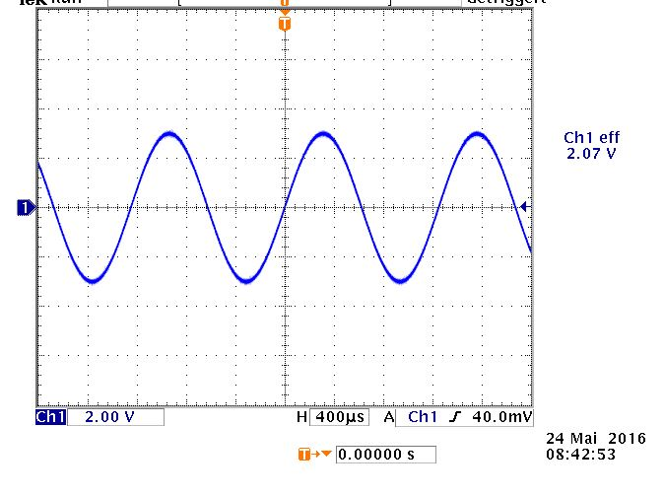

**Figure 4**

**Experiment 2: Non-sinusoidal signals**

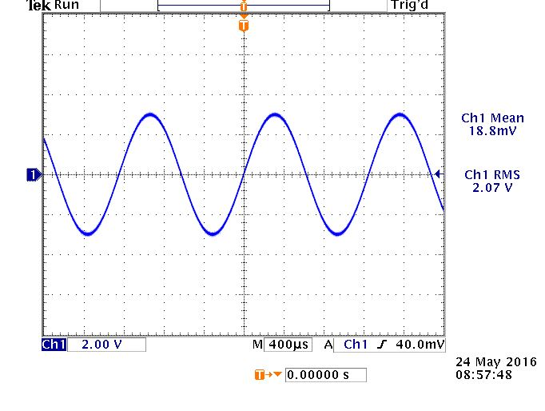

**Figure 5: Sine Wave**

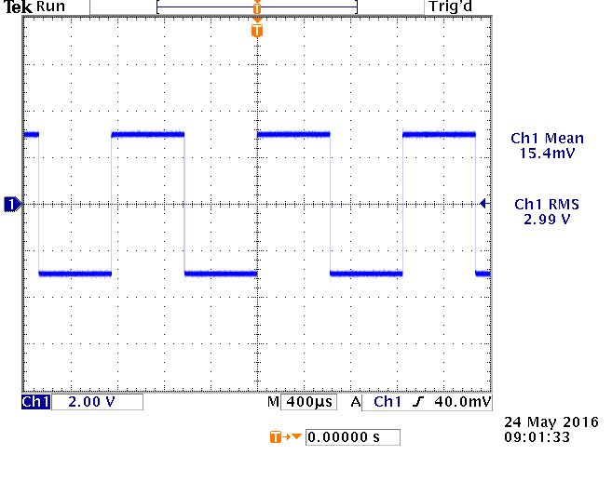

**Figure 6: Square Wave**

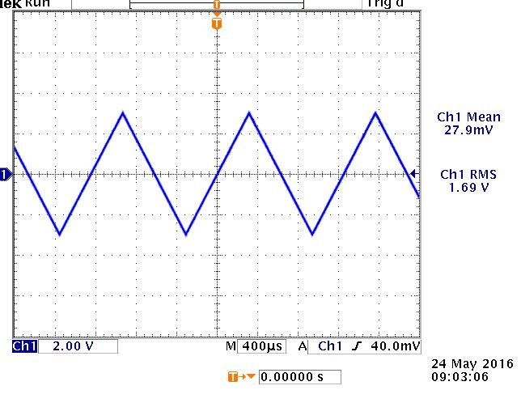

**Figure 7: Triangle Wave**

**Task B: Measure the RMS and Mean values of all signals with the digital voltmeter and the function “Measure” of the scope and compare the results of the scope, the voltmeter and the pre-calculation.**

**Table 4: RMS Voltage Values**

|  |  |  |  |
| --- | --- | --- | --- |
| Wave | Voltmeter | Oscilloscope | Pre-calculated |
| Sine | 2.116 | 2.07 | 2.12 |
| Triangle | 1.727 | 1.69 | 1.73 |
| Square | 2.986 | 2.99 | 3.00 |

**Table 5: Mean Voltage Values**

|  |  |  |  |
| --- | --- | --- | --- |
| Wave | Voltmeter | Oscilloscope | Pre-calculated |
| Sine | -0.0095 | 0.0188 | 0 |
| Triangle | -0.0057 | 0.0279 | 0 |
| Square | -0.0143 | 0.0154 | 0 |

**Task C: Set the function generator to square wave, 6 Vpp with a DC offset of 3V so that the signal changes between 0V and 6V. Measure the True RMS, RMS and mean value and compare them to the theoretical value.**



**Figure 8: RMS Value**

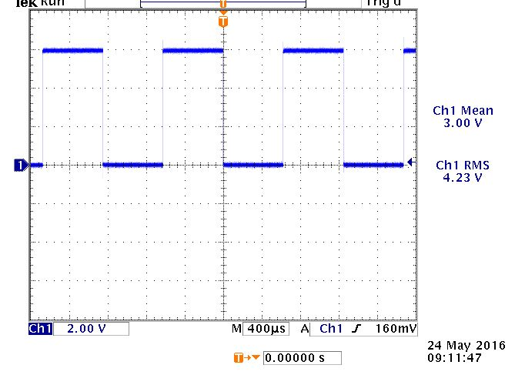

**Figure 9: True RMS Value**

**Table 6: Mean Voltage Values**

|  |  |  |  |
| --- | --- | --- | --- |
|  | Voltmeter | Oscilloscope | Pre-calculated |
| Mean | 2.999 | 3.01 | 3.0 |
| RMS | 2.997 | 2.99 | 3.0 |
| TRMS | 4.244 | 4.23 | 4.243 |

**Calculations:**

Umean = 3 V (DC)

Urms = 3 V (pre-calculation)

Utrms =  

**Experiment 3: 2-channel-mode and RC low-pass filter**

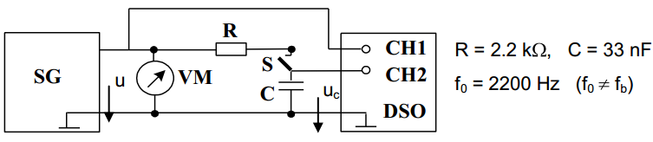

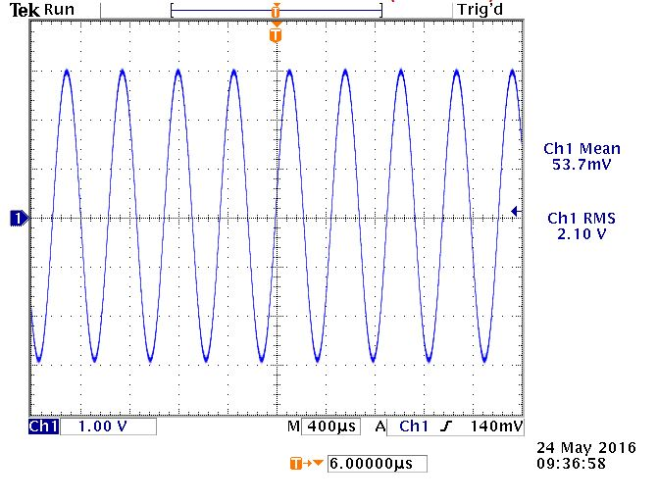

**Figure 10: channel 1, Input signal (U)**

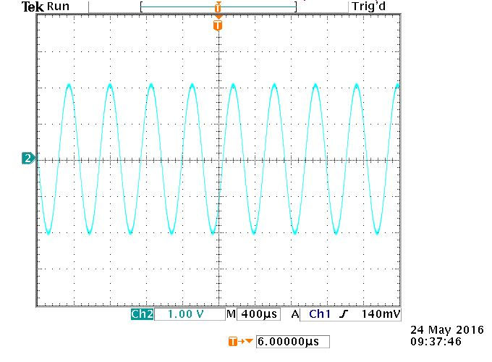

**Figure 11: channel 2, Output signal (Uc)**

**Task (b): Set the frequency to f0 and measure the time delay between both signals using the menus**

**“cursor” and the menu “Measure”. Calculate the phase angle for the given frequency and compare the results with the theoretical value of the pre-calculated Bode plot.**

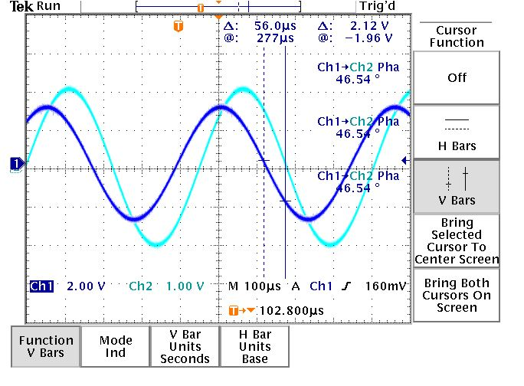

**Figure 12: “Cursor Menu”**

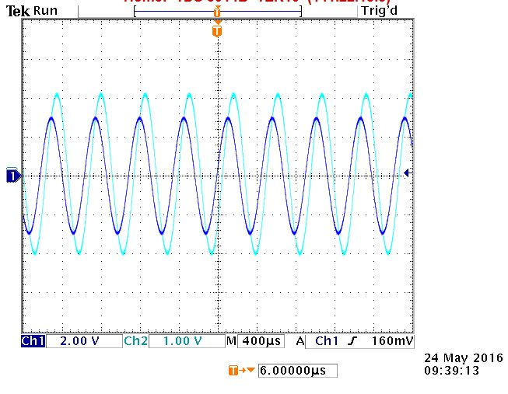

**Figure 13: “Measure Menu”**

**45.1**

**Table 7: Pre-calculations**

|  |  |  |  |
| --- | --- | --- | --- |
| f (Hz) | |F(w)| | Gain (dB) | Phase(◦) |
| 2192 | 0.707 | -3.012 | 45.01 |
| 2200 | 0.706 | -3.026 | 45.1 |

**Lab calculations:**

△t = 56μs

f=2200

phase angle = f*△t*360◦ = 2200*(56*10^-6)*360◦ = 44.35◦

**Task (c), part 1: Determine the peak-to-peak voltage uc and the phase angle between u and uc for the following frequencies: f = f0/5, f0/2, 2f0, 5f0.**

**Table 8**

|  |  |  |
| --- | --- | --- |
|  | Frequency(Hz) | Phase angle(◦) |
| f/5 | 440 | 11.34 |
| f/2 | 1100 | 27.25 |
| 2*f | 4400 | 63.32 |
| 5*f | 11000 | 76.22 |

**Task (c), part 2: Make a Bode plot of uc(f) in ϕ(f) and dB. Determine the cutoff frequency graphically and compare with the pre-calculated theoretical value fc.**

**Table 9: Practical values taken in lab (marked with bold)**

|  |  |  |  |
| --- | --- | --- | --- |
| R | 2200 | Ohm |  |
| C | 3.30E-09 | F |  |
|  |  |  |  |
| f (Hz) | |F(w)| | Gain (dB) | Phase(◦) |
| 100,00 | 0,999 | -0,009 | 2,60 |
| 200,00 | 0,996 | -0,036 | 5,21 |
| **440,00** | **0,980** | **-0,172** | **11,34** |
| 500,00 | 0,975 | -0,220 | 12,85 |
| 1000,00 | 0,910 | -0,821 | 24,52 |
| **1100,00** | **0,894** | **-0,975** | **27,25** |
| 2192,00 | 0,707 | -3,012 | 45,01 |
| 2200,00 | 0,706 | -3,026 | 45,10 |
| 3000,00 | 0,590 | -4,583 | 53,84 |
| **4400,00** | **0,446** | **-7,014** | **63,32** |
| 5000,00 | 0,402 | -7,925 | 66,33 |
| 10000,00 | 0,214 | -13,386 | 77,64 |
| **11000,00** | **0,195** | **-14,179** | **76,22** |
|  |  |  |  |
| fc Hz | 2192 |  |  |

**Сравенение лучше сделать на одном рисунке изобразив 2 графика разными цветами это будет наглядней**

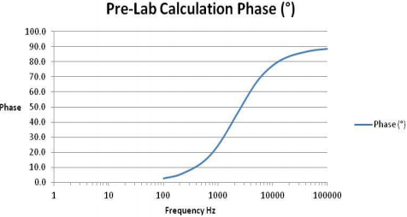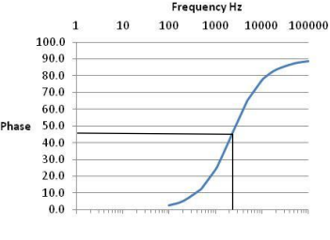

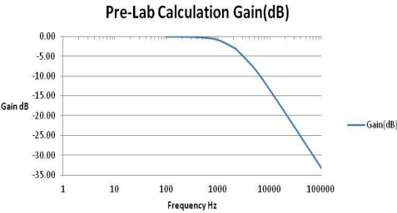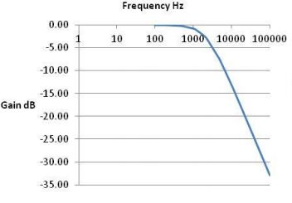

**Figure 14: Comparing pre-lab and lab calculations for both Phase and Gain**

**Experiment 3.2: Impact of RC filter on triangle and square wave**

**Task: Generate a triangle wave and a square wave with upp = 6.0 V and f = 1.0 kHz. Make a screen shot of both the original signal u(t) and the filtered signal uc(t). Try to explain why the wave form of the signal output is different from the signal input.**

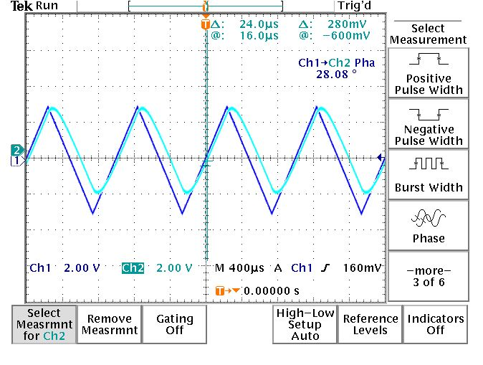

**Figure 15: Triangle wave**

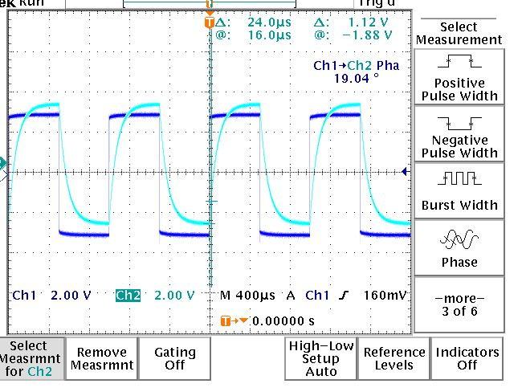

**Figure 16: Square wave**

The screenshots display an output signal which is no longer purely triangular or squared. Both curves show some sort of exponential behavior, which can be linked to the capacitor.

The charging and discharging of a capacitor is modeled by an exponential curve. These charges that are either accumulated or released cause the distortion of the signal.

**Conclusions from lab**

In this lab we have learned about how to operate with oscilloscope and measure periodic signals (period, frequency, amplitude). Also we saw the difference between pre-calculations and lab calculations and measurements, some of which can be visible in tables and Bode plots. Finally, we tried generating non-sinusoidal signals (triangle and square wave).

1. Переделай рисунки и формулы на ТАБЛИЦЫ и НОРМАЛЬНЫЕ ФОРМУЛЫ которые можно редактировать
2. Сделать сравнение сначала ТЕОР и ПРАКТ значений, а потом изобразить это на ОДНОМ графике
3. Написать вывод для лабораторной работы

**В задании Task (c), part 2 надо будет графически определить fc, и посчитать погрешность, и сделать выводы**