**Sensors:**

* Variable resistance:
* ***Tactile Sensors***(mechanical force closes electrical contact; for position and collision)
* ***Slide-wire sensors*** (slider varies the resistance in a potentiometer; for displacement)
* ***Strain gauge*** (mechanical stress results in change of resistance; for strain, force, torque)
* ***Resistance Thermometer*** (metal or semiconductor with large temperature coefficient; for temperature)
* ***Photoconductive Cell(LDR)***(radiation dependent number of charge carriers; for: display light control)
* Variable inductance
* ***Eddy current gauge***(inductance changed by distance of plate; for thickness, displacement)
* ***Differential transformer***(transformer with movable magnetic core; for displacement, position, pressure, force)
* ***Hall-effect sensor*** (magnetic field generates voltage due to Lorentz force; for field strength, position)
* Variable Capacitance
* ***Adjustable Capacitor***(capacitance varies with electrode distance; for displacement, pressure)
* ***Dielectric gauge*** (capacity varied by changes in the dielectric; for liquid level)
* Other:

1. ***Ultrasonic sensors*** (time of flight of ultrasonic pulse; for distance, liquid level, flow speed, medical imaging)

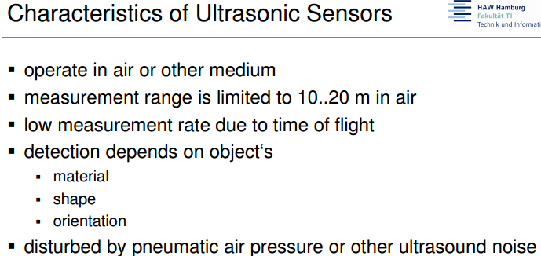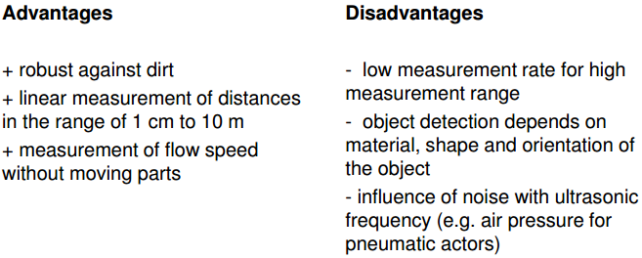

1. ***Photodiode*** (electrical leakage current in reverse direction is increased by light; for remote control, light barriers)

Advantages

1. Low resistance

2. Very good spectral response

3. Fastest photo detector

Disadvantages

1. Light sensitive device

2. Dark current increased with temperature

3. Should not exceed the working temperature limit specified by the manufactures.

Applications

1. Light detector

2. Demodulators

3. Encoders

4. Optical communication system

5. High speed counting and switching circuits

6. Computer punching cards and tapes

7. Light operated switches

8. Sound track films

9. Electronic control circuits

1. ***Cameras***(array of photodiodes; for presence detection, position control, quality inspection, security)

