Prepration

1. Information about AC and DC coupling of a scope:

The signal on the input of the oscilloscope is applied to the screen through an AC or DC coupling switch. Each position of the switch is used to show different aspects of the signal.  
  
DC Coupling

DC coupling describes any voltage signal acquisition in which both AC and DC components are measured.

Like a very fast voltmeter, the voltage on the input to the scope is traced directly on the display. Large transitions can be observed, and when the voltage stays high or low, the trace stays high or low.

AC Coupling

AC coupling blocks the steady voltage, but allows the variations to be shown on the display

Benefits:

The whole purpose of the oscilloscope is to help analyze what is happening in an electronic circuit Sometimes seeing small changes in the voltage is necessary  
DC allows the entire signal to be coupled to the screen, including the steady plus or minus voltages. AC blocks the steady voltage to allow the small variations to be coupled to the display.

2. Information about the terms fall time, rise time and pulse duration

Rise time

rise time is defined as "the time required for the response to rise from x% to y% of its final value"Typically, in [analog electronics](http://en.wikipedia.org/wiki/Analog_electronics), these values are 10% and 90% of the step height

**Fall time**

is the [time](http://en.wikipedia.org/wiki/Time) taken for the amplitude of a [pulse](http://en.wikipedia.org/wiki/Pulse) to decrease (fall) from a specified value (usually 90% of the peak value exclusive of [overshoot](http://en.wikipedia.org/wiki/Overshoot_(signal)) or undershoot) to another specified value (usually 10% of the maximum value exclusive of overshoot or undershoot).

**pulse duration**

pulse duration is the interval between the [time](http://en.wikipedia.org/wiki/Time), during the first transition, that the [amplitude](http://en.wikipedia.org/wiki/Pulse_amplitude) of the [pulse](http://en.wikipedia.org/wiki/Pulse_(signal_processing)) reaches a specified fraction (level) of its final amplitude, and the time the pulse amplitude drops, on the last transition, to the same level.

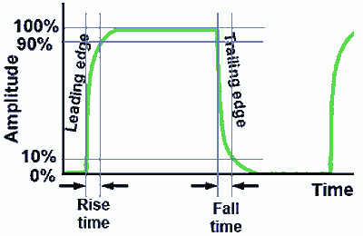

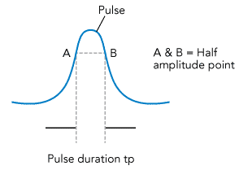

**3.Varistor**

A **varistor** is an [electronic component](http://en.wikipedia.org/wiki/Electronic_component) with a "[diode](http://en.wikipedia.org/wiki/Diode)-like" [nonlinear](http://en.wikipedia.org/wiki/Nonlinear_system) [current–voltage characteristic](http://en.wikipedia.org/wiki/Current%E2%80%93voltage_characteristic). The name is a [portmanteau](http://en.wikipedia.org/wiki/Portmanteau) of [*variable resistor*](http://en.wikipedia.org/wiki/Resistor#Variable_resistors). Varistors are often used to protect [circuits](http://en.wikipedia.org/wiki/Electrical_network) against excessive transient [voltages](http://en.wikipedia.org/wiki/Voltage).

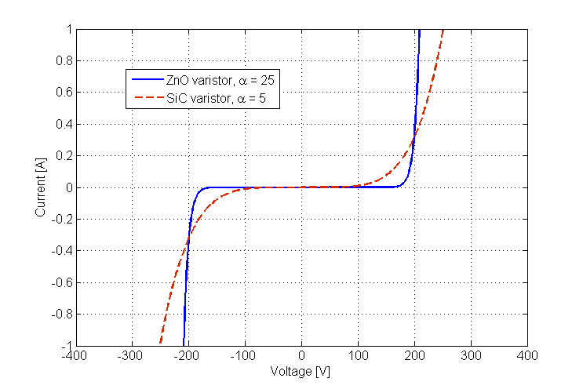

**Experiment 1:Impact of DC/AC-coupling.**

MEASURING EQUIPMENTS:

1. MetraHit Digital Multimeter (1851)
2. Digital storage oscilloscope
3. Signal generator

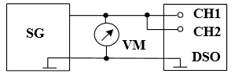

Assignment A:

|  |  |  |  |  |  |  |  |  |  |  |  |  |
| --- | --- | --- | --- | --- | --- | --- | --- | --- | --- | --- | --- | --- |
| Frequency | 997,3 mHz | 1,995  Hz | 3,005  Hz | 3,996  Hz | 4,998  Hz | 6,991  Hz | 9,992  Hz | 14,95  Hz | 19,96  Hz | 29,95  Hz | 40,00  Hz | 49,93  Hz |
| Ch1 TRMS | 2,11V | 2,11V | 2,11V | 2,11V | 2,11V | 2,11V | 2,11V | 2,11V | 2,11V | 2,11V | 2,11V | 2,11V |
| Ch2 TRMS | 290mV | 562mV | 807mV | 1,02V | 1,19V | 1,46V | 1,71V | 1,90V | 1,99V | 2,05V | 2,08V | 2,09V |
| Phase | -83,5° | -74,40° | -68,39° | -60,14° | -55,44° | -46,54° | -35,11° | -26,15° | -19,25° | -13,51° | -11,22° | -8,020° |

Assignment B:

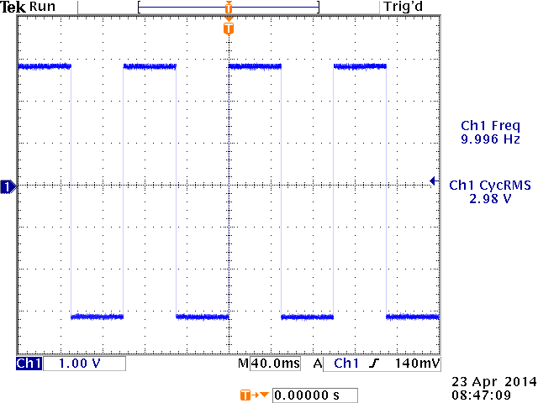

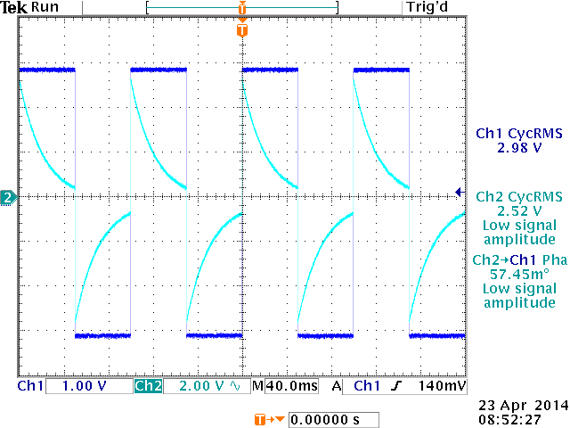

Conclusion : In AC coupling mode we add a capacitor in series.

The curved lines show charging and discharging of that capacitor.

**Experiment 2: Measurerise-time, fall-time, and cycle duration of a pulse.**

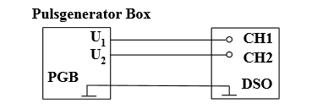

Assignment A: the rise-time tR, fall-time tF and cycle duration TP .

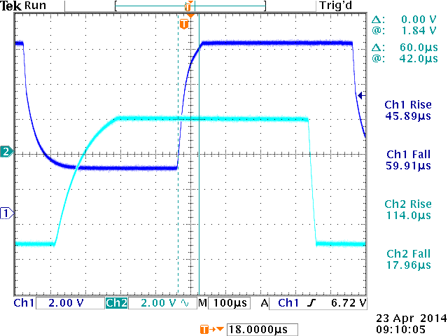

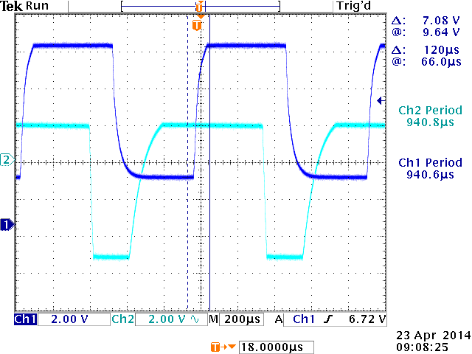

Assignment B: the time delay between both signals both using the menu “Cursor” and the menu “Measure” .

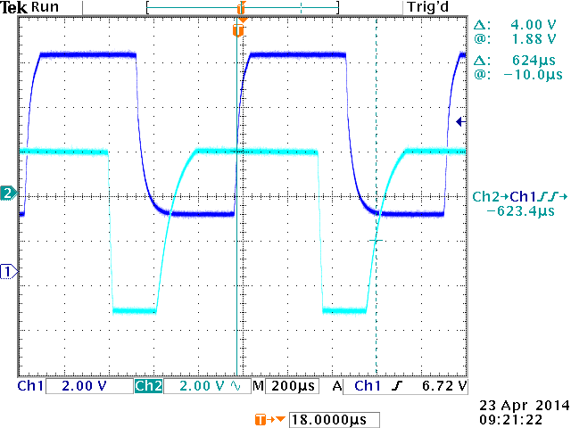

Conclusion : Measurments shows 623.4 µs which is almost the same as curser which is 426µF.

**Experiment3: x-y-mode**

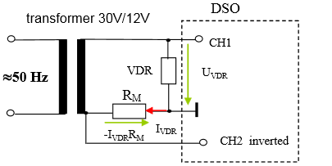

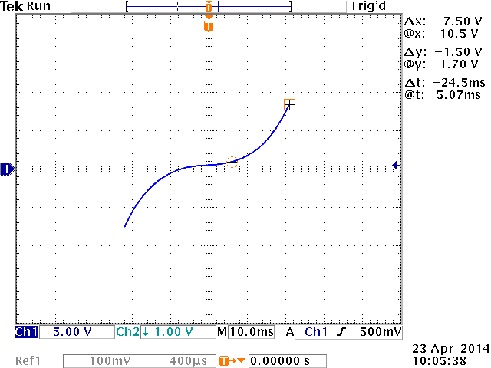

Pre-calculated diagram

Conclusion: According to pre-calculations and base on formula (1,75*((E3)^0,36)) we got the plot above.

For instance at 10.5V which is the maximum voltage we measured with the oscilloscope , the voltage of resistor in the circuit regarding the Y-axis is 1.7V.

So that as we have two components(varistor and resistor)in series , the current should be the same for both of them.

The resistor we used is 10 Ohms which gives us the current of roughly 170mA.

As a result the current of pre-calculations is 11.11V which is roughly close to oscilloscope voltage for varistor which is 10.5V, but for lower voltages the measurements and pre-calculations do not match.