**Lab 1**

**Group 1**

**Lab team:**

1. **Ievgenii Nudga**

**Assignment 1: Webshop**

1. What is to be sold, what are main positions and how many sections?
2. Are there any examples of Panels that customer might have seen and got impressed with?
3. If not: what does customer want to see first among the data and how many columns or rows?
4. If yes: discuss whether certain example suits the needs and what should be added or excluded.
5. What should be in the Admin Panel (e.g. changing price, pictures, text, alignment and other kinds of modifications) and who will have access to it (qualification and so on)?
6. Is there any need for automatically built graphs, diagrams or else?
7. Where will the data be saved: locally (in hard drives) or in “cloud” services, or both for insurance sake?
8. Does the customer wish to have a mobile version of Admin Panel or adaptive design?
9. Other options: type of database system, synchronization, Big Data

**Assignment 2: Bank Database**

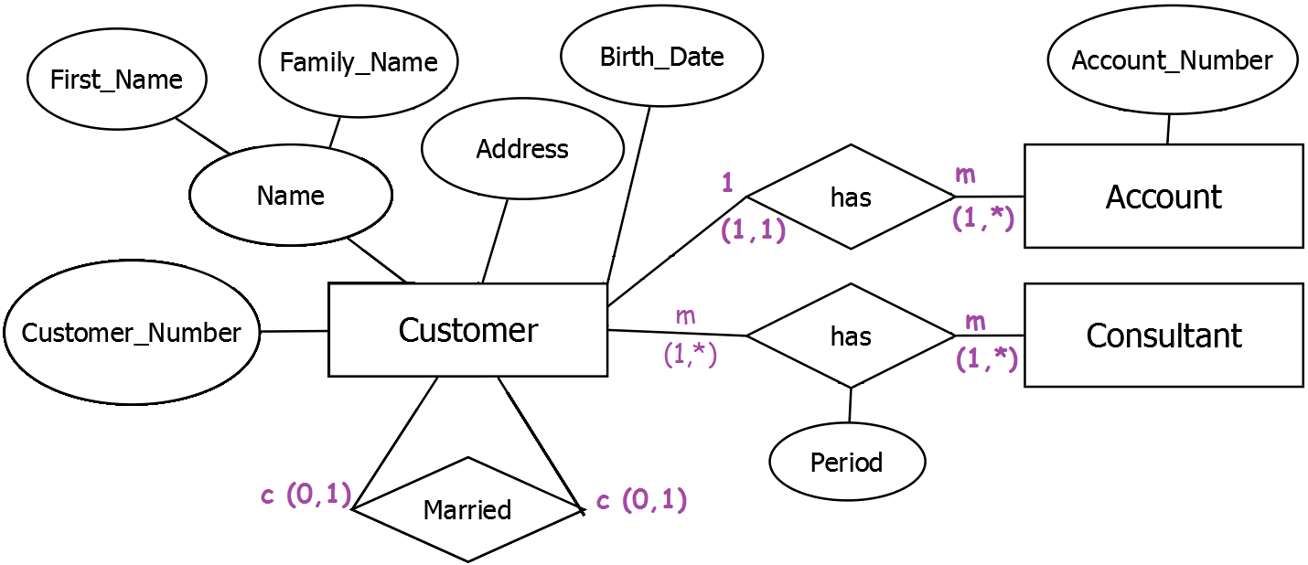

**Assignment 3: Movies Database**

|  |  |  |  |  |
| --- | --- | --- | --- | --- |
|  |  | T | F | M |
| 1 | There are actors in this database that have been performing in no movies. |  | X |  |
| 2 | There are some actors who have acted in more than ten movies. |  |  | X |
| 3 | Every actor performs in at least one movie. | X |  |  |
| 4 | A movie can have only a maximum of two lead actors. |  | X |  |
| 5 | Some actors have done a lead role in multiple movies. |  |  | X |
| 6 | Every director has been an actor in some movie. |  |  | X |
| 7 | No producer has ever been an actor. |  |  | X |
| 8 | A producer cannot be an actor in some other movie. |  | X |  |
| 9 | There are movies with more than ten actors. |  |  | X |
| 10 | Most movies have one director and one producer. |  |  | X |
| 11 | Every movie has one director. |  |  | X |
| 12 | Every movie has at least one producer. |  | X |  |
| 13 | Some movies have two directors. |  |  | X |
| 14 | Some movies have one director but several producers. |  |  | X |
| 15 | Some producers have been a director as well. |  |  | X |
| 16 | There are some actors that have done a lead role, directed a movie  and produced some movie. |  |  | X |
| 17 | No movie has a director that also acted in that movie. |  |  | X |

1. Each actor performs in at least one movie.
2. No actual data, since we don’t know the actual amount (limit) of movies.
3. Every actor performs in at least one movie.
4. Every movie can have at least one lead role actor, and there is no limit of lead roles.
5. No actual data, since there’s no limit for number of lead roles.
6. No actual data, since director can be an actor in at least one movie.
7. No actual data, but producer can be an actor.
8. Producer actually can perform in at least one movie.
9. No actual data, since there’s no limit of actors.
10. No actual data, since movies may have no director and no producer (judging from 0:m).
11. No actual data, since every movie may have no director.
12. The amount of producers is from 0 to n.
13. No actual data, since movies may have no director.
14. No actual data, since movies may have no one director and there’s no actual limit of producers.
15. Not shown in diagram (no “relation” between director and producer).
16. No actual data, since actor can be director, producer and perform in movie.
17. No actual data, since director can be an actor in his movie.

**Assignment 4: Webshop Database**

Transforming the ERM to an External Schema