**Lab 1**

**Group 1**

**Lab team:**

1. **Ievgenii Nudga**
2. **Aryan Sultan**

**Assignment 1: Webshop**

1. What is to be sold, what are main positions and how many sections?
2. Are there any examples of Panels that customer might have seen and got impressed with?
3. If not: what does customer want to see first among the data and how many columns or rows?
4. If yes: discuss whether certain example suits the needs and what should be added or excluded.
5. What should be in the Admin Panel (e.g. changing price, pictures, text, alignment and other kinds of modifications) and who will have access to it (qualification and so on)?
6. Is there any need for automatically built graphs, diagrams or else?
7. Where will the data be saved: locally (in hard drives) or in “cloud” services, or both for insurance sake?
8. Does the customer wish to have a mobile version of Admin Panel or adaptive design?
9. What data do we ask for registration on website?
10. Options: type of database system, synchronization, Big Data?
11. What is the main key for certain positions? (key attribute)
12. What are the description points for every position? (attributes)
13. Any relations between positions? (relationships, like if we buy a computer, then we can offer certain computer accessories, but not all available accessories are for computers, there are some for laptops, mini-PC and so on)

**Assignment 2: Bank Database**

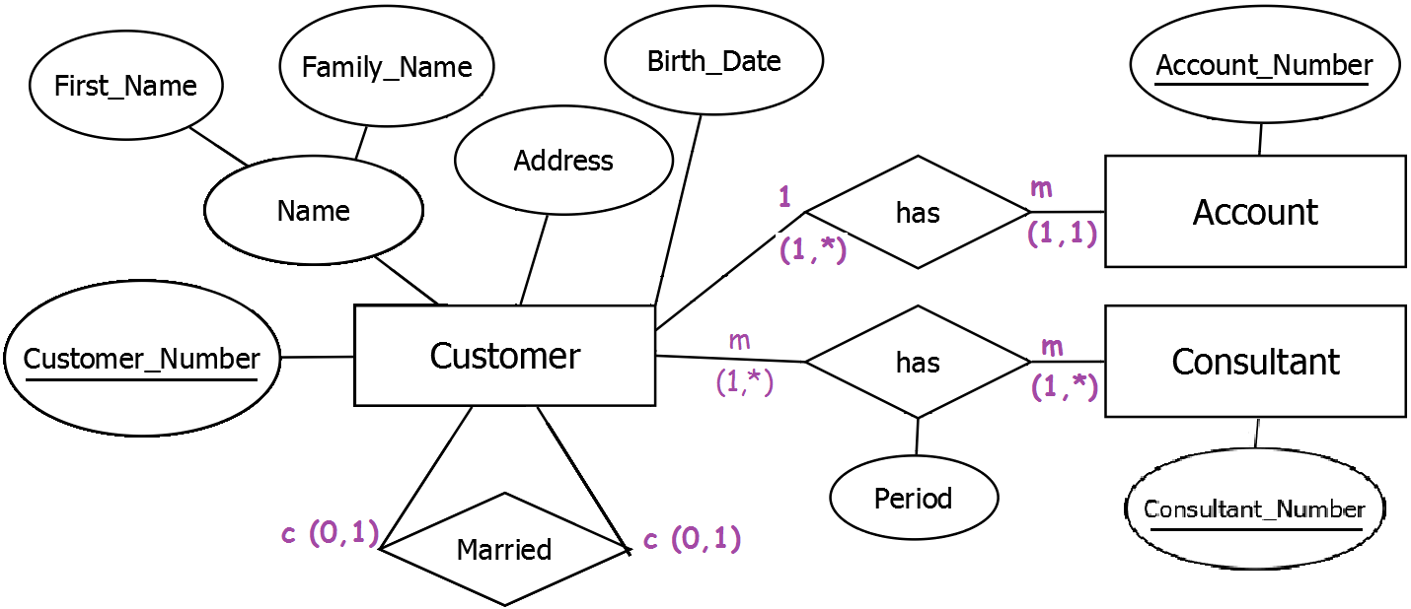

**Assignment 3: Movies Database**

|  |  |  |  |  |
| --- | --- | --- | --- | --- |
|  |  | T | F | M |
| 1 | There are actors in this database that have been performing in no movies. |  | X |  |
| 2 | There are some actors who have acted in more than ten movies. |  |  | X |
| 3 | Every actor performs in at least one movie. | X |  |  |
| 4 | A movie can have only a maximum of two lead actors. |  | X |  |
| 5 | Some actors have done a lead role in multiple movies. |  |  | X |
| 6 | Every director has been an actor in some movie. |  |  | X |
| 7 | No producer has ever been an actor. |  |  | X |
| 8 | A producer cannot be an actor in some other movie. |  | X |  |
| 9 | There are movies with more than ten actors. |  |  | X |
| 10 | Most movies have one director and one producer. |  |  | X |
| 11 | Every movie has one director. |  |  | X |
| 12 | Every movie has at least one producer. |  | X |  |
| 13 | Some movies have two directors. |  |  | X |
| 14 | Some movies have one director but several producers. |  |  | X |
| 15 | Some producers have been a director as well. |  |  | X |
| 16 | There are some actors that have done a lead role, directed a movie  and produced some movie. |  |  | X |
| 17 | No movie has a director that also acted in that movie. |  |  | X |

1. Each actor performs in at least one movie.
2. No actual data, since we don’t know the actual amount (limit) of movies.
3. Every actor performs in at least one movie.
4. Every movie can have at least one lead role actor, and there is no limit of lead roles.
5. No actual data, since there’s no limit for number of lead roles.
6. No actual data, since director can be an actor in at least one movie.
7. No actual data, but producer can be an actor.
8. Producer actually can perform in at least one movie.
9. No actual data, since there’s no limit of actors.
10. No actual data, since movies may have no director and no producer (judging from 0:m).
11. No actual data, since every movie may have no director.
12. The amount of producers is from 0 to n.
13. No actual data, since movies may have no director.
14. No actual data, since movies may have no one director and there’s no actual limit of producers.
15. Not shown in diagram (no “relation” between director and producer).
16. No actual data, since actor can be director, producer and perform in movie.
17. No actual data, since director can be an actor in his movie.

**Assignment 4: Webshop Database**

**a) Take the results of the questionaire of Assignment 1 and identify possible external schemes for such a webshop.**

**!!!!! First three external schemes are for webshop owner's use**

|  |  |  |  |  |  |  |  |  |  |  |
| --- | --- | --- | --- | --- | --- | --- | --- | --- | --- | --- |
| Computer | Type (PC, laptop, mini-PC, arduino and so on) | Name (of company) | Model | Processor | RAM | Screen size | Avaliability (paint in red when low) | Price | How many sold | Forecast (how many to order from distibutor or producer |
|  |  |  |  |  |  |  |  |  |  |  |

|  |  |  |  |  |  |  |  |
| --- | --- | --- | --- | --- | --- | --- | --- |
| Computer accessories | Type | Name (of company) | Model | Avaliability (paint in red when low) | Price | How many sold | Forecast (how many to order from distibutor or producer |
|  |  |  |  |  |  |  |  |

|  |  |  |  |  |  |  |  |
| --- | --- | --- | --- | --- | --- | --- | --- |
| New tech | Type | Name (of company) | Model | Avaliability (paint in red when low) | Price | How many sold | Forecast (how many to order from distibutor or producer |
|  |  |  |  |  |  |  |  |

**Now this external scheme is for delivery personnel (in warehouse)**

|  |  |  |  |  |  |
| --- | --- | --- | --- | --- | --- |
| Name of position (e.g. “computer”, “computer accessory” or “new tech”) | Type | Name (of company) | Model | Avaliability   1. shows how many 2. Paint in red if low 3. Offer to choose “not avaliable” in corresponding case | Date of delivery |
|  |  |  |  |  |  |

**b) Think about possible requests to access that webshop.**

Type of position, its name, model

Type of accessory, its name, model

Type of new tech (quadrocopters, gopro and so on), its name, model

Registration page

**c) What data has to be saved, to be able to process and answer the requests of b).**

type, name, model

email, nickname, name, family name and so on

**d) Think about possible operations to change the content of the webshop.**

Position add/delete

Type

Model

…..

Owner of webshop can change virtually everything, except changing the customer's account data.