**Lab 3**

Group 1

Lab team: Ievgenii Nudga, Aryan Sultan

Instructor: Florian Ocker

HAW Hamburg Data Base

**Assignment 8: Functional Dependencies and Normalization**

**A) The (full) Functional Dependencies**

lect_ID----->Lec_Name

Prof_ID---->pro_name

Note_ID--->price, quantity

lect_id,prof_id ---->note_id,price,quantity

**B) Primary key for the table**

lect_id, prof_id

**C) Transforming the schema to 2NF**

Main Table

|  |  |  |  |  |  |  |
| --- | --- | --- | --- | --- | --- | --- |
| Lec_id(PK) | Lec_name | Prof_id(PK) | Prof-name | Note_ID | Price | Quantity |
| 24 | DB | 47 | Miller | 5 | 32 | 12 |
| 24 | DB | 272 | Adams | 1 | 35 | 15 |
| 24 | DB | 251 | Meyer | 5 | 32 | 12 |
| 25 | JAVA | 47 | Miller | 3 | 22 | 19 |

1-2NF

|  |  |  |  |  |
| --- | --- | --- | --- | --- |
| Lec_id(FK) | Prof_id(FK) | Note_ID(PK) | Price | Quantity |
| 24 | 47 | 5 | 32 | 12 |
| 24 | 272 | 1 | 35 | 15 |
| 24 | 251 | 5 | 32 | 12 |
| 25 | 47 | 3 | 22 | 19 |

2-prof (prof_id, prof_name)

|  |  |
| --- | --- |
| Prof_id(PK) | Prof-name |
| 47 | Miller |
| 272 | Adams |
| 251 | Meyer |
| 47 | Miller |

3-lecture (lect_id, lec_name)

|  |  |
| --- | --- |
| Lec_id(PK) | Lec_name |
| 24 | DB |
| 24 | DB |
| 24 | DB |
| 25 | JAVA |

*\*\*\*A note for Evgeniy:*

*why we didn’t create a separate table for Noted because*

*Note id need both primary key elements (keep this in mind)*

**D) Transforming the schema to 3NF**

2NF table

|  |  |  |  |  |
| --- | --- | --- | --- | --- |
| Lec_id(FK) | Prof_id(FK) | Note_ID(PK) | Price | Quantity |
| 24 | 47 | 5 | 32 | 12 |
| 24 | 272 | 1 | 35 | 15 |
| 24 | 251 | 5 | 32 | 12 |
| 25 | 47 | 3 | 22 | 19 |

**From 2NF to 3NF**

*\*\*\*A note for Evgeniy:*

Here to know price and quantity it is just enough to know Note_ID and you dot need prof id and lec id.

We bring out this part as a new table

3NF

|  |  |  |
| --- | --- | --- |
| Lec_id(FK) | Prof_id(FK) | Note_ID(FK) |
| 24 | 47 | 5 |
| 24 | 272 | 1 |
| 24 | 251 | 5 |
| 25 | 47 | 3 |

Note

|  |  |  |
| --- | --- | --- |
| Note_ID(PK) | Price | Quantity |
| 5 | 32 | 12 |
| 1 | 35 | 15 |
| 5 | 32 | 12 |
| 3 | 22 | 19 |

Prof

|  |  |
| --- | --- |
| Prof_id**(PK)** | Prof-name |
| 47 | Miller |
| 272 | Adams |
| 251 | Meyer |
| 47 | Miller |

Lectures

|  |  |
| --- | --- |
| Lec_id(PK) | Lec_name |
| 24 | DB |
| 24 | DB |
| 24 | DB |
| 25 | JAVA |

**E) Draw an ER diagram of the 3NF schema obtained in (D)**

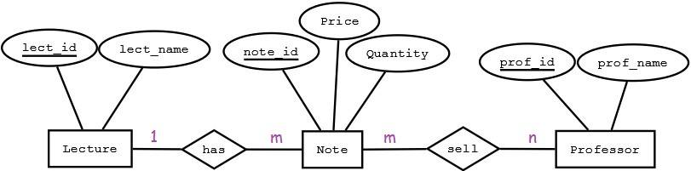

**Assignment 9: DML**

**A)DNA- Analyse**

**It should the data of Trent, the true father of Jane and Joe and also his**

**Parents are inserted into the database.**

**The SQL statement is:**

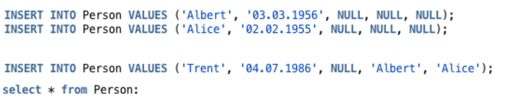

**The output is:**

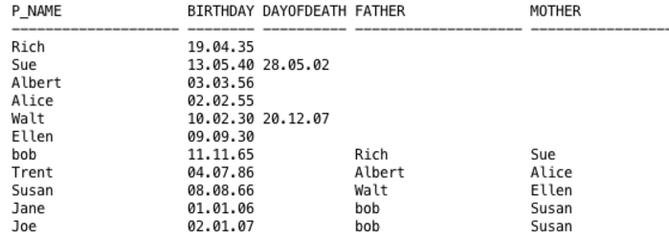

**B) Update**

**As the next SQL statement, Trent will be father of Jane and Joe.**

**The SQL statement is:**

**UPDATE person SET Father = 'Trent' WHERE Father = 'bob';**

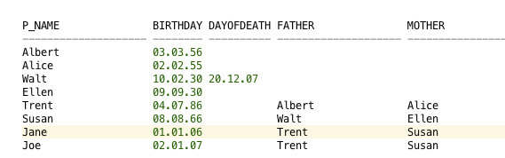

**C) Since the data of Bob and his parents are no longer important to us**

**They are deleted from the table as follow:**

https://lh4.googleusercontent.com/H378AfFNcP-buf73IFui7nOVFmO6PE3kU5NzY57gCDq_ijngi3TxuDQUrAQQkN-JcmskEBcaTgMgGH86gnyylcUc6VvUco4uc-iQnJxawbUmQucxsn7Eviyvztt-8tT173U-CBsS

https://lh4.googleusercontent.com/psA5Ftx0b9hyYKVPxyq61QIyBHwRyCAwo_0JhvFywiWzE0IMliZtRJS8yaWWeai98pnCdClUX09HqMw5T7nW2q9za0r8DAAUnZLJwmQfcNZ72wNVPmHryhweCZmteS84vubr0G1b

**The output is:**

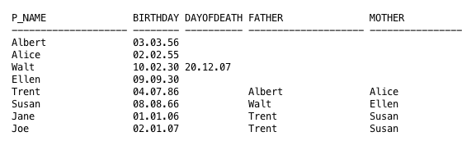

**Assignment 10: Queries**

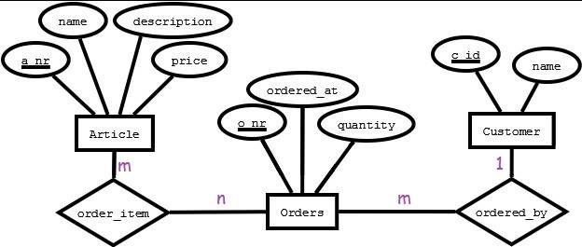

1. **Display all articles**

SELECT * FROM article;

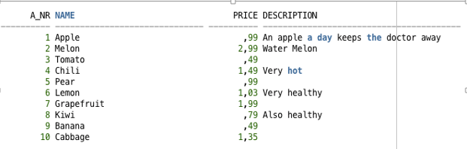

ii. show article with the price 0.99€.

SELECT * FROM article WHERE price= 0.99;

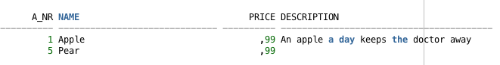

iii. How much is an “ Apple”?

SELECT * FROM article WHERE name= 'Apple';

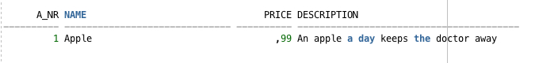

iv. List the name and price of articles without description

SELECT name, price FROM article WHERE description is null;

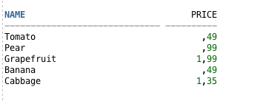

v. List name and articles in alphabetic order.

SELECT name, price FROM ARTICLE order by name ASC , price ASC;-- alphabetic order

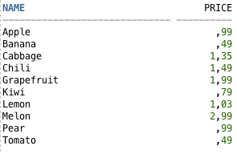

vi. List name and articles in price order. Expensive first.

SELECT name, price FROM ARTICLE order by price DESC, name ASC;

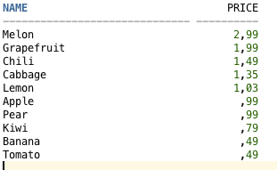

vii. What is the average price of articles?

SELECT AVG(price) FROM article;

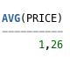

viii. What is the maxumiun price of articles?

SELECT MAX(price) FROM article;

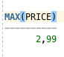

ix. What is the lowest price?

SELECT MIN(price) FROM article;

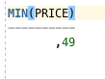

x. list the order numbers of Ringo

SELECT o_nr FROM customer ,

orders  WHERE customer.name = 'Ringo' AND customer.c_id = orders.c_id ;

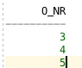

xi. List are coustomers and coustomers numbers.

SELECT customer.name, Orders.o_nr FROM customer

JOIN Orders

ON customer.c_Id = Orders.c_Id;

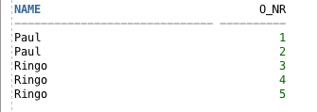

xii. Liste all customer numbers ( also those who not orders sth) and order numbers

SELECT customer.name, Orders.o_nr FROM customer

LEFT JOIN Orders

ON customer.c_Id = Orders.c_Id;

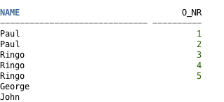

xiii. What are the articles ever ordered by every single customer? Give the customers' and articles' names. Eliminate duplicates. Sort the output alphabetically for both names.

SELECT distinct customer.name,Articel.name from customer

JOIN orders NR  ON customer.c_id= NR.c_id

JOIN order_item Nr_Item ON Nr_Item.o_nr= NR.o_nr

JOIN article Articel ON Articel.a_nr= Nr_Item.a_nr ORDER BY customer.name, Articel.name;

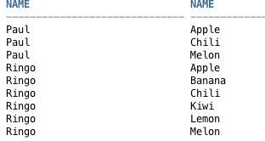

xiv. Display an summary for order 5: For every order item, give the article name, the article's price per unit, the quantity, and the price of the order item. Sort the output alphabetically according to the articles' names.

SELECT article.name, article.price,order_item.quantity,

order_item.quantity*article.price total price

FROM order_item JOIN article ON order_item.a_nr=article.a_nr

WHERE order_item.o_nr=5 ORDER BY article.name;

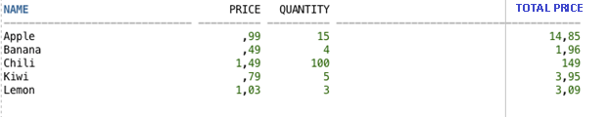

xv. How expensive is the whole order with o_nr 5?

SELECT SUM(article .price*order_item.quantity)

FROM order_item

JOIN article

ON article.a_nr = order_item.a_nr WHERE order_item.o_nr = 5;

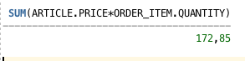

xvi. Give a summary of all orders: display the o_nr and the total price. HINT: use "group by"

SELECT order_item.o_nr, SUM(article .price*order_item.quantity)AS SUM

FROM order_item

JOIN article ON article.a_nr = order_item.a_nr

JOIN ORDERS ON orders.O_nr = order_item.O_nr

GROUP BY order_item.o_nr;

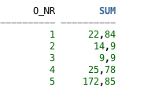

xvii. Give a summary of all orders: display the o_nr, the customer name, and the total price. HINT: use "group by".

SELECT order_item.o_nr, customer.name, SUM(article.price*order_item.quantity) AS SUM

FROM order_item

JOIN article ON article.a_nr = order_item.a_nr

JOIN ORDERS ON orders.o_nr = order_item.o_nr

JOIN customer ON orders.c_id = customer.c_id

GROUP BY order_item.o_nr, customer.name

ORDER BY order_item.o_nr;

