**Lab 3**

Group 1

Lab team: Ievgenii Nudga, Aryan Sultan

Instructor: Florian Ocker

HAW Hamburg Data Base

**Assignment 8: Functional Dependencies and Normalization**

**A) The (full) Functional Dependencies**

lect_ID----->Lec_Name

Prof_ID---->pro_name

Note_ID--->price

lect_id,prof_id ---->note_id,price,quantity

**B) Primary key for the table**

lect_id, prof_id

**C) Transforming the schema to 2NF**

Main Table

|  |  |  |  |  |  |  |
| --- | --- | --- | --- | --- | --- | --- |
| Lec_id(PK) | Lec_name | Prof_id(PK) | Prof-name | Note_ID | Price | Quantity |
| 24 | DB | 47 | Miller | 5 | 32 | 12 |
| 24 | DB | 272 | Adams | 1 | 35 | 15 |
| 24 | DB | 251 | Meyer | 5 | 32 | 12 |
| 25 | JAVA | 47 | Miller | 3 | 22 | 19 |

1-2NF

|  |  |  |  |  |
| --- | --- | --- | --- | --- |
| Lec_id(FK)(PK) | Prof_id(FK)(PK) | Note_ID | Price | Quantity |
| 24 | 47 | 5 | 32 | 12 |
| 24 | 272 | 1 | 35 | 15 |
| 24 | 251 | 5 | 32 | 12 |
| 25 | 47 | 3 | 22 | 19 |

2-prof (prof_id, prof_name)

|  |  |
| --- | --- |
| Prof_id(PK) | Prof-name |
| 47 | Miller |
| 272 | Adams |
| 251 | Meyer |

3-lecture (lect_id, lec_name)

|  |  |
| --- | --- |
| Lec_id(PK) | Lec_name |
| 24 | DB |
| 25 | JAVA |

*\*\*\*A note for Evgeniy:*

*why we didn’t create a separate table for Noted because*

*Note_id need both primary key elements (keep this in mind)*

**D) Transforming the schema to 3NF**

2NF table

|  |  |  |  |  |
| --- | --- | --- | --- | --- |
| Lec_id(FK)(PK) | Prof_id(FK)(PK) | Note_ID | Price | Quantity |
| 24 | 47 | 5 | 32 | 12 |
| 24 | 272 | 1 | 35 | 15 |
| 24 | 251 | 5 | 32 | 12 |
| 25 | 47 | 3 | 22 | 19 |

**From 2NF to 3NF**

*\*\*\*A note for Evgeniy:*

Here to know price it is just enough to know Note_ID and you dot need prof id and lec id.

We bring out this part as a new table

3NF

|  |  |  |  |
| --- | --- | --- | --- |
| Lec_id(FK)(PK) | Prof_id(FK)(PK) | Note_ID(FK) | Quantity |
| 24 | 47 | 5 | 12 |
| 24 | 272 | 1 | 15 |
| 24 | 251 | 5 | 12 |
| 25 | 47 | 3 | 19 |

Note

|  |  |
| --- | --- |
| Note_ID(PK)(FK) | Price |
| 1 | 35 |
| 5 | 32 |
| 3 | 22 |

Prof

|  |  |
| --- | --- |
| Prof_id(PK)(FK) | Prof-name |
| 272 | Adams |
| 251 | Meyer |
| 47 | Miller |

Lectures

|  |  |
| --- | --- |
| Lec_id(PK)(FK) | Lec_name |
| 24 | DB |
| 25 | JAVA |

**E) Draw an ER diagram of the 3NF schema obtained in (D)**

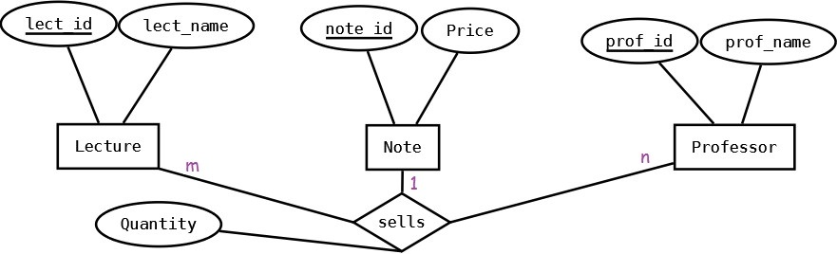

**Assignment 9: DML**

**Script:**

DELETE FROM Person WHERE Name1 = 'Walt' OR Name1 = 'Ellen' OR Name1 = 'Bob';

INSERT INTO Person VALUES('Alice', TO_DATE( '02-02-1955', 'DD-MM-YYYY' ), null, null, null);

INSERT INTO Person VALUES('Albert', TO_DATE( '03-03-1956', 'DD-MM-YYYY' ), null, null, null);

INSERT INTO Person VALUES('Trent', TO_DATE('04-07-1986', 'DD-MM-YYYY' ), null, 'Albert', 'Alice');

UPDATE Person SET Father = 'Trent' WHERE Name1 = 'Jane' OR Name1 = 'Joe' ;

**Output:**

3 rows deleted.

1 row inserted.

1 row inserted.

1 row inserted.

2 rows updated.

**Assignment 10: Queries**

**A) Creating an ER-Model**

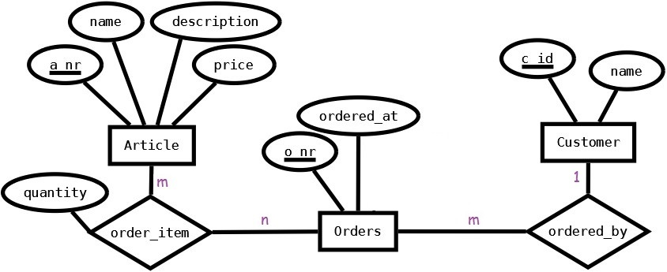

**B) “SELECT” statements (17 in total) with Oracle syntax and outputs**

1. **Display all articles:**

SELECT *FROM article;

**A question for Prof. Ocker:**

**It would be nice to know ways to manipulate with tables, like adjusting words on each column on the left side, also I wanted to get 0.49, instead of ,49.**

**So far I found about SET LINESIZE 2000;**

**Googled a bit more, but the code is different and maybe I should look into program settings and try finding some tweaks?**

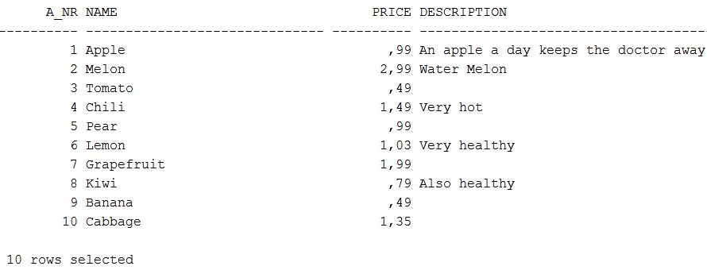

1. **List articles with price 0.99**

SELECT * FROM article WHERE price = 0.99;

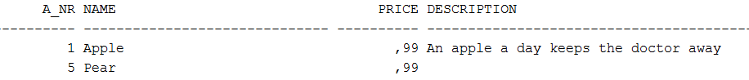

1. **Price of the article Apple**

SELECT price FROM article WHERE name = ‘Apple’;

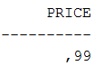

1. **List of articles wit NULL description**

SELECT name, price FROM article WHERE description IS NULL;

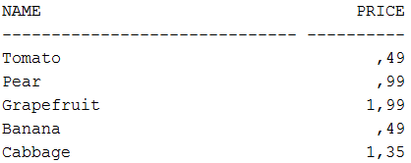

1. **List of articles in alphabetical order**

SELECT name, price FROM article ORDER BY name ASC;

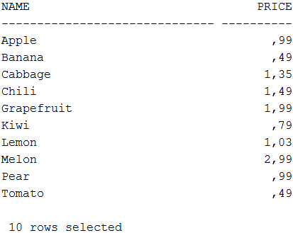

1. **List of articles (most expensive first)**

SELECT name, price FROM article ORDER BY price DESC;

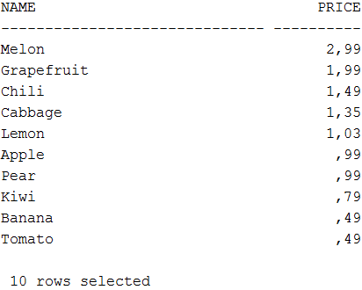

1. **The average price of articles**

SELECT AVG (price) FROM article;



1. **Highest price of articles**

SELECT MAX (price) FROM article;

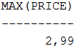

1. **Lowest price of articles**

SELECT MIN (price) FROM article;

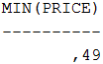

1. **List of order numbers (o_nr) of all Ringo’s orders**

SELECT orders.o_nr FROM customer, orders WHERE customer.name = 'Ringo' AND customer.c_id = orders.c_id ORDER BY orders.o_nr ASC;

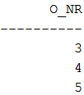

1. **List of customer names and their order numbers**

SELECT customer.name, orders.o_nr FROM customer, orders WHERE customer.c_id = orders.c_id ORDER BY orders.o_nr ASC;

or

SELECT customer.name, orders.o_nr FROM customer INNER JOIN orders ON customer.c_id = orders.c_id ORDER BY orders.o_nr ASC;

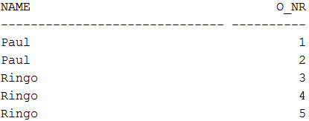

1. **List of ALL customer names and corresponding order numbers (the difference is FULL OUTER JOIN so that we can also get names without any data (missing values o_nr filled with NULLs)**

SELECT customer.name, orders.o_nr FROM customer FULL OUTER JOIN orders ON customer.c_id = orders.c_id ORDER BY orders.o_nr ASC;

***but if we use this:***

SELECT customer.name, orders.o_nr FROM customer, orders WHERE customer.c_id = orders.c_id ORDER BY orders.o_nr ASC;

***then there wouldn’t be names with missing values o_nr***

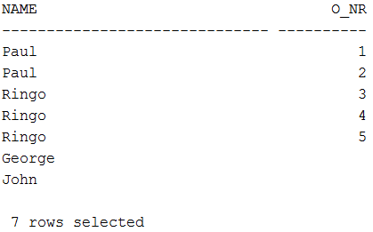

1. **Articles that has been ordered by every single customer**

SELECT DISTINCT customer.name, article.name FROM customer, article, order_item, orders

WHERE customer.c_id = orders.c_id AND orders.o_nr = order_item.o_nr AND article.a_nr = order_item.a_nr ORDER BY customer.name, article.name ASC;

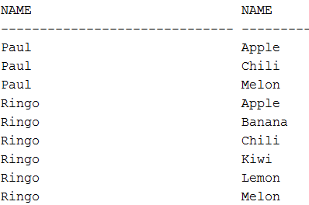

1. **Summary for order 5**

SELECT DISTINCT article.name, article.price, order_item.quantity, order_item.quantity * article.price

FROM article, order_item WHERE order_item.o_nr = 5 AND article.a_nr = order_item.a_nr

ORDER BY article.name ASC;

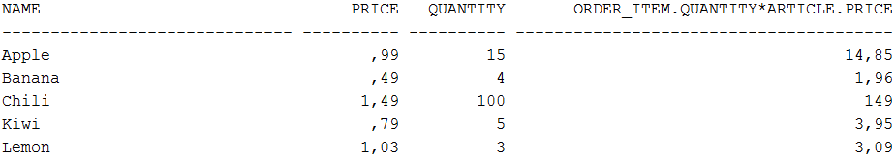

1. **The sum price of order 5**

SELECT SUM (article.price * order_item.quantity) FROM article, order_item WHERE order_item.o_nr = 5 AND article.a_nr = order_item.a_nr ORDER BY article.name ASC;

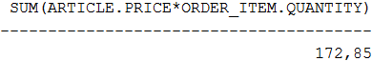

1. **Summary of all orders (o_nr and total price)**

SELECT order_item.o_nr, SUM (article.price * order_item.quantity) FROM article, order_item, orders WHERE orders.o_nr = order_item.o_nr AND article.a_nr = order_item.a_nr GROUP BY order_item.o_nr;

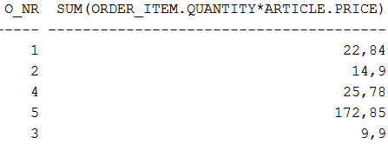

**Experiment**

SELECT order_item.o_nr, SUM (article.price * order_item.quantity) FROM article, order_item, orders WHERE orders.o_nr = order_item.o_nr AND article.a_nr = order_item.a_nr GROUP BY order_item.o_nr ORDER BY order_item.o_nr DESC;

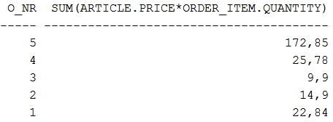

1. **Summary of all orders (o_nr, customer name and total price)**

SELECT order_item.o_nr, customer.name, SUM (article.price * order_item.quantity)

FROM article, order_item, orders, customer

WHERE orders.o_nr = order_item.o_nr AND article.a_nr = order_item.a_nr AND customer.c_id = orders.c_id GROUP BY order_item.o_nr, customer.name ORDER BY order_item.o_nr ASC;

