**Lab 4 preparation report:**

Walter Keyes

Ievgenii Nudga

Ganesh Simha Reddy Pucha

Firstly users enter the text on the console window, it is sent via UART to the microcontroller which updates the text string on the LED pendulum. We are using a pushbutton which changes the background color.

The text we entered in the console window will be displayed on the LED pendulum. The text can consists of letters (A to Z) and numbers (0 to 9) and special characters. We can type 10 characters on the console window and it is displayed on the pendulum during a swing from left to right.

When the UART1 receives the new characters from PC to the Microcontrollers then interrupt handler will update the new characters . When the push button is pressed, interrupt handler will toggle the global variable.

We are using port D4 as the receiver for the UART port and port P0 as the push button input.

**Block diagram :**

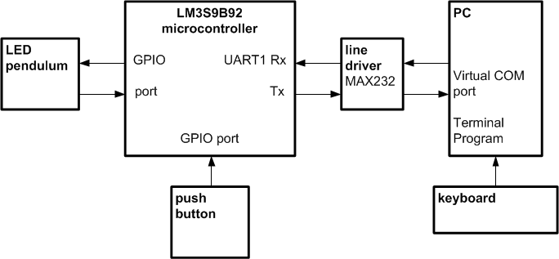

**Nassi-Shneider-Diagram:**

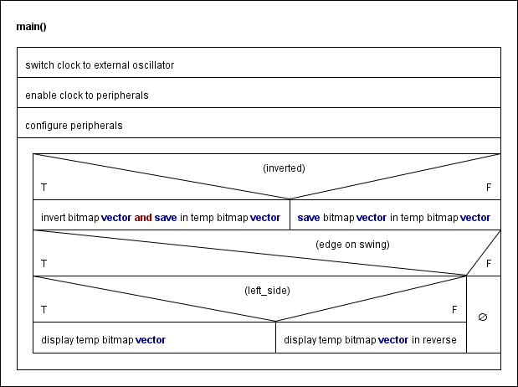

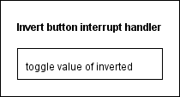

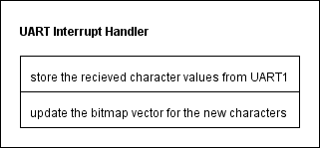

**Work Plan:**

Our goal for the first lab is to have a program that allows us to easily change the output on the LED pendulum. We will have a header file that defines bit maps for all of our desired characters (A-Z uppercase and lowercase, 0-9, and special characters). The LED pendulum will display up to 10 8 x 5 characters at a time and will show them while moving in both directions.

For the second lab, we will write functions to configure the UART module, read values received by the UART module, and an interrupt handler for the pushbutton. Ganesh will write a function to read the values from the UART module. Ievgenii will write an interrupt handler for the pushbutton. Walter will write a function to configure the UART module. These will be put together to add functionality for the inverting button and the UART module with polling.

For the third lab we will adapt the UART reading function to be an interrupt handler. We will also create our PowerPoint presentation of the project.