**Game “BallRun” Concept**

**Team Members:** Kulakov Michael, Jeonghyun Son, Shvets Volodymyr.

**Game description**

The concept of the game is next: player controls the ball (simple red dot on the pendulum “display”) with control keyboard buttons (arrows up, down, right and left) and the task is to avoid obstacles which are moving from the left part of the display to the right with some fixed speed. Player wins if he coped with all obstacles and survive. The game is over when the ball was caught with the obstacle, so it means the ball and the obstacle have reached the right part of the display. In addition, several complexity levels with different speed would be included. Using push buttons, player can change the pause the game or end the game. Using interrupts, we would update the ball position on the display.

**Peripherals description**

To implement our game, we will use the system which is shown at *Fig. 1.*

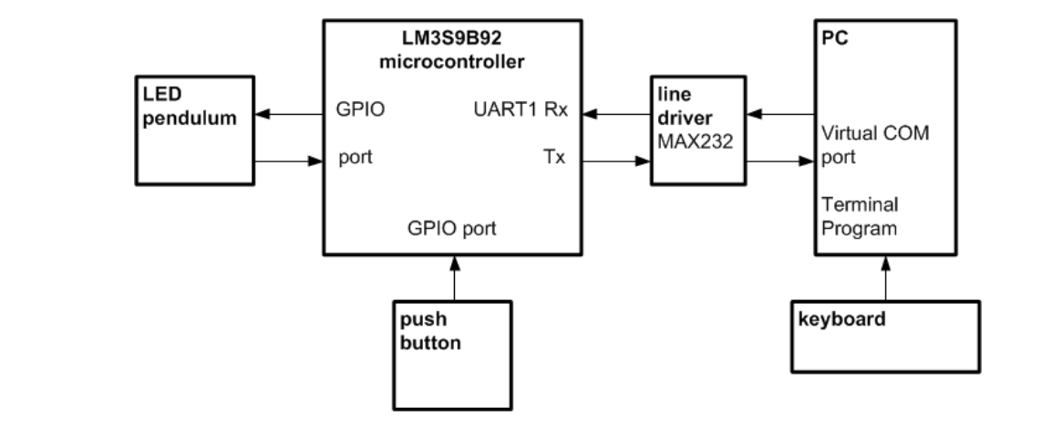

Fig. 1 The block diagram of overall system [1]

* **Keyboard**: for user interaction with the system. User controls the ball position with the next buttons: Up, Down, Right and Left arrows which change ball position in the corresponding manner.
* **LED pendulum:** display the game process (show moving simulation of the obstacles and changing ball position).
* **Line driver MAX232:** UART connection between PC and Microcontroller which sends data frames of the user commands to the Microcontroller.
* **Microcontroller:** processes requests from the PC (user commands) and forward commands to the LED pendulum. Moreover, it takes care of the push button interrupts which should be served in the corresponding way.
* **PC:** receives user commands from the keyboard and forward them via UART to the Microcontroller.
* **Push buttons:** pause the game (display PAUSE) or end the game (display END).

**Top-level Nassi-Shneider-Diagram**

Main NSD of the system is shown at the *Fig. 2.*

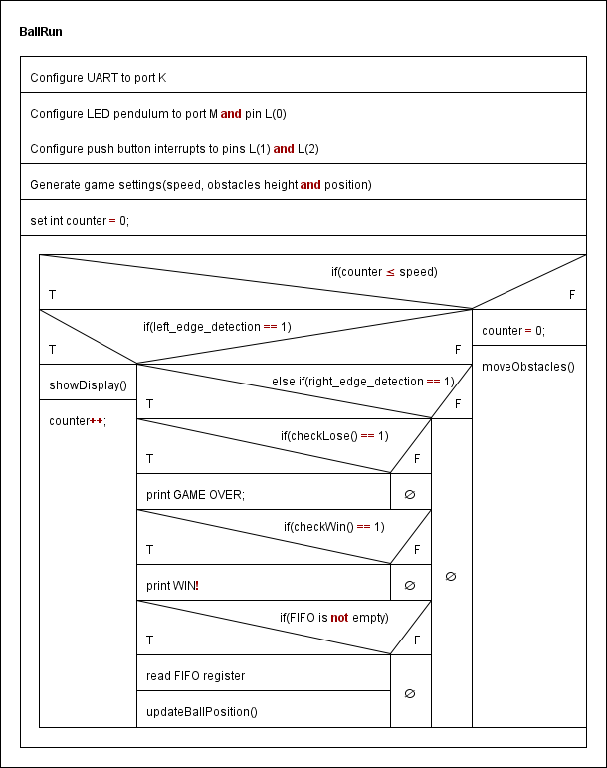

Fig. 2 Main NSD of the overall system process.

**Interrupt 1: “Pause the game”** means if the push button 1 was pressed the game should be stopped. If the button was pressed one more time (the wait release button approach should be realized) the game will continue running.

**Interrupt 2: “End the game”** means if the button was pressed end the game process.

**Roles**

**Kulakov Michael**

**Estimated time:** 10 – 15 hours.

**Responsibilities:**

* + design game logic;
  + write interrupts and connect them to push buttons;
  + design and implement the overall concept of the system;
  + combine programmed system components provided by other team members;
  + test and verify the system running.

**Jeonghyun Son**

**Estimated time:** 10 – 12 hours.

**Responsibilities:**

* design and simulate moving obstacle objects;
* write showDisplay() and updateBallPosition() functions;
* display next titles: „PAUSE “, „END “, „GAME OVER “, „WIN “.

**Shvets Volodymyr**

**Estimated time:** 10 – 12 hours.

**Responsibilities:**

* design and implement UART connection between PC and MC;
* implement and test keyboard inputs from the PC;
* write checkLose(), checkWin() and moveObstacles() functions.