Software Engineering (IE4-SEL)

Laboratory Report

Lab number: <{1}>

Lab date: <4th April 2016>

Authors: <Sami Ullah>

<Augusto Pinheiro>

<Evgeniy Nud’ga>

|  |  |
| --- | --- |
| H:\buero\schlichting\logos\haw\aktuell\HAW_Logos\05_HAW_Logos\05_HAW_Logo_P_rgb.tif | HAW Hamburg  Faculty of Engineering & Computer Science  Department of Information & Electrical Engineering |

**1 < Stakeholder analysis>**

b) Create *one* aligned stakeholder table for your group.

|  |  |  |  |
| --- | --- | --- | --- |
| Stakeholders | | Functions | Main Interests |
| 1 | Customer | General manager, receptionist, guest, IT administrator | The Software fulfills all the requirements and needs according to their expectations. |
| 2 | Management Team | project manager, group manager software | To fulfill the basic features of the customer and to check the work progress |
| 3 | Development Team | Software architect, software application developer, graphical design specialist, test engineer | Maintainability, Choosing a standard way of pursuing application development, determining a best way to test the software. Quality assurance. |
| 4 | Owner | Shareholders | Profit and Success of the business. |
| 5 | Security Department | Security officers | To secure the personal data of the guests and the hotel |
| 6 | Finance Department | Finance Manager/ Account Manager | Sales and the present Market Prices. |
| 7 | Publication Market | Technical publication Manager | Technical writing |

6) Write down statements on the following:

a) How many stakeholders did you originally identify in the preparation work?

We Identified 4 stakeholders.

b) How many stakeholders were identified by your group?

Six stakeholders were identified by our group.

c) How many *additional* stakeholders were identified by the other group?

Three additional stakeholders were identified by the other group.

d) List the additional stakeholders identified by the other group. Explain the risks for your development project and/or software product, if you would not include these stakeholders in the requirement analysis.

Document Specialist

Database experts : If we would not include these stakeholders we had to repeat our documentation phase many times and re-do our database section.

**2 < Kano model >**

7) Methods and stakeholders

1. For each of the three categories in Kano’s model propose methods to identify requirements for the software system. Explain why you have chosen a specific method.
2. For each method list the main stakeholders to involve. Explain *why* these should be involved.

Basic Features:

* Visiting different websites of other hotels because in this way we can easily get an idea about the basic needs. For example how easy it is to use a web site, how quickly it responded to different requests.
* Interviewing guests and requesting them to fill a questionnaire which includes questions about their experience in visiting the websites.

Performance Features:

* To identify Performance features we have consult the customers and interview because these features are always stated and entirely depend on the desires the customers.

Delighters:

* To find delighters of the customers we should have brainstorming with management team and development team because they can find the output of their work.
* We can interview the customers.
* We can ask the customers to fill a questionnaire.

|  |  |  |
| --- | --- | --- |
| **Requirement category** | **Method** | **Stakeholders** |
| Basic Features | Interviewing guests and requesting them to fill a questionnaire which includes questions about their experience in visiting the websites.  Visiting different websites of other hotels because in this way we can easily get an idea about the basic needs. For example how easy it is to use a web site, how quickly it responded to different requests. | Guests |
| Performance Features | To identify Performance features we have to consult the customers and interview because these features are always stated and entirely depend on the desires of the customers | Customers |
| Delighters | To find delighters of the customers we should have brainstorming with management team and development team because they can find the output of their work.  We can interview the customers.  We can ask the customers to fill a questionnaire. | Customers, Management Team,  Development, Guests. |

**8) Requirements:**

a) For each of the three categories in Kano’s model list examples for requirements for the software system

|  |  |  |
| --- | --- | --- |
| Basic Features | Performance Features | Delighters |
| Easy to use | Payment methods | Breakfast and special packages can be easily created |
| Accessible while using pc, smart phone and tablets. | Translation of the web page in different languages | Sending an alert to the cleaning after each checkout to clean the room |
| Real time access | Different accommodation types | Usability and design of the software |
| Change/add/remove rooms | Pictures and description of rooms included | Information about internet facilities |
| Group bookings | Feedback system | Sending automatic email to the guests before certain time of check in |
| Edit details | Storing data of the guests | Block out certain rooms or the whole building for a period of time |
| Handle cancellations | Offer discounts to corporate guests | Send manual or automatic booking confirmation by text messages |

**4.3 Non-functional requirements**

* Performance requirements
* Availability requirements
* Security requirements
* Usability requirements
* Safety requirements

…**4.4 Use case Diagram**

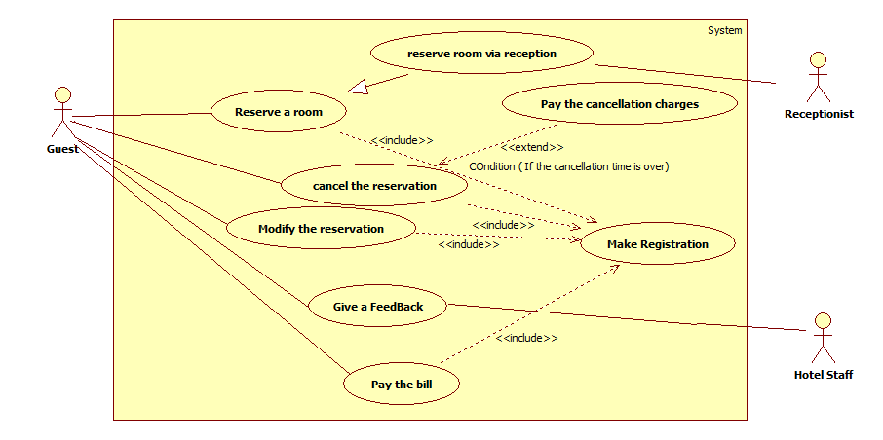

— End of document —