Software Engineering (IE4-SEL)

Laboratory Report

Lab number: 3

Lab date: 17.05.2016

Authors: Ievgenii Nudga, Carlos A. Sousa, Sami Ullah

|  |  |
| --- | --- |
| H:\buero\schlichting\logos\haw\aktuell\HAW_Logos\05_HAW_Logos\05_HAW_Logo_P_rgb.tif | HAW Hamburg  Faculty of Engineering & Computer Science  Department of Information & Electrical Engineering |

# State Diagrams for each component

**Central Unit**

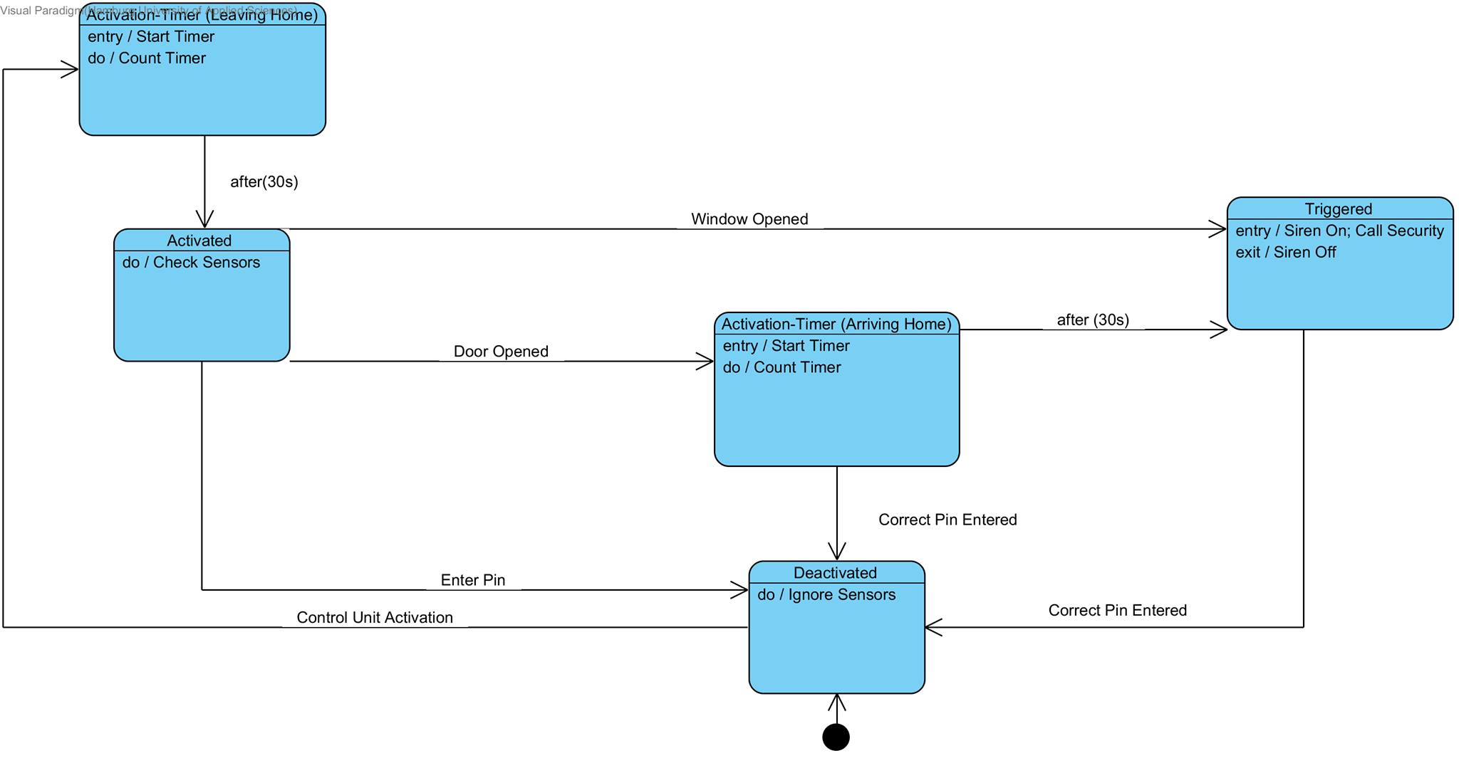

**Control Unit**

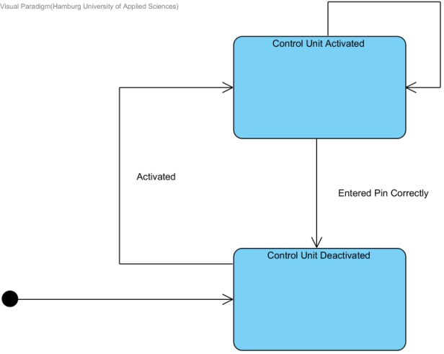

**Sensors**

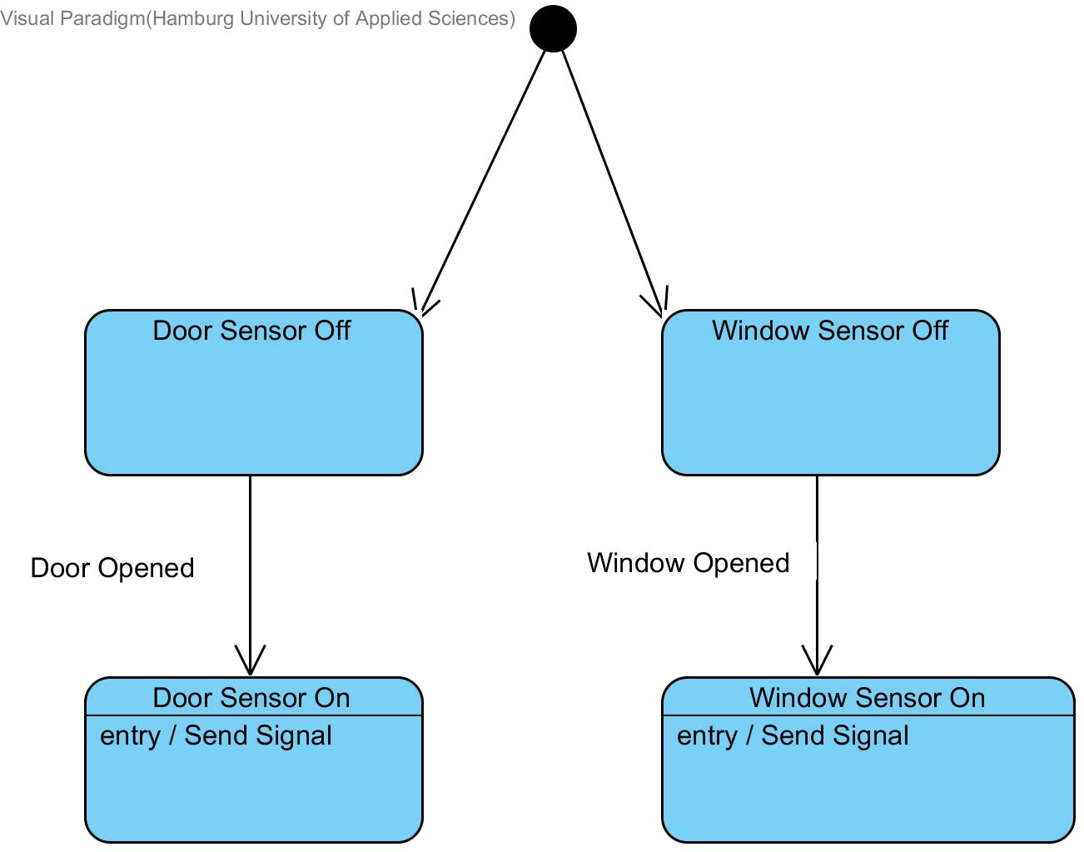

**Siren**

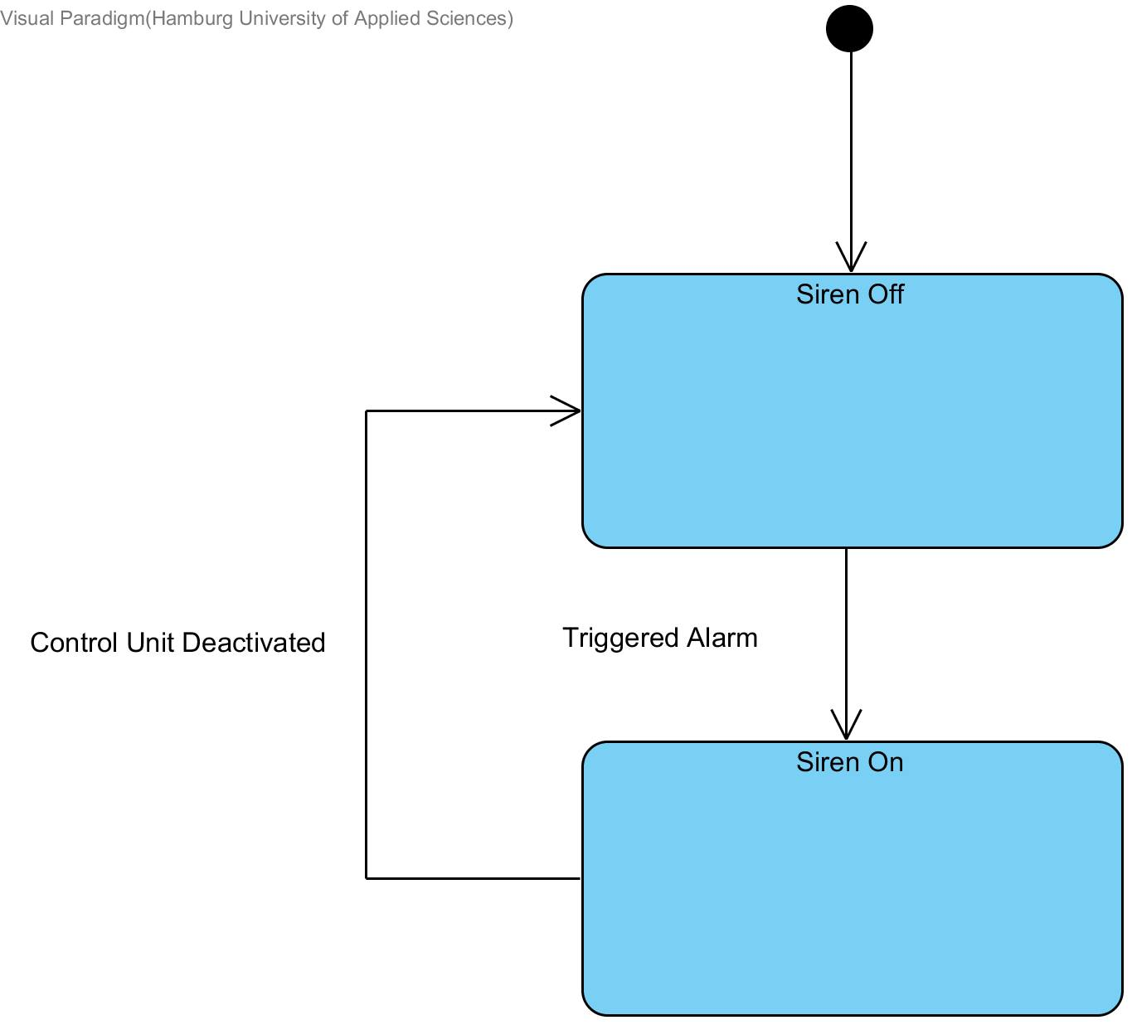

**Communication Diagram**

**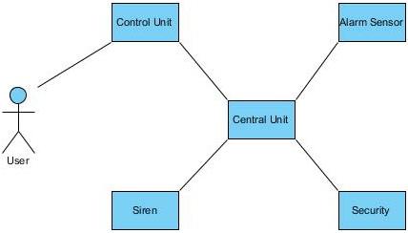**

**Sequence Diagram**

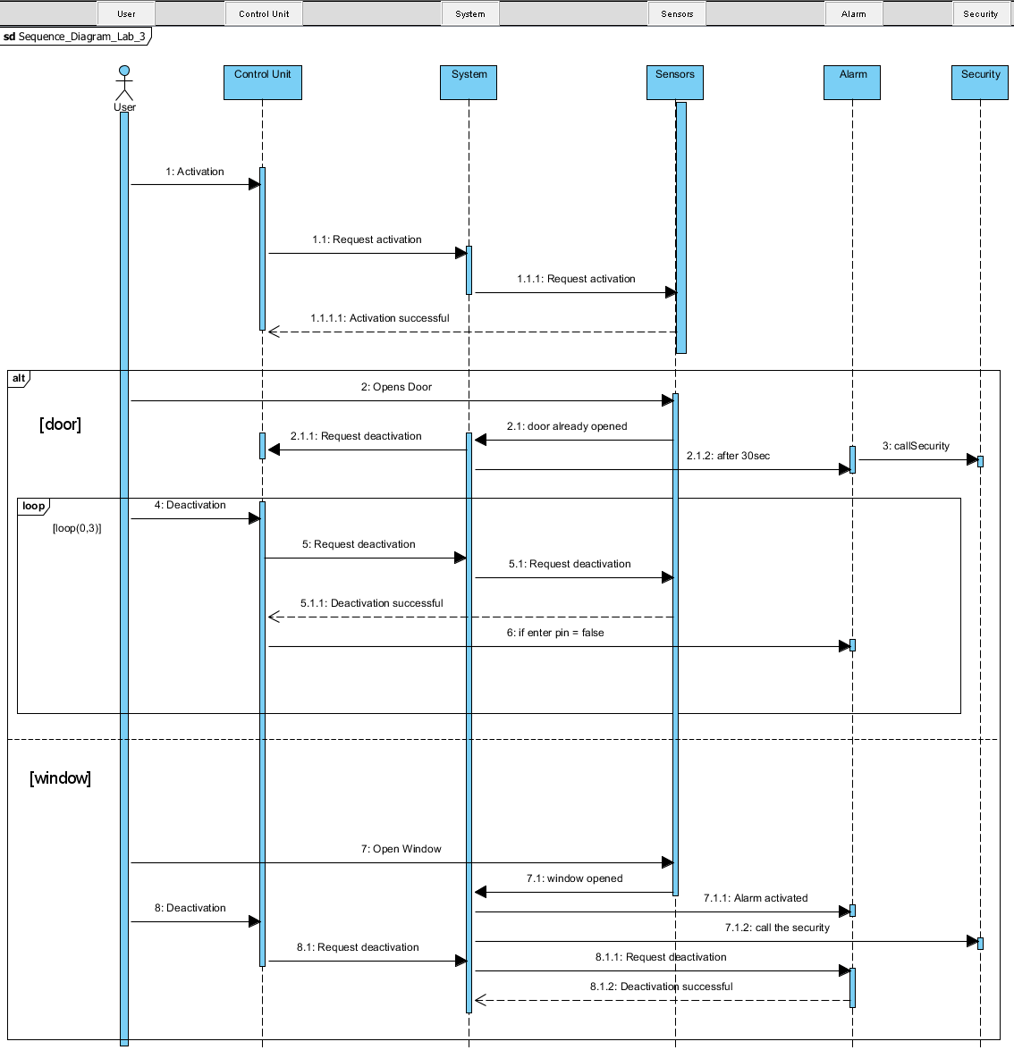

|  |  |
| --- | --- |
| Date | Description of change / rework |
| <Date> | Initial version |