Software Engineering (IE4-SEL)

Laboratory Report

Lab number: 4

Lab date: 06.06.16

Authors: Ievgenii Nudga, Carlos A. Sousa, Sami Ullah

|  |  |
| --- | --- |
| H:\buero\schlichting\logos\haw\aktuell\HAW_Logos\05_HAW_Logos\05_HAW_Logo_P_rgb.tif | HAW Hamburg  Faculty of Engineering & Computer Science  Department of Information & Electrical Engineering |

# Class diagram

# D:\1Univ\SE_Software_Engineering\Labs_2016\lab_4\class_diagram.jpg

**Communication diagram**

**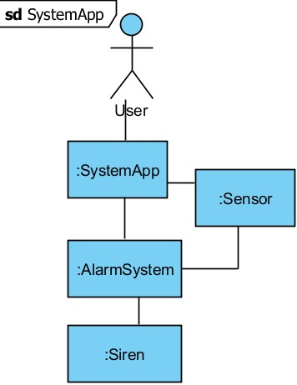**

**State machine diagram for the system states**

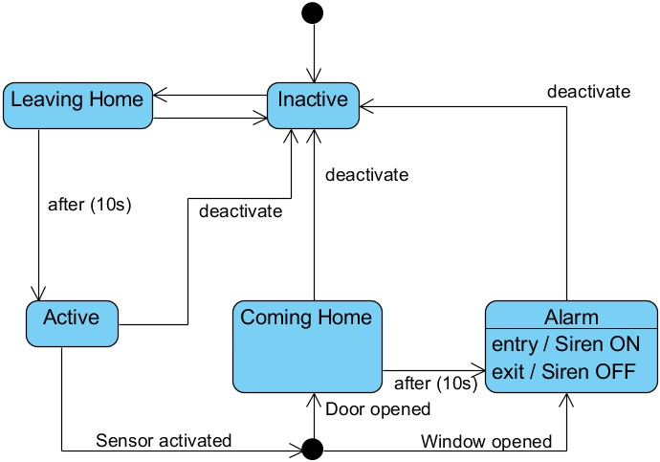

|  |  |
| --- | --- |
| Date | Description of change / rework |
| <Date> | Initial version |

— End of document —