**Activity Diagram**

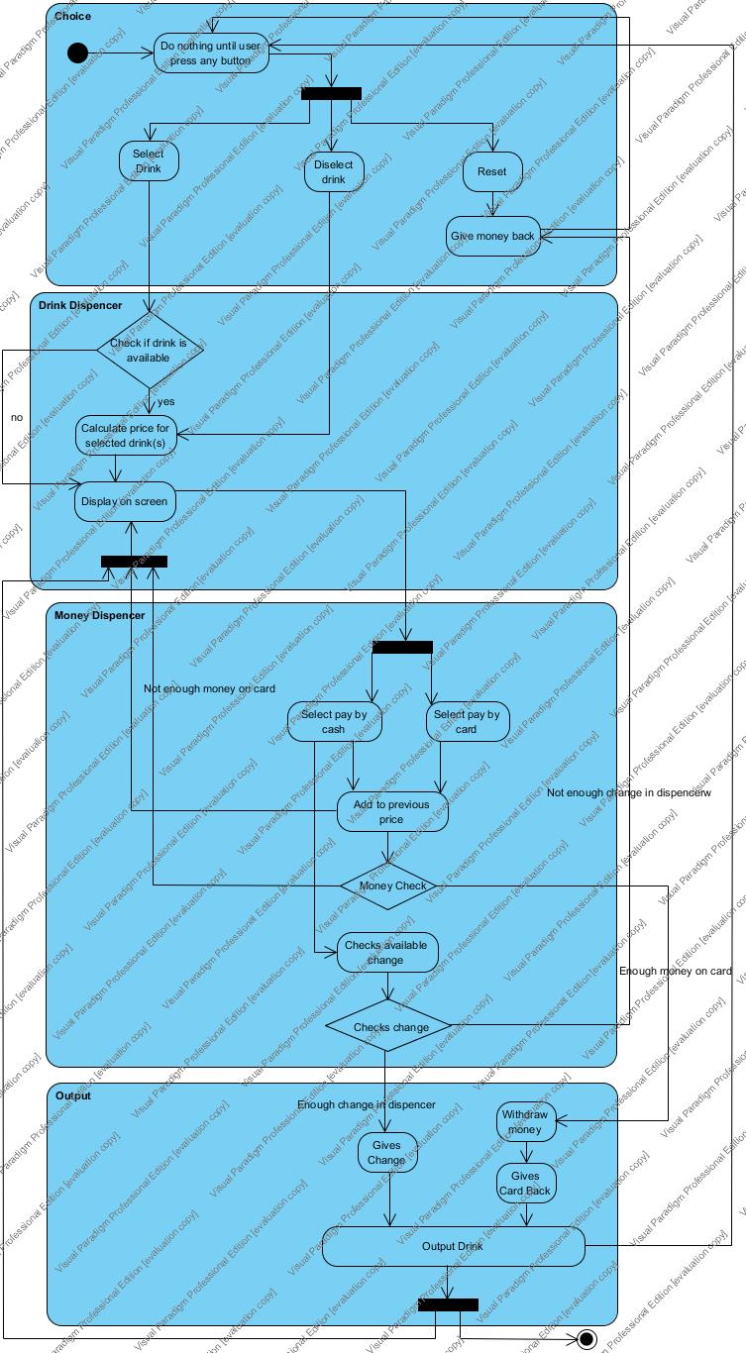

**Class Diagram**

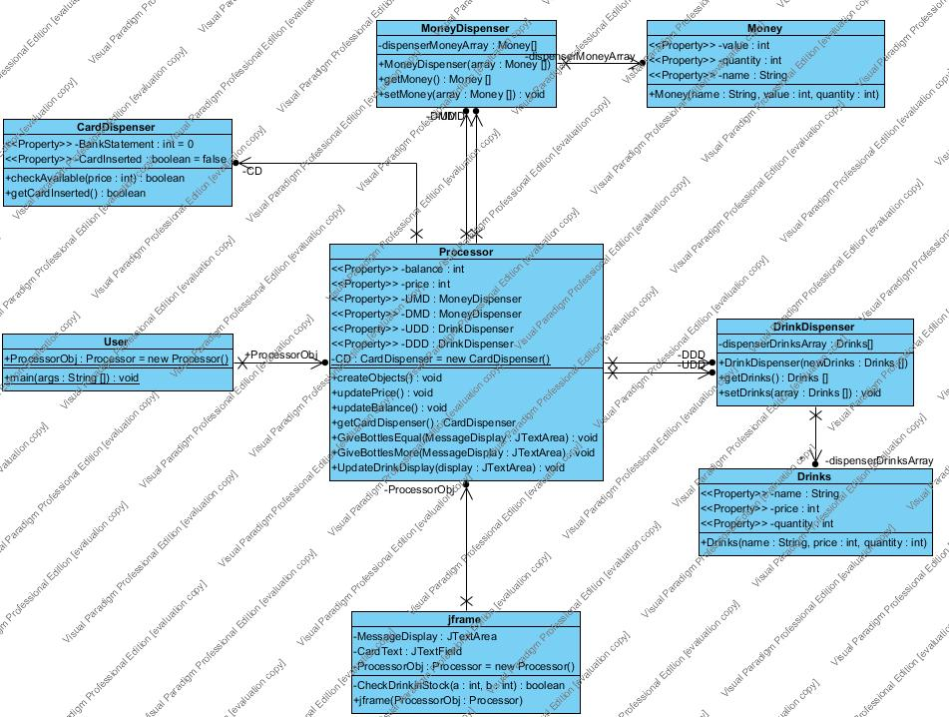

**Source Code**

**Class Card.java**

**public** **class** Card {

**private** **double** amount;

**public** Card(){

**this**.amount = 10;

}

**public** **double** getAmount(){

**return** **this**.amount;

}

**public** **void** setAmount( **double** amount){

**this**.amount = amount;

}

**public** String toString(){

**return** String.*valueOf*(**this**.amount);

}

**public** **void** cardInserted(){

}

}

**Dispenser.java**

**public** **class** Dispenser {

**private** **int**[] bottles;

**public** Dispenser() {

**this**.bottles = **new** **int**[9];

**for**(**int** i = 0; i < **this**.bottles.length; i++){

**this**.bottles[i] = 20;

}

}

**public** **int**[] getBottles(){

**return** **this**.bottles;

}

**public** **void** setBottles(**int**[] bottles){

**this**.bottles = bottles;

}

**public** **void** takeBottles(**int** bottles[]){

**for**(**int** i = 0; i < **this**.bottles.length; i++){

**this**.bottles[i]-=bottles[i];

}

}

}

**DispenserView.java**

**import** java.awt.Color;

**import** java.awt.EventQueue;

**import** java.awt.event.ActionEvent;

**import** java.awt.event.ActionListener;

**import** javax.swing.JButton;

**import** javax.swing.JFrame;

**import** javax.swing.JLabel;

**import** javax.swing.JTextArea;

**public** **class** DispenserView {

**private** JFrame frame;

**private** System system;

**private** JTextArea txtrMoneyreturn;

**private** JTextArea txtrOutputbox;

**private** JLabel lblDisplay;

**private** JButton btnDeselectDrink;

/**

* Launch the application.

*/

**public** **static** **void** main(String[] args) {

EventQueue.*invokeLater*(**new** Runnable() {

**public** **void** run() {

**try** {

DispenserView window = **new** DispenserView();

window.frame.setVisible(**true**);

} **catch** (Exception e) {

e.printStackTrace();

}

}

});

}

/**

* Create the application.

*/

**public** DispenserView() {

**this**.system = **new** System();

//isDeselect = true;

initialize();

}

/**

* Initialize the contents of the frame.

*/

**private** **void** initialize() {

frame = **new** JFrame();

frame.setBounds(100, 100, 505, 431);

frame.setDefaultCloseOperation(JFrame.*EXIT_ON_CLOSE*);

frame.getContentPane().setLayout(**null**);

JButton btnCoke = **new** JButton("Coke(1,10)");

btnCoke.addActionListener(**new** ActionListener(){

@Override

**public** **void** actionPerformed(ActionEvent e) {

**try** {

system.addDrink("Coke");

lblDisplay.setText(system.getDisplay().getDisplayString());

} **catch** (NotEnoughDrinksException e1) {

lblDisplay.setText("Not enough drinks");

}

}

});

btnCoke.setBounds(10, 11, 151, 23);

frame.getContentPane().add(btnCoke);

JButton btnSprite = **new** JButton("Sprite(1,10)");

btnSprite.addActionListener(**new** ActionListener(){

@Override

**public** **void** actionPerformed(ActionEvent e) {

**try** {

system.addDrink("Sprite");

lblDisplay.setText(system.getDisplay().getDisplayString());

} **catch** (NotEnoughDrinksException e1) {

lblDisplay.setText("Not enough drinks");

}

}

});

btnSprite.setBounds(171, 11, 148, 23);

frame.getContentPane().add(btnSprite);

JButton btnBeer = **new** JButton("Beer(2,30)");

btnBeer.addActionListener(**new** ActionListener(){

@Override

**public** **void** actionPerformed(ActionEvent e) {

**try** {

system.addDrink("Beer");

lblDisplay.setText(system.getDisplay().getDisplayString());

} **catch** (NotEnoughDrinksException e1) {

lblDisplay.setText("Not enough drinks");

}

}

});

btnBeer.setBounds(329, 11, 150, 23);

frame.getContentPane().add(btnBeer);

JButton btnLightBeer = **new** JButton("Light Beer(2,40)");

btnLightBeer.addActionListener(**new** ActionListener(){

@Override

**public** **void** actionPerformed(ActionEvent e) {

**try** {

system.addDrink("LightBeer");

lblDisplay.setText(system.getDisplay().getDisplayString());

} **catch** (NotEnoughDrinksException e1) {

lblDisplay.setText("Not enough drinks");

}

}

});

btnLightBeer.setBounds(10, 45, 151, 23);

frame.getContentPane().add(btnLightBeer);

JButton btnFunBeer = **new** JButton("Fun Beer(2,10)");

btnFunBeer.addActionListener(**new** ActionListener(){

@Override

**public** **void** actionPerformed(ActionEvent e) {

**try** {

system.addDrink("FunBeer");

lblDisplay.setText(system.getDisplay().getDisplayString());

} **catch** (NotEnoughDrinksException e1) {

lblDisplay.setText("Not enough drinks");

}

}

});

btnFunBeer.setBounds(171, 45, 148, 23);

frame.getContentPane().add(btnFunBeer);

JButton btnMineralWater = **new** JButton("Mineral Water(1,00)");

btnMineralWater.addActionListener(**new** ActionListener(){

@Override

**public** **void** actionPerformed(ActionEvent e) {

**try** {

system.addDrink("MineralWater");

lblDisplay.setText(system.getDisplay().getDisplayString());

} **catch** (NotEnoughDrinksException e1) {

lblDisplay.setText("Not enough drinks");

}

}

});

btnMineralWater.setBounds(329, 45, 150, 23);

frame.getContentPane().add(btnMineralWater);

JButton btnAppleJuice = **new** JButton("Apple Juice(1,80)");

btnAppleJuice.addActionListener(**new** ActionListener(){

@Override

**public** **void** actionPerformed(ActionEvent e) {

**try** {

system.addDrink("AppleJuice");

lblDisplay.setText(system.getDisplay().getDisplayString());

} **catch** (NotEnoughDrinksException e1) {

lblDisplay.setText("Not enough drinks");

}

}

});

btnAppleJuice.setBounds(10, 79, 151, 23);

frame.getContentPane().add(btnAppleJuice);

JButton btnOrangeJuice = **new** JButton("Orange Juice(1,90)");

btnOrangeJuice.addActionListener(**new** ActionListener(){

@Override

**public** **void** actionPerformed(ActionEvent e) {

**try** {

system.addDrink("OrangeJuice");

lblDisplay.setText(system.getDisplay().getDisplayString());

} **catch** (NotEnoughDrinksException e1) {

lblDisplay.setText("Not enough drinks");

}

}

});

btnOrangeJuice.setBounds(171, 79, 148, 23);

frame.getContentPane().add(btnOrangeJuice);

JButton btnWine = **new** JButton("Wine(2,80)");

btnWine.addActionListener(**new** ActionListener(){

@Override

**public** **void** actionPerformed(ActionEvent e) {

**try** {

system.addDrink("Wine");

lblDisplay.setText(system.getDisplay().getDisplayString());

} **catch** (NotEnoughDrinksException e1) {

lblDisplay.setText("Not enough drinks");

}

}

});

btnWine.setBounds(329, 79, 150, 23);

frame.getContentPane().add(btnWine);

btnDeselectDrink = **new** JButton("Deselect Drink");

btnDeselectDrink.addActionListener(**new** ActionListener() {

@Override

**public** **void** actionPerformed(ActionEvent e) {

system.setIsDecelect(!system.getIsDeselect());

**if**(system.getIsDeselect()){

btnDeselectDrink.setText("Select Drink");

}

**else**{

btnDeselectDrink.setText("Deselect Drink");

}

}

});

btnDeselectDrink.setForeground(Color.*RED*);

btnDeselectDrink.setBounds(10, 136, 132, 23);

frame.getContentPane().add(btnDeselectDrink);

lblDisplay = **new** JLabel("Please, select drink(s)");

lblDisplay.setBackground(Color.*WHITE*);

lblDisplay.setBounds(171, 136, 249, 18);

frame.getContentPane().add(lblDisplay);

JLabel lblCash = **new** JLabel("Cash:");

lblCash.setBounds(61, 170, 46, 14);

frame.getContentPane().add(lblCash);

JButton btn_10c = **new** JButton("10c");

btn_10c.addActionListener(**new** ActionListener() {

@Override

**public** **void** actionPerformed(ActionEvent e) {

system.payWithCash(0.10);

lblDisplay.setText(system.getDisplay().getDisplayString());

}

});

btn_10c.setBounds(10, 195, 59, 23);

frame.getContentPane().add(btn_10c);

JButton btn_20c = **new** JButton("20c");

btn_20c.addActionListener(**new** ActionListener() {

@Override

**public** **void** actionPerformed(ActionEvent e) {

system.payWithCash(0.20);

lblDisplay.setText(system.getDisplay().getDisplayString());

}

});

btn_20c.setBounds(79, 195, 63, 23);

frame.getContentPane().add(btn_20c);

JButton btn_50c = **new** JButton("50c");

btn_50c.addActionListener(**new** ActionListener() {

@Override

**public** **void** actionPerformed(ActionEvent e) {

system.payWithCash(0.50);

lblDisplay.setText(system.getDisplay().getDisplayString());

}

});

btn_50c.setBounds(10, 229, 59, 23);

frame.getContentPane().add(btn_50c);

JButton btn_1euro = **new** JButton("1\u20AC");

btn_1euro.addActionListener(**new** ActionListener() {

@Override

**public** **void** actionPerformed(ActionEvent e) {

system.payWithCash(1);

lblDisplay.setText(system.getDisplay().getDisplayString());

}

});

btn_1euro.setBounds(79, 229, 63, 23);

frame.getContentPane().add(btn_1euro);

JButton btn_2euro = **new** JButton("2\u20AC");

btn_2euro.addActionListener(**new** ActionListener() {

@Override

**public** **void** actionPerformed(ActionEvent e) {

system.payWithCash(2);

lblDisplay.setText(system.getDisplay().getDisplayString());

}

});

btn_2euro.setBounds(48, 263, 59, 23);

frame.getContentPane().add(btn_2euro);

JLabel lblNotes = **new** JLabel("Notes:");

lblNotes.setBounds(212, 170, 46, 14);

frame.getContentPane().add(lblNotes);

JButton btn_5euro = **new** JButton("5\u20AC");

btn_5euro.addActionListener(**new** ActionListener() {

@Override

**public** **void** actionPerformed(ActionEvent e) {

system.payWithNote(5);

lblDisplay.setText(system.getDisplay().getDisplayString());

}

});

btn_5euro.setBounds(171, 195, 63, 23);

frame.getContentPane().add(btn_5euro);

JButton btn_10euro = **new** JButton("10\u20AC");

btn_10euro.addActionListener(**new** ActionListener() {

@Override

**public** **void** actionPerformed(ActionEvent e) {

system.payWithNote(10);

lblDisplay.setText(system.getDisplay().getDisplayString());

}

});

btn_10euro.setBounds(244, 195, 59, 23);

frame.getContentPane().add(btn_10euro);

JButton btn_20euro = **new** JButton("20\u20AC");

btn_20euro.addActionListener(**new** ActionListener() {

@Override

**public** **void** actionPerformed(ActionEvent e) {

system.payWithNote(20);

lblDisplay.setText(system.getDisplay().getDisplayString());

}

});

btn_20euro.setBounds(198, 229, 73, 23);

frame.getContentPane().add(btn_20euro);

JLabel lblCard = **new** JLabel("Card:");

lblCard.setBounds(374, 170, 46, 14);

frame.getContentPane().add(lblCard);

JButton btnPayByCard = **new** JButton("Pay by card");

btnPayByCard.addActionListener(**new** ActionListener() {

@Override

**public** **void** actionPerformed(ActionEvent e) {

system.payWithCard();

lblDisplay.setText(system.getDisplay().getDisplayString());

}

});

btnPayByCard.setBounds(329, 195, 150, 23);

frame.getContentPane().add(btnPayByCard);

txtrOutputbox = **new** JTextArea();

txtrOutputbox.setText("OutputBox");

txtrOutputbox.setBounds(10, 309, 132, 73);

frame.getContentPane().add(txtrOutputbox);

txtrMoneyreturn = **new** JTextArea();

txtrMoneyreturn.setText("MoneyReturn");

txtrMoneyreturn.setBounds(171, 309, 171, 73);

frame.getContentPane().add(txtrMoneyreturn);

JButton btnGetTheBottles = **new** JButton("Get the Bottles!!!");

btnGetTheBottles.addActionListener(**new** ActionListener() {

@Override

**public** **void** actionPerformed(ActionEvent e) {

**try** {

system.finishProcess();

lblDisplay.setText(system.getDisplay().getDisplayString());

txtrMoneyreturn.setText(system.getDisplay().getMoneyReturnString());

txtrOutputbox.setText(system.getDisplay().getOutputBoxString());

system.reset();

} **catch** (NotEnoughChangeException e1) {

txtrMoneyreturn.setText("Not enough change to return");

} **catch** (NotEnoughMoneyException e1) {

txtrMoneyreturn.setText("Not enough money. Add more, please");

}

}

});

btnGetTheBottles.setBounds(352, 339, 127, 43);

frame.getContentPane().add(btnGetTheBottles);

JButton btnCancelOrder = **new** JButton("cancel order");

btnCancelOrder.addActionListener(**new** ActionListener() {

@Override

**public** **void** actionPerformed(ActionEvent e) {

system.cancelOrder();

lblDisplay.setText(system.getDisplay().getDisplayString());

txtrMoneyreturn.setText(system.getDisplay().getMoneyReturnString());

}

});

btnCancelOrder.setBounds(352, 291, 127, 36);

frame.getContentPane().add(btnCancelOrder);

}

}

**Display.java**

**public** **class** Display {

**private** String displayString;

**private** String moneyReturnString;

**private** String outputBoxString;

**public** Display() {

**this**.displayString = "";

}

**public** String getDisplayString(){

**return** **this**.displayString;

}

**public** **void** setDisplayString(String str){

**this**.displayString = str;

}

**public** String getMoneyReturnString() {

**return** moneyReturnString;

}

**public** **void** setMoneyReturnString(String moneyReturnString) {

**this**.moneyReturnString = moneyReturnString;

}

**public** String getOutputBoxString() {

**return** outputBoxString;

}

**public** **void** setOutputBoxString(String outputBoxString) {

**this**.outputBoxString = outputBoxString;

}

}

**DrinkType.java**

**public** **interface** DrinkType{

enum DRINKTYPE{

Coke(1.10), Sprite(1.10), Beer(2.30), LightBeer(2.40), FunBeer(2.10), MineralWater(1.00), AppleJuice(1.80), OrangeJuice(1.90), Wine(2.80);

**private** **double** *cost*;

DRINKTYPE(**double** cost){

**this**.cost = cost;

}

**public** **double** getCost(){

**return** **this**.cost;

}

}

}

**MoneyDispenser.java**

**public** **class** MoneyDispenser {

**private** **int**[] returnMoneyHolder;

**private** **double** cash;

**public** MoneyDispenser() {

**this**.returnMoneyHolder = **new** **int**[5];

**for**(**int** i = 0; i < **this**.returnMoneyHolder.length; i++){

**this**.returnMoneyHolder[i] = 20;

}

**this**.setCash(0);

}

**public** **int**[] getReturnMoneyHolder(){

**return** **this**.returnMoneyHolder;

}

**public** **void** setReturnMoneyHolder(**int**[] returnMoneyHolder){

**this**.returnMoneyHolder = returnMoneyHolder;

}

**public** **double** getCash() {

**return** cash;

}

**public** **void** setCash(**double** cash) {

**this**.cash = cash;

}

**public** **void** addCash(**double** cash){

**this**.cash = (**double**)Math.*round*((**this**.cash + cash)*1000)/1000;

}

}

**Note.java**

**public** **class** Note {

**private** **double** amount;

**public** Note(){

**this**.amount = 0;

}

**public** **double** getAmount(){

**return** **this**.amount;

}

**public** **void** addNote(**double** amount){

**this**.amount+=amount;

}

**public** String toString(){

**return** String.*valueOf*(**this**.amount);

}

}

**NotEnoughChangeException.java**

**public** **class** NotEnoughChangeException **extends** Exception {

**public** NotEnoughChangeException(String message){

**super**(message);

}

}

**NotEnoughDrinksException.java**

**public** **class** NotEnoughDrinksException **extends** Exception {

**public** NotEnoughDrinksException() {

**super**();

}

}

**NotEnoughMoneyException.java**

**public** **class** NotEnoughMoneyException **extends** Exception {

**public** NotEnoughMoneyException(String message){

**super**(message);

}

}

**System.java**

**import** DrinkType.DRINKTYPE;

**public** **class** System {

**private** **double** cashInserted;

**private** **double**[] returnMoneyValue;

**private** Note note;

**private** **double** moneyToPay;

**private** **int**[] drinkSelected;

**private** **double** change;

**private** Card card;

**private** Dispenser dispenser;

**private** MoneyDispenser moneyDispenser;

**private** Display display;

**private** **boolean** isCard;

**private** **boolean** isCash;

**private** **boolean** isNote;

**private** **boolean** isPaid;

**private** **boolean** isDeselect;

**private** **boolean** drinkIsSeleceted;

**public** System(){

**this**.cashInserted = 0;

**this**.note = **new** Note();

**this**.drinkSelected = **new** **int**[9];

**this**.moneyToPay = 0;

**this**.returnMoneyValue = **new** **double**[5];

**this**.returnMoneyValue[0] = 0.10;

**this**.returnMoneyValue[1] = 0.20;

**this**.returnMoneyValue[2] = 0.50;

**this**.returnMoneyValue[3] = 1.00;

**this**.returnMoneyValue[4] = 2.00;

**this**.change = 0;

**this**.card = **new** Card();

**this**.dispenser = **new** Dispenser();

**this**.moneyDispenser = **new** MoneyDispenser();

**this**.display = **new** Display();

}

**public** **boolean** getIsDeselect(){

**return** **this**.isDeselect;

}

**public** **void** setIsDecelect(**boolean** isDeselect){

**this**.isDeselect = isDeselect;

}

**public** **void** payWithCash(**double** money){

**if**(**this**.drinkIsSeleceted){

**if**(!**this**.isPaid){

**if**(!**this**.isNote){

**this**.isCash = **true**;

**this**.cashInserted = (**double**)Math.*round*((money + **this**.cashInserted)*1000)/1000;

**double** moneyLeftToPay = (**double**)Math.*round*((**this**.moneyToPay - **this**.cashInserted)*1000)/1000;

**this**.display.setDisplayString("Left to pay: " + moneyLeftToPay + "ˆ");

**if**(moneyLeftToPay <= 0){

**this**.isPaid = **true**;

**this**.display.setDisplayString("Please, take your order and come again:)");

}

}

**else**{

**this**.display.setDisplayString("Please, continue to pay with previous method");

}

}

**else**{

**this**.display.setDisplayString("Allready paid, please take your order");

}

}

**else**{

**this**.display.setDisplayString("Please, select drink(s) first");

}

}

**public** **void** payWithNote(**double** money){

**if**(**this**.drinkIsSeleceted){

**if**(!**this**.isPaid){

**if**(!**this**.isCash){

**this**.isNote = **true**;

**this**.note.addNote((**double**)Math.*round*((money + **this**.cashInserted)*1000)/1000);

**double** moneyLeftToPay = (**double**)Math.*round*((**this**.moneyToPay - **this**.note.getAmount())*1000)/1000;

**this**.display.setDisplayString("Left to pay: " + moneyLeftToPay + "ˆ");

**if**(moneyLeftToPay <= 0){

**this**.isPaid = **true**;

**this**.display.setDisplayString("Please, take your order and come again:)");

}

}

**else**{

**this**.display.setDisplayString("Please, continue to pay with previous method");

}

}

**else**{

**this**.display.setDisplayString("Allready paid, please take your order");

}

}

**else**{

**this**.display.setDisplayString("Please, select drink(s) first");

}

}

**public** **void** payWithCard(){

**if**(**this**.drinkIsSeleceted){

**if**(!**this**.isPaid){

**if**(!**this**.isCash && !**this**.isNote){

**if**(**this**.card.getAmount() > **this**.moneyToPay){

**this**.isCard = **true**;

isPaid = **true**;

**this**.card.setAmount((**double**)Math.*round*((**this**.card.getAmount() - **this**.moneyToPay)*1000)/1000);

**this**.display.setDisplayString("Please, take your order and come again:)");

}

**else**{

**this**.display.setDisplayString("Not enough mney on card");

}

}

**else**{

**this**.display.setDisplayString("Please, continue to pay with previous method");

}

}

**else**{

**this**.display.setDisplayString("Allready paid, please take your order");

}

}

**else**{

**this**.display.setDisplayString("Please, select drink(s) first");

}

}

**public** **void** addDrink(String drink) **throws** NotEnoughDrinksException{

**for**(**int** i = 0; i < DRINKTYPE.values().length; i++){

**if**(drink.equals(DRINKTYPE.values()[i].name())){

**if**(!isDeselect){

**if**(**this**.dispenser.getBottles()[i] != 0){

**this**.moneyToPay= (**double**)Math.*round*((DRINKTYPE.values()[i].getCost() + **this**.moneyToPay)*1000)/1000;

**this**.drinkSelected[i]++;

**this**.display.setDisplayString("Money to pay:" + **this**.moneyToPay);

}

**else**{

**throw** **new** NotEnoughDrinksException();

}

}

**else**{

**if**(**this**.drinkSelected[i] != 0){

**this**.moneyToPay= (**double**) Math.*round*((**this**.moneyToPay - DRINKTYPE.values()[i].getCost())*1000)/1000;

**this**.drinkSelected[i]--;

**this**.display.setDisplayString("Money to pay:" + **this**.moneyToPay);

}

**else**{

**this**.display.setDisplayString("This drink wasn't selected");

}

}

}

}

**if**(**this**.moneyToPay > 0){

**this**.drinkIsSeleceted = **true**;

}

}

**public** **void** finishProcess() **throws** NotEnoughChangeException, NotEnoughMoneyException{

**if**(isCash){

**if**(**this**.checkReturnMoneyAvailable(**this**.getCash())){

**if**(**this**.getChange()!=0){

**this**.display.setDisplayString("Take your drinks. Please come again :)");

**this**.display.setMoneyReturnString("Take back change please: " + **this**.getChange() + "ˆ");

}

**else**{

**this**.display.setDisplayString("Take your drinks. Please come again :)");

**this**.display.setMoneyReturnString("No money for u!!! \r\n Just kidding, you inserted \r\n precise amount :)");

}

}

**else**{

**throw** **new** NotEnoughChangeException("Not enough drinks");

}

}

**else** **if**(isNote){

**if**(**this**.getNote().getAmount() > **this**.getMoneyToPay()){

**if**(**this**.checkReturnMoneyAvailable(**this**.getNote().getAmount())){

**if**(**this**.getChange()!=0){

**this**.display.setDisplayString("Take your drinks. Please come again :)");

**this**.display.setMoneyReturnString("Take back change please: " + **this**.getChange() + "ˆ");

isPaid = **true**;

}

**else**{

**this**.display.setDisplayString("Take your drinks. Please come again :)");

**this**.display.setMoneyReturnString("No money for u!!! \r\n Just kidding, you inserted \r\n precise amount :)");

isPaid = **true**;

}

}

**else**{

**throw** **new** NotEnoughChangeException("Not enough drinks");

}

}

}

**else** **if**(isCard){

**this**.card.setAmount(**this**.card.getAmount() - **this**.moneyToPay);

**this**.display.setDisplayString("Take your drinks. Please come again :)");

**this**.isPaid = **true**;

}

**if**(isPaid){

String display = "";

**for**(**int** i = 0; i < **this**.getDrinksSelected().length; i++){

**if**(**this**.getDrinksSelected()[i] > 0){

display+= **this**.getDrinksSelected()[i] + " " + DrinkType.*DRINKTYPE*.values()[i].name() + "\r\n";

}

}

**this**.display.setOutputBoxString(display);

}

**this**.dispenser.takeBottles(drinkSelected);

}

**public** Display getDisplay(){

**return** **this**.display;

}

**public** **double** getMoneyToPay(){

**return** **this**.moneyToPay;

}

**public** **void** takeMoneyFromBank(**double** money){

**this**.card.setAmount((**double**)(Math.*round*((**this**.card.getAmount() - money)*1000))/1000);

}

**public** **int**[] getDrinksSelected(){

**return** **this**.drinkSelected;

}

**public** Card getCard(){

**return** **this**.card;

}

**public** **double** getCash(){

**return** **this**.cashInserted;

}

**public** **void** addCash(**double** money){

**this**.cashInserted+=money;

}

**public** **double** getChange(){

**return** **this**.change;

}

**public** **boolean** checkReturnMoneyAvailable(**double** moneyInserted) **throws** NotEnoughChangeException, NotEnoughMoneyException{

**double** change = (**double**)(Math.*round*((moneyInserted - **this**.moneyToPay)*1000))/1000;

**if**(change < 0){

**throw** **new** NotEnoughMoneyException("Not enough money was inserted");

}

**else** **if**(change == 0){

**return** **true**;

}

**else**{

**for**(**int** i = **this**.returnMoneyValue.length-1; i >= 0; i-- ){

**if**(moneyDispenser.getReturnMoneyHolder()[i] !=0 ){

**if**(change - returnMoneyValue[i]>0){

**this**.change+=returnMoneyValue[i];

change= (**double**)(Math.*round*((change - returnMoneyValue[i])*1000))/1000;

**this**.moneyDispenser.getReturnMoneyHolder()[i]--;

i++;

}

**else** **if**(change - returnMoneyValue[i] == 0){

**this**.change+=**this**.returnMoneyValue[i];

**return** **true**;

}

}

}

}

**throw** **new** NotEnoughChangeException("Not enough change. Sorry.");

}

;

**public** Note getNote(){

**return** **this**.note;

}

**public** **void** reset(){

**this**.isCard = **false**;

**this**.isCash = **false**;

**this**.isDeselect = **false**;

**this**.isNote = **false**;

**this**.moneyDispenser.addCash(**this**.cashInserted);

**this**.cashInserted = 0;

**this**.drinkSelected = **new** **int**[**this**.drinkSelected.length];

**this**.drinkIsSeleceted = **false**;

**this**.change = 0;

**this**.moneyToPay = 0;

}

**public** **void** cancelOrder(){

**this**.change = 0;

**if**(**this**.isCard){

**this**.card.setAmount((**double**)Math.*round*((**this**.cashInserted + **this**.card.getAmount())));

**this**.display.setDisplayString("Money was returned to your card");

**this**.display.setMoneyReturnString("");

}

**else** **if**(**this**.isCash){

**this**.display.setDisplayString("Please take your money and come again");

**this**.display.setMoneyReturnString("Take inserted money:" + **this**.cashInserted);

**this**.cashInserted = 0;

}

**else** **if**(**this**.isNote){

**this**.display.setDisplayString("We don't return Notes");

**this**.display.setMoneyReturnString("");

**this**.cashInserted = 0;

}

**else**{

**this**.display.setDisplayString("Please come again");

**this**.display.setMoneyReturnString("");

}

**this**.isCard = **false**;

**this**.isCash = **false**;

**this**.isNote = **false**;

**this**.isPaid = **false**;

**this**.drinkSelected = **new** **int**[**this**.drinkSelected.length];

**this**.moneyToPay = 0;

**this**.drinkIsSeleceted = **false**;

}

**public** String toString(){

String str = "";

str+="Cash inserted = " + String.*valueOf*(**this**.cashInserted) + "\n";

str+="Money to pay = " + String.*valueOf*(**this**.moneyToPay) + "\n";

str+="Available drinks and there price: " + "\n";

**for**(**int** i = 0; i < DrinkType.*DRINKTYPE*.values().length; i++){

str+=DrinkType.*DRINKTYPE*.values()[i].name();

str+= " " + String.*valueOf*(DrinkType.*DRINKTYPE*.values()[i].getCost()) + "ˆ" + "\n";

}

**return** str;

}

}